Supplementary Material

Anaerobic Hydrogen Consumption of nutrient-limited Aquifer Sediment microbial Communities examined by stable Isotope Analysis
Michaela Löffler ª, Laura Schwab ª, Frank Dethlefsen ^{b}, Louisa Lagmöller ^{b}, Carsten Vogt ª , Hans Hermann Richnow ^{a,c}
ª Department Isotope Biogeochemistry, Helmholtz Centre for Environmental Research – UFZ, Leipzig, Germany
^{b} Aquatic Geochemistry & Hydrogeology, Applied Geosciences, University of Kiel, Kiel 24118, Germany
^{c} Isodetect GmbH, Deutscher Platz 5b, 04103 Leipzig, Germany (current address)

Genetic Analyses

DNA Content
DNA-content was measured on a Qubit Fluorometer 3.0 (Thermo Fisher, USA), shown in the following table. DNA-content was unusually low in replicate 1 of the biological control.
Table S-1: DNA content of all replicates and setups
Sample | Replicate | DNA [ng μl⁻¹]
 |  | Measurement 1 | Measurement 2
Biological Control | 1 | 0.055 | 0.436
 | 2 | 8.00 | 3.68
 | 3 | 3.75 | 1.30
Groundwater Ions | 1 | 3.71 | 1.19
 | 2 | 8.17 | 3.19
 | 3 | 4.72 | 3.29
Trace Elements | 1 | 4.20 | 1.44
 | 2 | 28.4 | 5.09
 | 3 | 4.73 | 3.35
Macro Nutrients | 1 | 12.20 | 5.64
 | 2 | 5.11 | 3.81
 | 3 | 3.84 | 1.92
Abiotic Control | 1 | n.d. | n.d.
 | 2 | n.d. | n.d.

PCR programs
The used programs for the PCR (polymerase chain reaction) of bacterial DNA and were as follows:
Table S-2: PCR-program for the amplification of the bacterial 16S rRNA gene
Temperature (°C) | Time (s)
95 | 180
95 | 30 | 25 Cycles
55 | 30
72 | 30
72 | 300

Table S-3: Two-step PCR-program for the amplification of the mcrA gene
Temperature (°C) | Time (s)
95 | 180
95 | 20 | 4 Cycles
48 | 20
72 | 15
Ramp 48 - 72
95 | 20 | 24 Cycles
55 | 20
72 | 15
72 | 600

Analysis of the mcrA gene
The analysis of the mcrA showed that a Methanbacterium was dominant in all microcosms (Figure S-1).
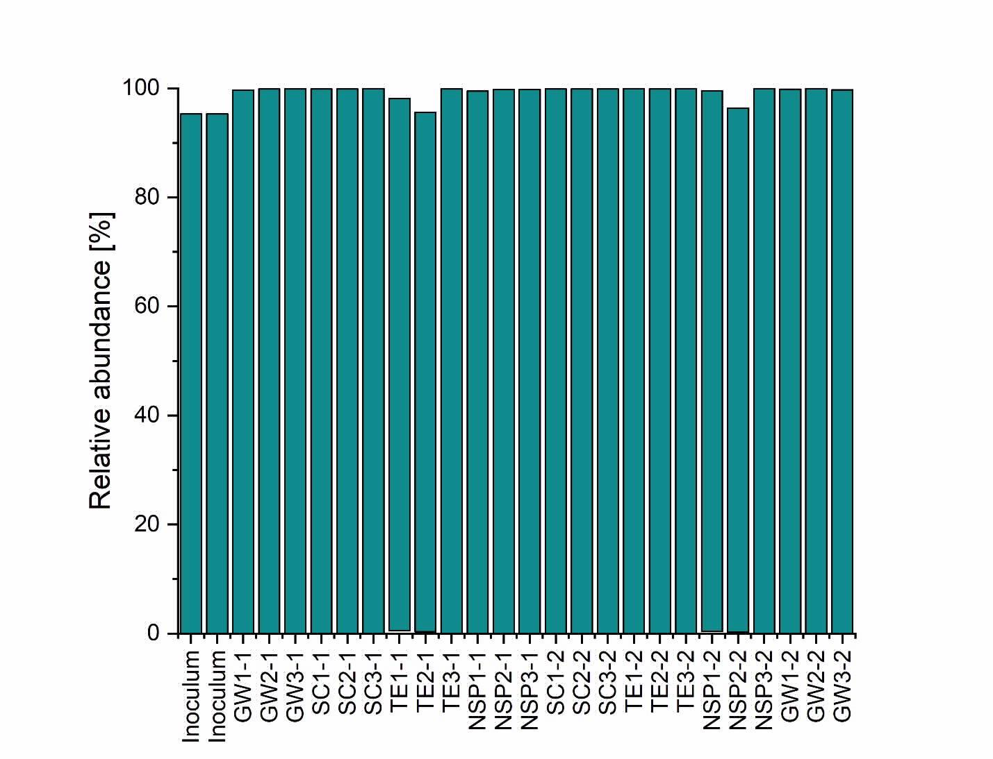
Figure S-1: Distribution of bacterial species across biotic microcosms. Cut-off was 0.9 %. Labels are shortened according to the experimental names (SC: biological control, GW: groundwater ions, TE: trace elements, NSP: macro nutrients). Two technical replicates of each biological replicate were used. Dominating species (>90% relative abundance) was Methanobacterium.

Isotope and Concentration Analyses

Workflow
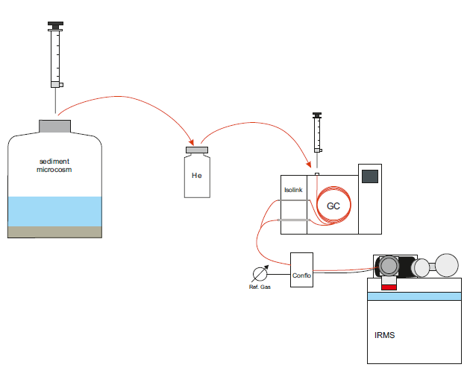
The microcosms were sampled and the samples stored in 10 ml vials flushed with He before measurement on a GC-IRMS setup.
Figure S-2: Schematic workflow from sampling to measurement with the GC-IRMS system. He: Helium, GC: Gas chromatograph, Isolink: device that contains and heats reactors for conversion of compounds; Conflo: Instrument which regulates flow into mass spectrometer; IRMS: isotope ratio mass spectrometer.

Respikes
Date | t [d] | amount [ml] | gas
23.05.2019 | 2 | 3 | H₂
04.06.2019 | 14 | 3 | H₂
19.06.2019 | 29 | 3 | H₂
24.07.2019 | 64 | 1 | H₂
31.07.2019 | 71 | 3 | H₂
08.08.2019 | 80 | 3 | H₂
21.08.2019 | 93 | 3 | H₂
30.08.2019 | 102 | 3 | H₂
02.09.2019 | 105 | 12 | H₂
02.09.2019 | 105 | 1 | CO₂

Abiotic Controls
Concentration and isotope measurements of the abiotic control replicates are shown in Figure S-3. The isotope ratio was stable over the course of the experiment. Concentrations decrease due to continuous sampling. Slight overpressure lead to measurement of seemingly higher H₂-concentrations in the beginning.

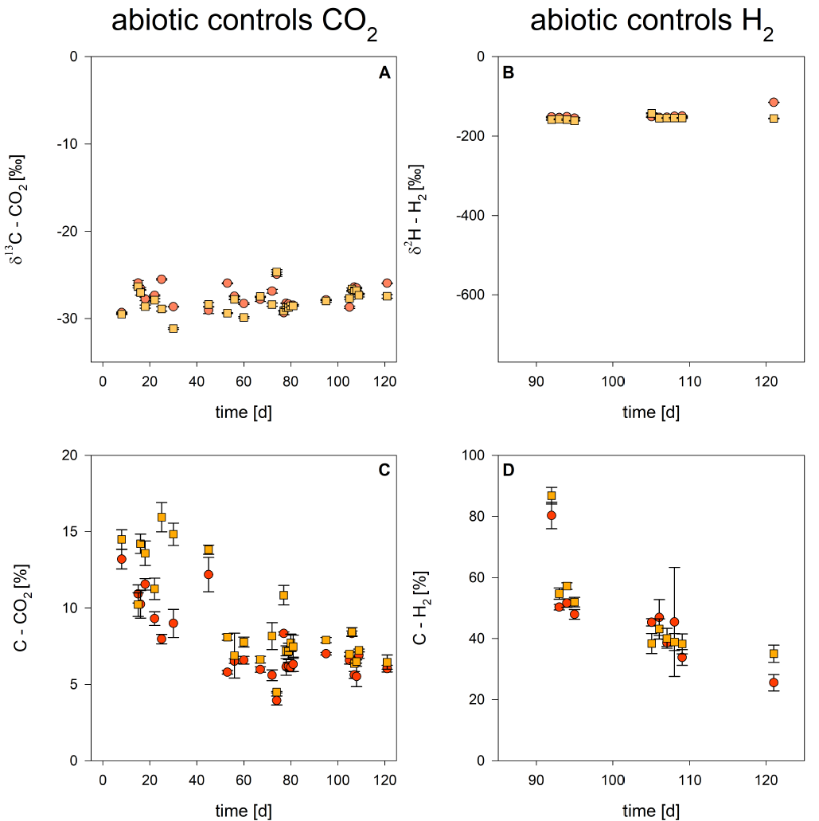
Figure S-3: δ²H- and δ¹³C values (A, C) and concentrations of CO₂ and H₂ (C,D) in the abiotic controls, shown here in two microcosm replicates (yellow, orange) as average with standard deviation of technical replicates.

Concentration analyses

CO₂ and CH₄
CO₂-concentrations decreased in biological replicates over time due to dissolution, loss and microbial consumption (cf. Figure S-4, Table S-4). The CO₂ concentrations on day 121 are below the abiotic controls.
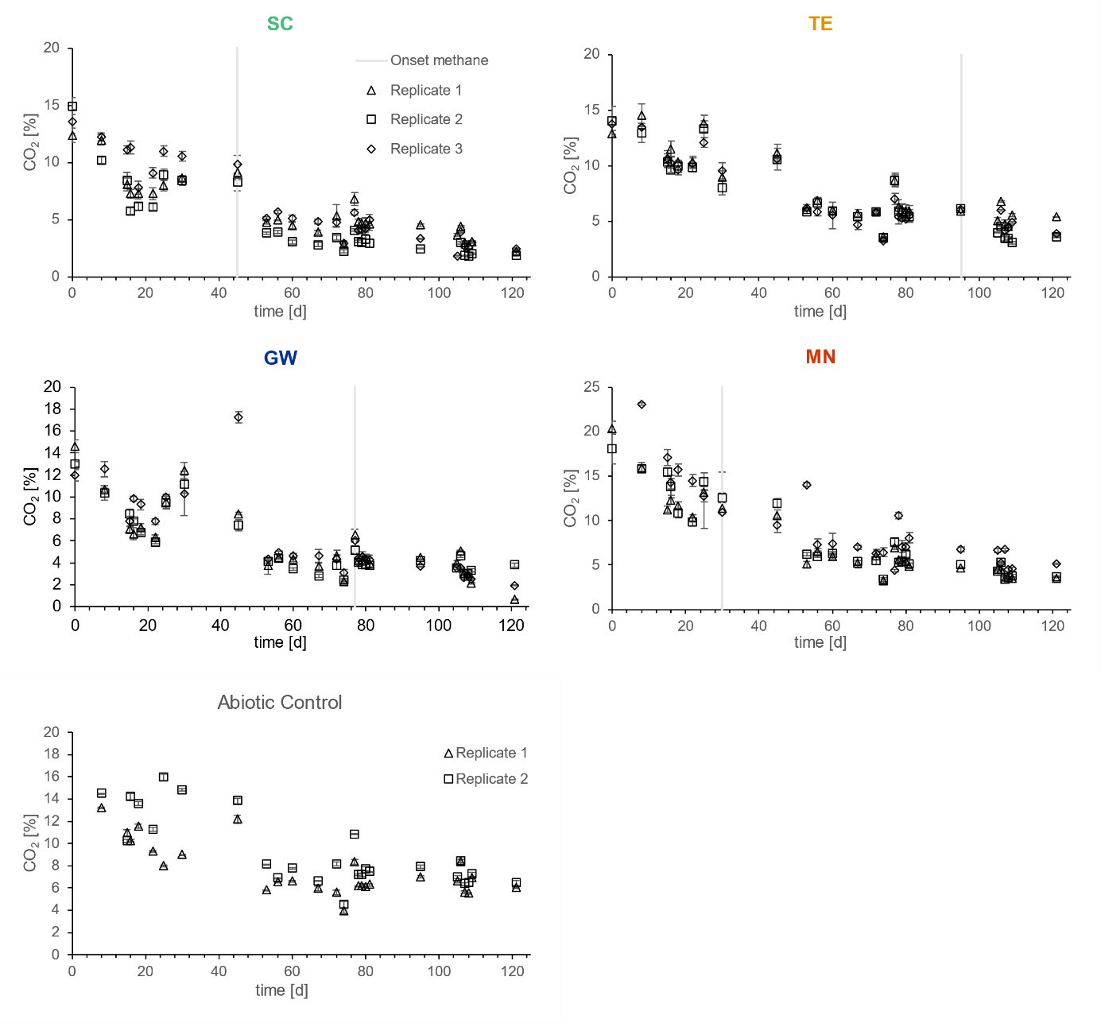
Figure S-4: Concentrations of CO₂ of three biological replicates and two abiotic controls with standard deviation in the four setups. Onset of methane production is indicated with grey bar.

Methane concentrations varied in the different setups (Table S-4). Two groundwater ion replicates yielded no methane.
Table S-4: CO₂ concentrations of biotic microcosm at day 0 and day 121, as well as CH₄-concentrations on day 121. Shown is the average of triplicate measurements with standard deviation.
Sample | Replicate | C_{CO2, t=0} [%] |  | C_{CO2, t=121d} [%] |  | C_{CH4 t=121d} [%]
 |  | average | stdev | average | stdev | average | stdev
biological control | 1 | 12.4 | ± 0.7 | 2.2 | ± 0.1 | 3.4 | ± 0.1
 | 2 | 14.9 | ± 0.7 | 1.9 | ± 0.1 | 2.7 | ± 0.1
 | 3 | 13.6 | ± 1.1 | 2.4 | ± 0.1 | 3.7 | ± 0.1
ground-water ions | 1 | 14.6 | ± 0.6 | 0.6 | ± 0.0 | n.d.
 | 2 | 13.0 | ± 0.2 | 3.8 | ± 0.2 | n.d.
 | 3 | 12.0 | ± 0.6 | 2.0 | ± 0.0 | 3.6 | ± 0.1
trace elements | 1 | 12.9 | ± 0.3 | 5.4 | ± 0.1 | 0.2 | ± 0.0
 | 2 | 14.1 | ± 1.3 | 3.6 | ± 0.1 | 1.8 | ± 0.0
 | 3 | 13.7 | ± 0.6 | 3.9 | ± 0.1 | 1.6 | ± 0.0
macro nutrients | 1 | 20.3 | ± 0.8 | 3.5 | ± 0.1 | 3.0 | ± 0.1
 | 2 | 18.0 | ± 1.7 | 3.7 | ± 0.1 | 2.8 | ± 0.1
 | 3 | 23.1 | ± 0.4 | 4.9 | ± 0.1 | 2.2 | ± 0.0
n.d.: not determined, below detection limit

H₂
Before the re-spike on day 93, only a few samples contained residual H₂ and on the last day of the experiment, only replicate 2 of the groundwater ions setup and replicate 1 of the trace element setup contained remaining H₂ (Table (S-5).
Sample | Replicate | C_{H2, t=92d} [%] |  | C_{H2,t=93d} [%] |  | C_{H2, t=94d} [%] |  | C_{H2, t=105d} [%] |  | C_{H2, t=109d} [%] |  | C_{H2, t=121d} [%]
 |  | av. | stdev | av. | stdev | av. | stdev | av. | stdev | av. | stdev | av. | stdev
biological control | 1 | 6.9 | ± 0.6 | 9.2 | ± 0.2 | 7.5 | ± 0.3 | 10.4 | ± 0.9 | 4.8 | ± 0.5 | n.d.
 | 2 | n.d. |  | 2.0 | ± 0.1 | 0.6 | ± 0.0 | 5.6 | ± 0.5 | n.d. |  | n.d.
 | 3 | n.d. |  | 1.3 | ± 0.1 | 0.7 | ± 0.1 | n.d. |  | 0.9 | ± 0.1 | n.d.
ground-water ions | 1 | n.d. |  | 7.2 | ± 0.2 | 4.4 | ± 0.2 | 14.0 | ± 1.5 | n.d. |  | n.d.
 | 2 | n.d. |  | 6.7 | ± 0.3 | 1.6 | ± 0.0 | 14.4 | ± 3.3 | 8.8 | ± 0.9 | 9.3 | ± 0.9
 | 3 | 3.1 | ± n.d. | 6.5 | ± 0.6 | 1.7 | ± 0.1 | 16.1 | ± 1.4 | 2.8 | ± 0.3 | n.d.
trace elements | 1 | 6.6 | ± 0.2 | 15.0 | ± 0.9 | 11.4 | ± 0.3 | 5.9 | ± 0.4 | 7.2 | ± 1.1 | 5.9 | ± 0.4
 | 2 | 9.4 | ± 0.3 | 17.0 | ± 0.8 | 11.7 | ± 0.6 | 4.3 | ± 0.6 | n.d. |  | n.d.
 | 3 | 5.0 | ± 0.1 | 12.8 | ± 0.2 | 7.1 | ± 0.5 | 16.2 | ± 0.8 | 5.7 | ± 0.1 | n.d.
macro nutrients | 1 | n.d. |  | 7.1 | ± 0.8 | 2.7 | ± 0.2 | 11.1 | ± 0.9 | n.d. |  | n.d.
 | 2 | n.d. |  | 6.9 | ± 0.5 | 2.4 | ± 0.2 | 4.4 | ± 0.7 | n.d. |  | n.d.
 | 3 | n.d. |  | 6.8 | ± 0.2 | 2.5 | ± 0.2 | 7.6 | ± 0.1 | n.d. |  | n.d.
 |  |  |  | re-spike |  |  |  | re-spike |  |  |  | end
Table S-5: Average concentration of H₂ of three biological replicates with standard deviation in the four different setups. Setups were spiked again at days 92 and 105, respectively. Samples are shown in percent of headspace volume.
n.d.: not determined, below detection limit

General Coping Mechanisms for Nutrient Limitations
Microbes often carry optimised proteins and enzymes, which require less potentially limited elements. Additionally, the entire genome is never expressed, which enables structural and functional adjustment. Still, natural environments are characterised by the available nutrients, which implies lack of others. There are four general strategies followed by microorganisms when faced with nutrient limitations: acquisition, mobilisation, sparing and recycling [1]. The first step is usually change in acquisition of the limited element or compound. Here, additional uptake systems are employed. Low-affinity uptake systems are replaced by high-affinity ones that come with higher energy demand [2–4]. At the same time, stored resources are mobilised. If these measures were not effective, sparing is the next step. This is an umbrella term for austerity measures, which aims to reduce cellular demand. Here, non-essential proteins and macromolecules might be selectively repressed or the limited element might be substituted [1,3]. The last measure microorganisms can employ is recycling. Elements are recovered via autophagy. When limitations are lifted and the nutrient is available again, catabolisation can be fast [3].

References
[1] Merchant SS, Helmann JD. Elemental economy: microbial strategies for optimizing growth in the face of nutrient limitation. Adv Microb Physiol. 2012;60:91–210.
[2] Bradley AS, Leavitt WD, Schmidt M, et al. Patterns of sulfur isotope fractionation during microbial sulfate reduction. Geobiology. 2016;14:91–101.
[3] Harder W, Dijkhuizen L. Physiological responses to nutrient limitation. Annu Rev Microbiol. 1983;37:1–23.
[4] Sim MS, Ono S, Bosak T. Effects of iron and nitrogen limitation on sulfur isotope fractionation during microbial sulfate reduction. Appl Env Microbiol. 2012;78:8368–8376.

