Supplement: Ammonia emissions from a dairy housing and wastewater treatment plant quantified with an inverse dispersion method accounting for deposition loss

Alex C. Valach, Christoph Häni, Marcel Bühler, Joachim Mohn, Sabine Schrade, and Thomas Kupper

SI1. Dairy housing

SI1.1 Supplementary data

Additional figures on the weather conditions, site operations, data processing, and instrument outputs are presented below for both sites.
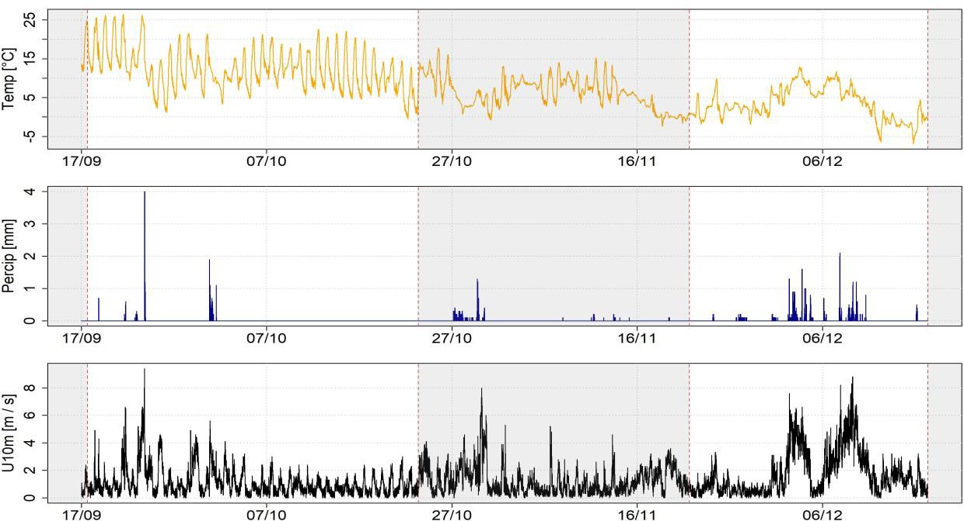

Figure SI1.1. Meteorological conditions (temperature, precipitation, and wind speed) from the nearby weather station (Taenikon in Aadorf, MeteoSwiss) during the first (autumn) and second (winter) measurement periods (non-shaded sectors) at the dairy housing in 2018. Reproduced from the supplemental information in Bühler et al. (2022).

Due to the filtering requirements (including valid wind directions, atmospheric turbulence and stability conditions, and bLS outputs) data retention was relatively low with a bias towards higher retention during the day than at night averaging in 69% data loss across all measurements (Figure SI1.2).

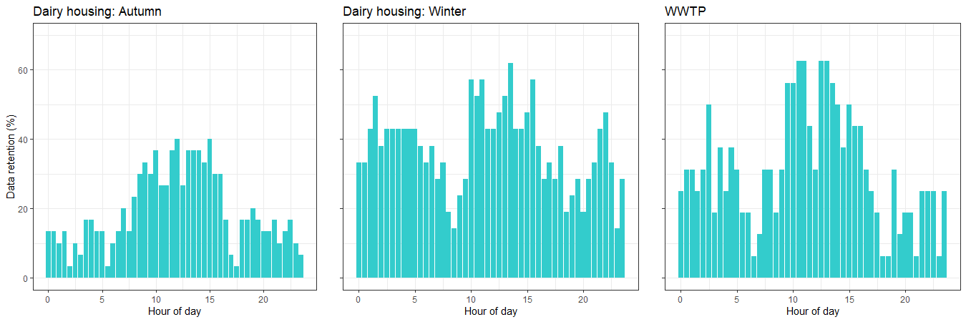
Figure SI1.2. Diel averages of data retention (as % of data available during instrument uptime) for both measurement periods at the dairy housing (left and middle panels) and the WWTP (right panel).

Since emissions could only be determined for wind directions perpendicular to the line-integrated measurements Figure SI1.3 indicates the dominant wind directions with time. In order to calculate the concentration increase due to the emission source, the instruments were assigned the up- or downwind position according to the dominant wind direction for each 30-min period.
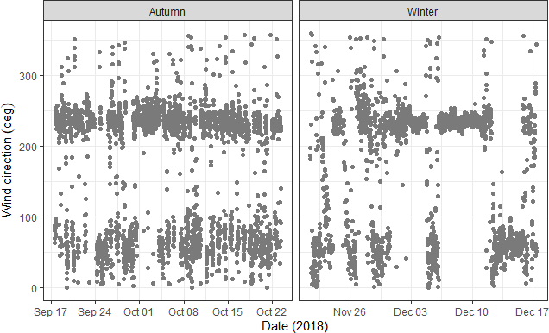

Figure SI1.3. Wind directions for each 30-min averaging period at the dairy housing during both measurement campaigns.

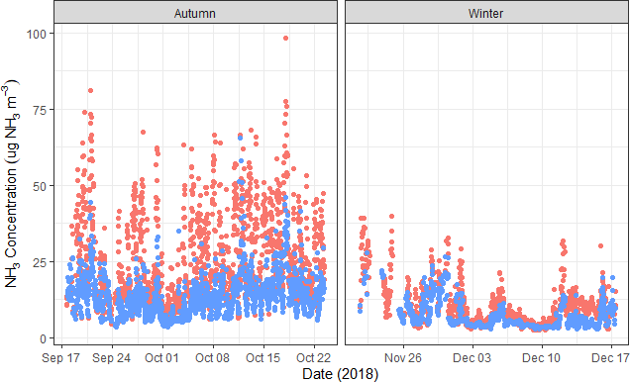

Figure SI1.4. Raw (unfiltered by micrometeorological conditions) 30-min NH3 concentration data of the upwind background (blue) and downwind plume (red) levels.

SI1.2 Correlation statistics

Correlations of NH3 emissions with environmental conditions by measurement period and wind direction are summarized in Table SI1.1.
Table SI1.1 Correlation statistics of NH3 emissions with environmental variables at the dairy housing.

Time  offset (h) | Measurement  period | Wind  direction | Temperature |  | Wind speed
 |  |  | coefficient r | p - value | coefficient r | p - value
0 | Autumn | SW | 0.07 | 0.62 | 0.005 | 0.96
 |  | NE | 0.14 | 0.18 | 0.33 | <0.001***
 |  | all | 0.27 | <0.001*** | 0.27 | <0.001***
 | Winter | SW | 0.16 | 0.06 | -0.01 | 0.83
 |  | NE | 0.42 | <0.01** | 0.13 | 0.18
 |  | all | 0.06 | 0.37 | -0.03 | 0.62
 | all | all | 0.51 | <0.001*** | -0.18 | <0.001***
1-2 | Autumn | SW | 0.28 | <0.01** | 0.08 | 0.4
 |  | NE | 0.24 | <0.01** | 0.37 | <0.001***
 |  | all | 0.33 | <0.001*** | 0.30 | <0.001***
 | Winter | SW | 0.31 | <0.001*** | -0.06 | 0.35

 |  | NE | 0.26 | <0.01** | -0.03 | 0.70
 |  | all | 0.21 | <0.001*** | -0.06 | 0.25
 | all | all | 0.55 | <0.001*** | -0.20 | <0.001***
Statistically significant correlations are marked with * for p <0.05, ** for p <0.01, and *** for p <0.001.

SI1.3 Wind direction dependencies of emissions

The winds were more dominant from the NE during autumn and from the SW during winter (Figure SI1.5).
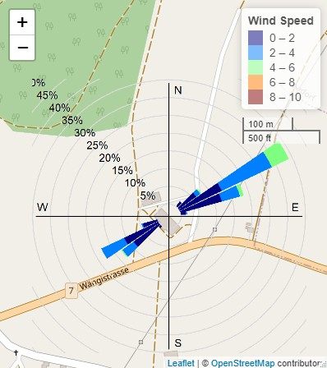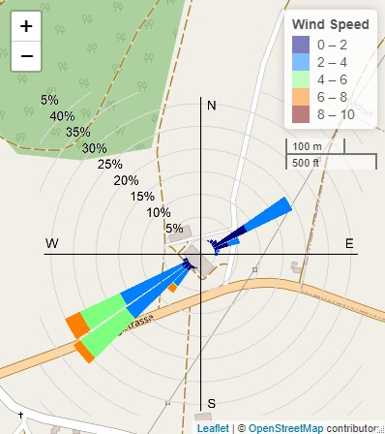
Figure SI1.5. Wind roses superimposed on the site map showing the wind speed frequency by wind direction for the autumn (left) and winter (right) measurement periods at the dairy housing. Map data © OpenStreetMap contributors.

Daily profiles of NH3 emissions and correlations with friction velocity u* are shown in Figure SI1.6 with approx. 20% higher emissions with NE winds during autumn, which also showed slightly higher correlations.

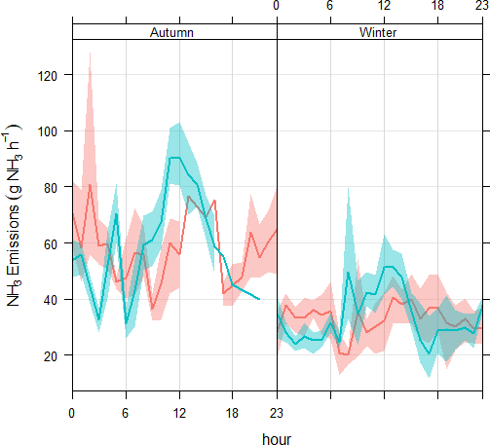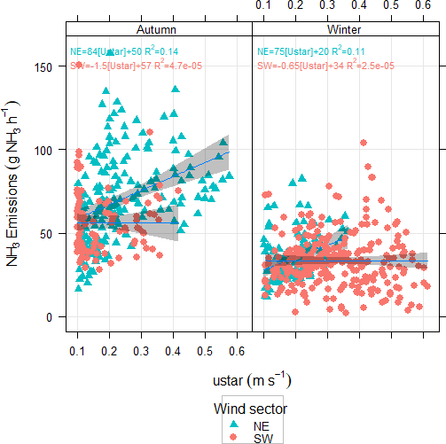

Figure SI1.6 Mean diel NH3 emissions (a, left) separated by sector (red SW, blue NE) and correlated with friction velocity u* (b, right) with linear regressions and coefficients for each wind direction and measurement period at the dairy housing.

SI1.4 iTRM measurements

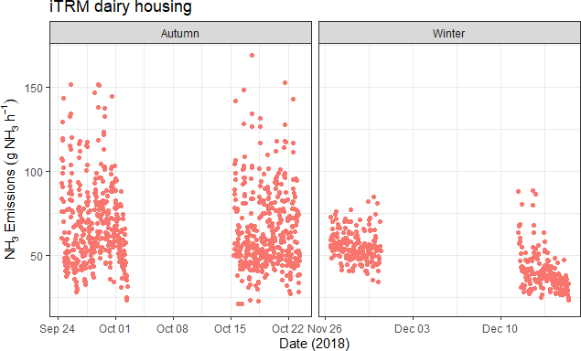

Figure SI1.7. 30-min averaged NH3 emissions (g NH3 h⁻¹) from the inhouse tracer ratio method (iTRM) at the dairy housing during the autumn and winter measurement periods.

SI2. Wastewater treatment plant

SI2.1 Supplementary data
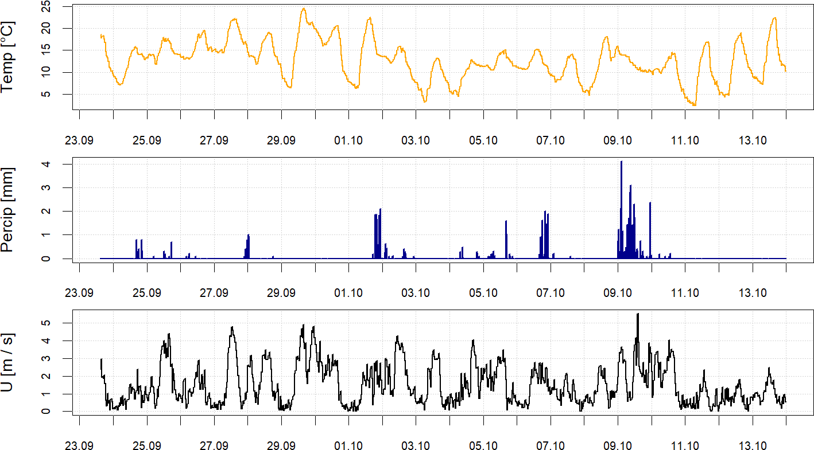
Figure SI2.1. Meteorological conditions (temperature, precipitation, and wind speed) recorded on site during the measurements at the WWTP. Reproduced from the supplemental information in Bühler et al. (2022).

Operational parameters and conditions at the WWTP during the measurement period are shown in Table SI2.1 and bLS weightings for each emitting structure at the WWTP are given in Table SI2.2. The WWTP had a total digester volume of 2200 m³, and 1960 m³ for the sludge storage tanks (surface of 331 m²), of which 632 m³ were in use during the measurement period. Measured concentrations by the up- and downwind miniDOAS instruments, as well as the wind directions at the WWTP are shown in Figures SI2.2 and 2.3.

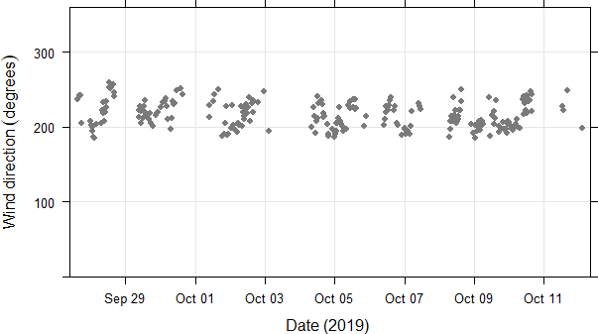

Figure SI2.2 Wind directions for the instrument placements up- and downwind of the WWTP after filtering for valid measurement conditions.
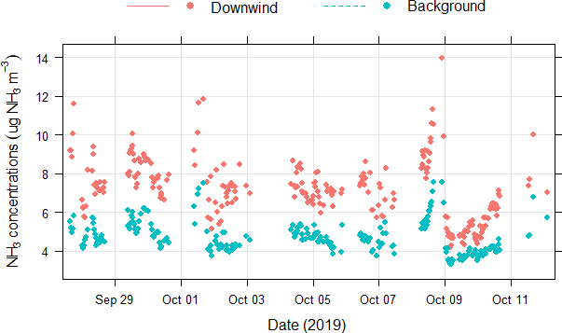

Figure SI2.3 Filtered ammonia concentrations for valid conditions measured by the miniDOAS instruments placed up- (blue) and downwind (red) of the emission source at the WWTP.

SI2.2 Operational data and statistics

Table SI2.1 Mean operational conditions at the wastewater treatment plant during the measurement period.

Parameter | Units | Mean | Median | SD | Min | Max
Inflow pH |  | 7.39 | 7.39 | 0.23 | 6.79 | 7.93
Temperature | °C | 17.7 | 18.0 | 1.3 | 15.3 | 20.
Dry matter (fresh sludge) | % | 5.46 | 5.34 | 0.76 | 3.52 | 6.72
Inflow rate | L s-1 | 141 | 118 | 54 | 91 | 314
Inflow volume | m3 d-1 | 11168 | 9380 | 6497 | 7829 | 30660
NH4-N (inflow) | mg l⁻¹ | 33.1 | 36.2 | 8.67 | 15.7 | 42.3
NH4-N (outflow) | mg l⁻¹ | 0.09 | 0.05 | 0.14 | 0.02 | 0.52
Total NH4-N flow | kg d⁻¹ | 336 | 341 | 233 | 230 | 1034
COD* concentration | g l-1 | 299 | 310 | 42 | 156 | 424
COD* Flow | kg d⁻¹ | 2862 | 2933 | 1090 | 1866 | 6133
*COD: Chemical Oxygen Demand

Table SI2.2 Weightings applied to the emission of the different source structures at the wastewater treatment plant.

Structure | Weighting* | Reference
Storage tanks | 0.81 | Kupper et al., 2020
Sand trap | 0.1 | Samuelsson et al., 2018
Digester | 0.4 | Samuelsson et al., 2018
Primary clarifier | 0.04 | Samuelsson et al., 2018
Secondary clarifier | 0.004 | Samuelsson et al., 2018
Aeration tanks | 0.006 | Samuelsson et al., 2018
*Weightings are calculated as fractions from emission factors for each source area, which were based on values from the literature.

Table SI2.3 summarises correlations of NH3 emissions with different driver variables using a synchronous correlation, as well as lagged correlations, whereby a positive lag indicates that the predictor variable lags behind the NH3 emissions, while a negative lag shows that it precedes changes in emissions. The lagged correlations are only presented if they were higher than the synchronous correlation and only the lag with the maximum offset correlation is shown.
Table SI2.3 Correlations of predictor variables for NH3 emissions at the WWTP.

Parameter | Time offset (h) | Correlation coefficient | p-value
Air temperature | 0 | 0.48 | <0.001***
 | +3 | 0.75 | <0.001***
pH | 0 | 0.15 | 0.022*
 | -4 | 0.53 | <0.001***
Sludge tank agitation | 0 | -0.11 | 0.088
 | -4 | -0.19 | 0.002**
 | +4 | 0.33 | <0.001***
Incoming solar radiation | 0 | 0.68 | <0.001***
Statistically significant correlations are marked with * for p <0.05, ** for p <0.01, and *** for p <0.001.

