1 Supplementary Information for
2
- Social elite in the power centre of Late Antique Gallaecia? Revisiting
- San Bartolomé de Rebordáns (Tui, Spain)
5
6
- Patxi Pérez-Ramallo^{1,2}, Nieves Veiga López³, Aurora Grandal-d´Anglade⁴, José
- Carlos Sánchez-Pardo⁵.
9
- 1iso-TROPIC Research Group, Department of Archaeology, Max Planck Institute of Geoanthropology.
- Kahlaische Str. 10, 07745, Jena, Germany.
2
- Faculty of Medicine and Nursing, University of the Basque Country (EHU). C/ Pº Dr. Beguiristain 105,
- 20014, San Sebastián-Donostia, Spain.
- 3Collegiate Archaeologist number 6685. Veiga Arqueología.Servicios de arqueología y Gestión del
- Patrimonio Cultural.15707 Santiago de Compostela.
- 4Instituto Universitario de Xeoloxía, Universidade da Coruña (UDC). ESCI. 15071, A Coruña, Spain.
- 5Departamento de Historia, Faculty of History, University of Santiago de Compostela (USC). Praza da
- Universidade, 1, 15703, Santiago de Compostela, Spain.
19
20 *correspondence to: Patxi Pérez-Ramallo (ramallo@shh.mpg.de)
21
22
- This PDF file includes:
- Figures S1to S4

Figure S1. View of the church of San Bartolomé de Rebordáns from the West.
- Source: https://gl.wikipedia.org/wiki/Rebord%C3%A1ns,_Tui#/media/Ficheiro:Iglesia_sanbartolome.jpg
27
28
29 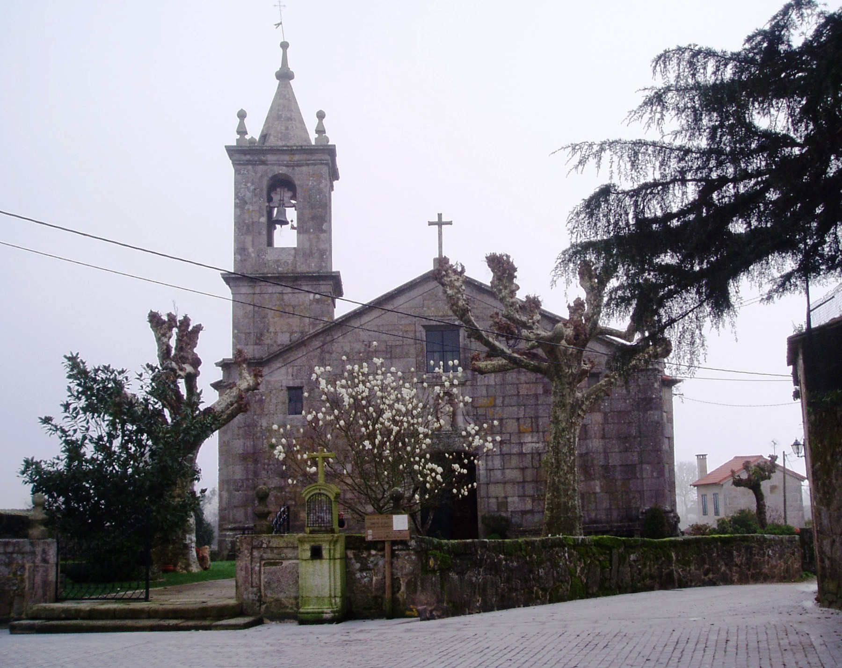
30
31
32
33
34
35
36
37
38
39
40
41
42
43
44
45
46

Figure S2. View of the church of San Bartolomé de Rebordáns from the north,
- where the new excavations of 2016 took place
49
50
51 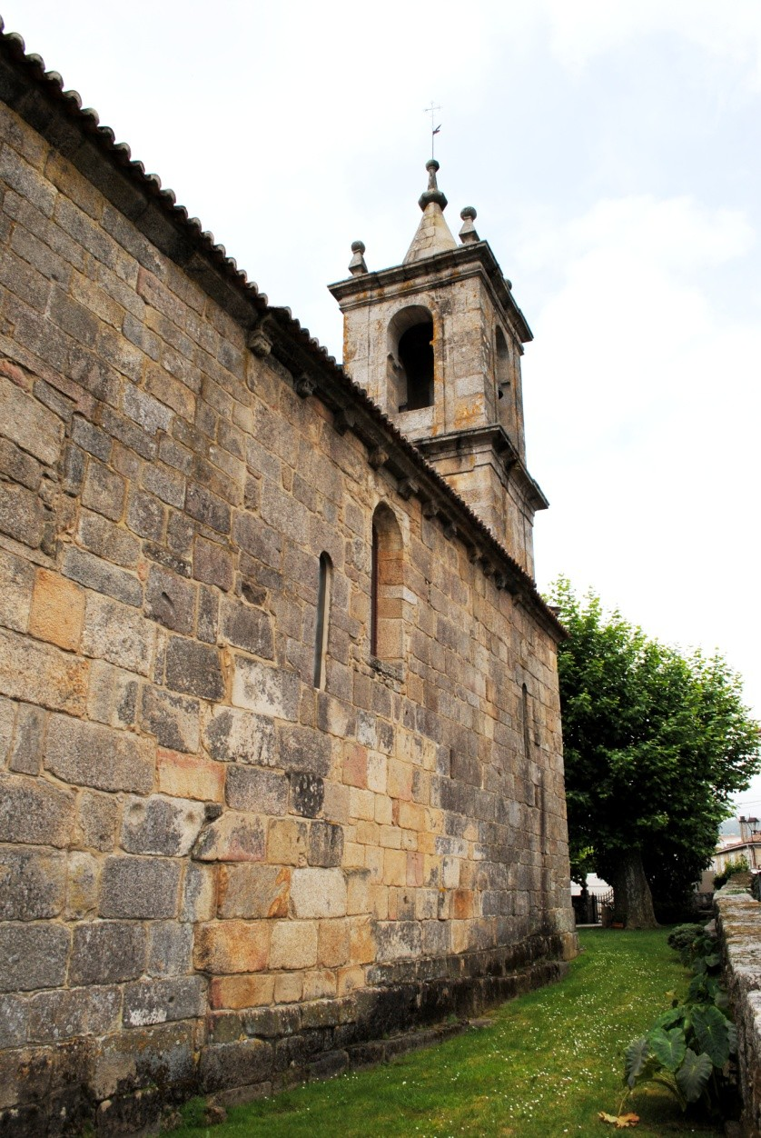
52
53
54
55

Figure S3. Image of the excavation under the church of Rebordáns carried out in
- 1970 by Manuel Chamoso Lamas and José Filgueira. Source: Chamoso and

Filgueira (1976)
59
60 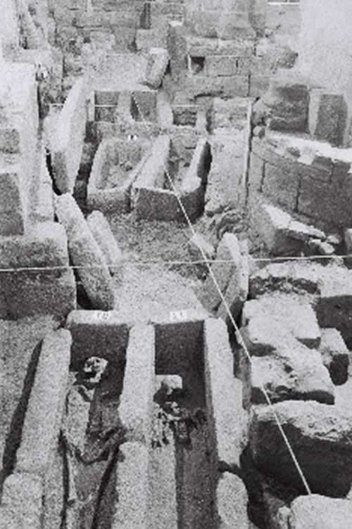
61
62

Figure S4. FRUITS Box Plot with the estimation of terrestrial and marine
- contribution for the 4 individuals of Rebordáns site
65
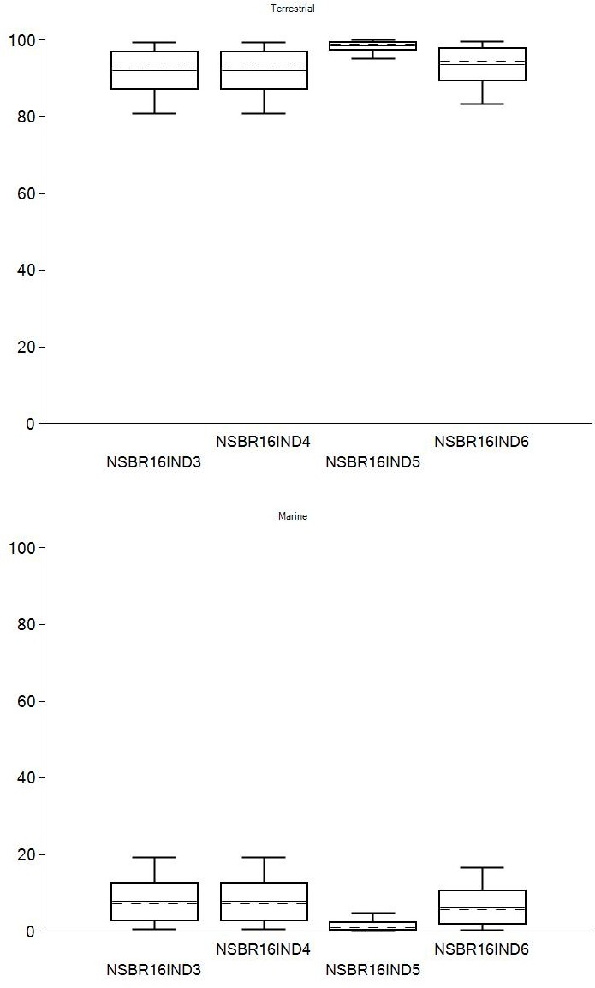
66

