Supplementary Materials
Supplemental Table 1. Number of Cirsium pitcheri plants at different life stages in a demographic monitoring plot (30 x 100 meters) at Ship Canal Nature Preserve from 2016 to 2022. This plot is separate from the pollinator observation plots but is representative of changes seen across the whole site (approximately 10 acres of dune habitat). The entire population of Cirsium pitcheri at Ship Canal includes plants in the preserve and plants on 10 adjacent privately held lakefront homes with relatively low numbers of plants.

Stage | No. of Plants (2016) | No. of Plants (2017) | No. of Plants (2018) | No. of Plants (2019) | No. of Plants (2020) | No. of Plants (2021) | No. of Plants (2022)
Seedlings | 275 | 696 | 641 | 278 | 110 | 63 | 5
Vegetative Plants | 482 | 337 | 317 | 452 | 192 | 98 | 25
Flowering Plants | 50 | 37 | 28 | 27 | 18 | 4 | 4

Number of flowering Cirsium pitcheri plants over the entire Ship Canal Preserve from 2015 to 2022.
Year | Flowering plant count
2015 | 362
2016 | 645
2017 | Data not collected
2018 | 288
2019 | 263
2020 | 352
2021 | 164
2022 | 54

Figure S1. Ship Canal Nature Preserve plant-pollinator network in 2016, before invasive plant removal and decline of Cirsium pitcheri.
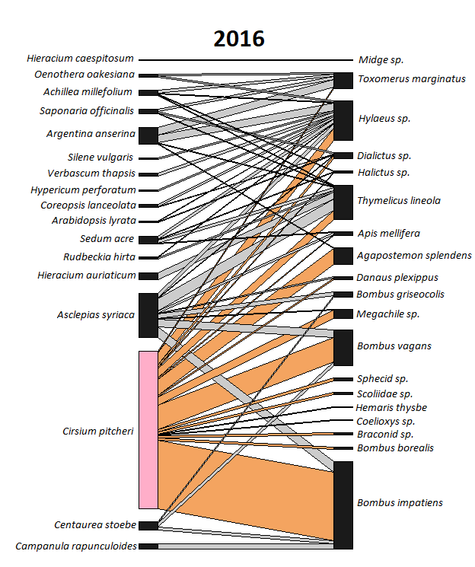

Figure S2. Ship Canal Nature Preserve plant-pollinator network in 2021, after invasive plant removal and the beginning of Cirsium pitcheri decline.
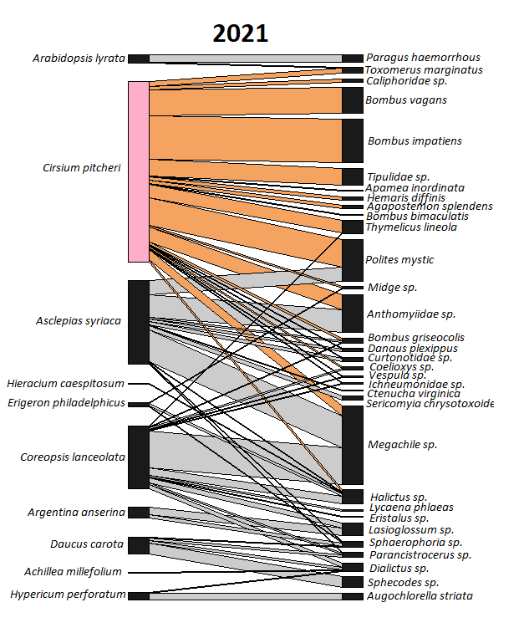

Figure S3. Ship Canal Nature Preserve plant-pollinator network in 2022, after invasive plant removal and the continued decline of Cirsium pitcheri.
