Supporting Information

Synergistic effects of climate warming and atmospheric nutrient deposition on the alpine lake ecosystem in the South-Eastern Tibetan Plateau during the Anthropocene
Can Zhang¹, Xiangzhen Kong^{1,2*}, Bin Xue¹, Cheng Zhao³, Xiangdong Yang¹, Longjuan Cheng^{4*}, Qi Lin¹, Ke Zhang¹, Ji Shen³
¹ State Key Laboratory of Lake Science and Environment, Nanjing Institute of Geography and Limnology, Chinese Academy of Science, Nanjing 210008, China
² Department of Lake Research, UFZ - Helmholtz Centre for Environmental Research, Magdeburg 39114, Germany
³ School of Geography and Marine Science, Nanjing University, Nanjing 210046, China
⁴ School of Geographical Science, Nantong University, Nantong 226007, Jiangsu Province, China

* Correspondence:
Xiangzhen Kong: xzkong@niglas.ac.cn
Longjuan Cheng: longjuan822@ntu.edu.cn

Supporting information include:
- Table S1. Calibrated parameter and the optimized values of the lake model.
- Figure S1. Chronology of sediment cores.
- Figure S2. Meteorology data used for the short-term model simulation from 2010 to 2014.
- Figure S3. Correction of air temperature from the ERA5 data.
- Figure S4. Meteorology projections used for the long-term model simulation from 1860 to 2020.
- Figure S5. Annually-averaged precipitation, discharge, nutrient concentration from 1860 to 2020 estimated by the export coefficient model.
- Figure S6. Model simulation results at daily time step in 2013.
SI Table

Table S1. Model parameters for calibration and the optimized values
Parameter | Module | Definition | Unit | Parameter values (calibrated)
 |  |  |  | Default | CQ lake (this study)
A | GOTM | non-visible fraction of shortwave radiation | [-] | 0.7 | 0.732219
g1 | GOTM | e-folding depth of non-visible shortwave radiation | m | 0.4 | 1.47809
g2 | GOTM | e-folding depth of visible shortwave radiation | m | 8 | 5.35742
kmin | GOTM | minimum turbulent kinetic energy | m²/s² | 1.00e-10 | 1.20291e-10
cFiltMax | WET (daphnia) | maximum filtering rate | L mgDW⁻¹ d⁻¹ | 4.5 | 2.0
cPrefBlue | WET (daphnia) | selection factor for blue-greens | [-] | 0.125 | 0.20
cPrefDiat | WET (daphnia) | selection factor for diatoms | [-] | 0.75 | 0.70
cPrefGren | WET (daphnia) | selection factor for greens | [-] | 0.75 | 0.55
hFilt | WET (daphnia) | half-saturation constant for food conc. on zooplankton | gDW/m³ | 1 | 1.46
cMuMax | WET (diatoms) | maximum growth rate diatoms | 1/d | 2 | 2.4
cMuMax | WET (greens) | maximum growth rate greens algae | 1/d | 1.5 | 1.25
cMuMax | WET (cyanobacteria) | maximum growth rate blue-greens algae | 1/d | 0.6 | 0.5

SI Figures
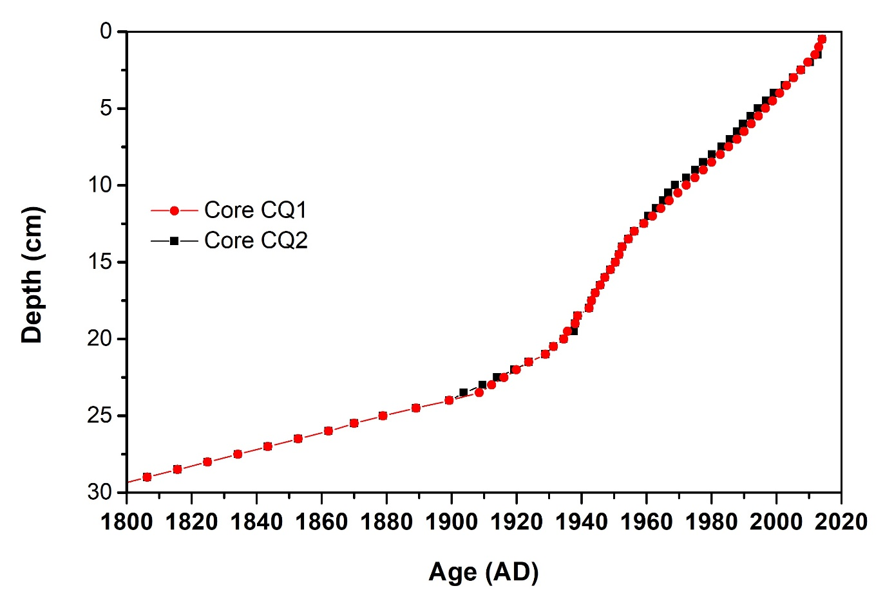
Fig. S1. Chronology of sediment cores. (a) Age-depth models of core CQ1 and CQ2 were previously published in Chai et al., 2018; Zhang et al., 2022.

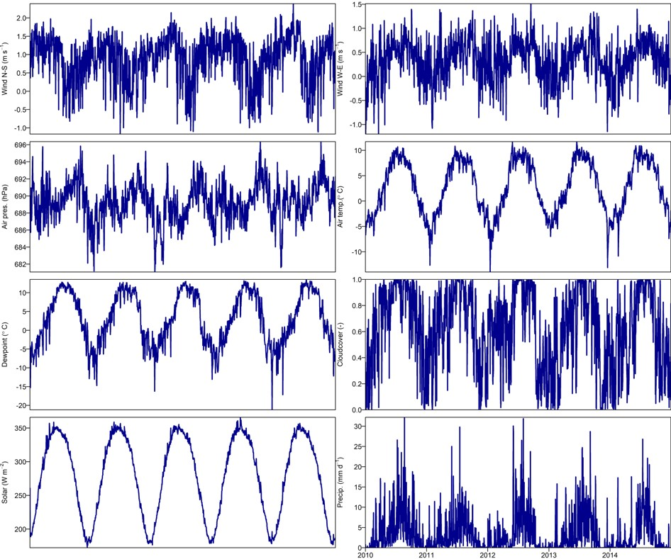
Fig. S2. Meteorology data used for the short-term model simulation from 2010 to 2014, collected from the ERA5 database at hourly basis (here aggregated to daily for display). Note that both normal and clear sky solar radiation were depicted and clear sky data was used as model inputs.

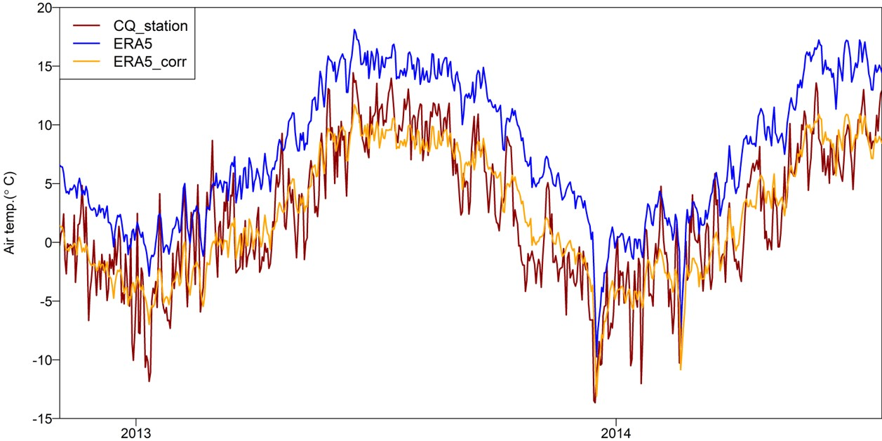
Fig. S3. Correction of air temperature from the ERA5 data based on the the national meteorology station (CMA) ‘Shangrila’ (xx km northeast? of Lake Cuoqia), which is slightly lower than the ERA5 air temperature data. The correction was performed using linear regression and the corrected ERA5 data were used for model simulation in 2013 and also from1900 to 2020.

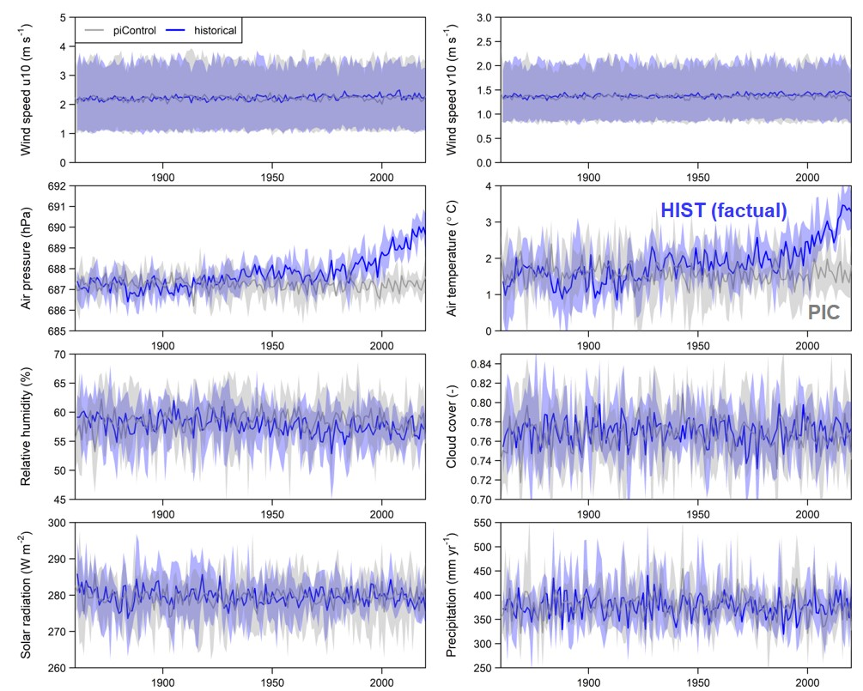
Fig. S4. Meteorology projections used for the long-term model simulation from 1860 to 2020, collected from ISIMIP project under the ‘piControl’ (without anthropogenic climate change) and historical (factual). The dataset was aggregated to annual basis to display. The ISIMIP data were derived using four Global Climate Models (GCMs) (HadGEM2-ES, IPSL-CM5A-LR, MIROC-ESM-CHEM, and GFDL-ESM2M). The solid lines are the average value, and the shaded areas are the variation calculated from the projections of the four GCMs.

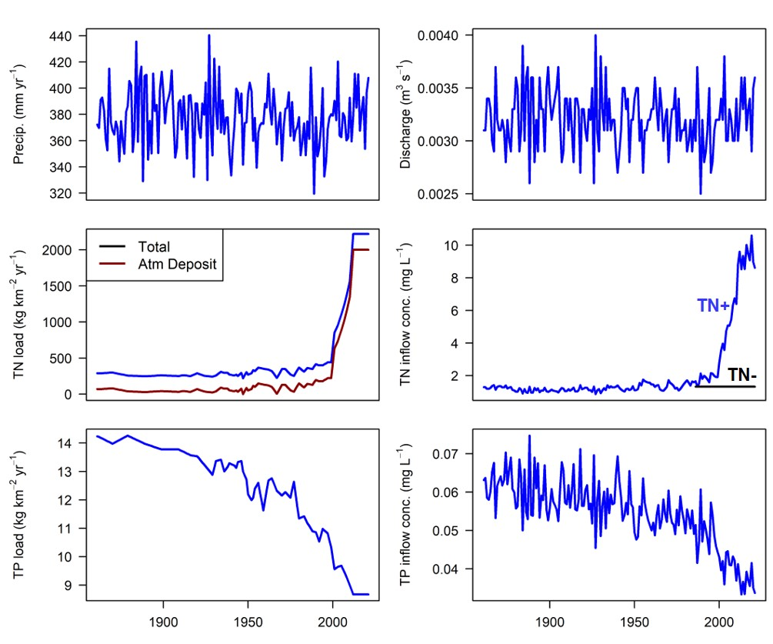
Fig. S5. Annually-averaged precipitation, discharge from the catchment to lake, nutrient concentration and load in the inflow (TN and TP) in Lake Cuoqia from 1860 to 2020 estimated by the export coefficient model. For TN loading, the additional inputs from atmospheric deposition is also shown. The scenario of TN- where TN concentration in the inflow remains constant after the 1980s is also provided. Note that the TP concentration in the inflow is corrected based on the reconstructed TP fraction in sediment records.
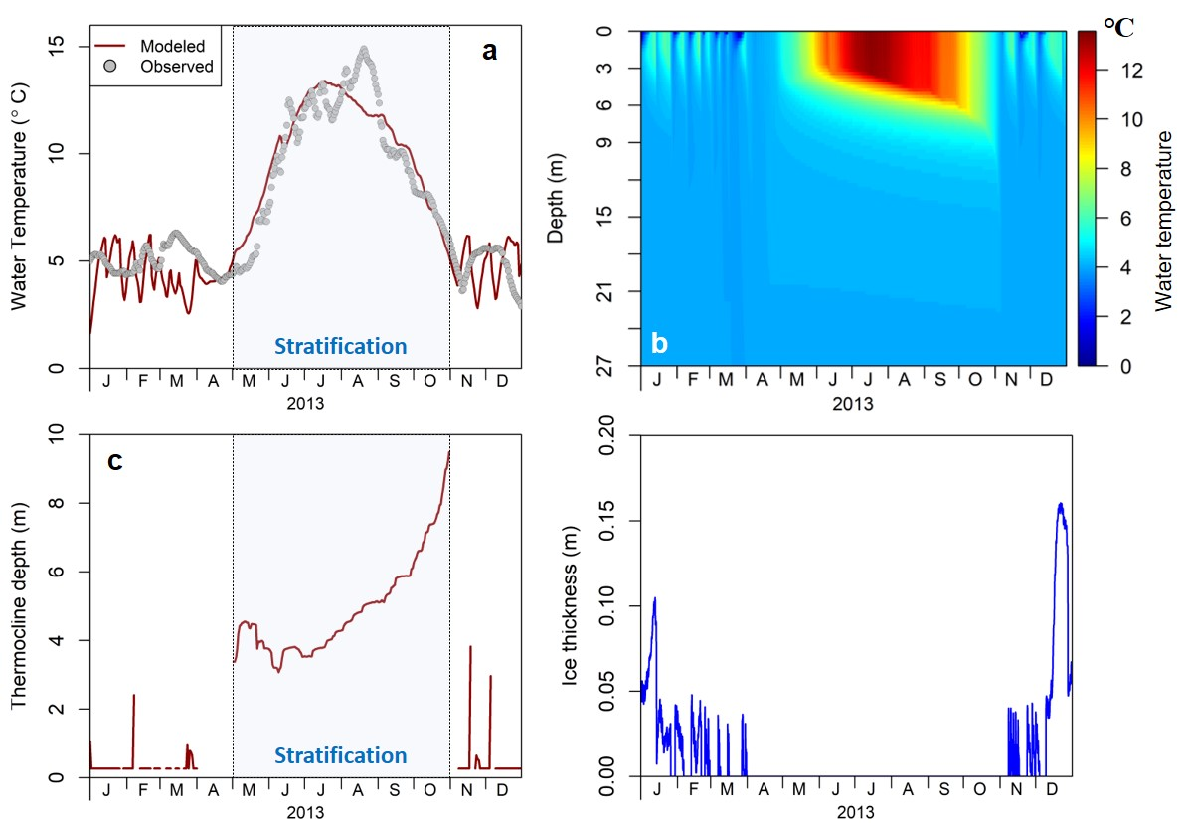
Fig. S6. Model simulation results at daily time step in 2013. (a) Observed and modeled water temperature at the depth of 1 m, (b) water temperature profiles along the vertical dimension, (c) Thermocline depth, (d) ice thickness. The blue strip in panel a and c denotes the period of water stratification in the lake.

Reference:
Chai, Y., Zhang, C., Kong, L., Zhao, C., 2018. Climatic changes and heavy metal pollution over the past 200 years recorded by Lake Cuoqia, southwestern Yunnan Province (in Chinese). J. Lake Sci. 30, 1732–1744.
Zhang, C., Zhao, C., Yu, S., et al. 2022. Seasonal imprint of Holocene temperature reconstruction on the Tibetan Plateau. Earth-Science Reviews. 226, 103927.

