Supplementary Information

Akash Ganguly*^{,,2}, Virendra Padhya¹, Harsh Oza¹, Gerhard Strauch³, R.D. Deshpande¹

¹Geosciences Division, Physical Research Laboratory, Navrangpura, Ahmedabad, 380009, India

²Indian Institute of Technology Gandhinagar, Gandhinagar, 382355, India

³Department of Hydrogeology, UFZ – Helmholtz Centre for Environmental Research, Germany
Supplementary Material
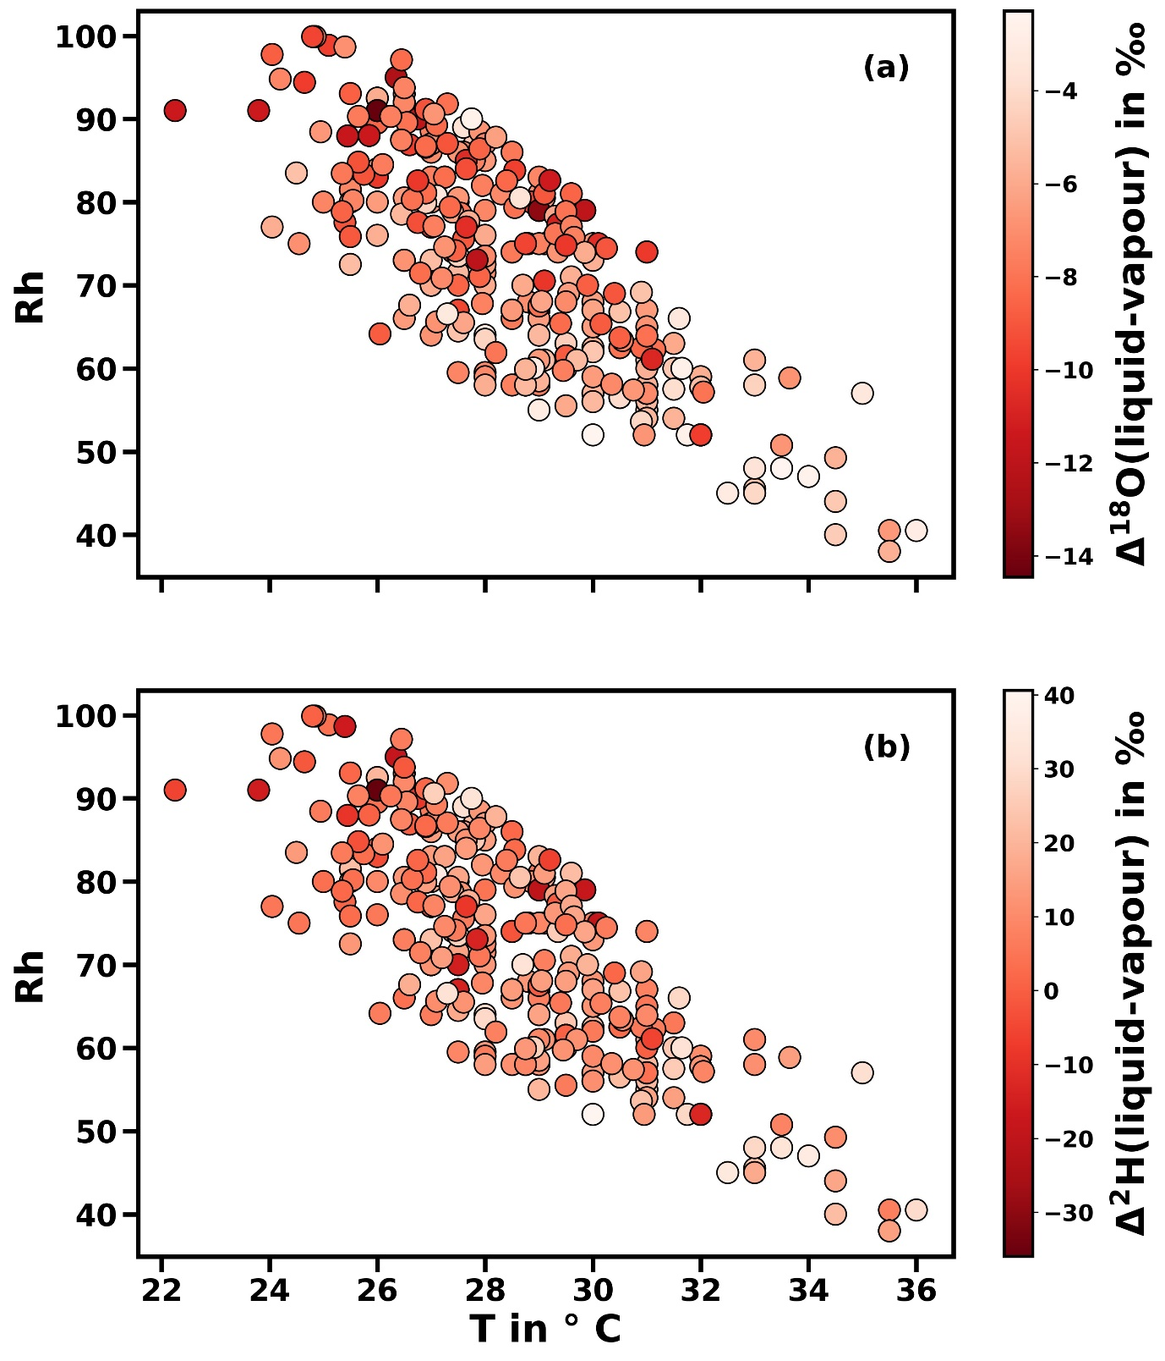Figure S1. (a)- The isotopic difference (Δ = δ_{liquid} - δ_{vapor}) in δ¹⁸O between each pair of liquid and vapor samples is plotted against its T and RH, within a narrow range of S_{i} (3.5 to 5.5). The darker shaded represents more depleted liquid compared to vapor, representing more fractionation. The greater extent of isotopic depletion due to more kinetic fractionation is observed under lower T - higher RH condition, within a narrow range of supersaturation; (b) The similar plot for δ²H.
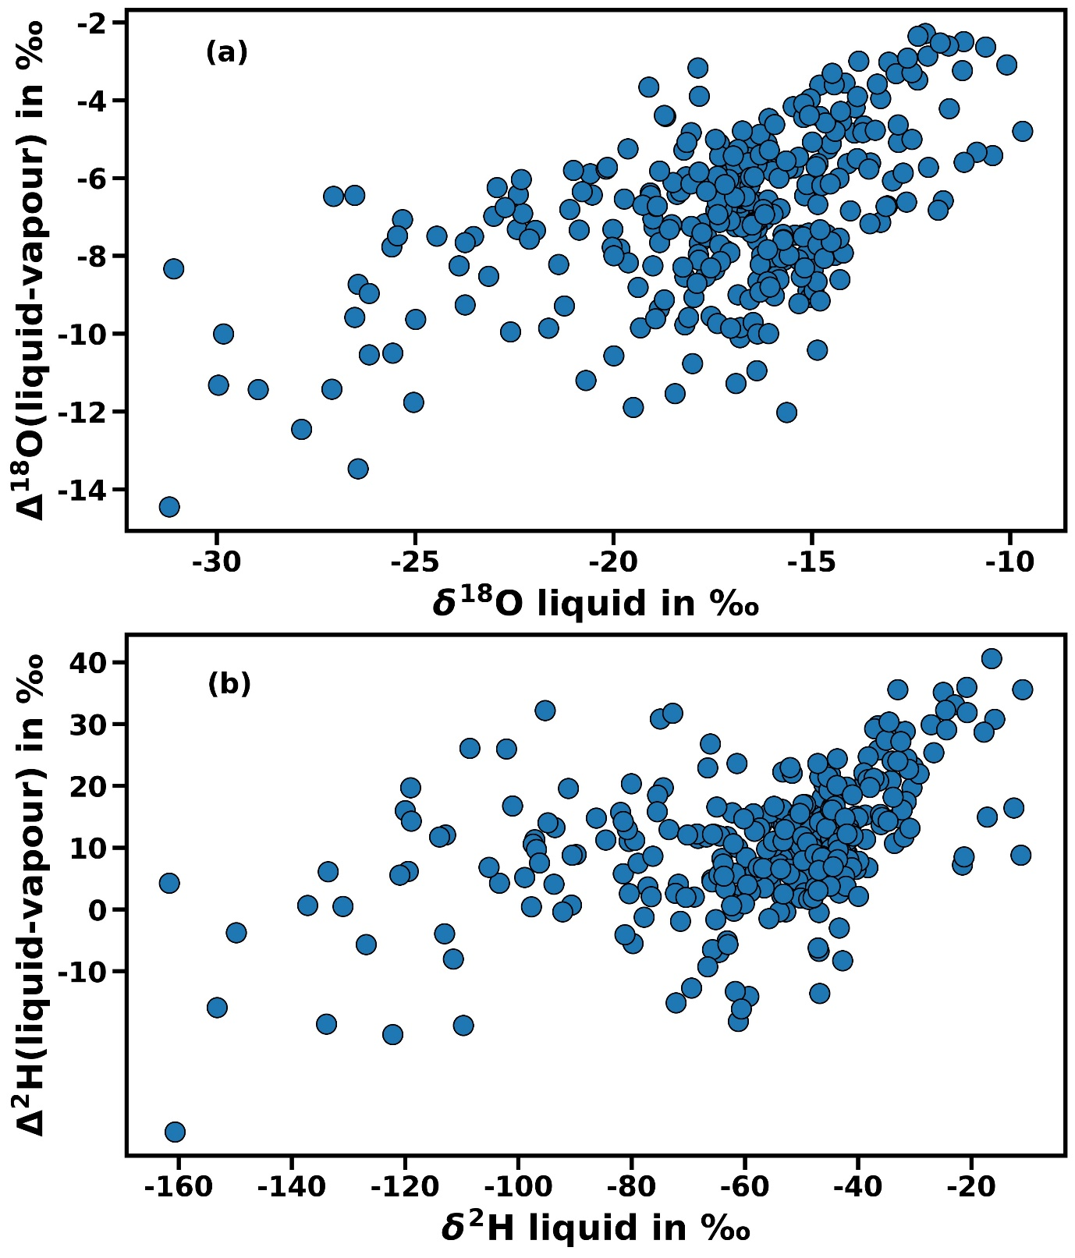
Figure S2. (a) The isotopic difference (Δ = δ_{liquid} - δ_{vapor)} in δ¹⁸O between each pair of liquid and vapor samples is plotted against δ¹⁸O of liquid, for a narrow range of S_{i} (3.5 to 5.5) showing positive correlation between the two which confirms that isotopic depletion varies even under similar extent of supersaturation. (b) The similar plot for δ²H.

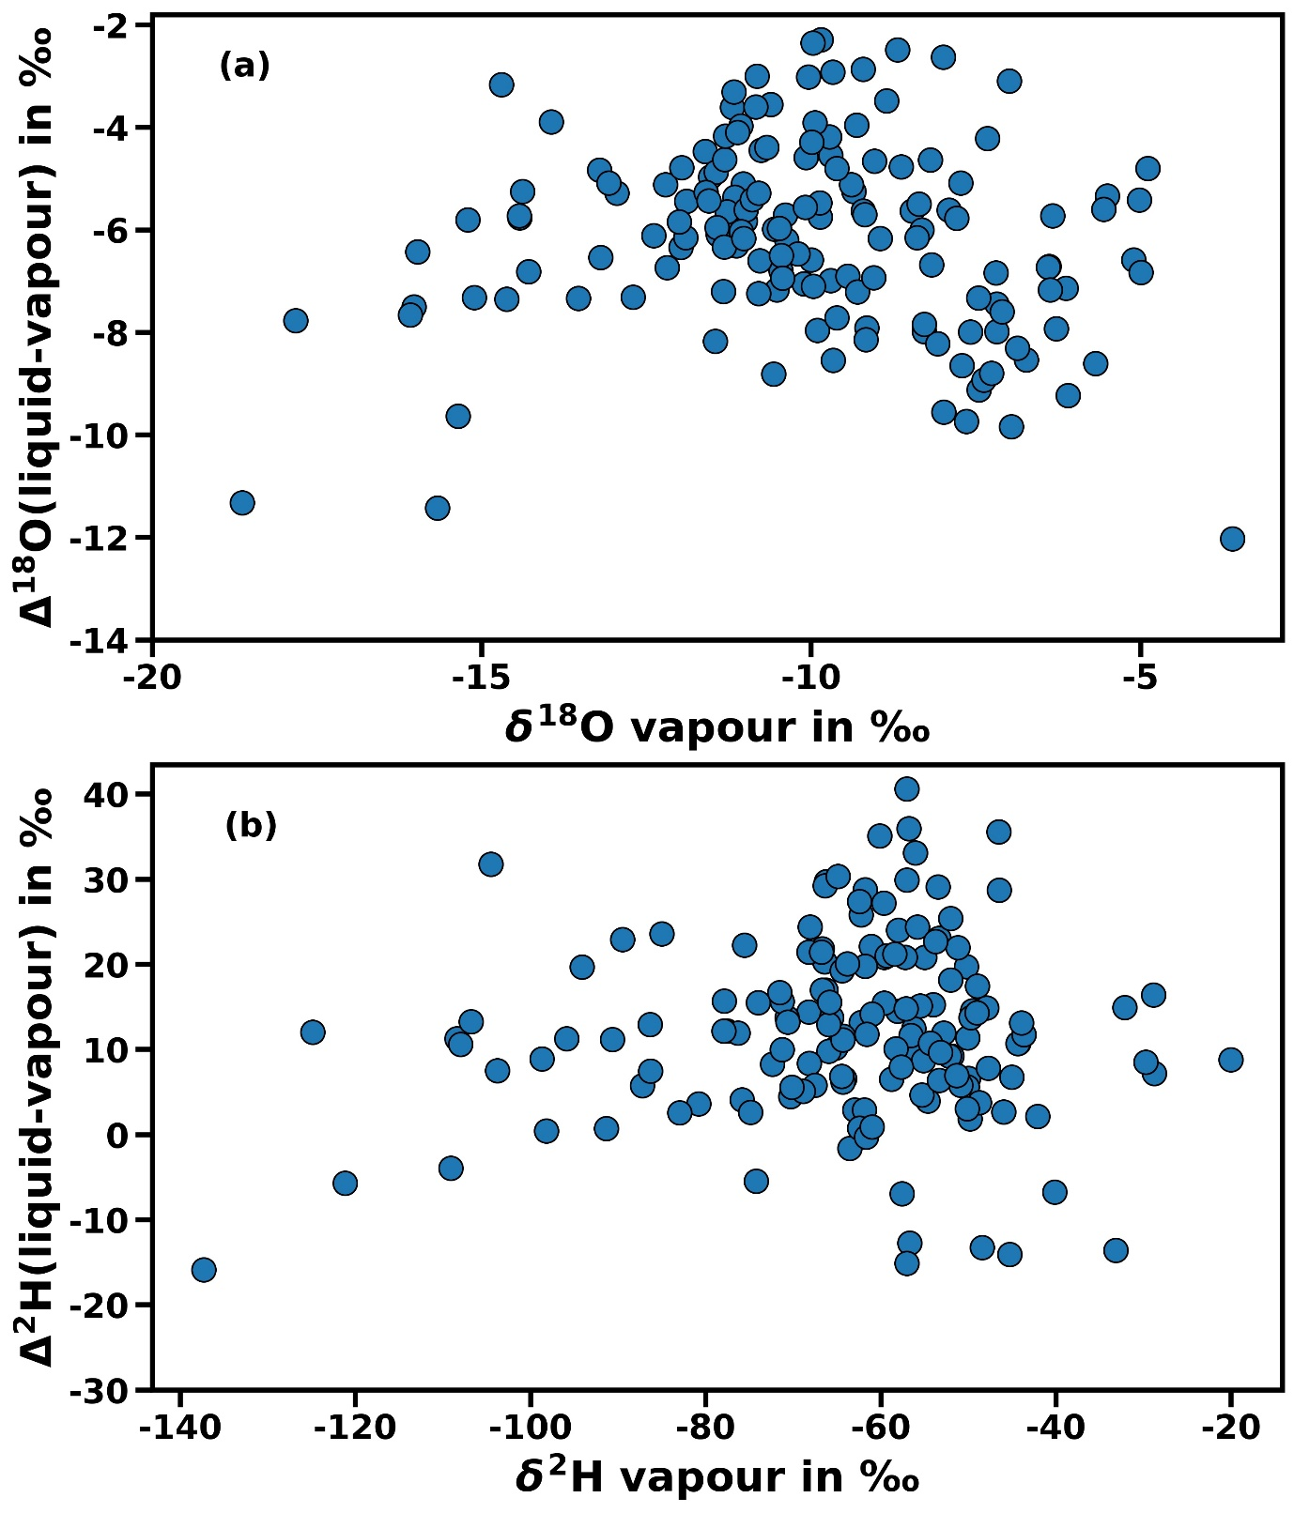
Figure S3. (a) The isotopic difference (Δ = δ_{liquid} - δ_{vapor)} in δ¹⁸O between each pair of liquid and vapor samples is plotted against δ¹⁸O of vapour for a narrow range of S_{i} (3.5 to 4.5) showing no correlation between the two which confirms that isotopic depletion is independent of the δ¹⁸O of starting vapour. (b) The similar plot for δ²H.
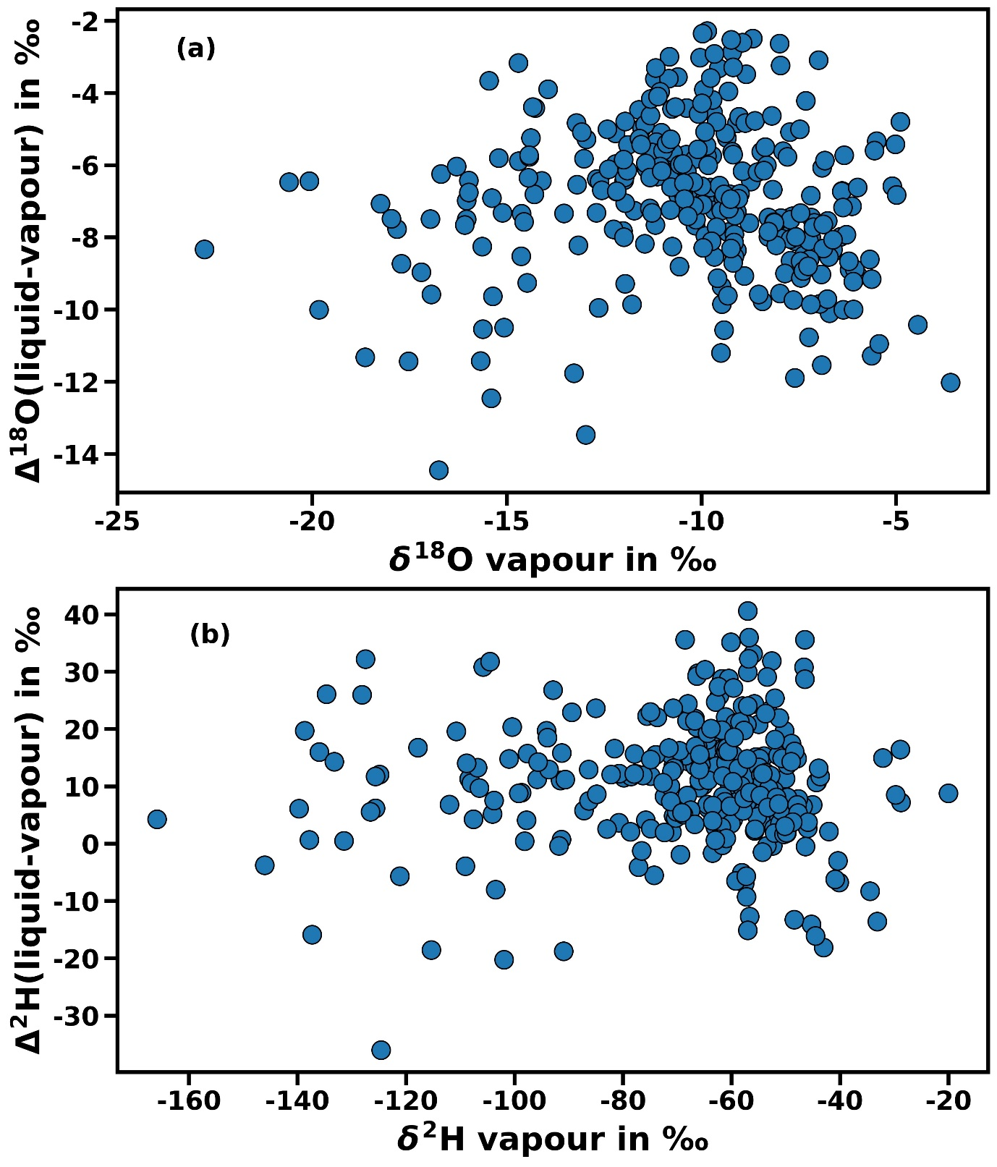 Figure S4. (a) The isotopic difference (Δ = δ_{liquid} - δ_{vapor)} in δ¹⁸O between each pair of liquid and vapor samples is plotted against δ¹⁸O of vapour for a narrow range of S_{i} (3.5 to 5.5) showing no correlation between the two which confirms that isotopic depletion is independent of the δ¹⁸O of starting vapour. (b) The similar plot for δ²H.

Model Architecture and  Performance | ANN for δ¹⁸O | ANN for δ²H
Model layout | 5-10-10-1 | 5-20-18-16-15-1
Activation layers | RELU (Rectified Linear Units) for hidden layers, Linear for final layer | RELU (Rectified Linear Units) for hidden layers, Linear for final layer
Batch size | 8 | 9
Number of epochs | 120 | 125
RMSE: On training dataset | 1.59 ‰ | 8.37 ‰
RMSE: On test data set | 1.70 ‰ | 10.18 ‰
Mean error on test data set | -0.24 ‰ | 0.53 ‰
Standard deviation of test error | 1.69 ‰ | 10.19 ‰
No of Train/Test Samples | 337,144 | 337,144

Table 1 ANN model architecture and performance in predicting vapour isotopic composition
The input layer dimensions (5 nodes) represents the number of feature vectors used for training while the final layer in case of a regression problem always has just 1 layer with a linear activation function. Since the non-linearity demonstrated for the oxygen isotope (18O) with respect to variation in diffusivity and other experimental limitations or constraints was less, a shallower neural network was chosen with 2 hidden layers having 10 nodes each and additional regularization was not deemed necessary. For the case of hydrogen isotopes, due to the intrinsic non-linearity in the problem statement owing to large range in Sic, a denser more complex network gave the best performance with 4 hidden layers having 20-18-16-15 nodes respectively.
We chose Rectified Linear units (RELU) as activation function after experimenting with RELU, sigmoid and tanh as possible choices. Since this is a relatively small dataset (~500 datapoints), we chose a relatively small batch size to update the hyper-parameters. Convergence was achieved for both models at around total ~120-125 iterations/ epochs after which there was not much improvement. Root mean squared error as well as mean absolute error were used as metrics for model validation whereas mean squared error was chosen as the loss function.
We employed Dropout (0.1), i.e. 10% of interlinkages/synapses between nodes were dropped for ²H in order to prevent overfitting whereas no regularisation was required for ¹⁸O. Further we used 5 fold cross validation in our training to ensure generalisation and robustness on an unknown dataset. The whole dataset was split randomly into 70-30 % with 70 % data for training the model and 30 % for model testing and validation. GridSearchCV was employed for hyperparameter tuning by running maximum permutations and combinations of different model architecture with different number of hidden layers and varying activation functions.
The relatively comparable values of both RMSE (root mean squared error) and mean of absolute error for both models hint at a robust fit without overfitting. The RMSE for δ¹⁸O is almost an order of magnitude lower than that for δ²H, but we must realise RMSE is not robust to outliers and is also dependent on the range of the target variable. For δ¹⁸O, we have a range of 19.16 ‰ for vapour, for which RMSE around 1.7 ‰ is quite reliable. For δ²H, we have a range in vapour of 147.73 ‰, for which an RMSE score of ≈ 10 ‰ is still quite reasonable. The tendency of mean error to lie near 0 further indicates the absence of a strong negative or positive bias in either case. Hence given a liquid sample, Rh and T, we can arrive at vapour isotope value within -0.24±1.69 ‰ for δ¹⁸O and 0.53±10.19 ‰ for δ²H with 1 standard deviation.
However, it must be noted that this uncertainty mentioned is only that of the ANN model and does not include the analytical uncertainty arising out of IRMS measurements. Hence, we need to account for the analytical uncertainty of 0.1 ‰ for δ¹⁸O and 1 ‰ for δ²H coming from IRMS. It is reasonable to assume the sources of both uncertainties are mutually exclusive, thus we can arrive at combined uncertainty for each tracer as
$Net_uncertainty =\sqrt{{(Model_uncer)}^{2}+{(Analytical_uncert)}^{2}})$.
We can arrive at vapour isotope value within -0.24±1.79 ‰ for δ¹⁸O and 0.53±11.23 ‰ for δ²H, which provides a viable novel alternative way of sampling vapour isotopes over a large network simultaneously, especially in remote areas having logistical limitations.

* Corresponding author- Akash Ganguly, Email – akashg@prl.res.in

