SUPPLEMENTARY FILE 1

- Report on COVID-19 cases and restrictions in Germany during the assessment period (March to July 2020)
Restrictions during the assessment period in Germany
Stay-at-home restrictions - There were no restrictions in place in Germany at the beginning nor at the end of the assessment period. In the middle of the assessment period, restrictions were in place, requiring individuals not to leave the house with exceptions for daily exercise, grocery shopping, and ‘essential’ trips.
School closures - At the beginning of the assessment period, school closures were mandatory in some regions of Germany. At the end of the assessment period, school closures were recommended.
Workplace closures - At the beginning of the assessment period, there were no workplace closures in place. At the end of the assessment period, workplace closures were mandatory in some regions.
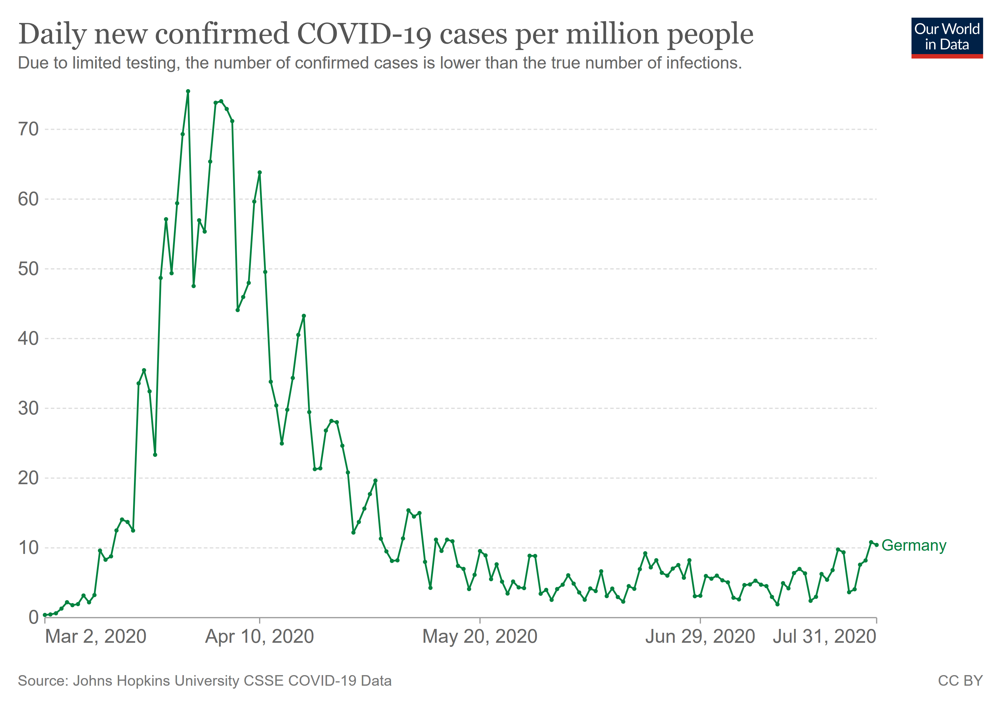
Figure 1. Number of new COVID-19 cases (per million) in Germany during the assessment period. Note. Data was published by the John Hopkins University (Dong et al., 2020) and downloaded via ourworldindata.org.
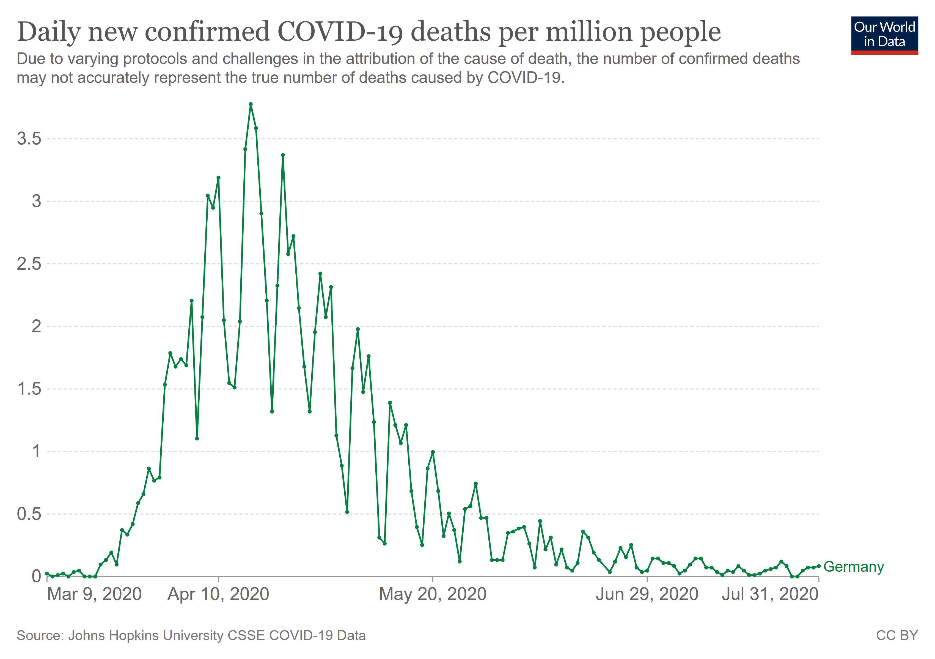
Figure 2. Number of confirmed COVID-19 deaths (per million) in Germany during the assessment period. Note. Data was published by the John Hopkins University (Dong et al., 2020) and downloaded via ourworldindata.org.
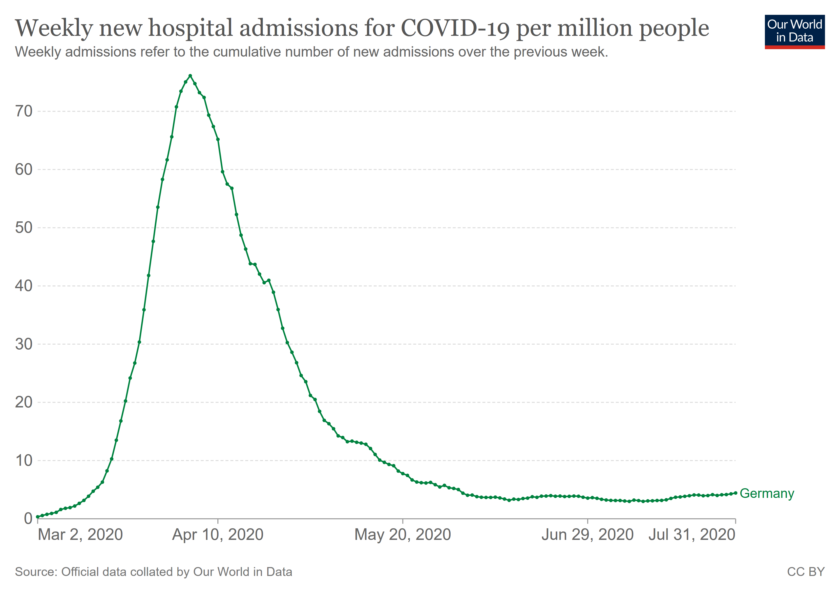
Figure 3. Weekly new hospital admissions for COVID-19 (per million) in Germany during the assessment period. Note. Data was published by the John Hopkins University (Dong et al., 2020) and downloaded via ourworldindata.org.

- Pre-experimental measures
Table 1
Descriptive data on pre-experimental questionnaires
Measure | N | M | SD | Min | Max
COVID-19 distress | 108 | 25.06 | 6.48 | 13.00 | 39.00
COVID-19 rumination | 108 | 29.49 | 10.73 | 15.00 | 57.00
Trait anxiety | 108 | 38.10 | 9.86 | 21.00 | 61.00

Table 2
Self-reported history of COVID-19, related risks, and financial problems
Item | N | # Yes | # No | % Yes
History of COVID-19 – Self | 108 | 7 | 101 | 6.50
History of COVID-19 – Relatives & close friends | 108 | 4 | 104 | 3.70
History of COVID-19 – Relatives & close friends At risk for a severe course of COVID-19 | 108 | 0 | 108 | 0.00
At risk for a severe course of COVID-19 - Self | 108 | 2 | 106 | 1.90
At risk for a severe course of COVID-19 - Relatives & close friends | 108 | 42 | 66 | 38.90
Financial problems related to the pandemic | 108 | 33 | 75 | 30.60
Note. Risk for a severe course of COVID-19 = one or more risk such as older age; immune deficits; pregnancy; etc.

Items of the Perseverative Thinking Questionnaire adapted to COVID-19 by S. K. Schäfer (English version)
Original publication: Ehring, T., Zetsche, U., Weidacker, K., Wahl, K., Schönfeld, S., & Ehlers, A. (2011). The Perseverative Thinking Questionnaire (PTQ): Validation of a content-independent measure of repetitive negative thinking. Journal of Behavior Therapy and Experimental Psychiatry, 42(2), 225–232.
All items are rated on a five-point scale: 0 = never; 1 = rarely; 2 = sometimes; 3 = often; 4 = almost always.
- The same thoughts about COVID-19 are going through my mind again and again.
- Thoughts about COVID-19 intrude into my mind.
- I can’t stop dwelling on thoughts about COVID-19.
- I think about many problems connected to COVID-19 without solving any of them.
- I can’t do anything else while thinking about COVID-19.
- My thoughts about COVID-19 repeat themselves.
- Thoughts about COVID-19 come to my mind without me wanting them to.
- I get stuck on certain issues connected to COVID-19 and can’t move on.
- I keep asking myself questions connected to COVID-19 without finding an answer.
- My thoughts about COVID-19 prevent me from focusing on other things.
- I keep thinking about the same issue connected to COVID-19 all the time.
- Thoughts about COVID-19 just pop into my mind.
- I feel driven to continue dwelling on the same issue connected to COVID-19.
- My thoughts about COVID-19 are not much help to me.
- My thoughts about COVID-19 take up all my attention.

Items of the Peritraumatic Distress Inventory adapted to COVID-19 by S. K. Schäfer (English version)
Original publication: Brunet, A., Weiss, D. S., Metzler, T. J., Best, S. R., Neylan, T. C., Rogers, C., ... & Marmar, C. R. (2001). The Peritraumatic Distress Inventory: a proposed measure of PTSD criterion A2. American Journal of Psychiatry, 158(9), 1480–1485.
All items are rated on a five-point scale ranging from “0 = not true at all” to “4 = extremely true”. Item 9 of the original inventory (“I had difficulties controlling my bowl and bladder”) was not included in the adapted version. Instead, we added an item measuring fear for the life of loved ones.

- When I think about COVID-19, I feel helpless.
- When I think about COVID-19, I feel sadness and grief.
- I feel frustrated or angry because I cannot do more against COVID-19.
- I feel afraid for my safety due to COVID-19.
- I feel guilty for not doing more against COVID-19.
- I feel ashamed of my emotional reactions to COVID-19.
- I feel worried about the safety of others due to COVID-19.
- I have the feeling I am about to lose control of my emotions due to COVID-19.
- I am horrified by the COVID-19 outbreak.
- I have physical reactions like sweating, shaking, and pounding heart due to COVID-19.
- When I think about COVID-19, I feel I might pass out.
- I am afraid I might die due to COVID-19.
- I am afraid that my loved ones might die due to COVID-19.

- Differential associative fear learning task - experimental procedure
Preparation
At the beginning of the procedure, the participants were instructed to put on their headphones and adjust the volume to a level that should be noisy but not painful. The transmitted volume was individually set by presenting a neutral test tone, which was matched to the loudness of the aversive film clip.
Presentation of film clip
Afterwards, participants were introduced to the female protagonist of the film clip. Then, the film clip showing an accident in a kitchen during which the victim sustains severe burns was presented for 10 seconds.
Instructions regarding learning phase
Thereafter, participants were informed that a short version of the film clip would follow some (but not all) everyday objects that were to be presented on the screen and to pay attention which objects were associated with the clip.

Habituation phase
During the habituation phase, three objects (brush, cellphone, and glasses) were presented three times for 7 seconds with an inter-stimulus interval of 1 second. The order of objects was randomized and all objects were presented in a wooden box. During object presentation, subjects were asked to rate their expectation of seeing the aversive film clip after the objects. Ratings were made on a visual analog scale below the object (0 = very low US expectancy, 100 = very high US expectancy).
Pre-rating phase
Prior to the learning phase, all objects were presented without the wooden box. Participants were asked to provide valence (0 = highly unpleasant, 100 = highly pleasant), arousal (0 = absolutely non-arousing, 100 = very arousing), and fear (0 = no fear at all, 100 = maximal fear) ratings on visual analog scales below the objects.
Learning phase
During the learning phase, one of the three objects was presented as the CS⁻ whereas the other two objects were presented as CS⁺¹ and CS⁺². The two different CS⁺s were used to implement two separate learning procedures, which was necessary for further manipulations that took place after the assessment of analog symptoms. Hence, the learning procedure was divided in two halves. In one half of the learning procedure, participants saw eight CS⁻ trials and eight CS⁺¹ trials, six of which were followed by the US. In the other half of the procedure, participants saw eight CS⁻ trials and eight CS⁺² trials, six of which were followed by the US. Both halves were presented without interruption and the order of presentation was counterbalanced across participants. During each trial, participants first saw an empty wooden box, serving as the learning context (10 seconds). Subsequently, the objects (CS) appeared in the wooden box (7 seconds) and participants were asked to provide a US expectancy rating. During reinforced trials, the US (6 seconds) was presented immediately after CS offset. During unreinforced trials, the trial ended after CS offset.
Post-rating phase
After the learning procedure, valence, arousal, and fear ratings for each CS were re-assessed as described for the pre-rating phase. Finally, attention to experimental stimuli was tested by presenting three short test tones without prior instruction and subsequently asking participants how many tones they had heard.

- Differential associative learning task – manipulation check
Table 3
Descriptive data of the associative learning task (N = 108) and F values for CS*Time/Trial interactions based on univariate analyses of variance (ANOVAs)
Measure | Pre-learning |  |  |  | Post-learning |  |  |  |  | F(1,107)
 | CS+ |  | CS- |  | CS+ |  | CS-
 | M | SD | M | SD | M | SD | M | SD
Valence | 52.15 | 17.93 | 52.21 | 21.10 | 26.77 | 19.78 | 67.88 | 25.11 | 133.76*
Arousal | 13.08 | 16.86 | 15.19 | 21.74 | 61.88 | 26.82 | 13.80 | 22.21 | 214.61*
Fear | 7.94 | 12.59 | 9.27 | 15.44 | 53.88 | 30.60 | 7.96 | 18.16 | 203.46*
US expectancy | 25.56 | 21.25 | 17.90 | 19.30 | 90.32 | 12.09 | 8.08 | 18.02 | 106.48*
Note. CS+ values were averaged across blocks. CS- values were averaged across blocks for US expectancy. For US expectancy, CS ratings of the first (pre-learning) and the last trial (post-learning) are presented but all trials were included in the analysis. * p < .05.

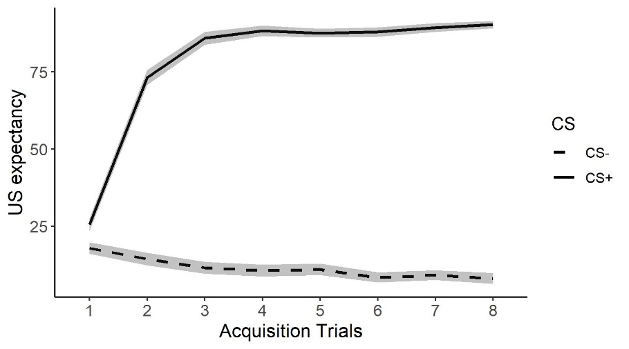
Figure 4. Mean trajectory of US expectancy ratings based on means and standard deviations (ribbon) across trials. Note. CS+ and CS-values were averaged across blocks.

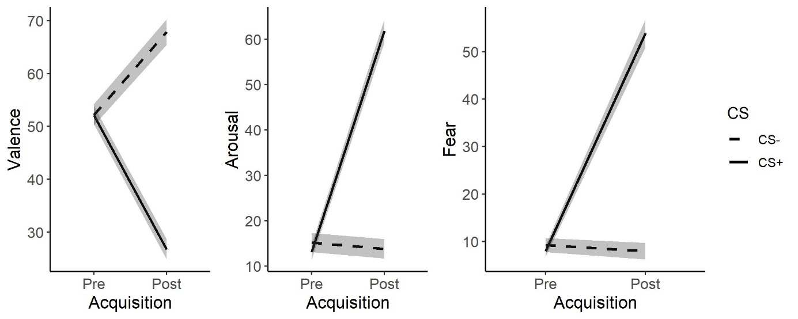
Figure 5. Change in valence, arousal and fear ratings based on means and standard deviations (ribbon) from pre- to post-learning. Note. CS+ values were averaged over CS+¹ and CS+².

- Descriptive raw data of analog intrusions and rumination related to the aversive film clip
Table 4
Descriptive data on analog intrusions and rumination related to the aversive film clip
 | Measure | N | M | SD | Min | Max
Intrusions | Frequency | 108 | 3.08 | 3.45 | 0 | 20
 | Duration (min) | 108 | 8.94 | 14.13 | 0 | 80
 | Distress (0-100) | 108 | 36.27 | 29.92 | 0 | 100
Rumination | Frequency | 108 | 2.17 | 2.78 | 0 | 20
 | Duration (min) | 103 | 35.15 | 75.64 | 0 | 600
 | Distress (0-100) | 108 | 37.07 | 30.28 | 0 | 100

- Correlation tables

Table 5.

Bivariate associations between COVID-19 related measures, strength of associative learning, and analog PTSD symptoms

Measures | 1. | 2. | 3. | 4. | 5. | 6. | 7. | 8. | 9. | 10. | 11. | 12. | 13.
1. COVID-19 distress | -
2. COVID-19 rumination | .75* | -
3. Post-ACQ CS_{diff} Valence | -.18 | -.11 | -
4. Post-ACQ CS_{diff} Arousal | .16 | .08 | -.63* | -
5. Post-ACQ CS_{diff} Fear | .17 | -.003 | -.55* | .81* | -
6. Post-ACQ CS_{diff} US EXP | -.05 | -.03 | -.42* | .45* | .37* | -
7. Post-ACQ CS- Valence | .12 | .11 | -.85* | .45* | .31* | .42* | -
8. Post-ACQ CS- Arousal | .12 | .11 | .35* | -.55* | -.29* | -.50* | -.48* | -
9. Post-ACQ CS- Fear | .17 | .22* | .25* | -.38* | -.31* | -.47* | -.40* | .77* | -
10. Post-ACQ CS- US EXP | .07 | .13 | .39* | -.44* | -.36* | -.86* | -.45* | .63* | .64* | -
11. Intrusion Load | .23* | .08 | -.30* | .29* | .38* | .11 | .08 | .04 | .10 | -.05 | -
12. Rumination Load | .25* | .09 | -.19 | .15 | .22* | -.03 | -.03 | .17 | .17 | .14 | .72* | -
13. Trait Anxiety | .33* | .34* | .14 | -.03 | -.16 | -.20* | -.12 | .002 | .19 | .22* | -.10 | .07 | -
Note. Pearson correlation coefficients. ACQ = Acquisition; EXP = Expectancy; CS+ = (aversive) conditioned stimulus; CS- = safety stimulus; CS_{diff} = ([CS+]-[CS-]); US = unconditioned stimulus. * = p < .05.

- Additional mediation analyses
Mediation models including CS difference scores

Figure 6. Mediation models examining the effect of COVID-19-related distress (X) on analog symptoms (Y) mediated by CS difference scores (M). All models included the covariates (U) trait anxiety and attention-check scores. Path c shows the total effect of X on Y, and path c′ shows the direct effect after controlling for M. Standard errors are given in parentheses. CI = confidence interval (bias-corrected); CS+ = conditioned stimulus; US = unconditioned stimulus.
Mediation models including CS- scores

Figure 7. Mediation models examining the effect of COVID-19-related distress (X) on analog symptoms (Y) mediated by CS- scores (M). All models included the covariates (U) trait anxiety and attention-check scores. Path c shows the total effect of X on Y, and path c′ shows the direct effect after controlling for M. Standard errors are given in parentheses. CI = confidence interval (bias-corrected); CS+ = conditioned stimulus; US = unconditioned stimulus.

