Introduction of the model calibration
We firstly tuned the parameters for water temperature and then for the ecological part. Based on our simulation experience (Mi et al., 2019) and the related studies (Jin et al., 2019; Chuo et al., 2019; Carr et al., 2019), shading (SHADE) and wind sheltering (WSC) coefficients are the most influential parameters for the temperature calculation which were calibrated by a common “trail and error” analysis, and all other internal hydrodynamics parameters were left unchanged because they have a solid empirical basis (Mi et al., 2018). To be noted, in the model, the background light extinction coefficient was not calibrated but determined based on in situ measurements of photosynthetically available radiation with two spherical LiCor LI-193SA light sensors (0.45 m⁻¹, see Mi et al. (2020)).
. More parameters were related to the ecological simulation, and our philosophy was to determine a priori as many parameters as possible. Our measurements in the reservoir showed that spring diatoms belong to r-strategists with high maximum growth and mortality rate, moderate light requirements, broad temperature range for the growth and low nutrient affinity, whereas P. rubescens should be classified as k-strategists with low growth and mortality rate, adaptation to low light and cold regimes, and also high nutrient affinity which helps the bacteria be competitive in nutrient limited environment (Posch et al., 2012). Combining such trait properties with values from related literatures, we were able to a priori fixed all parameters for the two types of phytoplankton (Table S1) except four key parameters referring to their light-dependent growth kinetics (i.e. AG#1, AG#2, ASAT#1, and ASAT#2, please see Table S2 for details), which were manually calibrated within the reasonable range (Table S2). To be noted our model does not account for an active-depth selection by P. rubescens, instead its metalimnetic bloom largely reflects the parameterized low-light tolerance, narrow temperature range for its growth (Kerimoglu et al., 2017; Walsby and Schanz, 2002). Besides, sediment oxygen demand (SOD) was evaluated based on hypolimnetic DO concentration dynamics using the model of Livingstone and Imboden (1996), which separates pelagic from sediment-related oxygen depletion. Values for the other parameters were taken either from default ones of CE-QUAL-W2 or previous related studies (Table S1), and for more details about the calibration process readers are referred to our previous study (Mi et al., 2020).

Table S1. Values of a priori determined parameters including references
Parameter | Description | Value | Reference
AR#1 | Dark respiration rate for P-rub (day⁻¹) | 0.02 | Brito et al. (2018)
AR#2 | Dark respiration rate for diatoms (day⁻¹) | 0.05 | Kobler et al. (2018)
AE#1 | Excretion rate for P-rub (day⁻¹) | 0.01 | Kerimoglu et al. (2017)
AE#2 | Excretion rate for diatoms (day⁻¹) | 0.05 | Cole and Wells (2006)
AM#1 | Mortality rate for P-rub (day⁻¹) | 0.005 | Carraro et al. (2012)
AM#2 | Mortality rate for diatoms (day⁻¹) | 0.05 | Sadeghian et al. (2018)
AS#1 | Settling rate for P-rub (day⁻¹) | 0.001 | Cole and Wells (2006)
AS#2 | Settling rate for diatoms (day⁻¹) | 0.05 | Chuo et al. (2019)
AHSP#1 | Half-saturation coefficient for phosphorus limited growth for P-rub (g m⁻³) | 0.002 | Carraro et al. (2012)
AHSP#2 | Half-saturation coefficient for phosphorus limited growth for diatoms (g m⁻³) | 0.002 | Cole and Wells (2006)
AHSN#1 | Half-saturation coefficient for nitrogen limited growth for P-rub (g m⁻³) | 0.005 | Bowie et al. (1985)
AHSN#2 | Half-saturation coefficient for nitrogen limited growth for diatoms (g m⁻³) | 0.1 | Cole and Wells (2006)
AHSSI#2 | Half-saturation coefficient for silica limited growth for diatom (g m⁻³) | 0.1 | Bowie et al. (1985)
AT1#1 | Lower temperature for P-rub growth (ºC) | 5 | Park et al. (2014)
AT1#2 | Lower temperature for diatoms growth (ºC) | 0 | Kobler et al. (2018)
AT2#1 | Lower temperature for maximum P-rub growth (ºC) | 10 | Bowie et al. (1985)
AT2#2 | Lower temperature for maximum diatoms growth (ºC) | 11 | Kobler et al. (2018)
AT3#1 | Upper temperature for maximum P-rub growth (ºC) | 14 | Fenocchi et al. (2019)
AT3#2 | Upper temperature for maximum diatoms growth (ºC) | 15 | Kobler et al. (2018)
AT4#1 | Upper temperature for P-rub growth (ºC) | 18 | Bowie et al. (1985)
AT4#2 | Upper temperature for diatoms growth (ºC) | 30 | Kobler et al. (2018)
ACHLA#1 | Ratio between P-rub biomass and chlorophyll a in terms of mg dry weight /µg chl a | 0.18 | Wentzky et al. (2019)
Parameter | Description | Value | Reference
ACHLA#2 | Ratio between diatoms biomass and chlorophyll a in terms of mg dry weight/µg chl a | 0.12 | Smith et al. (2014)
O2AG#1 | Oxygen stoichiometry for P-rub primary production  (mg O₂/mg organic matter) | 1.1 | Wentzky et al. (2019)
O2AG#2 | Oxygen stoichiometry for diatoms primary production  (mg O₂/mg organic matter) | 1.4 | Chuo et al. (2019)
O2AR#1 | Oxygen stoichiometry for P-rub primary respiration  (mg O₂/mg organic matter) | 1.1 | Cole and Wells (2006)
O2AR#2 | Oxygen stoichiometry for diatoms primary respiration  (mg O₂/mg organic matter) | 1.4 | Deliman and Gerald (2002)
ORGP | Stoichiometric equivalent between organic matter  and phosphorus | 0.005 | Cole and Wells (2006)
ORGN | Stoichiometric equivalent between organic matter  and nitrogen | 0.08 | Cole and Wells (2006)
ORGC | Stoichiometric equivalent between organic matter  and carbon | 0.45 | Cole and Wells (2006)
ORGSI | Stoichiometric equivalent between organic matter  and silica | 0.18 | Cole and Wells (2006)
POMS | Particulate organic matter settling rate (m day⁻¹) | 0.5 | Chuo et al. (2019)
PO4R | Sediment release rate of phosphorus, fraction of  SOD | 0.015 | Chuo et al. (2019)
NH4R | Sediment release rate of ammonium, fraction of  SOD | 0.15 | Chuo et al. (2019)
NH4DK | Ammonium decay rate (day⁻¹) | 0.15 | Brito et al. (2018)
NO3DK | Nitrate decay rate (day⁻¹) | 0.05 | Sadeghian et al. (2018)
DSIR | Dissolved silica sediment release rate, fraction of SOD | 0.1 | Cole and Wells (2006)
SODT1 | Lower temperature for SOD (ºC) | 4 | Cole and Wells (2006)
SODT2 | Upper temperature for SOD (ºC) | 30 | Cole and Wells (2006)
SODK1 | Fraction of SOD at lower temperature | 0.1 | Cole and Wells (2006)
SODK2 | Fraction of SOD at upper temperature | 0.99 | Cole and Wells (2006)

Table S2. The applied minimum and maximum values as well as their intervals for the calibrated parameters
Parameters | Description | Minimum | Maximum | Interval | Calibrated values
AG #1 | Growth rate for P-rub (day⁻¹) | 0.35 | 0.65 | 0.05 | 0.55
AG #2 | Growth rate for diatoms (day⁻¹) | 0.8 | 2.5 | 0.1 | 1.5
ASAT#1 | Light saturation intensity at maximum photosynthetic rate for P-rub (W m⁻²) | 4 | 15 | 1 | 8
ASAT#2 | Light saturation intensity at maximum photosynthetic rate for diatoms (W m⁻²) | 20 | 50 | 5 | 35

Methods and results for the model sensitivity analysis

We used the specific sensitivity coefficients (SSC) to test the sensitivity and uncertainty of the input parameters. The same test, for the simulated oxygen concentration, has been successfully applied in our previous research (see Mi et al. (2020)) and here we do the job for the maximum concentration of P. rubescens (P.rubs_{max}), in which SSC was calculated as:
In the equation the indices P_{ref} and P_{mod} stand for reference (i.e. used for the scenario analysis) and modified parameter settings, respectively. For the test all the input parameters were changed four times (±5% and ±10%) based on their reference settings, and we averaged the specific SSC values in order to achieve an average sensitivity result at the local vicinity of each parameter value.
The results shows that the uncertainty of simulated P. rubescens concentration is not only from the parameters directly related to the growth of P. rubescens (e.g. its growth rate, temperature span for its maximum growth rate), but also those related to diatoms growth (e.g. respiration and mortality rate for diatoms) and nutrients dynamics (e.g. sediment release rate of phosphorus), which illustrates the complicate interaction among such water quality variables (see Table S3).
Despite uncertainties of P. rubescens concentration due to the changes of some parameters, based on all the simulation results the maximum concentration always occurs at 10 m or 11 m depth around day 214 (Fig.S1). Consequently, the model performance in capturing the P. rubescens bloom in the metalimnion is robust against parameter changes.

Table S3. Specific sensitivity coefficients (SSC) for the the maximum concentration of P. Rubescens (absolute values higher than 1 were highlighted by red color)
Parameter | Description | Calibrated Value | SSC
AG #1 | Growth rate for P-rub (day⁻¹) | 0.55 | 2.72
AG #2 | Growth rate for diatoms (day⁻¹) | 1.5 | -1.57
AR#1 | Dark respiration rate for P-rub (day⁻¹) | 0.02 | -0.67
AR#2 | Dark respiration rate for diatoms (day⁻¹) | 0.05 | 1.38
AE#1 | Excretion rate for P-rub (day⁻¹) | 0.01 | 0.33
AE#2 | Excretion rate for diatoms (day⁻¹) | 0.05 | -0.54
AM#1 | Mortality rate for P-rub (day⁻¹) | 0.005 | -0.94
AM#2 | Mortality rate for diatoms (day⁻¹) | 0.05 | 1.62
AS#1 | Settling rate for P-rub (day⁻¹) | 0.001 | 0.22
AS#2 | Settling rate for diatoms (day⁻¹) | 0.05 | 1.71
AHSP#1 | Half-saturation coefficient for phosphorus limited growth for P-rub (g m⁻³) | 0.002 | -2.2
AHSP#2 | Half-saturation coefficient for phosphorus limited growth for diatoms (g m⁻³) | 0.002 | 0.2
AHSN#1 | Half-saturation coefficient for nitrogen limited growth for P-rub (g m⁻³) | 0.005 | 0.0
AHSN#2 | Half-saturation coefficient for nitrogen limited growth for diatoms (g m⁻³) | 0.1 | 0.0
AHSSI#1 | Half-saturation coefficient for silica limited growth for P-rub (g m⁻³) | 0 | ---
AHSSI#2 | Half-saturation coefficient for silica limited growth for diatom (g m⁻³) | 0.1 | 0.0
Parameters | Description | Calibrated Value | SSC
ASAT#1 | Light saturation intensity at maximum photosynthetic rate for P-rub (W m⁻²) | 8 | -0.41
ASAT#2 | Light saturation intensity at maximum photosynthetic rate for diatoms (W m⁻²) | 35 | 1.35
AT1#1 | Lower temperature for P-rub growth (ºC) | 5 | ---
AT1#2 | Lower temperature for diatoms growth (ºC) | 0 | ---
AT2#1 | Lower temperature for maximum P-rub growth (ºC) | 10 | -1.05
AT2#2 | Lower temperature for maximum diatoms growth (ºC) | 11 | 1.07
AT3#1 | Upper temperature for maximum P-rub growth (ºC) | 14 | 0.38
AT3#2 | Upper temperature for maximum diatoms growth (ºC) | 15 | 0.27
AT4#1 | Upper temperature for P-rub growth (ºC) | 18 | -0.77
AT4#2 | Upper temperature for diatoms growth (ºC) | 30 | -0.2
ACHLA#1 | Ratio between P-rub biomass and chlorophyll a in terms of mg dry weight/µg chl a | 0.18 | 0.0
ACHLA#2 | Ratio between diatoms biomass and chlorophyll a in terms of mg dry weight /µg chl a | 0.12 | 0.0
O2AG#1 | Oxygen stoichiometry for P-rub primary production  (mg O₂/mg organic matter) | 1.1 | 0.13
O2AG#2 | Oxygen stoichiometry for diatoms primary production  (mg O₂/mg organic matter) | 1.4 | -0.19
O2AR#1 | Oxygen stoichiometry for P-rub primary respiration  (mg O₂/mg organic matter) | 1.1 | -0.08
O2AR#2 | Oxygen stoichiometry for diatoms primary respiration  (mg O₂/mg organic matter) | 1.4 | -1.93
ORGP | Stoichiometric equivalent between organic matter  and phosphorus | 0.005 | 0.0
ORGN | Stoichiometric equivalent between organic matter  and nitrogen | 0.08 | 0.0
Parameters | Description | Calibrated Value | SSC
ORGC | Stoichiometric equivalent between organic matter  and carbon | 0.45 | 0.0
ORGSI | Stoichiometric equivalent between organic matter  and silica | 0.18 | 0.0
POMS | Particulate organic matter settling rate (m day⁻¹) | 0.5 | 0.11
PO4R | Sediment release rate of phosphorus, fraction of  SOD | 0.015 | 1.02
NH4R | Sediment release rate of ammonium, fraction of  SOD | 0.15 | -0.82
NH4DK | Ammonium decay rate (day⁻¹) | 0.15 | 0.87
NO3DK | Nitrate decay rate (day⁻¹) | 0.05 | 0.81
DSIR | Dissolved silica sediment release rate, fraction of SOD | 0.1 | 0.0
SOD | Maximum sediment oxygen demand (gO₂ m⁻² day⁻¹) | 3 | -2.42
SODT1 | Lower temperature for SOD (ºC) | 4 | -0.65
SODT2 | Upper temperature for SOD (ºC) | 30 | 0.11
SODK1 | Fraction of SOD at lower temperature | 0.1 | 1.44
SODK2 | Fraction of SOD at upper temperature | 0.99 | ---

Fig S1. Cumulative frequency for the occurrence time of the maximum P. rubescens concentration, based on the simulation results from the sensitivity test scenarios. The vertical dashed line shows the time under the reference simulation (i.e. day of 214).

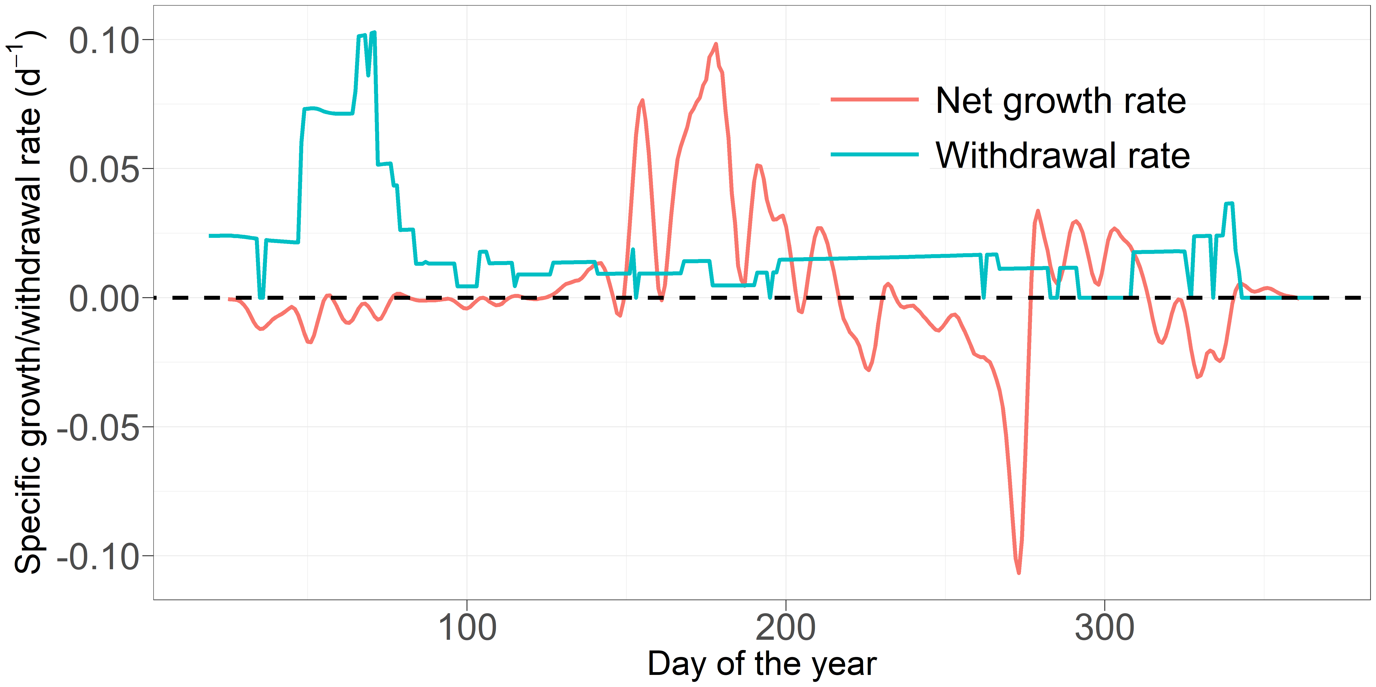

Fig S2. Comparison of net specific growth rates of P. rubescens in the reference scenario (scenario R), averaged over the depth layer from 10 to 12 m, with the specific water withdrawal rates from the same water layer. The dashed line indicates the rate of 0.

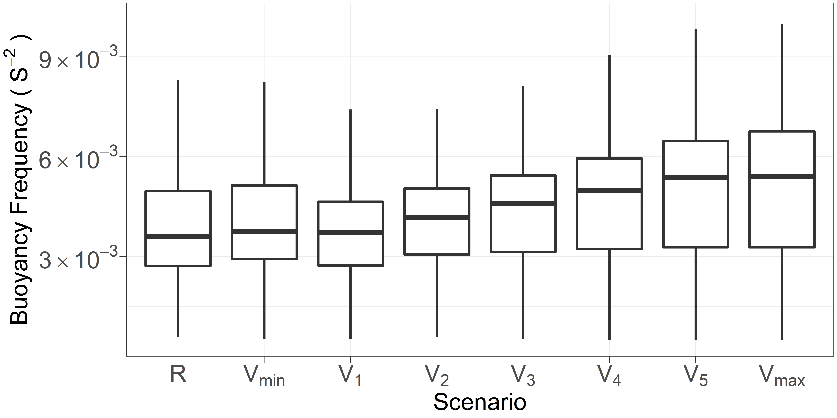
Fig S3. Average buoyancy frequency in the metalimnion (10 to 12 m, from day 180 to 240) under scenario R and V.

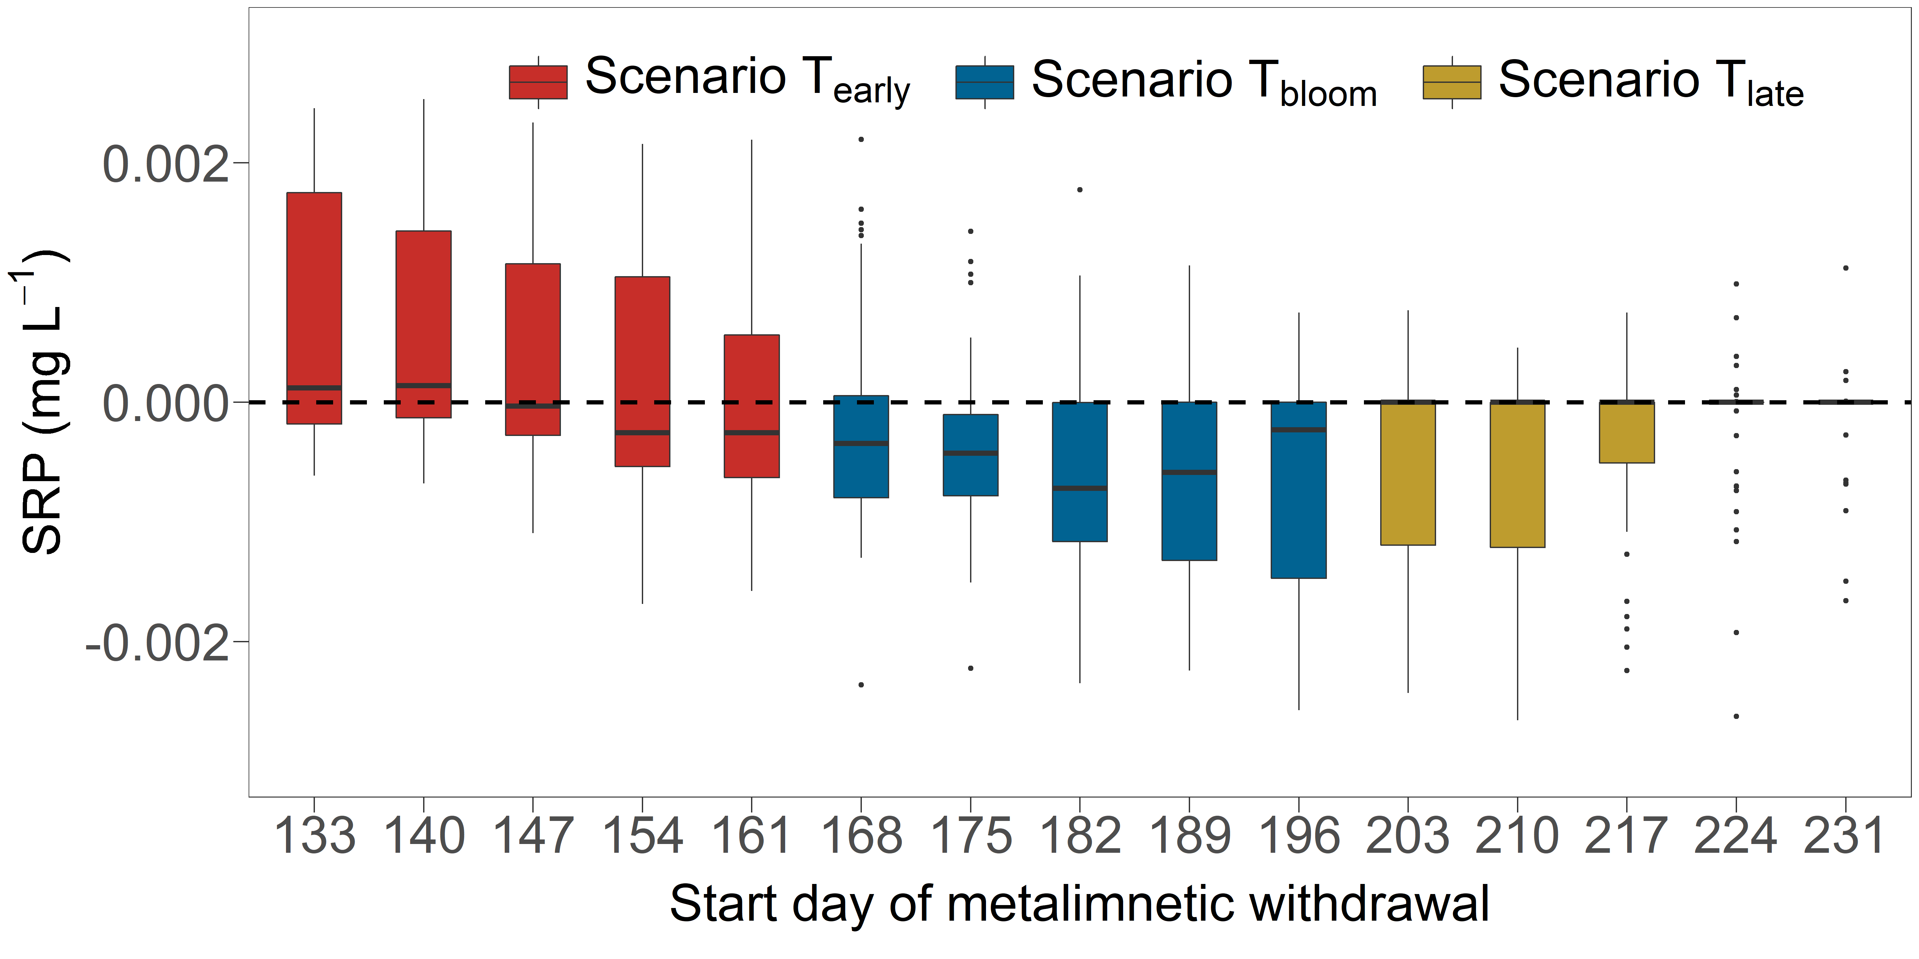
Fig S4. Difference in SRP concentration between the reference scenario and scenario T, in the metalimnion during summer (i.e., 10 to 12 m, from day 180 to 240). The horizontal axis shows the start day of the metalimnetic withdrawal, and vertical axis shows the difference of SRP between the reference scenario and the respective T-scenario (e.g., the first boxplot shows the results of scenario R-scenario T₁₃₃). The dashed line indicates the value of 0.

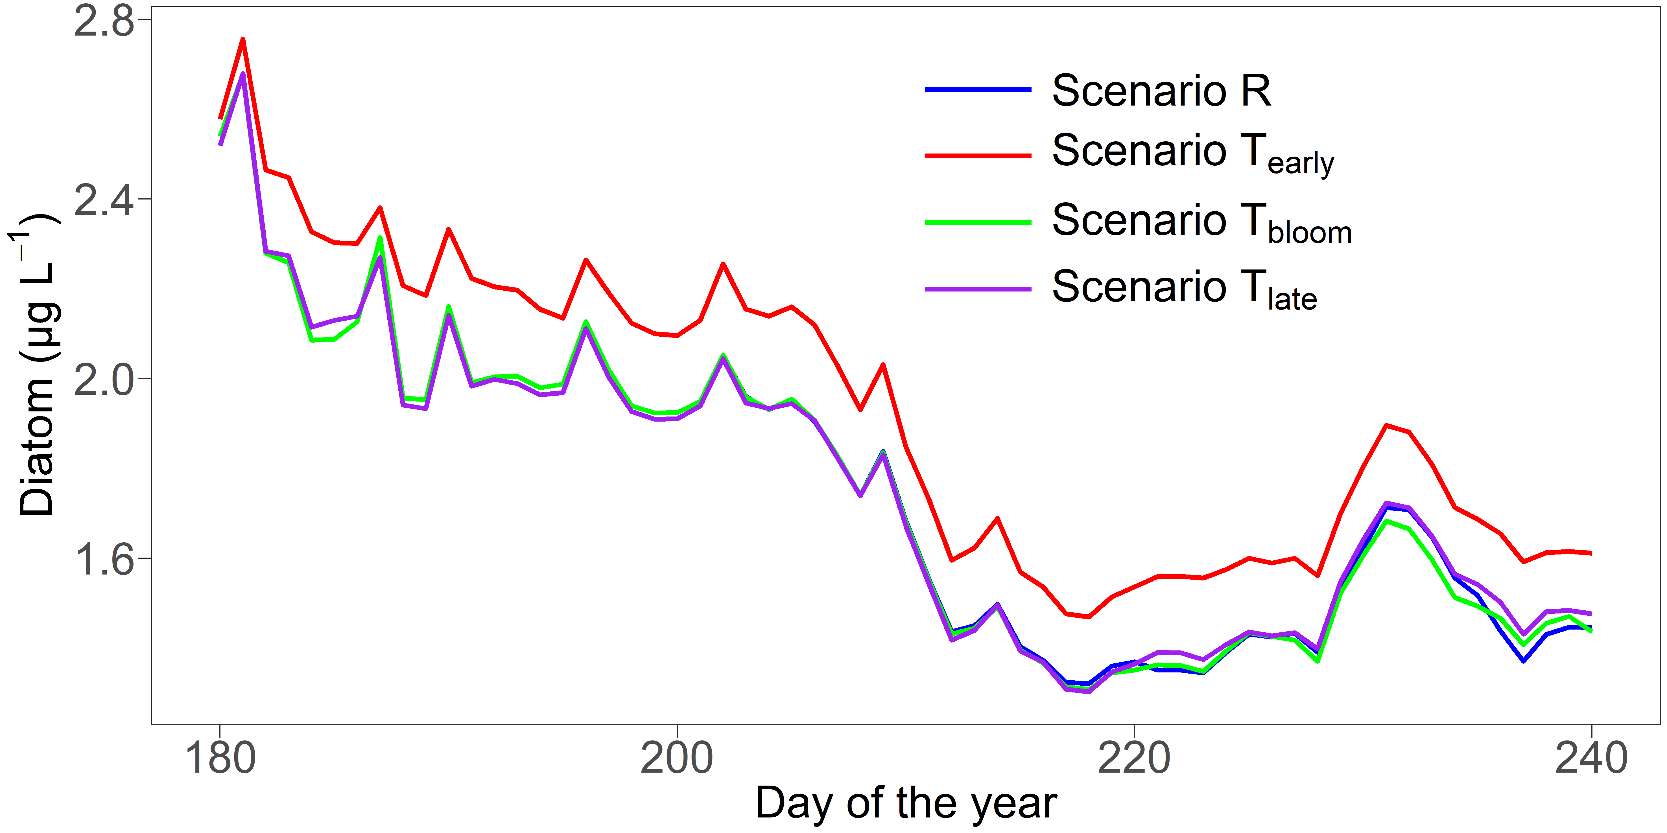
Fig S5. Vertically averaged concentration of diatoms (as chlorophyll a) during summer (day 180 to 240) for 2016 under scenario T. Each line indicates the mean result from 5 sub-scenarios included.

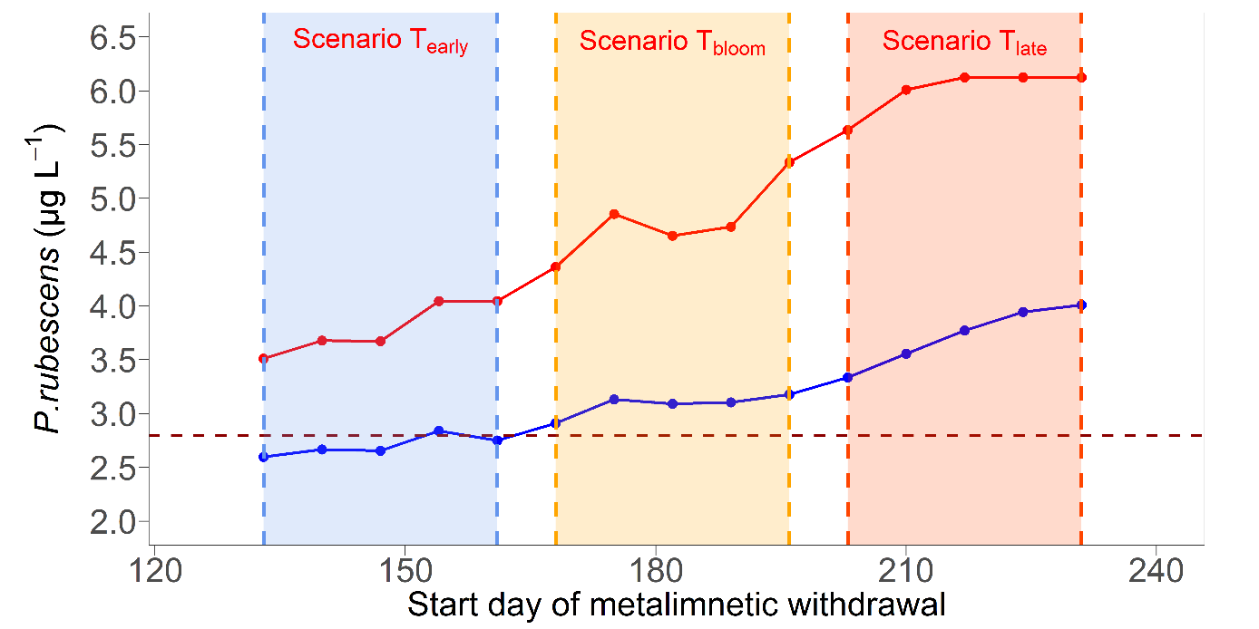
Fig S6. The same as Fig.5, but under scenario VT.

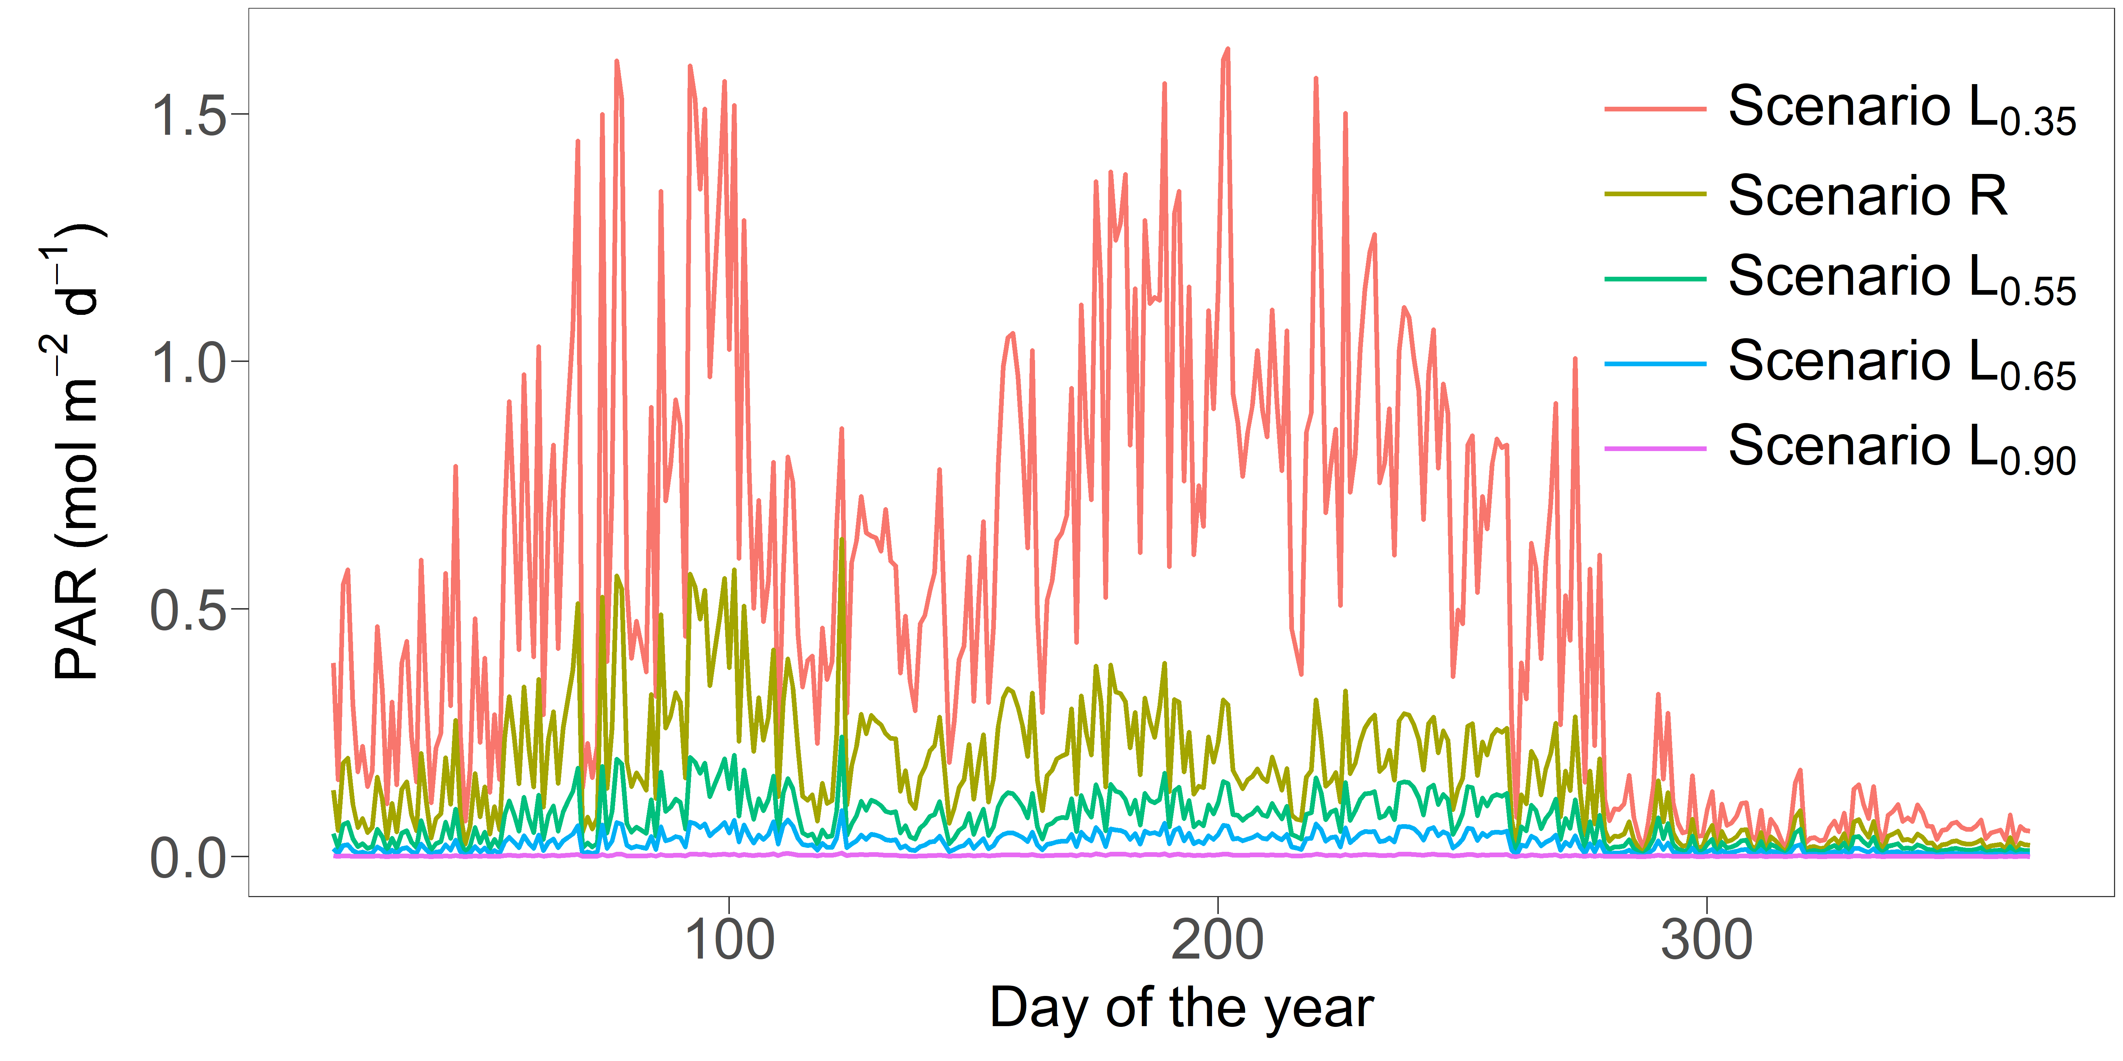
Fig S7. Average photosynthetically active radiation (PAR) in the metalimnion under scenario R and L as outlined in Table 1.

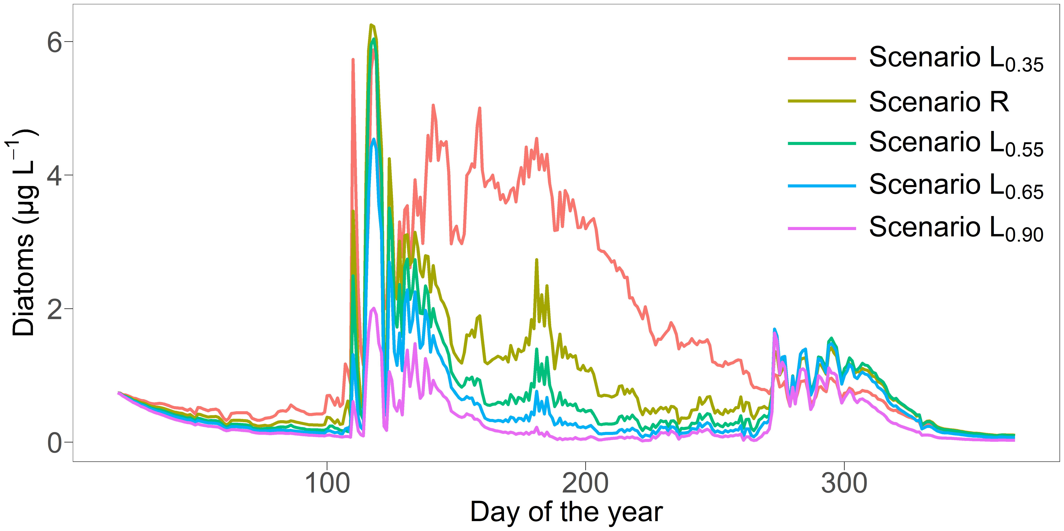

Fig S8. Average concentration of diatoms in the metalimnion under scenario R and L as outlined in Table 1.

References

Bowie, G. L., Mills, W. B., Porcella, D. B., Campbell, C. L., Pagenkopf, J. R., Rupp, G. L., Johnson, K. M., Chan, P., Gherini, S. A., and Chamberlin, C. E.: Rates, constants, and kinetics formulations in surface water quality modeling, EPA, 600, 3-85, 1985.
Brito, D., Ramos, T. B., Gonçalves, M. C., Morais, M., and Neves, R.: Integrated modelling for water quality management in a eutrophic reservoir in south-eastern Portugal, Environmental Earth Sciences, 77, 40, 2018.
Carr, M. K., Sadeghian, A., Lindenschmidt, K.-E., Rinke, K., and Morales-Marin, L.: Impacts of Varying Dam Outflow Elevations on Water Temperature, Dissolved Oxygen, and Nutrient Distributions in a Large Prairie Reservoir, Environ Eng Sci, 2019.
Carraro, E., Guyennon, N., Hamilton, D., Valsecchi, L., Manfredi, E. C., Viviano, G., Salerno, F., Tartari, G., and Copetti, D.: Coupling high-resolution measurements to a three-dimensional lake model to assess the spatial and temporal dynamics of the cyanobacterium Planktothrix rubescens in a medium-sized lake, in: Hydrobiologia, Springer, 77-95, 2012.
Chuo, M., Ma, J., Liu, D., and Yang, Z.: Effects of the impounding process during the flood season on algal blooms in Xiangxi Bay in the Three Gorges Reservoir, China, Ecological Modelling, 392, 236-249, http://dx.doi.org/10.1016/j.ecolmodel.2018.11.017, 2019.
Cole, T. M., and Wells, S. A.: CE-QUAL-W2: A two-dimensional, laterally averaged, hydrodynamic and water quality model, version 3.5, 2006.
Deliman, P. N., and Gerald, J. A.: Application of the Two-Dimensional Hydrothermal and Water Quality Model, CE-QUAL-W2, to the Chesapeake Bay–Conowingo Reservoir, Lake Reserv. Manage., 18, 10-19, 2002.
Fenocchi, A., Rogora, M., Morabito, G., Marchetto, A., Sibilla, S., and Dresti, C.: Applicability of a one-dimensional coupled ecological-hydrodynamic numerical model to future projections in a very deep large lake (Lake Maggiore, Northern Italy/Southern Switzerland), Ecological Modelling, 392, 38-51, 2019.
Jin, J., Wells, S. A., Liu, D., Yang, G., Zhu, S., Ma, J., and Yang, Z.: Effects of water level fluctuation on thermal stratification in a typical tributary bay of Three Gorges Reservoir, China, PeerJ, 7, e6925, http://dx.doi.org/10.7717/peerj.6925, 2019.
Kerimoglu, O., Jacquet, S., Vinçon-Leite, B., Lemaire, B. J., Rimet, F., Soulignac, F., Trévisan, D., and Anneville, O.: Modelling the plankton groups of the deep, peri-alpine Lake Bourget, Ecological Modelling, 359, 415-433, 2017.
Kobler, U. G., Wüest, A., and Schmid, M.: Effects of Lake–Reservoir Pumped-Storage Operations on Temperature and Water Quality, Sustainability, 10, 1968, https://doi.org/10.3390/su10061968, 2018.
Livingstone, D. M., and Imboden, D. M.: The prediction of hypolimnetic oxygen profiles: a plea for a deductive approach, Canadian Journal of Fisheries and Aquatic Sciences, 53, 924-932, 1996.
Mi, C., Frassl, M. A., Boehrer, B., and Rinke, K.: Episodic wind events induce persistent shifts in the thermal stratification of a reservoir (Rappbode Reservoir, Germany), International Review of Hydrobiology, 103, 71-82, 2018.
Mi, C., Sadeghian, A., Lindenschmidt, K.-E., and Rinke, K.: Variable withdrawal elevations as a management tool to counter the effects of climate warming in Germany’s largest drinking water reservoir, Environmental Sciences Europe, 31, 19, 2019.
Mi, C., Shatwell, T., Ma, J., Wentzky, V. C., Boehrer, B., Xu, Y., and Rinke, K.: The formation of a metalimnetic oxygen minimum exemplifies how ecosystem dynamics shape biogeochemical processes: A modelling study, Water Research, https://doi.org/10.1016/j.watres.2020.115701, 2020.
Park, Y., Cho, K. H., Kang, J.-H., Lee, S. W., and Kim, J. H.: Developing a flow control strategy to reduce nutrient load in a reclaimed multi-reservoir system using a 2D hydrodynamic and water quality model, Science of the total environment, 466, 871-880, 2014.
Posch, T., Koster, O., Salcher, M. M., and Pernthaler, J.: Harmful filamentous cyanobacteria favoured by reduced water turnover with lake warming, Nature Climate Change, 2, 809-813, http://dx.doi.org/10.1038/nclimate1581, 2012.
Sadeghian, A., Chapra, S. C., Hudson, J., Wheater, H., and Lindenschmidt, K.-E.: Improving in-lake water quality modeling using variable chlorophyll a/algal biomass ratios, Environmental Modelling & Software, 101, 73-85, http://dx.doi.org/10.1016/j.envsoft.2017.12.009, 2018.
Smith, E. A., Kiesling, R. L., Galloway, J. M., and Ziegeweid, J. R.: Water quality and algal community dynamics of three deepwater lakes in Minnesota utilizing CE-QUAL-W2 models, US Geological Survey2328-0328, 2014.
Walsby, A., and Schanz, F.: Light‐dependent growth rate determines changes in the population of Planktothrix rubescens over the annual cycle in Lake Zürich, Switzerland, New Phytol, 154, 671-687, 2002.
Wentzky, V. C., Frassl, M. A., Rinke, K., and Boehrer, B.: Metalimnetic oxygen minimum and the presence of Planktothrix rubescens in a low-nutrient drinking water reservoir, Water Research, 208-218, 2019.

