Supplementary Files

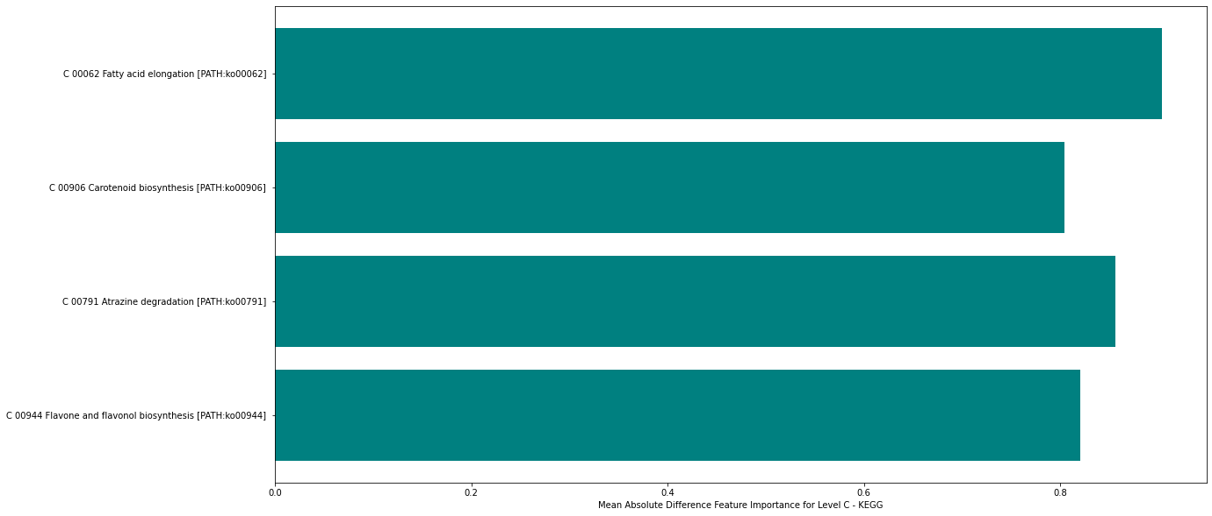
Figure S1: Top important metabolic pathways yielded by Mean Absolute Difference (MAD) algorithm.
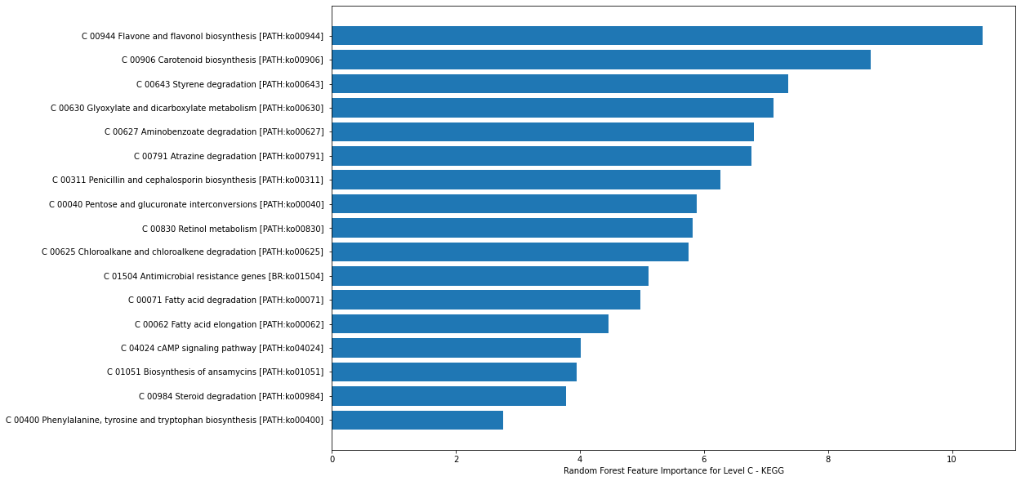
Figure S2: Metabolic pathways importance yielded by Random Forest (RF) algorithm.
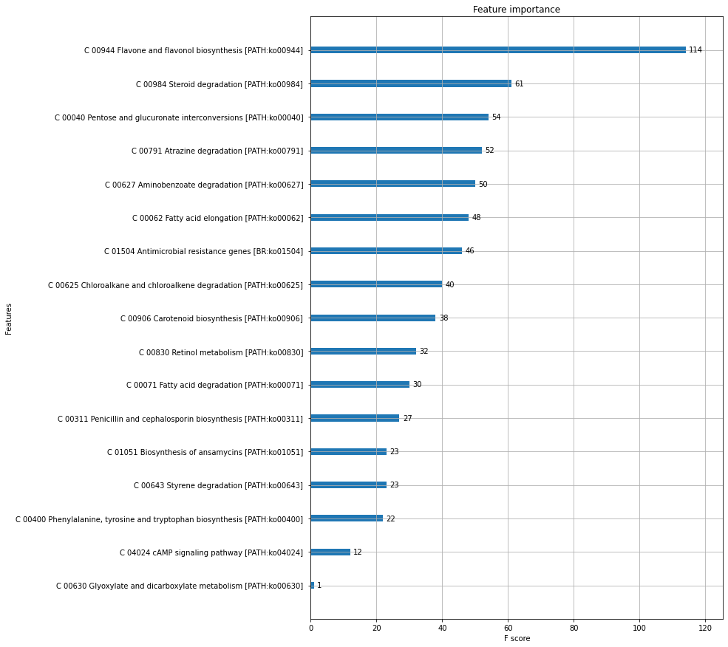
Figure S3: Metabolic pathways (features) importance yielded by XGBoost algorithm.

Table S1. Cocoa Microbial and Functional Biomarkers (↑ upregulated and ↓ downregulated).
Pathway Name (level C)[Kegg ID]  (Level B) | KO | Gene; Enzyme name  [EC number] | Genus | Pathway Abundance
 |  |  |  | Raw | 50 | 70 | 90 | 120
Aminobenzoate degradation [PATH:ko00627]  (09111 Xenobiotics biodegradation and metabolism) | K00141 | xylC; benzaldehyde dehydrogenase (NAD) [EC:1.2.1.28] | Oxalobacter | ↑ | ↑ | ↑ | ↑ | ↑
 | K00493 | E1.14.14.1; unspecific monooxygenase [EC:1.14.14.1] | Aeromicrobium | ↑ | ↑ | ↑ | ↑ | ↑
 | K01034 | atoD; acetate CoA/acetoacetate CoA-transferase alpha subunit [EC:2.8.3.8 2.8.3.9] | Intestinimonas, Megasphaera | ↑ | ↑ | ↑ | ↑ | ↑
 | K01035 | atoA; acetate CoA/acetoacetate CoA-transferase beta subunit [EC:2.8.3.8 2.8.3.9] | Intestinimonas, Megasphaera | ↑ | ↑ | ↑ | ↑ | ↑
 | K01101 | E3.1.3.41; 4-nitrophenyl phosphatase [EC:3.1.3.41] | Holdemania | ↑ | ↑ | ↑ | ↑ | ↑
 | K01426 | E3.5.1.4, amiE; amidase [EC:3.5.1.4] | Aeromicrobium, Enterococcus, Oxalobacter, Sutterella | ↑ | ↑ | ↑ | ↑ | ↑
 | K01501 | E3.5.5.1; nitrilase [EC:3.5.5.1] | Megasphaera, Oxalobacter | ↑ | ↑ | ↑ | ↑ | ↑
 | K01512 | acyP; acylphosphatase [EC:3.6.1.7] | Bifidobacterium, Enterococcus, Lachnoclostridium, Megamonas, Roseburia, Ruminococcus | ↑ | ↑ | ↑ | ↑ | ↑
 | K01692 | paaF, echA; enoyl-CoA hydratase [EC:4.2.1.17] | Aeromicrobium, Oxalobacter | ↑ | ↑ | ↑ | ↑ | ↑
 | K03186 | ubiX, bsdB, PAD1; flavin prenyltransferase [EC:2.5.1.129] | Alistipes, Lachnoclostridium, Megamonas, Oxalobacter, Ruminiclostridium | ↑ | ↑ | ↑ | ↑ | ↑
 | K03862 | vanA; vanillate monooxygenase [EC:1.14.13.82] | Oxalobacter | ↑ | ↑ | ↑ | ↑ | ↑
 | K03863 | vanB; vanillate monooxygenase ferredoxin subunit | Oxalobacter | ↑ | ↑ | ↑ | ↑ | ↑
 | K09461 | E1.14.13.40; anthraniloyl-CoA monooxygenase [EC:1.14.13.40] | Oxalobacter | ↑ | ↑ | ↑ | ↑ | ↑
Antimicrobial resistance genes [BR:ko01504]  (09183 Protein families: signaling and cellular processes) | K02171 | blaI; BlaI family transcriptional regulator, penicillinase repressor | Coprococcus, Intestinimonas, Lachnoclostridium | ↑ | ↑ | ↓ | ↓ | ↑
 | K02172 | blaR1; bla regulator protein blaR1 | Coprococcus, Lachnoclostridium, Megamonas | ↑ | ↑ | ↓ | ↓ | ↑
 | K03367 | dltA; D-alanine--poly(phosphoribitol) ligase subunit 1 [EC:6.1.1.13] | Enterococcus | ↑ | ↑ | ↓ | ↓ | ↑
 | K04343 | strB; streptomycin 6-kinase [EC:2.7.1.72] | Aeromicrobium | ↑ | ↑ | ↓ | ↓ | ↑
 | K07644 | cusS, copS, silS; two-component system, OmpR family, heavy metal sensor histidine kinase CusS [EC:2.7.13.3] | Oxalobacter | ↑ | ↑ | ↓ | ↓ | ↑
 | K07665 | cusR, copR, silR; two-component system, OmpR family, copper resistance phosphate regulon response regulator CusR | Oxalobacter | ↑ | ↑ | ↓ | ↓ | ↑
Atrazine degradation [PATH:ko00791]  (09111 Xenobiotics biodegradation and metabolism) | K01428 | ureC; urease subunit alpha [EC:3.5.1.5] | Oxalobacter | ↑ | ↓ | ↓ | ↓ | ↓
 | K01429 | ureB; urease subunit beta [EC:3.5.1.5] | Haemophilus, Oxalobacter | ↑ | ↓ | ↓ | ↓ | ↓
 | K01430 | ureA; urease subunit gamma [EC:3.5.1.5] | Haemophilus, Oxalobacter | ↑ | ↓ | ↓ | ↓ | ↓
 | K01457 | atzF; allophanate hydrolase [EC:3.5.1.54] | Oxalobacter | ↑ | ↓ | ↓ | ↓ | ↓
 | K03382 | atzB; hydroxydechloroatrazine ethylaminohydrolase [EC:3.5.4.43] | Lachnoclostridium | ↑ | ↓ | ↓ | ↓ | ↓
Biosynthesis of ansamycins [PATH:ko01051]  (09109 Metabolism of terpenoids and polyketides) | K00615 | E2.2.1.1, tktA, tktB; transketolase [EC:2.2.1.1] | Acidaminococcus, Aeromicrobium, Alistipes, Bacteroides, Bifidobacterium, Coprococcus, Enterococcus, Faecalibacterium, Haemophilus, Intestinimonas, Lachnoclostridium, Megamonas, Megasphaera, Oxalobacter, Parabacteroides, Roseburia, Ruminiclostridium, Ruminococcus, Sutterella, Veillonella | ↑ | ↑ | ↑ | ↓ | ↑
cAMP signaling pathway [PATH:ko04024]  (09132 Signal transduction) | K00232 | E1.3.3.6, ACOX1, ACOX3; acyl-CoA oxidase [EC:1.3.3.6] | Aeromicrobium | ↓ | ↑ | ↑ | ↑ | ↑
Carotenoid biosynthesis [PATH:ko00906]  (09109 Metabolism of terpenoids and polyketides) | K02291 | crtB; 15-cis-phytoene synthase [EC:2.5.1.32] | Oxalobacter | ↓ | ↓ | ↓ | ↓ | ↑
 | K06443 | lcyB, crtL1, crtY; lycopene beta-cyclase [EC:5.5.1.19] | Aeromicrobium | ↓ | ↓ | ↓ | ↓ | ↑
 | K09879 | crtU, cruE; carotenoid phi-ring synthase / carotenoid chi-ring synthase [EC:1.3.99.39 1.3.99.40] | Aeromicrobium | ↓ | ↓ | ↓ | ↓ | ↑
 | K10027 | crtI; phytoene desaturase [EC:1.3.99.26 1.3.99.28 1.3.99.29 1.3.99.31] | Aeromicrobium | ↓ | ↓ | ↓ | ↓ | ↑
Chloroalkane and chloroalkene degradation [PATH:ko00625]  (09111 Xenobiotics biodegradation and metabolism) | K00001 | E1.1.1.1, adh; alcohol dehydrogenase [EC:1.1.1.1] | Acidaminococcus, Alistipes, Bifidobacterium, Enterococcus, Megasphaera, Ruminiclostridium, Sutterella | ↓ | ↑ | ↓ | ↓ | ↓
 | K00121 | frmA, ADH5, adhC; S-(hydroxymethyl)glutathione dehydrogenase / alcohol dehydrogenase [EC:1.1.1.284 1.1.1.1] | Haemophilus | ↓ | ↑ | ↓ | ↓ | ↓
 | K00128 | ALDH; aldehyde dehydrogenase (NAD+) [EC:1.2.1.3] | Acidaminococcus, Aeromicrobium, Alistipes, Bifidobacterium, Coprococcus, Intestinimonas, Megasphaera, Oxalobacter | ↓ | ↑ | ↓ | ↓ | ↓
 | K01560 | E3.8.1.2; 2-haloacid dehalogenase [EC:3.8.1.2] | Coprococcus, Enterococcus, Intestinimonas, Lachnoclostridium, Oxalobacter | ↓ | ↑ | ↓ | ↓ | ↓
 | K02586 | nifD; nitrogenase molybdenum-iron protein alpha chain [EC:1.18.6.1] | Ruminiclostridium, Oxalobacter | ↓ | ↑ | ↓ | ↓ | ↓
 | K02588 | nifH; nitrogenase iron protein NifH | Intestinimonas, Lachnoclostridium, Megasphaera, Ruminiclostridium, Ruminococcus | ↓ | ↑ | ↓ | ↓ | ↓
 | K02591 | nifK; nitrogenase molybdenum-iron protein beta chain [EC:1.18.6.1] | Ruminiclostridium, Oxalobacter | ↓ | ↑ | ↓ | ↓ | ↓
 | K04072 | adhE; acetaldehyde dehydrogenase / alcohol dehydrogenase [EC:1.2.1.10 1.1.1.1] | Bifidobacterium, Enterococcus, Lachnoclostridium, Ruminiclostridium, Ruminococcus | ↓ | ↑ | ↓ | ↓ | ↓
Fatty acid degradation [PATH:ko00071]  (09103 Lipid metabolism) | K00001 | E1.1.1.1, adh; alcohol dehydrogenase [EC:1.1.1.1] | Acidaminococcus, Alistipes, Bifidobacterium, Enterococcus, Megasphaera, Ruminiclostridium, Sutterella | ↓ | ↑ | ↓ | ↓ | ↓
 | K00121 | frmA, ADH5, adhC; S-(hydroxymethyl)glutathione dehydrogenase / alcohol dehydrogenase [EC:1.1.1.284 1.1.1.1] | Haemophilus | ↓ | ↑ | ↓ | ↓ | ↓
 | K00128 | ALDH; aldehyde dehydrogenase (NAD+) [EC:1.2.1.3] | Acidaminococcus, Aeromicrobium, Alistipes, Bifidobacterium, Coprococcus, Intestinimonas, Megasphaera, Oxalobacter | ↓ | ↑ | ↓ | ↓ | ↓
 | K00232 | E1.3.3.6, ACOX1, ACOX3; acyl-CoA oxidase [EC:1.3.3.6] | Aeromicrobium | ↓ | ↑ | ↓ | ↓ | ↓
 | K00248 | ACADS, bcd; butyryl-CoA dehydrogenase [EC:1.3.8.1] | Acidaminococcus, Faecalibacterium, Intestinimonas, Lachnoclostridium, Roseburia | ↓ | ↑ | ↓ | ↓ | ↓
 | K00249 | ACADM, acd; acyl-CoA dehydrogenase [EC:1.3.8.7] | Aeromicrobium | ↓ | ↑ | ↓ | ↓ | ↓
 | K00496 | alkB1_2, alkM; alkane 1-monooxygenase [EC:1.14.15.3] | Aeromicrobium | ↓ | ↑ | ↓ | ↓ | ↓
 | K00529 | hcaD; 3-phenylpropionate/trans-cinnamate dioxygenase ferredoxin reductase component [EC:1.18.1.3] | Aeromicrobium | ↓ | ↑ | ↓ | ↓ | ↓
 | K00626 | E2.3.1.9, atoB; acetyl-CoA C-acetyltransferase [EC:2.3.1.9] | Acidaminococcus, Aeromicrobium, Coprococcus, Faecalibacterium, Intestinimonas, Lachnoclostridium, Megasphaera, Roseburia, Veillonella | ↓ | ↑ | ↓ | ↓ | ↓
 | K00632 | fadA, fadI; acetyl-CoA acyltransferase [EC:2.3.1.16] | Intestinimonas | ↓ | ↑ | ↓ | ↓ | ↓
 | K01692 | paaF, echA; enoyl-CoA hydratase [EC:4.2.1.17] | Aeromicrobium | ↓ | ↑ | ↓ | ↓ | ↓
 | K01782 | fadJ; 3-hydroxyacyl-CoA dehydrogenase / enoyl-CoA hydratase / 3-hydroxybutyryl-CoA epimerase [EC:1.1.1.35 4.2.1.17 5.1.2.3] | Aeromicrobium | ↓ | ↑ | ↓ | ↓ | ↓
 | K01897 | ACSL, fadD; long-chain acyl-CoA synthetase [EC:6.2.1.3] | Acidaminococcus, Aeromicrobium, Alistipes, Bacteroides, Bifidobacterium, Faecalibacterium, Haemophilus, Lachnoclostridium, Oxalobacter, Parabacteroides, Ruminiclostridium, Ruminococcus, Sutterella, Veillonella | ↓ | ↑ | ↓ | ↓ | ↓
 | K04072 | adhE; acetaldehyde dehydrogenase / alcohol dehydrogenase [EC:1.2.1.10 1.1.1.1] | Bifidobacterium, Enterococcus, Lachnoclostridium, Ruminiclostridium, Ruminococcus | ↓ | ↑ | ↓ | ↓ | ↓
Fatty acid elongation [PATH:ko00062]  (09103 Lipid metabolism) | K07509 | HADHB; acetyl-CoA acyltransferase [EC:2.3.1.16] | Sutterella | ↑ | ↓ | ↓ | ↓ | ↓
Flavone and flavonol biosynthesis [PATH:ko00944]  (09110 Biosynthesis of other secondary metabolites) | K01195 | uidA, GUSB; beta-glucuronidase [EC:3.2.1.31] | Faecalibacterium | ↓ | ↑ | ↑ | ↑ | ↑
Glyoxylate and dicarboxylate metabolism [PATH:ko00630]  (09101 Carbohydrate metabolism) | K00015 | gyaR, GOR1; glyoxylate reductase [EC:1.1.1.26] | Oxalobacter | ↓ | ↓ | ↓ | ↓ | ↑
 | K00018 | hprA; glycerate dehydrogenase [EC:1.1.1.29] | Alistipes, Bacteroides, Coprococcus, Faecalibacterium, Haemophilus, Lachnoclostridium, Ruminiclostridium, Ruminococcus | ↓ | ↓ | ↓ | ↓ | ↑
 | K00042 | garR, glxR; 2-hydroxy-3-oxopropionate reductase [EC:1.1.1.60] | Lachnoclostridium | ↓ | ↓ | ↓ | ↓ | ↑
 | K00048 | fucO; lactaldehyde reductase [EC:1.1.1.77] | Alistipes, Bacteroides, Bifidobacterium, Coprococcus, Faecalibacterium, Lachnoclostridium, Megamonas, Roseburia, Ruminococcus, Veillonella | ↓ | ↓ | ↓ | ↓ | ↑
 | K00104 | glcD; glycolate oxidase [EC:1.1.3.15] | Acidaminococcus, Aeromicrobium, Intestinimonas, Lachnoclostridium, Megasphaera | ↓ | ↓ | ↓ | ↓ | ↑
 | K00123 | fdoG, fdhF, fdwA; formate dehydrogenase major subunit [EC:1.17.1.9] | Haemophilus, Sutterella | ↓ | ↓ | ↓ | ↓ | ↑
 | K00124 | fdoH, fdsB; formate dehydrogenase iron-sulfur subunit | Haemophilus, Sutterella | ↓ | ↓ | ↓ | ↓ | ↑
 | K00127 | fdoI, fdsG; formate dehydrogenase subunit gamma | Haemophilus, Sutterella | ↓ | ↓ | ↓ | ↓ | ↑
 | K00282 | gcvPA; glycine dehydrogenase subunit 1 [EC:1.4.4.2] | Intestinimonas, Lachnoclostridium, Megamonas | ↓ | ↓ | ↓ | ↓ | ↑
 | K00283 | gcvPB; glycine dehydrogenase subunit 2 [EC:1.4.4.2] | Intestinimonas, Lachnoclostridium, Megamonas | ↓ | ↓ | ↓ | ↓ | ↑
 | K00382 | DLD, lpd, pdhD; dihydrolipoamide dehydrogenase [EC:1.8.1.4] | Aeromicrobium, Alistipes, Bacteroides, Bifidobacterium, Enterococcus, Haemophilus, Intestinimonas, Lachnoclostridium, Megamonas, Oxalobacter, Parabacteroides | ↓ | ↓ | ↓ | ↓ | ↑
 | K00600 | glyA, SHMT; glycine hydroxymethyltransferase [EC:2.1.2.1] | Acidaminococcus, Aeromicrobium, Alistipes, Bacteroides, Coprococcus, Enterococcus, Faecalibacterium, Haemophilus, Intestinimonas, Lachnoclostridium, Megamonas, Oxalobacter, Parabacteroides, Roseburia, Ruminiclostridium, Ruminococcus, Sutterella, Veillonella | ↓ | ↓ | ↓ | ↓ | ↑
 | K00605 | gcvT, AMT; aminomethyltransferase [EC:2.1.2.10] | Alistipes, Bacteroides, Intestinimonas, Lachnoclostridium, Megamonas, Parabacteroides | ↓ | ↓ | ↓ | ↓ | ↑
 | K00626 | E2.3.1.9, atoB; acetyl-CoA C-acetyltransferase [EC:2.3.1.9] | Acidaminococcus, Aeromicrobium, Coprococcus, Faecalibacterium, Intestinimonas, Lachnoclostridium, Megasphaera, Roseburia, Veillonella | ↓ | ↓ | ↓ | ↓ | ↑
 | K00865 | glxK, garK; glycerate 2-kinase [EC:2.7.1.165] | Aeromicrobium, Bacteroides, Bifidobacterium, Coprococcus, Enterococcus, Haemophilus, Lachnoclostridium, Megamonas, Parabacteroides, Roseburia, Ruminiclostridium, Ruminococcus | ↓ | ↓ | ↓ | ↓ | ↑
 | K01091 | gph; phosphoglycolate phosphatase [EC:3.1.3.18] | Acidaminococcus, Aeromicrobium, Alistipes, Bacteroides, Bifidobacterium, Coprococcus, Enterococcus, Faecalibacterium, Haemophilus, Intestinimonas, Lachnoclostridium, Megamonas, Megasphaera, Oxalobacter, Parabacteroides, Roseburia, Ruminiclostridium, Ruminococcus, Sutterella, Veillonella | ↓ | ↓ | ↓ | ↓ | ↑
 | K01433 | purU; formyltetrahydrofolate deformylase [EC:3.5.1.10] | Aeromicrobium, Bacteroides, Haemophilus | ↓ | ↓ | ↓ | ↓ | ↑
 | K01455 | E3.5.1.49; formamidase [EC:3.5.1.49] | Oxalobacter | ↓ | ↓ | ↓ | ↓ | ↑
 | K01608 | gcl; tartronate-semialdehyde synthase [EC:4.1.1.47] | Oxalobacter | ↓ | ↓ | ↓ | ↓ | ↑
 | K01625 | eda; 2-dehydro-3-deoxyphosphogluconate aldolase / (4S)-4-hydroxy-2-oxoglutarate aldolase [EC:4.1.2.14 4.1.3.42] | Alistipes, Bacteroides, Enterococcus, Faecalibacterium, Intestinimonas, Lachnoclostridium, Megamonas, Megasphaera, Parabacteroides, Roseburia, Ruminiclostridium | ↓ | ↓ | ↓ | ↓ | ↑
 | K01637 | E4.1.3.1, aceA; isocitrate lyase [EC:4.1.3.1] | Aeromicrobium | ↓ | ↓ | ↓ | ↓ | ↑
 | K01638 | aceB, glcB; malate synthase [EC:2.3.3.9] | Aeromicrobium, Oxalobacter | ↓ | ↓ | ↓ | ↓ | ↑
 | K01647 | CS, gltA; citrate synthase [EC:2.3.3.1] | Bacteroides, Bifidobacterium, Coprococcus, Faecalibacterium, Intestinimonas, Lachnoclostridium, Megamonas, Megasphaera, Oxalobacter, Parabacteroides, Roseburia, Ruminiclostridium, Ruminococcus | ↓ | ↓ | ↓ | ↓ | ↑
 | K01681 | ACO, acnA; aconitate hydratase [EC:4.2.1.3] | Acidaminococcus, Aeromicrobium, Bacteroides, Bifidobacterium, Coprococcus, Faecalibacterium, Intestinimonas, Lachnoclostridium, Megamonas, Megasphaera, Oxalobacter, Parabacteroides, Roseburia, Ruminiclostridium, Ruminococcus, Sutterella | ↓ | ↓ | ↓ | ↓ | ↑
 | K01816 | hyi, gip; hydroxypyruvate isomerase [EC:5.3.1.22] | Aeromicrobium, Oxalobacter, Parabacteroides | ↓ | ↓ | ↓ | ↓ | ↑
 | K01847 | MUT; methylmalonyl-CoA mutase [EC:5.4.99.2] | Aeromicrobium, Alistipes, Bacteroides, Intestinimonas, Megamonas, Parabacteroides, Veillonella | ↓ | ↓ | ↓ | ↓ | ↑
 | K01848 | E5.4.99.2A, mcmA1; methylmalonyl-CoA mutase, N-terminal domain [EC:5.4.99.2] | Megamonas, Veillonella | ↓ | ↓ | ↓ | ↓ | ↑
 | K01849 | E5.4.99.2B, mcmA2; methylmalonyl-CoA mutase, C-terminal domain [EC:5.4.99.2] | Megamonas, Veillonella | ↓ | ↓ | ↓ | ↓ | ↑
 | K01895 | ACSS, acs; acetyl-CoA synthetase [EC:6.2.1.1] | Aeromicrobium, Alistipes, Bacteroides, Oxalobacter, Parabacteroides, Ruminiclostridium, Ruminococcus | ↓ | ↓ | ↓ | ↓ | ↑
 | K01915 | glnA, GLUL; glutamine synthetase [EC:6.3.1.2] | Aeromicrobium, Alistipes, Bacteroides, Bifidobacterium, Coprococcus, Enterococcus, Faecalibacterium, Haemophilus, Intestinimonas, Lachnoclostridium, Megamonas, Megasphaera, Parabacteroides, Roseburia, Ruminiclostridium, Ruminococcus, Sutterella, Veillonella | ↓ | ↓ | ↓ | ↓ | ↑
 | K01965 | PCCA, pccA; propionyl-CoA carboxylase alpha chain [EC:6.4.1.3] | Aeromicrobium | ↓ | ↓ | ↓ | ↓ | ↑
 | K01966 | PCCB, pccB; propionyl-CoA carboxylase beta chain [EC:6.4.1.3 2.1.3.15] | Aeromicrobium, Bacteroides, Parabacteroides | ↓ | ↓ | ↓ | ↓ | ↑
 | K03779 | ttdA; L(+)-tartrate dehydratase alpha subunit [EC:4.2.1.32] | Acidaminococcus, Veillonella | ↓ | ↓ | ↓ | ↓ | ↑
 | K03780 | ttdB; L(+)-tartrate dehydratase beta subunit [EC:4.2.1.32] | Acidaminococcus, Sutterella, Veillonella | ↓ | ↓ | ↓ | ↓ | ↑
 | K03781 | katE, CAT, catB, srpA; catalase [EC:1.11.1.6] | Aeromicrobium, Alistipes, Bacteroides, Enterococcus, Haemophilus, Intestinimonas, Parabacteroides | ↓ | ↓ | ↓ | ↓ | ↑
 | K05606 | MCEE, epi; methylmalonyl-CoA/ethylmalonyl-CoA epimerase [EC:5.1.99.1] | Aeromicrobium, Alistipes, Bacteroides, Intestinimonas, Megamonas, Parabacteroides, Veillonella | ↓ | ↓ | ↓ | ↓ | ↑
 | K07246 | ttuC, dmlA; tartrate dehydrogenase/decarboxylase / D-malate dehydrogenase [EC:1.1.1.93 4.1.1.73 1.1.1.83] | Acidaminococcus, Ruminiclostridium | ↓ | ↓ | ↓ | ↓ | ↑
 | K07248 | aldA; lactaldehyde dehydrogenase / glycolaldehyde dehydrogenase [EC:1.2.1.22 1.2.1.21] | Parabacteroides | ↓ | ↓ | ↓ | ↓ | ↑
 | K08691 | mcl; malyl-CoA/(S)-citramalyl-CoA lyase [EC:4.1.3.24 4.1.3.25] | Aeromicrobium | ↓ | ↓ | ↓ | ↓ | ↑
 | K11263 | bccA, pccA; acetyl-CoA/propionyl-CoA carboxylase, biotin carboxylase, biotin carboxyl carrier protein [EC:6.4.1.2 6.4.1.3 6.3.4.14] | Aeromicrobium, Bifidobacterium | ↓ | ↓ | ↓ | ↓ | ↑
Penicillin and cephalosporin biosynthesis [PATH:ko00311]  (09110 Biosynthesis of other secondary metabolites) | K01060 | cah; cephalosporin-C deacetylase [EC:3.1.1.41] | Enterococcus, Ruminiclostridium | ↑ | ↑ | ↑ | ↓ | ↑
 | K01434 | E3.5.1.11; penicillin amidase [EC:3.5.1.11] | Aeromicrobium | ↑ | ↑ | ↑ | ↓ | ↑
Pentose and glucuronate interconversions [PATH:ko00040]  (09101 Carbohydrate metabolism) | K00008 | SORD, gutB; L-iditol 2-dehydrogenase [EC:1.1.1.14] | Lachnoclostridium, Megamonas, Oxalobacter, Roseburia, Ruminiclostridium | ↑ | ↓ | ↑ | ↓ | ↑
 | K00012 | UGDH, ugd; UDPglucose 6-dehydrogenase [EC:1.1.1.22] | Acidaminococcus, Aeromicrobium, Alistipes, Bacteroides, Bifidobacterium, Coprococcus, Lachnoclostridium, Megamonas, Megasphaera, Parabacteroides, Roseburia, Veillonella | ↑ | ↓ | ↑ | ↓ | ↑
 | K00040 | uxuB; fructuronate reductase [EC:1.1.1.57] | Faecalibacterium, Intestinimonas, Lachnoclostridium, Megasphaera, Roseburia, Ruminiclostridium | ↑ | ↓ | ↑ | ↓ | ↑
 | K00041 | uxaB; tagaturonate reductase [EC:1.1.1.58] | Bacteroides, Faecalibacterium, Intestinimonas, Lachnoclostridium, Megasphaera, Parabacteroides | ↑ | ↓ | ↑ | ↓ | ↑
 | K00065 | kduD; 2-dehydro-3-deoxy-D-gluconate 5-dehydrogenase [EC:1.1.1.127] | Lachnoclostridium, Megamonas | ↑ | ↓ | ↑ | ↓ | ↑
 | K00848 | rhaB; rhamnulokinase [EC:2.7.1.5] | Alistipes, Bacteroides, Enterococcus, Lachnoclostridium, Megamonas, Parabacteroides, Roseburia | ↑ | ↓ | ↑ | ↓ | ↑
 | K00853 | araB; L-ribulokinase [EC:2.7.1.16] | Aeromicrobium, Alistipes | ↑ | ↓ | ↑ | ↓ | ↑
 | K00854 | xylB, XYLB; xylulokinase [EC:2.7.1.17] | Alistipes, Bacteroides, Bifidobacterium, Coprococcus, Enterococcus, Lachnoclostridium, Megamonas, Megasphaera, Parabacteroides, Ruminiclostridium, Ruminococcus, Sutterella | ↑ | ↓ | ↑ | ↓ | ↑
 | K00880 | lyxK; L-xylulokinase [EC:2.7.1.53] | Lachnoclostridium | ↑ | ↓ | ↑ | ↓ | ↑
 | K00963 | UGP2, galU, galF; UTP--glucose-1-phosphate uridylyltransferase [EC:2.7.7.9] | Acidaminococcus, Aeromicrobium, Bifidobacterium, Enterococcus, Faecalibacterium, Haemophilus, Intestinimonas, Megamonas, Megasphaera, Oxalobacter, Ruminiclostridium, Sutterella, Veillonella | ↑ | ↓ | ↑ | ↓ | ↑
 | K01051 | E3.1.1.11; pectinesterase [EC:3.1.1.11] | Bacteroides, Faecalibacterium, Lachnoclostridium, Roseburia | ↑ | ↓ | ↑ | ↓ | ↑
 | K01195 | uidA, GUSB; beta-glucuronidase [EC:3.2.1.31] | Faecalibacterium | ↑ | ↓ | ↑ | ↓ | ↑
 | K01629 | rhaD; rhamnulose-1-phosphate aldolase [EC:4.1.2.19] | Alistipes, Bacteroides, Enterococcus, Faecalibacterium, Lachnoclostridium, Megamonas, Parabacteroides, Roseburia | ↑ | ↓ | ↑ | ↓ | ↑
 | K01685 | uxaA; altronate hydrolase [EC:4.2.1.7] | Bacteroides, Faecalibacterium, Intestinimonas, Lachnoclostridium, Megasphaera, Parabacteroides | ↑ | ↓ | ↑ | ↓ | ↑
 | K01686 | uxuA; mannonate dehydratase [EC:4.2.1.8] | Bacteroides, Enterococcus, Faecalibacterium, Intestinimonas, Lachnoclostridium, Megasphaera, Parabacteroides, Roseburia, Ruminiclostridium | ↑ | ↓ | ↑ | ↓ | ↑
 | K01783 | rpe, RPE; ribulose-phosphate 3-epimerase [EC:5.1.3.1] | Acidaminococcus, Aeromicrobium, Alistipes, Bacteroides, Bifidobacterium, Coprococcus, Enterococcus, Faecalibacterium, Haemophilus, Intestinimonas, Lachnoclostridium, Megamonas, Megasphaera, Oxalobacter, Parabacteroides, Roseburia, Ruminiclostridium, Ruminococcus, Sutterella, Veillonella | ↑ | ↓ | ↑ | ↓ | ↑
 | K01804 | araA; L-arabinose isomerase [EC:5.3.1.4] | Aeromicrobium, Alistipes, Bacteroides, Bifidobacterium, Lachnoclostridium, Megamonas, Parabacteroides, Ruminiclostridium | ↑ | ↓ | ↑ | ↓ | ↑
 | K01805 | xylA; xylose isomerase [EC:5.3.1.5] | Aeromicrobium, Alistipes, Bacteroides, Bifidobacterium, Enterococcus, Lachnoclostridium, Parabacteroides, Ruminiclostridium | ↑ | ↓ | ↑ | ↓ | ↑
 | K01812 | uxaC; glucuronate isomerase [EC:5.3.1.12] | Alistipes, Bacteroides, Faecalibacterium, Intestinimonas, Lachnoclostridium, Megasphaera, Parabacteroides, Roseburia, Ruminiclostridium | ↑ | ↓ | ↑ | ↓ | ↑
 | K01815 | kduI; 4-deoxy-L-threo-5-hexosulose-uronate ketol-isomerase [EC:5.3.1.17] | Bacteroides, Enterococcus, Faecalibacterium, Lachnoclostridium, Parabacteroides | ↑ | ↓ | ↑ | ↓ | ↑
 | K03077 | araD, ulaF, sgaE, sgbE; L-ribulose-5-phosphate 4-epimerase [EC:5.1.3.4] | Bacteroides | ↑ | ↓ | ↑ | ↓ | ↑
 | K08092 | dlgD; 3-dehydro-L-gulonate 2-dehydrogenase [EC:1.1.1.130] | Lachnoclostridium | ↑ | ↓ | ↑ | ↓ | ↑
Retinol metabolism [PATH:ko00830]  (09108 Metabolism of cofactors and vitamins) | K00001 | E1.1.1.1, adh; alcohol dehydrogenase [EC:1.1.1.1] | Acidaminococcus, Alistipes, Bifidobacterium, Enterococcus, Megasphaera, Ruminiclostridium, Sutterella | ↓ | ↑ | ↓ | ↓ | ↓
 | K00121 | frmA, ADH5, adhC; S-(hydroxymethyl)glutathione dehydrogenase / alcohol dehydrogenase [EC:1.1.1.284 1.1.1.1] | Haemophilus | ↓ | ↑ | ↓ | ↓ | ↓
Styrene degradation [PATH:ko00643]  (09111 Xenobiotics biodegradation and metabolism) | K00146 | feaB; phenylacetaldehyde dehydrogenase [EC:1.2.1.39] | Oxalobacter | ↓ | ↑ | ↓ | ↓ | ↓
 | K00451 | HGD, hmgA; homogentisate 1,2-dioxygenase [EC:1.13.11.5] | Aeromicrobium, Oxalobacter | ↓ | ↑ | ↓ | ↓ | ↓
 | K01026 | pct; propionate CoA-transferase [EC:2.8.3.1] | Coprococcus, Intestinimonas, Lachnoclostridium, Megasphaera, Oxalobacter | ↓ | ↑ | ↓ | ↓ | ↓
 | K01039 | gctA; glutaconate CoA-transferase, subunit A [EC:2.8.3.12] | Acidaminococcus | ↓ | ↑ | ↓ | ↓ | ↓
 | K01040 | gctB; glutaconate CoA-transferase, subunit B [EC:2.8.3.12] | Acidaminococcus | ↓ | ↑ | ↓ | ↓ | ↓
 | K01426 | E3.5.1.4, amiE; amidase [EC:3.5.1.4] | Enterococcus, Oxalobacter, Sutterella | ↓ | ↑ | ↓ | ↓ | ↓
 | K01501 | E3.5.5.1; nitrilase [EC:3.5.5.1] | Megasphaera, Oxalobacter | ↓ | ↑ | ↓ | ↓ | ↓
 | K01555 | FAH, fahA; fumarylacetoacetase [EC:3.7.1.2] | Aeromicrobium, Oxalobacter | ↓ | ↑ | ↓ | ↓ | ↓

