Table S1. Main characteristics of the LINA sub-cohort analyzed in this study, overall and separately for each wave.

Parameters |  | 1st wave  (age 7) | 2nd wave  (age 8) | 3rd wave  (age 10) | Overall
 |  | N=372 | N=334 | N=268 | N=373
Sex of the child | Females # | 187 | 165 | 132 | 188
 | Males # | 185 | 169 | 136 | 185
Number of siblings | Total * | 0.80 ± 0.75 | 0.79 ± 0.76 | 0.82 ± 0.74 | 0.80 ± 0.75
 | Older sisters * | 0.16 ± 0.37 | 0.14 ± 0.35 | 0.16 ± 0.37 | 0.15 ± 0.36
 | Older brothers * | 0.15 ± 0.36 | 0.16 ± 0.36 | 0.15 ± 0.36 | 0.15 ± 0.36
Child behavioral problems | SDQ * º | 0.18 ± 0.11 | 0.18 ± 0.11 | 0.18 ± 0.13 | 0.18 ± 0.12
 | FBB-HKS * º | 0.17 ± 0.14 | 0.18 ± 0.14 | 0.17 ± 0.14 | 0.18 ± 0.14
Maternal stress | PSQ: prenatal * º | 0.31 ± 0.16 | 0.31 ± 0.16 | 0.31 ± 0.16 | 0.31 ± 0.16
 | PSQ: in the three waves * º | 0.43 ± 0.19 | 0.42 ± 0.19 | 0.41 ± 0.18 | 0.42 ± 0.19
Satisfaction with social and environmental factors | Relationship with neighbors * º | - | - | 0.64 ± 0.17 | -
 | Natural environment * º | - | - | 0.73 ± 0.19 | -
 | Safety of the area * º | - | - | 0.74 ± 0.20 | -
 | Availability of social areas * º | - | - | 0.60 ± 0.20 | -
 | Availability of shops * º | - | - | 0.71 ± 0.21 | -
 | Availability of other infrastructures * º | - | - | 0.71 ± 0.16 | -
Monthly income | Low # | - | - | 24 | -
 | Intermediate # | - | - | 88 | -
 | High # | - | - | 135 | -
Maternal education level | Primary education | 1 | 1 | 1 | 1
 | Lower secondary education | 4 | 4 | 3 | 4
 | Upper secondary education | 131 | 116 | 93 | 132
 | Post-secondary non-tertiary education | 80 | 75 | 62 | 80
 | Tertiary education (1st stage) | 152 | 136 | 107 | 152
 | Tertiary education (2nd stage) | 4 | 2 | 2 | 4

The numbers included in the Overall column include all participants who participated in at least one of the three waves, so that information was available on both child behavior and maternal stress levels. Monthly income (i.e. household income per month) was categorized as "low" (<2000 €), "intermediate" (2000-3500 €) or "high" (>3500 €). # stands for number of participants, * stands for mean ± SD, and º stands for indices ranging from 0 to 1.

Table S2. Results of the longitudinal model, including estimates, standard errors (SE), z values and p values. Significant test predictors are marked with an asterisk and are in bold in the p column.

PARAMETERS | Estimate | SE | z values | p
Variances
BEH_T1 | 0.01 | 0.00 | 7.82 | <0.001*
dBEH1 | 0.00 | 0.00 | 4.27 | <0.001*
dBEH2 | 0.00 | 0.00 | 3.48 | 0.001*
STRl_T1 | 0.03 | 0.00 | 11.70 | <0.001*
dSTR1 | 0.01 | 0.00 | 3.10 | 0.002*
dSTR2 | 0.01 | 0.00 | 4.03 | <0.001*
Intercepts
BEH_T1 | 0.18 | 0.01 | 32.95 | <0.001*
dBEH1 | 0.00 | 0.01 | 0.26 | 0.795
dBEH2 | 0.02 | 0.01 | 1.80 | 0.071
STRl_T1 | 0.43 | 0.01 | 43.87 | <0.001*
dSTR1 | 0.05 | 0.02 | 2.48 | 0.013*
dSTR2 | 0.09 | 0.02 | 4.00 | <0.001*
Cross-domain relationships
dBEH1 ~ STR_T1 | 0.05 | 0.03 | 1.68 | 0.093
dBEH2 ~ STR_T2 | -0.02 | 0.03 | -0.82 | 0.415
dSTR1 ~ BEH_T1 | -0.10 | 0.08 | -1.13 | 0.260
dSTR2 ~ BEH_T2 | 0.00 | 0.09 | -0.04 | 0.969
BEH_T1 ~~ STR_T1 | 0.01 | 0.00 | 5.98 | <0.001*
dBEH1 ~~ dSTR1 | 0.00 | 0.00 | 1.58 | 0.115
dBEH2 ~~ dSTR2 | 0.00 | 0.00 | 1.57 | 0.118
Auto-regression
dBEH1 ~ BEH_T1 | -0.13 | 0.06 | -2.13 | 0.033*
dBEH2 ~ BEH _T2 | -0.09 | 0.07 | -1.20 | 0.231
dSTR1 ~ STR_T1 | -0.11 | 0.05 | -2.01 | 0.044*
dSTR2 ~ STR_T2 | -0.20 | 0.05 | -3.83 | <0.001*

BEH_T1 and BEH_T2 stand for child behavioral problems in wave 1 and 2, respectively. dBEH1 and dBEH2 represent changes of this variable across waves (i.e. from wave 1 to wave 2, and from wave 2 to wave 3, respectively). STR_T1 and STR_T2 stand for maternal stress levels in wave 1 and 2, and dSTR1 and dSTR2 represent changes of this variable across waves (i.e. from wave 1 to wave 2, and from wave 2 to wave 3).

Figure S1. Maternal stress at testing time as measured with the PSQ questionnaire, as a function of parental satisfaction about the social areas in the enviroment they live in (from 0 to 1, i.e. from low to high satisfaction). Circles represent individual responses, and the dashed black line the fitted model unconditional on all the other predictors. Data were jittered horizontally to avoid overplotting.

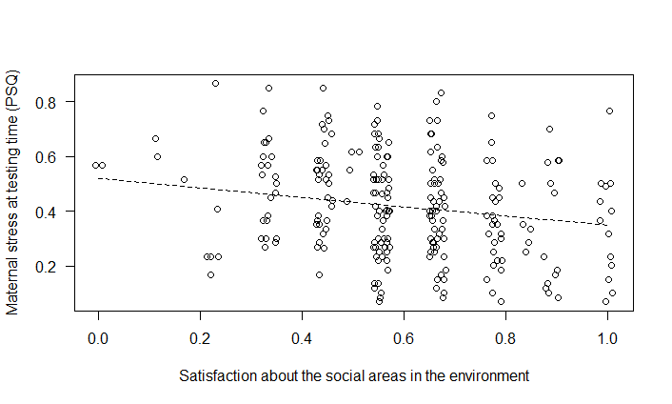
Figure S2. (a) SDQ child behavioral index (from 0 to 1, i.e. from less to more problematic), as a function of prenatal maternal stress, and (b) as a function of maternal stress at testing time; and (c) FBB-HKS child behavioral index (from 0 to 1, i.e. from less to more problematic), as a function of prenatal maternal stress, and (d) as a function of maternal stress at testing time. In all cases, maternal stress was measured with the PSQ questionnaire. Individual responses are represented with black circles for mothers of female children, and with grey crosses for mothers of male children. The dashed black line represents the fitted model unconditional on all the other predictors. Data were jittered horizontally to avoid overplotting.

