Supplementary Information
Table S1 Woolly wolf presence locations used for species distribution modelling

Study | Country | No. of Locations | Year
Mohammad Kabir et al., 2017 | Pakistan | 73 | 2017
Subba et al., 2016 | Nepal | 20 | 2016
Chetri et al., 2016 | Nepal | 14 | 2016
Deu Bahadur Rana (Thesis) 2018 | Nepal | 125 | 2018
Werhahn et al., 2019 | China | 10 | 2019
Lyngdoh et al., 2021 | India | 3223 | 2021
Reshamwala et al., 2021 | India | 267 | 2021
Habib 2007 | Afghanistan | 37 | 2007
Raza Khan et al., 2019 | Pakistan | 7 | 2019

Table S2 List of all environmental variables acquired along with descriptions for conducting current and future species distribution modeling of woolly wolf

No. | Environmental Layer | Source | Description | Type
1 | * BIO1 = Annual Mean Temperature | http://www.worldclim.com | WorldClim data Version 1.4 at 30 seconds, resolution 1 km | Climatic
2 | * BIO2 = Mean Diurnal Range (Mean of monthly (max temp - min temp)) | http://www.worldclim.com | WorldClim data Version 1.4 at 30 seconds, resolution 1 km | Climatic
3 | BIO3 = Isothermality (BIO2/BIO7) (×100) | http://www.worldclim.com | WorldClim data Version 1.4 at 30 seconds, resolution 1 km | Climatic
4 | BIO4 = Temperature Seasonality (standard deviation ×100) | http://www.worldclim.com | WorldClim data Version 1.4 at 30 seconds, resolution 1 km | Climatic
5 | BIO5 = Max Temperature of Warmest Month | http://www.worldclim.com | WorldClim data Version 1.4 at 30 seconds, resolution 1 km | Climatic
6 | BIO6 = Min Temperature of Coldest Month | http://www.worldclim.com | WorldClim data Version 1.4 at 30 seconds, resolution 1 km | Climatic
7 | BIO7 = Temperature Annual Range (BIO5-BIO6) | http://www.worldclim.com | WorldClim data Version 1.4 at 30 seconds, resolution 1 km | Climatic
8 | BIO8 = Mean Temperature of Wettest Quarter | http://www.worldclim.com | WorldClim data Version 1.4 at 30 seconds, resolution 1 km | Climatic
9 | BIO9 = Mean Temperature of Driest Quarter | http://www.worldclim.com | WorldClim data Version 1.4 at 30 seconds, resolution 1 km | Climatic
10 | BIO10 = Mean Temperature of Warmest Quarter | http://www.worldclim.com | WorldClim data Version 1.4 at 30 seconds, resolution 1 km | Climatic
11 | BIO11 = Mean Temperature of Coldest Quarter | http://www.worldclim.com | WorldClim data Version 1.4 at 30 seconds, resolution 1 km | Climatic
12 | BIO12 = Annual Precipitation | http://www.worldclim.com | WorldClim data Version 1.4 at 30 seconds, resolution 1 km | Climatic
13 | BIO13 = Precipitation of Wettest Month | http://www.worldclim.com | WorldClim data Version 1.4 at 30 seconds, resolution 1 km | Climatic
14 | * BIO14 = Precipitation of Driest Month | http://www.worldclim.com | WorldClim data Version 1.4 at 30 seconds, resolution 1 km | Climatic
15 | BIO15 = Precipitation Seasonality (Coefficient of Variation) | http://www.worldclim.com | WorldClim data Version 1.4 at 30 seconds, resolution 1 km | Climatic
16 | BIO16 = Precipitation of Wettest Quarter | http://www.worldclim.com | WorldClim data Version 1.4 at 30 seconds, resolution 1 km | Climatic
17 | * BIO17 = Precipitation of Driest Quarter | http://www.worldclim.com | WorldClim data Version 1.4 at 30 seconds, resolution 1 km | Climatic
18 | BIO18 = Precipitation of Warmest Quarter | http://www.worldclim.com | WorldClim data Version 1.4 at 30 seconds, resolution 1 km | Climatic
19 | * BIO19 = Precipitation of Coldest Quarter | http://www.worldclim.com | WorldClim data Version 1.4 at 30 seconds, resolution 1 km | Climatic
20 | * Aridity Index (AI) | https://cgiarcsi.community/2019/01/24/global-aridity-index-and-potential-evapotranspiration-climate-database-v2/ |  | Climatic
21 | * Potential Evapotranspiration  (PET) (Summer) | https://cgiarcsi.community/2019/01/24/global-aridity-index-and-potential-evapotranspiration-climate-database-v2/ | Mean (April to September) | Climatic
22 | PET (Winter) | https://cgiarcsi.community/2019/01/24/global-aridity-index-and-potential-evapotranspiration-climate-database-v2/ | Mean (October to March) | Climatic
23 | * Cloud cover (SD) | https://www.earthenv.org/cloud |  | Climatic
24 | * Cloud cover (Mean) | https://www.earthenv.org/cloud |  | Climatic
25 | Normalized Difference Vegetation Index (NDVI) (Summer) 2010 | https://lpdaac.usgs.gov | Mean (April to September), MOD13A2, version 006, resolution 1km at a 16-day interval | Topographical
26 | NDVI (Winter) 2010 | https://lpdaac.usgs.gov | Mean (October to March) MOD13A2, version 006, resolution 1km at a 16-day interval | Topographical
27 | * Digital elevation model (DEM) | https://www2.jpl.nasa.gov/srtm/ | SRTM elevation | Topographical
28 | * Current global Land Use Land Cover (LULC) | https://lpdaac.usgs.gov | SDS Land Cover Type 1, IGBP classification, 18 Land Cover classes reclassified into six broad classes, resolution 500 m | Topographical
29 | * Slope |  | Derived from DEM | Topographical
30 | Aspect |  | Derived from DEM | Topographical
31 | * Topographic position index (TPI) |  | Derived from DEM | Topographical
32 | Terrain ruggedness |  | Derived from DEM | Topographical
33 | * Vector ruggedness measure (VRM) |  | Derived from DEM | Topographical
34 | * Hill shade |  | Derived from DEM | Topographical
35 | * Distance to nearest water source | https://www.hydrosheds.org/page/gloric. | Processed from Global River Classification (GloRiC version 1.0) | Topographical
36 | Distance to nearest glaciers | http://glims.colorado.edu/glacierdata/ | Processed from Global Land Ice Measurements from Space (GLIMS) | Topographical
37 | * Distance to nearest roads | https://sedac.ciesin.columbia.edu/ | Processed from World road layers | Anthropogenic
38 | * Human Footprint | https://sedac.ciesin.columbia.edu/ |  | Anthropogenic
39 | Population density | https://sedac.ciesin.columbia.edu/ |  | Anthropogenic
40 - 58 | RCP 4.5 (2050) | http://www.worldclim.com | Version 1.4, downscaled CMIP5 projection at 30 seconds, resolution 1km, MICROC 5 GCM | Future Climatic
59 - 77 | RCP 8.5 (2050) | http://www.worldclim.com | Version 1.4, downscaled CMIP5 projection at 30 seconds, resolution 1km, MICROC 5 GCM | Future Climatic
78 - 96 | RCP 4.5 (2070) | http://www.worldclim.com | Version 1.4, downscaled CMIP5 projection at 30 seconds, resolution 1km, MICROC 5 GCM | Future Climatic
97 - 115 | RCP 8.5 (2070) | http://www.worldclim.com | Version 1.4, downscaled CMIP5 projection at 30 seconds, resolution 1km, MICROC 5 GCM | Future Climatic
116 | Future global LULC A1B scenario (2050) | http://geosimulation.cn/GlobalLUCCProduct.html | SDS Land Cover Type 1, IGBP classification, 18 Land Cover classes reclassified into six broad classes, resolution 500 m | Future topographical
Note: * Environmental variables with < 0.6 correlation used for analysis of current distribution
CMIP5 = Coupled Model Intercomparison Project Phase 5; RCP = Representative Concentration Pathway; GCM = Global Climatic Model. The current distribution was modelled using first 39 variables and for future projection only climatic and LULC layers were replaced with appropriate future scenarios.

Table S3: List of Maxent models conducted with various combinations for species distribution modelling of woolly wolf
Sr.no. | Models | Feature class | Regularization multiplier | Iterations | Bias File | Partitioned training set | Future scenario (2050) | Future scenario (2070)
1 | 1x1 grid locations + variables | Linear, Quadratic, Hinge | Default | 1 | nil | full | nil | nil
2 | 2x2 grid locations + variables | Linear, Quadratic, Hinge | Default | 1 | nil | full | nil | nil
3 | 3x3 grid locations + variables | Linear, Quadratic, Hinge | Default | 1 | nil | full | nil | nil
4 | 5x5 grid locations + variables | Linear, Quadratic, Hinge | Default | 1 | nil | full | nil | nil
5 | 7x7 grid locations + variables | Linear, Quadratic, Hinge | Default | 1 | nil | full | nil | nil
6 | 10x10 grid locations + variables | Linear, Quadratic, Hinge | Default | 1 | nil | full | nil | nil
7 | 1x1 grid locations + variables | Linear, Quadratic, Hinge | Default | 1 | 50km | full | nil | nil
8 | 2x2 grid locations + variables | Linear, Quadratic, Hinge | Default | 1 | 50km | full | nil | nil
9 | 3x3 grid locations + variables | Linear, Quadratic, Hinge | Default | 1 | 50km | full | nil | nil
10 | 5x5 grid locations + variables | Linear, Quadratic, Hinge | Default | 1 | 50km | full | nil | nil
11 | 7x7 grid locations + variables | Linear, Quadratic, Hinge | Default | 1 | 50km | full | nil | nil
12 | 10x10 grid locations + variables | Linear, Quadratic, Hinge | Default | 1 | 50km | full | nil | nil
13 | 1x1 grid locations + variables | Linear, Quadratic, Hinge | Default | 1 | 100km | full | nil | nil
14 | 2x2 grid locations + variables | Linear, Quadratic, Hinge | Default | 1 | 100km | full | nil | nil
15 | 3x3 grid locations + variables | Linear, Quadratic, Hinge | Default | 1 | 100km | full | nil | nil
16 | 5x5 grid locations + variables | Linear, Quadratic, Hinge | Default | 1 | 100km | full | nil | nil
17 | 7x7 grid locations + variables | Linear, Quadratic, Hinge | Default | 1 | 100km | full | nil | nil
18 | 10x10 grid locations + variables | Linear, Quadratic, Hinge | Default | 1 | 100km | full | nil | nil
19 | 1x1 grid locations + variables | Linear, Quadratic, Hinge | 0.25 | 1 | 100km | full | nil | nil
20 | 1x1 grid locations + variables | Linear, Quadratic, Hinge | 0.5 | 1 | 100km | full | nil | nil
21 | 1x1 grid locations + variables | Linear, Quadratic, Hinge | 1 | 1 | 100km | full | nil | nil
22 | 1x1 grid locations + variables | Linear, Quadratic, Hinge | 1.5 | 1 | 100km | full | nil | nil
23 | 1x1 grid locations + variables | Linear, Quadratic, Hinge | 2 | 1 | 100km | full | nil | nil
24 | 1x1 grid locations + variables | Linear, Quadratic, Hinge | 2 | 50 | 100km | set 1 | nil | nil
25 | 1x1 grid locations + variables | Linear, Quadratic, Hinge | 2 | 50 | 100km | set 2 | nil | nil
26 | 1x1 grid locations + variables | Linear, Quadratic, Hinge | 2 | 50 | 100km | set 3 | nil | nil
27 | 1x1 grid locations + variables | Linear, Quadratic, Hinge | 2 | 50 | 100km | set 4 | nil | nil
28 | 1x1 grid locations + variables | Linear, Quadratic, Hinge | 2 | 50 | 100km | set 5 | nil | nil
29 | 1x1 grid locations + variables excluding LULC | Linear, Quadratic, Hinge | 2 | 50 | 100km | set 1 | RCP 4.5 | nil
30 | 1x1 grid locations + variables excluding LULC | Linear, Quadratic, Hinge | 2 | 50 | 100km | set 2 | RCP 4.5 | nil
31 | 1x1 grid locations + variables excluding LULC | Linear, Quadratic, Hinge | 2 | 50 | 100km | set 3 | RCP 4.5 | nil
32 | 1x1 grid locations + variables excluding LULC | Linear, Quadratic, Hinge | 2 | 50 | 100km | set 4 | RCP 4.5 | nil
33 | 1x1 grid locations + variables excluding LULC | Linear, Quadratic, Hinge | 2 | 50 | 100km | set 5 | RCP 4.5 | nil
34 | 1x1 grid locations + variables excluding LULC | Linear, Quadratic, Hinge | 2 | 50 | 100km | set 1 | RCP 8.5 | nil
35 | 1x1 grid locations + variables excluding LULC | Linear, Quadratic, Hinge | 2 | 50 | 100km | set 2 | RCP 8.5 | nil
36 | 1x1 grid locations + variables excluding LULC | Linear, Quadratic, Hinge | 2 | 50 | 100km | set 3 | RCP 8.5 | nil
37 | 1x1 grid locations + variables excluding LULC | Linear, Quadratic, Hinge | 2 | 50 | 100km | set 4 | RCP 8.5 | nil
38 | 1x1 grid locations + variables excluding LULC | Linear, Quadratic, Hinge | 2 | 50 | 100km | set 5 | RCP 8.5 | nil
39 | 1x1 grid locations + variables excluding climatic | Linear, Quadratic, Hinge | 2 | 50 | 100km | set 1 | LULC A1b | nil
40 | 1x1 grid locations + variables excluding climatic | Linear, Quadratic, Hinge | 2 | 50 | 100km | set 2 | LULC A1b | nil
41 | 1x1 grid locations + variables excluding climatic | Linear, Quadratic, Hinge | 2 | 50 | 100km | set 3 | LULC A1b | nil
42 | 1x1 grid locations + variables excluding climatic | Linear, Quadratic, Hinge | 2 | 50 | 100km | set 4 | LULC A1b | nil
43 | 1x1 grid locations + variables excluding climatic | Linear, Quadratic, Hinge | 2 | 50 | 100km | set 5 | LULC A1b | nil
44 | 1x1 grid locations + variables | Linear, Quadratic, Hinge | 2 | 50 | 100km | set 1 | RCP4.5+LULCA1b | nil
45 | 1x1 grid locations + variables | Linear, Quadratic, Hinge | 2 | 50 | 100km | set 2 | RCP4.5+LULCA1b | nil
46 | 1x1 grid locations + variables | Linear, Quadratic, Hinge | 2 | 50 | 100km | set 3 | RCP4.5+LULCA1b | nil
47 | 1x1 grid locations + variables | Linear, Quadratic, Hinge | 2 | 50 | 100km | set 4 | RCP4.5+LULCA1b | nil
48 | 1x1 grid locations + variables | Linear, Quadratic, Hinge | 2 | 50 | 100km | set 5 | RCP4.5+LULCA1b | nil
49 | 1x1 grid locations + variables | Linear, Quadratic, Hinge | 2 | 50 | 100km | set 1 | RCP8.5+LULCA1b | nil
50 | 1x1 grid locations + variables | Linear, Quadratic, Hinge | 2 | 50 | 100km | set 2 | RCP8.5+LULCA1b | nil
51 | 1x1 grid locations + variables | Linear, Quadratic, Hinge | 2 | 50 | 100km | set 3 | RCP8.5+LULCA1b | nil
52 | 1x1 grid locations + variables | Linear, Quadratic, Hinge | 2 | 50 | 100km | set 4 | RCP8.5+LULCA1b | nil
53 | 1x1 grid locations + variables | Linear, Quadratic, Hinge | 2 | 50 | 100km | set 5 | RCP8.5+LULCA1b | RCP4.5+LULCA1b
54 | 1x1 grid locations + variables | Linear, Quadratic, Hinge | 2 | 50 | 100km | set 1 | nil | RCP4.5+LULCA1b
55 | 1x1 grid locations + variables | Linear, Quadratic, Hinge | 2 | 50 | 100km | set 2 | nil | RCP4.5+LULCA1b
56 | 1x1 grid locations + variables | Linear, Quadratic, Hinge | 2 | 50 | 100km | set 3 | nil | RCP4.5+LULCA1b
57 | 1x1 grid locations + variables | Linear, Quadratic, Hinge | 2 | 50 | 100km | set 4 | nil | RCP4.5+LULCA1b
58 | 1x1 grid locations + variables | Linear, Quadratic, Hinge | 2 | 50 | 100km | set 5 | nil | RCP8.5+LULCA1b
59 | 1x1 grid locations + variables | Linear, Quadratic, Hinge | 2 | 50 | 100km | set 1 | nil | RCP8.5+LULCA1b
60 | 1x1 grid locations + variables | Linear, Quadratic, Hinge | 2 | 50 | 100km | set 2 | nil | RCP8.5+LULCA1b
61 | 1x1 grid locations + variables | Linear, Quadratic, Hinge | 2 | 50 | 100km | set 3 | nil | RCP8.5+LULCA1b
62 | 1x1 grid locations + variables | Linear, Quadratic, Hinge | 2 | 50 | 100km | set 4 | nil | RCP8.5+LULCA1b
63 | 1x1 grid locations + variables | Linear, Quadratic, Hinge | 2 | 50 | 100km | set 5 | nil | RCP8.5+LULCA1b

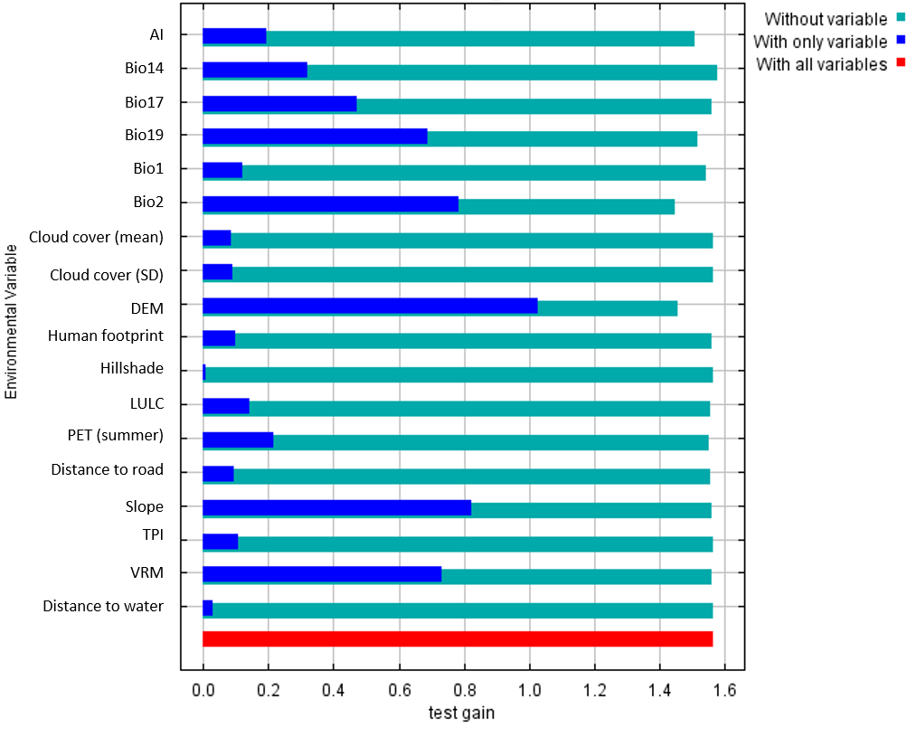
Figure S1: Results of Jackknife test showing percent contribution of each variable.

Table S4. Country wise gain/loss of woolly wolf suitable habitat both within (PA) and outside Protected Areas (OPA) in RCP 4.5 for 2050 and 2070 future scenarios with respect to current suitable habitat in three suitability classes
 |  | rcp45_2050 |  |  | rcp45_2070
Countries | Area | Low (%) | Medium (%) | High (%) | Low (%) | Medium (%) | High (%)
Mongolia | PA | -0.94 | 24.79 | 191.49 | -0.65 | 17.14 | 112.77
 | OPA | -0.88 | 71.80 | 1371.43 | -0.48 | 39.59 | 871.43
Afghanistan | PA | 13.96 | -9.33 | 22.92 | -9.50 | -25.95 | 159.66
 | OPA | -60.03 | 13.51 | 222.35 | -59.63 | -3.37 | 246.02
Pakistan | PA | 0.48 | 34.81 | -18.93 | 0.72 | 3.12 | -2.47
 | OPA | -0.55 | -16.13 | 4.89 | -0.82 | -11.91 | 3.80
China | PA | -7.23 | 63.42 | 164.48 | -9.05 | 82.88 | 164.82
 | OPA | 16377.16 | 7965.98 | 68108.62 | 16318.74 | 8186.01 | 67880.92
Kyrgyzstan | PA | 32.38 | -38.79 | 140.10 | 40.76 | -28.93 | -2.83
 | OPA | -98.43 | -83.72 | -44.62 | -98.38 | -81.21 | -77.04
Tajikistan | PA | 9.23 | -9.26 | 9.87 | 12.28 | -9.48 | 9.37
 | OPA | 11.80 | -7.98 | 1.23 | 26.64 | -13.14 | -1.82
India | PA | -57.12 | 5.02 | 74.70 | -58.98 | -0.82 | 91.86
 | OPA | 403.04 | 677.39 | 73727.27 | 390.14 | 623.66 | 91777.27

Table S5. Country wise gain/loss of woolly wolf suitable habitat both within (PA) and outside Protected Areas (OPA) in RCP 8.5 for 2050 and 2070 future scenarios with respect to current suitable habitat in three suitability classes
 |  | rcp85_2050 |  |  | rcp85_2070
Countries | Area | Low (%) | Medium (%) | High (%) | Low (%) | Medium (%) | High (%)
Mongolia | PA | -0.87 | 23.07 | 206.38 | -1.37 | 32.39 | 1706.38
 | OPA | -0.60 | 49.23 | 1314.29 | -1.43 | 114.43 | 14742.86
Afghanistan | PA | 8.89 | -13.45 | 55.35 | -3.14 | -13.02 | 76.92
 | OPA | -62.14 | 10.67 | 233.82 | -57.86 | -0.31 | 235.55
Pakistan | PA | 0.00 | 39.48 | -20.85 | 0.85 | 9.09 | -5.76
 | OPA | -1.29 | -5.24 | 2.09 | -1.43 | -15.26 | 5.03
China | PA | -10.68 | 99.73 | 172.34 | -11.37 | 102.73 | 222.90
 | OPA | 16095.94 | 8782.32 | 78142.46 | 16009.96 | 8715.46 | 96110.46
Kyrgyzstan | PA | 32.34 | -37.08 | 124.94 | 30.71 | -34.71 | 114.40
 | OPA | -98.37 | -83.77 | -50.94 | -98.55 | -81.74 | -52.70
Tajikistan | PA | 7.78 | -9.65 | 10.77 | -9.80 | -14.64 | 22.01
 | OPA | 13.59 | -6.71 | -0.93 | 23.31 | -13.61 | 0.39
India | PA | -61.67 | 2.76 | 87.19 | -68.63 | -9.50 | 127.87
 | OPA | 407.19 | 690.50 | 68772.73 | 361.00 | 735.78 | 83604.55

