Table S1. Accession numbers for the metagenomic sequences (library strategy: WGS, library source: metagenomic, library selection: random, library layout: paired, platform: Illumina, instrument model: Illumina HiSeq 2500).
accession number | study number | bioproject accession number | biosample accession number | library ID | title | design description | file-type | filename | filename2 | filename3 | filename4
SRR17041395 | SRP347939 | PRJNA782422 | SAMN23382798 | E1A_mg | Shotgun sequencing of the metagenomic DNA of sample E1A | Metagenomic DNA was extracted from compost of dry toilets. Prepared libraries (Nextera Flex) were sequenced on an Illumina HS2500 system | fastq | 20200302_AGEG_m_1_S5_L001_R1_001.fastq.gz | 20200302_AGEG_m_1_S5_L001_R2_001.fastq.gz | 20200302_AGEG_m_1_S5_L002_R1_001.fastq.gz | 20200302_AGEG_m_1_S5_L002_R2_001.fastq.gz
SRR17041394 | SRP347939 | PRJNA782422 | SAMN23382793 | E1BA_mg | Shotgun sequencing of the metagenomic DNA of sample E1BA | Metagenomic DNA was extracted from compost of dry toilets. Prepared libraries (Nextera Flex) were sequenced on an Illumina HS2500 system | fastq | 20200302_AGEG_m_2_S6_L001_R1_001.fastq.gz | 20200302_AGEG_m_2_S6_L001_R2_001.fastq.gz | 20200302_AGEG_m_2_S6_L002_R1_001.fastq.gz | 20200302_AGEG_m_2_S6_L002_R2_001.fastq.gz
SRR17041392 | SRP347939 | PRJNA782422 | SAMN23382804 | E2A_mg | Shotgun sequencing of the metagenomic DNA of sample E2A | Metagenomic DNA was extracted from compost of dry toilets. Prepared libraries (Nextera Flex) were sequenced on an Illumina HS2500 system | fastq | 20200302_AGEG_m_3_S7_L001_R1_001.fastq.gz | 20200302_AGEG_m_3_S7_L001_R2_001.fastq.gz | 20200302_AGEG_m_3_S7_L002_R1_001.fastq.gz | 20200302_AGEG_m_3_S7_L002_R2_001.fastq.gz
SRR17041391 | SRP347939 | PRJNA782422 | SAMN23382800 | E2BA_mg | Shotgun sequencing of the metagenomic DNA of sample E2BA | Metagenomic DNA was extracted from compost of dry toilets. Prepared libraries (Nextera Flex) were sequenced on an Illumina HS2500 system | fastq | 20200302_AGEG_m_4_S8_L001_R1_001.fastq.gz | 20200302_AGEG_m_4_S8_L001_R2_001.fastq.gz | 20200302_AGEG_m_4_S8_L002_R1_001.fastq.gz | 20200302_AGEG_m_4_S8_L002_R2_001.fastq.gz
SRR17041390 | SRP347939 | PRJNA782422 | SAMN23431679 | E1E_mg | Shotgun sequencing of the metagenomic DNA of sample E1E | Metagenomic DNA was extracted from compost of dry toilets. Prepared libraries (Nextera Flex) were sequenced on an Illumina HS2500 system | fastq | 20200302_AGEG_m_5_S9_L001_R1_001.fastq.gz | 20200302_AGEG_m_5_S9_L001_R2_001.fastq.gz | 20200302_AGEG_m_5_S9_L002_R1_001.fastq.gz | 20200302_AGEG_m_5_S9_L002_R2_001.fastq.gz
SRR17041389 | SRP347939 | PRJNA782422 | SAMN23431680 | E1BE_mg | Shotgun sequencing of the metagenomic DNA of sample E1BE | Metagenomic DNA was extracted from compost of dry toilets. Prepared libraries (Nextera Flex) were sequenced on an Illumina HS2500 system | fastq | 20200302_AGEG_m_6_S10_L001_R1_001.fastq.gz | 20200302_AGEG_m_6_S10_L001_R2_001.fastq.gz | 20200302_AGEG_m_6_S10_L002_R1_001.fastq.gz | 20200302_AGEG_m_6_S10_L002_R2_001.fastq.gz
SRR17041388 | SRP347939 | PRJNA782422 | SAMN23431681 | E2E_mg | Shotgun sequencing of the metagenomic DNA of sample E2E | Metagenomic DNA was extracted from compost of dry toilets. Prepared libraries (Nextera Flex) were sequenced on an Illumina HS2500 system | fastq | 20200302_AGEG_m_7_S11_L001_R1_001.fastq.gz | 20200302_AGEG_m_7_S11_L001_R2_001.fastq.gz | 20200302_AGEG_m_7_S11_L002_R1_001.fastq.gz | 20200302_AGEG_m_7_S11_L002_R2_001.fastq.gz
SRR17041387 | SRP347939 | PRJNA782422 | SAMN23431682 | E2BE_mg | Shotgun sequencing of the metagenomic DNA of sample E2BE | Metagenomic DNA was extracted from compost of dry toilets. Prepared libraries (Nextera Flex) were sequenced on an Illumina HS2500 system | fastq | 20200302_AGEG_m_8_S12_L001_R1_001.fastq.gz | 20200302_AGEG_m_8_S12_L001_R2_001.fastq.gz | 20200302_AGEG_m_8_S12_L002_R1_001.fastq.gz | 20200302_AGEG_m_8_S12_L002_R2_001.fastq.gz

Table S2. Forward and reverse read length, read count, number of base pairs and GC content of metagenomic reads before and after quality filtering (QF). Samples comprised samples from start and end of two composting repetitions (E1/E2) of two treatments each (without and with biochar (B)).
Sample | Forward read length (before QF) | Reverse read length (before QF) | Read count (before QF) | Base pairs (before QF) | GC content (before QF) | Forward read length  (after QF) | Reverse read length  (after QF) | Read count (after QF) | Base pairs (after QF) | GC content (after QF)
E1 start | 238 | 238 | 44,872,702 | 1.0722E+10 | 0.605821 | 239 | 238 | 44090688 | 1.053E+10 | 0.606537
E1-B start | 236 | 236 | 52,093,984 | 1.233E+10 | 0.592856 | 236 | 236 | 50950114 | 1.2056E+10 | 0.593721
E2 start | 237 | 237 | 57,943,718 | 1.3771E+10 | 0.613473 | 237 | 237 | 56984026 | 1.3542E+10 | 0.614155
E2-B start | 236 | 236 | 49,980,712 | 1.1803E+10 | 0.590313 | 236 | 236 | 49042284 | 1.1588E+10 | 0.591072
E1 end | 239 | 239 | 57,012,384 | 1.3636E+10 | 0.635177 | 239 | 238 | 55974358 | 1.3376E+10 | 0.636092
E1-B end | 237 | 237 | 79,650,442 | 1.8908E+10 | 0.632174 | 237 | 237 | 78211956 | 1.8563E+10 | 0.633127
E2 end | 239 | 239 | 94,600,400 | 2.2676E+10 | 0.639093 | 239 | 239 | 93059152 | 2.2287E+10 | 0.639957
E2-B end | 238 | 238 | 51,576,544 | 1.2294E+10 | 0.640451 | 238 | 238 | 50728850 | 1.2084E+10 | 0.6414

Table S3. qPCR primers and probes with target gene, sequence, amplicon size, positive control for generation of standards, and primer/probe reference. All programs were initiated with a denaturation step of 95 °C for 10 min. Fluorescence was measured during the 72 °C/1s step of the qPCR program. Standard curves of 10¹ to 10⁸ gene copies were used for quantification.
Target gene | Primer/Probe | Sequence (5’3’) | Amplicon size [bp] | Positive Control | Reference | qPCR program  (45 cycles)
16S rRNA | Bact348f | AGGCAGCAGTDRGGAAT | 439 | Escherichia coli K12 C600 | Takai & Horikoshi, (2000) | 95 °C | 10 s
 | Bact786r | GGACTACYVGGGTATCTAAT |  |  |  | 50 °C | 40 s
 | tpBact | 6FAM-TGCCAGCAGCCGCGGTAATACRDAG-TAMRA |  |  |  | 72 °C | 1 s
aph(2’’)-Ia | q_aph(2‘‘)-Ia-F | GCAGTTATTTTAGACCCTCA | 174 | Staphylococcus aureus SK5428 | this study | 95 °C | 10 s
 | q_aph(2‘‘)-Ia-R | CATTGCCTTAACATTTGTGG |  |  |  | 57 °C | 30 s
 | q_aph(2‘‘)-Ia-P | 6FAM- GCCAGAACATGAATTACACGAGGGCA -TAMRA |  |  |  | 72 °C | 1 s
aph(3’)-IIIa | q_aph(3‘)-IIIa-F | ACATATCGGATTGTCCCTATACGAA | 82 | Enterococcus faecalis RE25 | Woegerbauer et al. (2014) | 95 °C | 10 s
 | q_aph(3‘)-IIIa-R | TCGGCCAGATCGTTATTCAGTA |  |  |  | 60 °C | 20 s
 | q_aph(3‘)-IIIa-P | 6FAM-AGACAGCCGCTTAGCCGAATTGGATT-TAMRA |  |  |  | 72 °C | 1 s
ermA | q_ermA-F | TCTTATCGTTGAGAAGGGAT | 137 | Staphylococcus aureus MRSA 04-02981 | this study | 95 °C | 10 s
 | q_ermA-R | CTACACTTGGCTTAGGATGA |  |  |  | 55 °C | 30 s
 | q_ermA-P | 6FAM-TGCAAAATCTGCAACGAGCTTTGGG-TAMRA |  |  |  | 72 °C | 1 s
ermB | q_ermB-F | GGATTCTACAAGCGTACCTTGGA | 92 | Enterococcus gallinarum SF9117 | Böckelmann et al. (2009) | 95 °C | 15 s
 | q_ermB-R | GCTGGCAGCTTAAGCAATTGCT |  |  |  | 60 °C | 60 s
 | q_ermB-P | 6FAM–CACTAGGGTTGCTCTTGCACACTCAAGTC–TAMRA |  |  |  | 72 °C | 1 s
sul1 | q_sul1-F | CCGTTGGCCTTCCTGTAAAG | 66 | Escherichia coli K12 J53 | Heuer & Smalla (2007) | 95 °C | 10 s
 | q_sul1-R | TTGCCGATCGCGTGAAGT |  |  |  | 58 °C | 30 s
 | q_sul1-P | 6FAM-CAGCGAGCCTTGCGGCGG-TAMRA |  |  |  | 72 °C | 1 s
sul2 | q_sul2-F | CGGCTGCGCTTCGATT | 59 | Escherichia coli PS84 | Heuer et al. (2008) | 95 °C | 15 s
 | q_sul2-F | CGCGCGCAGAAAGGATT |  |  |  | 53 °C | 10 s
 | q_sul2-P | 6FAM-CGGTGCTTCTGTCTGTTTCGCGC-TAMRA |  |  |  | 60 °C | 60 s
 |  |  |  |  |  | 72 °C | 1 s
tetL | q_tetL-F | GGTTTTGAACGTCTCATTACCTGAT | 102 | Enterococcus faecium SF11770 | Peak et al. (2007) | 95 °C | 15 s
 | q_tetL-R | CCAATGGAAAAGGTTAACATAAAGG |  |  |  | 63 °C | 30 s
 | q_tetL-P | 6FAM-CCACCTGCGAGTACAAACTGGGTGAAC-TAMRA |  |  |  | 72 °C | 1 s
tetS | q_tetS-F | GTATGTTCATCTTTCTAAG | 190 | Lactobacillus lactis K214 | Manuzon et al., (2007) | 95 °C | 15 s
 | q_tetS-R | GCAATAACATCTTTTCAAC |  |  |  | 54 °C | 30 s
 | q_tetS-P | 6FAM-CCATGTGTCCAGGAGTATCTAC-TAMRA |  |  |  | 72 °C | 1 s

Table S4. Composition of qPCR reactions with final concentrations of primers, probes, and buffer (LightCycler® Probes Master, Roche Diagnostics Germany GmbH), as well as final volume of the template.
qPCR component | Target gene
 | 16S rRNA | aph(2’’)-Ia, aph(3’)-IIIa, ermA, ermB, sul1, tetL | sul2 | tetS
H₂O, PCR-grade | ad. 20 µL | ad. 20 µL | ad. 20 µL | ad. 20 µL
Primer F | 0.8 µM | 0.5 µM | 0.25 µM | 0.75 µM
Primer R | 0.8 µM | 0.5 µM | 0.25 µM | 0.75 µM
Probe | 0.2 µM | 0.1 µM | 0.1 µM | 0.15 µM
Buffer | 1x | 1x | 1x | 1x
Template (1:100) | 5 µL | 5 µL | 5 µL | 5 µL

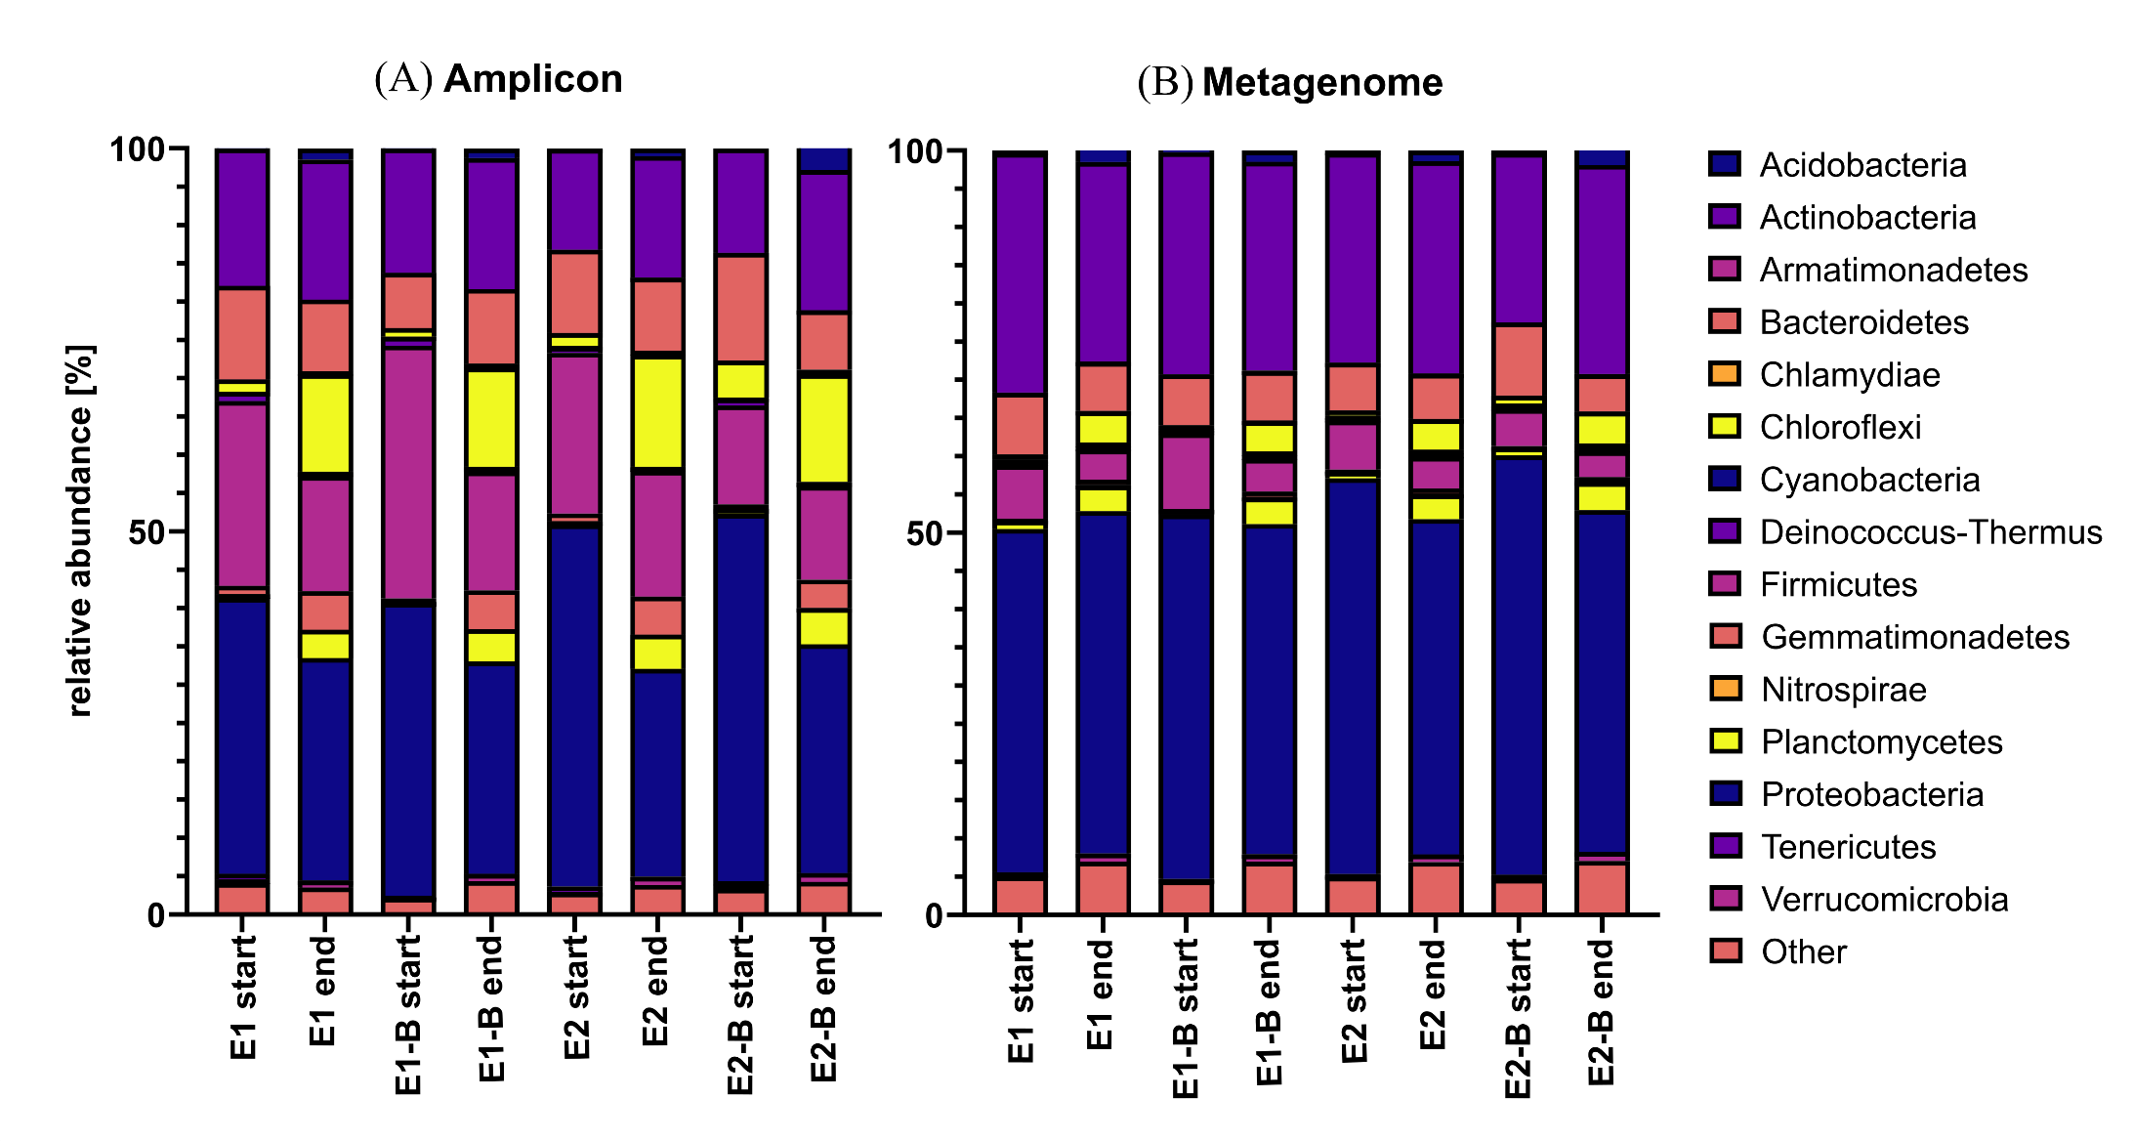
Figure S1. Relative abundance of bacterial phyla as assessed by 16S rRNA gene amplicon (A) and metagenomic sequencing (B). The composting trial comprised samples from start and end of composting of two repetitions (E1/E2), and two treatments (without and with biochar (B)), respectively. Amplicon sequencing was conducted on triplicate samples of mature compost. The average of these triplicates is depicted for better comparison with the metagenomic data. “Other” comprise unclassified OTUs, as well as phyla that were just present in either amplicon or metagenome data.
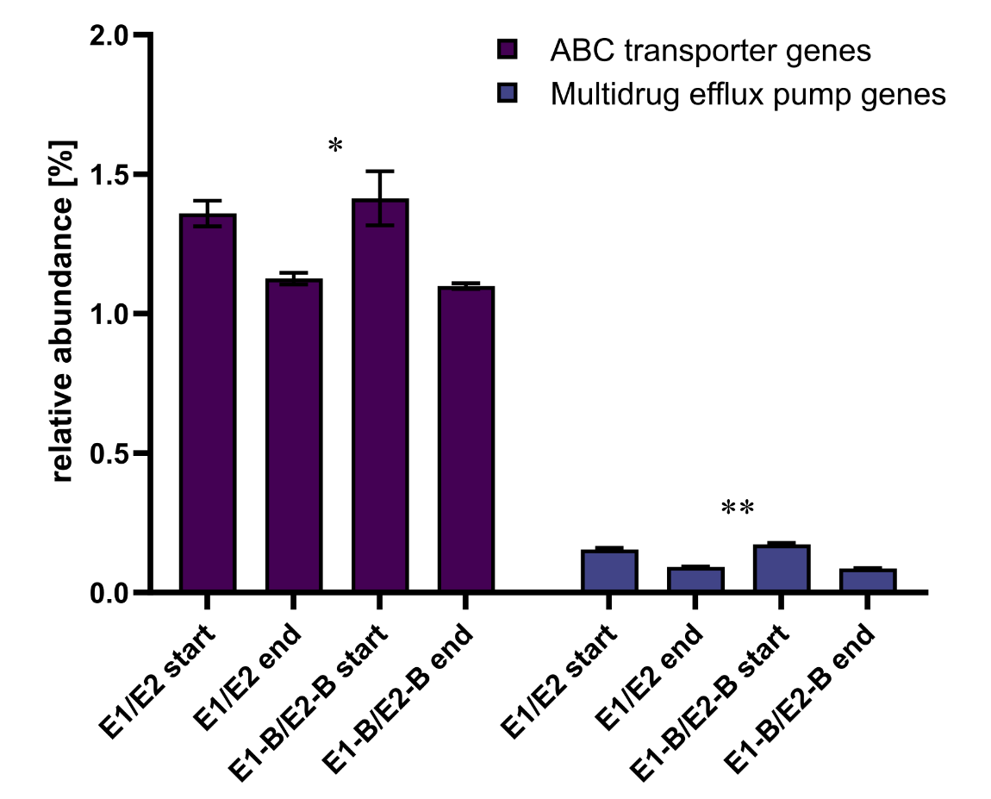
Figure S2. Relative abundance of ABC transporter and multidrug efflux pump genes as assigned by KEGG database. The bars depict the mean and standard deviation of the replicate compost piles without (E1/E2) and with biochar (E1-B/E2-B) for start and end of composting. 471 genes were assigned to ABC transporter and 27 to multidrug efflux pumps genes. Asterisks indicate the p-values obtained from Student’s t-test (** p < 0.01, * p < 0.05) representing the statistical significance of the data. P values were calculated to compare start with end samples of composting for all four compost piles combined (no differentiation of the treatments).

Table S5. qPCR results for aminoglycoside ARGs aph(2’’)-Ia and aph(3‘)-IIIa normalized to 1 g compost and 16S rRNA gene copies with standard deviation. Samples consist of two repetitions (E1 and E2), start, 14 day (14d) and end samples (triplicates: front (1), middle (2), back (3) of the compost piles). B indicates the biochar treatment of the compost trial.
Compost Sample | aph(2‘‘)-Ia |  |  |  | aph(3‘)-IIIa
 | Average Copy Number/ g compost | Standard deviation | Average Copies/  16S rRNA copies | Standard deviation | Average Copy Number/ g compost | Standard deviation | Average Copies/  16S rRNA copies | Standard deviation
E1 start | 1.27E+07 | 2.33E+06 | 0.000451 | 0.000091 | 2.68E+07 | 4.07E+06 | 0.001400 | 0.000558
E1 14d | 2.62E+06 | 1.72E+05 | 0.000083 | 0.000011 | 1.46E+07 | 2.63E+06 | 0.000549 | 0.000181
E1 end 1 | 1.06E+05 | 4.85E+04 | 0.000007 | 0.000003 | 2.36E+06 | 3.05E+05 | 0.000195 | 0.000081
E1 end 2 | 1.49E+05 | 3.56E+04 | 0.000011 | 0.000003 | 2.21E+06 | 9.67E+05 | 0.000200 | 0.000105
E1 end 3 | 9.46E+04 | 1.57E+04 | 0.000006 | 0.000001 | 1.42E+06 | 3.25E+05 | 0.000144 | 0.000059
E1-B start | 8.60E+06 | 7.76E+05 | 0.000313 | 0.000032 | 3.63E+07 | 6.17E+06 | 0.001450 | 0.000584
E1-B 14d | 9.48E+06 | 2.09E+06 | 0.000309 | 0.000082 | 3.22E+07 | 4.68E+06 | 0.001145 | 0.000429
E1-B end 1 | 8.04E+04 | 1.33E+04 | 0.000005 | 0.000001 | 3.87E+06 | 7.40E+05 | 0.000339 | 0.000124
E1-B end 2 | 9.42E+04 | 2.57E+04 | 0.000006 | 0.000002 | 2.79E+06 | 5.15E+05 | 0.000267 | 0.000105
E1-B end 3 | 9.79E+04 | 3.99E+04 | 0.000006 | 0.000003 | 2.96E+06 | 6.15E+05 | 0.000285 | 0.000094
E2 start | 1.61E+06 | 3.37E+05 | 0.000065 | 0.000014 | 2.20E+07 | 1.40E+06 | 0.000799 | 0.000313
E2 end 1 | 5.79E+04 | 1.74E+04 | 0.000003 | 0.000001 | 2.07E+06 | 8.74E+05 | 0.000205 | 0.000116
E2 end 2 | 6.41E+04 | 3.85E+04 | 0.000004 | 0.000003 | 2.17E+06 | 6.40E+05 | 0.000193 | 0.000092
E2h end 3 | 5.75E+04 | 2.80E+04 | 0.000005 | 0.000003 | 2.39E+06 | 5.26E+05 | 0.000298 | 0.000117
E2-B start | 7.58E+05 | 9.34E+04 | 0.000015 | 0.000003 | 6.86E+07 | 1.44E+07 | 0.002657 | 0.000934
E2-B end 1 | 1.16E+05 | 3.23E+04 | 0.000010 | 0.000003 | 1.98E+06 | 4.16E+05 | 0.000257 | 0.000114
E2-B end 2 | 1.32E+05 | 4.64E+04 | 0.000015 | 0.000006 | 1.49E+06 | 4.26E+05 | 0.000195 | 0.000088
E2-B end 3 | 7.59E+04 | 3.75E+04 | 0.000004 | 0.000002 | 1.28E+06 | 3.47E+05 | 0.000146 | 0.000072

Table S6. qPCR results for erythromycin ARGs ermA and ermB normalized to 1 g compost and 16S rRNA gene copies with standard deviation. Samples consist of two repetitions (E1 and E2), start, 14 day (14d) and end samples (triplicates: front (1), middle (2), back (3) of the compost piles). B indicates the biochar treatment of the compost trial.
Compost Sample | ermA |  |  |  | ermB
 | Average Copy Number/ g compost | Standard deviation | Average Copies/  16S rRNA copies | Standard deviation | Average Copy Number/ g compost | Standard deviation | Average Copies/  16S rRNA copies | Standard deviation
E1 start | 4.18E+07 | 3.16E+07 | 0.001741 | 0.001394 | 2.18E+08 | 7.83E+07 | 0.011375 | 0.004087
E1 14d | 2.42E+07 | 9.33E+06 | 0.001104 | 0.000502 | 3.89E+07 | 1.22E+07 | 0.001459 | 0.000458
E1 end 1 | 2.45E+06 | 1.01E+06 | 0.000231 | 0.000099 | 5.31E+05 | 2.00E+05 | 0.000044 | 0.000017
E1 end 2 | 3.09E+06 | 1.32E+06 | 0.000272 | 0.000129 | 5.20E+05 | 1.94E+05 | 0.000047 | 0.000018
E1 end 3 | 2.02E+06 | 8.15E+05 | 0.000176 | 0.000077 | 5.58E+05 | 2.26E+05 | 0.000057 | 0.000023
E1-B start | 1.22E+08 | 5.15E+07 | 0.005782 | 0.002947 | 5.19E+08 | 1.53E+08 | 0.020738 | 0.006101
E1-B 14d | 3.93E+07 | 1.48E+07 | 0.001752 | 0.000724 | 2.29E+08 | 6.21E+07 | 0.008142 | 0.002209
E1-B end 1 | 5.66E+06 | 2.92E+06 | 0.000474 | 0.000260 | 6.39E+05 | 2.78E+05 | 0.000056 | 0.000024
E1-B end 2 | 4.01E+06 | 1.96E+06 | 0.000364 | 0.000187 | 4.00E+05 | 1.74E+05 | 0.000038 | 0.000017
E1-B end 3 | 3.16E+06 | 1.33E+06 | 0.000281 | 0.000127 | 4.13E+05 | 1.66E+05 | 0.000040 | 0.000016
E2 start | 3.33E+07 | 1.65E+07 | 0.001255 | 0.000735 | 1.42E+08 | 4.13E+07 | 0.005156 | 0.001502
E2 end 1 | 2.33E+06 | 9.43E+05 | 0.000192 | 0.000082 | 3.93E+05 | 1.37E+05 | 0.000039 | 0.000014
E2 end 2 | 2.29E+06 | 1.26E+06 | 0.000232 | 0.000138 | 3.16E+05 | 1.10E+05 | 0.000028 | 0.000010
E2h end 3 | 3.23E+06 | 1.65E+06 | 0.000403 | 0.000212 | 4.19E+05 | 1.63E+05 | 0.000052 | 0.000020
E2-B start | 1.55E+07 | 7.23E+06 | 0.000445 | 0.000229 | 2.31E+07 | 7.72E+06 | 0.000893 | 0.000299
E2-B end 1 | 3.31E+06 | 1.70E+06 | 0.000472 | 0.000256 | 2.88E+05 | 9.29E+04 | 0.000037 | 0.000012
E2-B end 2 | 2.84E+06 | 1.47E+06 | 0.000366 | 0.000202 | 1.21E+05 | 9.70E+04 | 0.000016 | 0.000013
E2-B end 3 | 2.82E+06 | 1.36E+06 | 0.000248 | 0.000131 | 3.34E+05 | 6.92E+04 | 0.000038 | 0.000008

Table S7. qPCR results for sulfonamide ARGs sul1 and sul2 normalized to 1 g compost and 16S rRNA gene copies with standard deviation. Samples consist of two repetitions (E1 and E2), start, 14 day (14d) and end samples (triplicates: front (1), middle (2), back (3) of the compost piles). B indicates the biochar treatment of the compost trial.
Compost Sample | sul1 |  |  |  | sul2
 | Average Copy Number/ g compost | Standard deviation | Average Copies/  16S rRNA copies | Standard deviation | Average Copy Number/ g compost | Standard deviation | Average Copies/  16S rRNA copies | Standard deviation
E1 start | 1.88E+09 | 6.99E+08 | 0.098288 | 0.051408 | 1.17E+09 | 1.48E+08 | 0.060916 | 0.023733
E1 14d | 1.41E+09 | 5.94E+08 | 0.052969 | 0.026670 | 4.62E+08 | 4.01E+07 | 0.017306 | 0.005020
E1 end 1 | 1.81E+08 | 7.68E+07 | 0.014948 | 0.008651 | 2.80E+07 | 3.36E+06 | 0.002315 | 0.000953
E1 end 2 | 1.55E+08 | 6.54E+07 | 0.014013 | 0.007212 | 2.48E+07 | 2.22E+06 | 0.002245 | 0.000689
E1 end 3 | 7.93E+07 | 3.33E+07 | 0.008038 | 0.004334 | 2.03E+07 | 2.62E+06 | 0.002053 | 0.000743
E1-B start | 2.48E+09 | 8.30E+08 | 0.098996 | 0.049022 | 1.29E+09 | 1.41E+08 | 0.051600 | 0.019652
E1-B 14d | 2.37E+09 | 7.54E+08 | 0.084173 | 0.039519 | 8.31E+08 | 1.57E+08 | 0.029550 | 0.011618
E1-B end 1 | 1.73E+08 | 7.02E+07 | 0.015147 | 0.007746 | 3.36E+07 | 3.75E+06 | 0.002941 | 0.000972
E1-B end 2 | 1.54E+08 | 6.40E+07 | 0.014696 | 0.007947 | 2.95E+07 | 4.25E+06 | 0.002821 | 0.001056
E1-B end 3 | 1.39E+08 | 5.44E+07 | 0.013379 | 0.006253 | 2.95E+07 | 4.21E+06 | 0.002842 | 0.000833
E2 start | 2.09E+09 | 7.52E+08 | 0.075974 | 0.040109 | 6.91E+08 | 8.50E+07 | 0.025100 | 0.010186
E2 end 1 | 8.44E+07 | 3.45E+07 | 0.008347 | 0.004656 | 2.30E+07 | 3.03E+06 | 0.002271 | 0.000913
E2 end 2 | 8.52E+07 | 3.97E+07 | 0.007565 | 0.004530 | 2.37E+07 | 2.52E+06 | 0.002108 | 0.000823
E2h end 3 | 1.22E+08 | 5.19E+07 | 0.015177 | 0.008142 | 2.15E+07 | 1.90E+06 | 0.002679 | 0.000901
E2-B start | 1.47E+09 | 6.13E+08 | 0.056992 | 0.028674 | 6.91E+08 | 9.41E+07 | 0.026774 | 0.008373
E2-B end 1 | 8.57E+07 | 3.19E+07 | 0.012939 | 0.007036 | 1.79E+07 | 1.76E+06 | 0.002312 | 0.000930
E2-B end 2 | 9.50E+07 | 4.17E+07 | 0.012398 | 0.006987 | 1.86E+07 | 2.65E+06 | 0.002422 | 0.000922
E2-B end 3 | 1.20E+08 | 6.15E+07 | 0.013614 | 0.008984 | 1.97E+07 | 1.78E+06 | 0.002246 | 0.000949

Table S8. qPCR results for tetracycline ARGs tetL and tetS normalized to 1 g compost and 16S rRNA gene copies with standard deviation. Samples consist of two repetitions (E1 and E2), start, 14 day (14d) and end samples (triplicates: front (f), middle (m), back (b) of the compost piles). B indicates the biochar treatment of the compost trial.
Compost Sample | tetL |  |  |  | tetS
 | Average Copy Number/ g compost | Standard deviation | Average Copies/  16S rRNA copies | Standard deviation | Average Copy Number/ g compost | Standard deviation | Average Copies/  16S rRNA copies | Standard deviation
E1 start | 9.77E+08 | 7.22E+08 | 0.039442 | 0.025995 | 5.11E+06 | 4.70E+05 | 0.000184 | 0.000018
E1 14d | 4.08E+08 | 2.56E+08 | 0.015806 | 0.011225 | 8.64E+05 | 1.13E+05 | 0.000028 | 0.000004
E1 end 1 | 3.41E+07 | 2.29E+07 | 0.002917 | 0.002329 | 1.34E+04 | 1.29E+04 | 0.000001 | 0.000001
E1 end 2 | 3.98E+07 | 2.77E+07 | 0.003680 | 0.002829 | 1.32E+04 | 9.90E+03 | 0.000001 | 0.000001
E1 end 3 | 3.73E+07 | 2.88E+07 | 0.003633 | 0.002978 | 2.47E+04 | 2.39E+04 | 0.000002 | 0.000002
E1-B start | 1.74E+09 | 1.12E+09 | 0.071849 | 0.054641 | 4.60E+06 | 3.51E+05 | 0.000168 | 0.000015
E1-B 14d | 1.10E+09 | 7.30E+08 | 0.038108 | 0.027961 | 1.38E+06 | 7.33E+04 | 0.000045 | 0.000007
E1-B end 1 | 6.07E+07 | 4.65E+07 | 0.005280 | 0.004345 | 4.53E+04 | 5.58E+04 | 0.000003 | 0.000003
E1-B end 2 | 5.36E+07 | 3.46E+07 | 0.005221 | 0.003894 | 2.94E+04 | 3.02E+04 | 0.000002 | 0.000002
E1-B end 3 | 5.80E+07 | 3.74E+07 | 0.005741 | 0.004098 | 5.42E+03 | 5.36E+03 | 0.000000 | 0.000000
E2 start | 5.26E+08 | 3.41E+08 | 0.018933 | 0.014203 | 5.16E+05 | 1.05E+05 | 0.000021 | 0.000004
E2 end 1 | 5.25E+07 | 4.32E+07 | 0.004886 | 0.004262 | 3.23E+04 | 1.12E+04 | 0.000002 | 0.000001
E2 end 2 | 3.79E+07 | 2.46E+07 | 0.003397 | 0.002567 | 2.76E+04 | 3.13E+04 | 0.000002 | 0.000002
E2h end 3 | 3.50E+07 | 2.47E+07 | 0.004388 | 0.003421 | 1.40E+04 | 1.97E+04 | 0.000001 | 0.000002
E2-B start | 1.12E+08 | 7.85E+07 | 0.004340 | 0.003299 | 9.07E+05 | 2.09E+05 | 0.000018 | 0.000005
E2-B end 1 | 2.88E+07 | 2.07E+07 | 0.003985 | 0.003413 | 3.67E+04 | 4.61E+04 | 0.000003 | 0.000004
E2-B end 2 | 2.57E+07 | 1.92E+07 | 0.003254 | 0.002634 | 1.81E+04 | 1.16E+04 | 0.000002 | 0.000001
E2-B end 3 | 2.41E+07 | 1.74E+07 | 0.002740 | 0.002274 | 2.76E+04 | 3.90E+04 | 0.000001 | 0.000002

References
Böckelmann, U., Dörries, H. H., Ayuso-Gabella, M. N., De Marçay, M. S., Tandoi, V., Levantesi, C., Masciopinto, C., Houtte, E. Van, Szewzyk, U., Wintgens, T., & Grohmann, E. (2009). Quantitative PCR monitoring of antibiotic resistance genes and bacterial pathogens in three european artificial groundwater recharge systems. Applied and Environmental Microbiology, 75(1), 154–163. https://doi.org/10.1128/AEM.01649-08
Heuer, H., Focks, A., Lamshöft, M., Smalla, K., Matthies, M., & Spiteller, M. (2008). Fate of sulfadiazine administered to pigs and its quantitative effect on the dynamics of bacterial resistance genes in manure and manured soil. Soil Biology and Biochemistry, 40(7), 1892–1900. https://doi.org/10.1016/j.soilbio.2008.03.014
Heuer, H., & Smalla, K. (2007). Manure and sulfadiazine synergistically increased bacterial antibiotic resistance in soil over at least two months. Environmental Microbiology, 9(3), 657–666. https://doi.org/10.1111/j.1462-2920.2006.01185.x
Manuzon, M. Y., Hanna, S. E., Luo, H., Yu, Z., Harper, W. J., & Wang, H. H. (2007). Quantitative assessment of the tetracycline resistance gene pool in cheese samples by real-time TaqMan PCR. Applied and Environmental Microbiology, 73(5), 1676–1677. https://doi.org/10.1128/AEM.01994-06
Peak, N., Knapp, C. W., Yang, R. K., Hanfelt, M. M., Smith, M. S., Aga, D. S., & Graham, D. W. (2007). Abundance of six tetracycline resistance genes in wastewater lagoons at cattle feedlots with different antibiotic use strategies. Environmental Microbiology, 9(1), 143–151. https://doi.org/10.1111/j.1462-2920.2006.01123.x
Takai, K., & Horikoshi, K. (2000). Rapid detection and quantification of members of the archaeal community by quantitative PCR using fluorogenic probes. Applied and Environmental Microbiology, 66(11), 5066–5072. https://doi.org/10.1128/AEM.66.11.5066-5072.2000
Woegerbauer, M., Zeinzinger, J., Springer, B., Hufnagl, P., Indra, A., Korschineck, I., Hofrichter, J., Kopacka, I., Fuchs, R., Steinwider, J., Fuchs, K., Nielsen, K. M., & Allerberger, F. (2014). Prevalence of the aminoglycoside phosphotransferase genes aph(3’)-IIIa and aph(3’)-IIa in Escherichia coli, Enterococcus faecalis, Enterococcus faecium, Pseudomonas aeruginosa, Salmonella enterica subsp. Enterica and Staphylococcus aureus isolates in Austria. Journal of Medical Microbiology, 63, 210–217. https://doi.org/10.1099/jmm.0.065789-0

