Supplementary Material and Figures

Supplementary Figure 1. River width averaged for 10 km river segments obtained from satellite image analysis (Mallast et al., 2020). Fitted polynomial was used to calculate river width per km.

Supplementary Figure 2. Boxplot comparing discrete and continuous CH4 concentration data.

Supplementary Figure 3. Dissolved CO₂ versus stream km. Only data obtained when the vessel was moving at the speed of >4 kn (2.1 m sec⁻¹) were considered; tributaries were excluded.

Dissolved CO2
Gas samples in the Exetainer vials were analyzed using a gas chromatograph equipped with a flame ionization detector (SRI 8610, SRI Instruments, Torrance U.S.A.). Certified mixtures of 997 ppm CO₂ in N₂ were used as the standards. CO₂ concentrations in the water samples were calculated based on the mixing ratios in equilibrated headspace samples corrected for CO₂ concentrations in the applied air headspace according to Henry’s law as well as CO₂ data corrected for alkalinity (Koschorreck et al., 2021).
Dissolved CO2 concentrations revealed a clear diurnal pattern, in contrast to the dissolved CH4 (supplementary Figure 3).

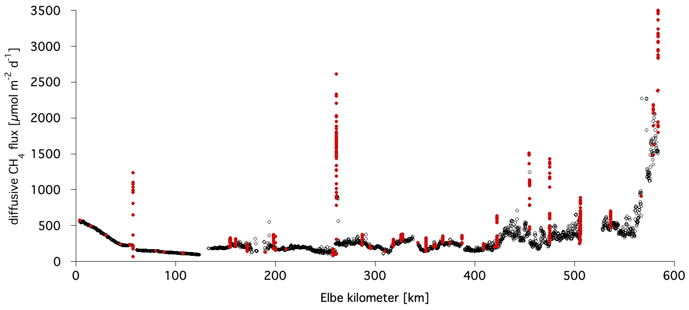

Supplementary Figure 4. Diffusive methane flux versus stream km. In red when the vessel’s speed was < 4 kn (2.1 m sec⁻¹), i.e. near harbors, in black when the vessel was moving at the speed of >4 kn.

Supplementary Figure 5 Relation between dissolved CH₄ concentration and flow velocity.

Supplementary Figure 6. Differences in CH₄ concentration near the shore and in the middle of the river, expressed as the percentage of concentration in the middle. The value 200% indicates that concentration near the shore is twice as high as that in the middle of the river. Elbe width data for January 2018 published by Mallast et al. (2020) were used.

Tributaries
Havel is a 334-km-long lowland river passing numerous lakes. Similar to the Schwarze Elster catchment, the Havel catchment and the Spree sub-basin are affected by large-scale open-pit lignite coal mining. The mean water discharge is 103 m³ s⁻¹, which was reduced to 5.5 m³ s⁻¹ in September August 2020, corresponding to 2% of the discharge of Elbe.

The „Schwarze Elster '' has a total length of 179 km and is affected by regulation measures since the 19th century as well as open cast lignite mining in the Lusatian mining region. The river mean water discharge is 18.4 m3 s-1. During the sampling, discharge amounted to 1.38 m3 s-1 which was about 0.6% of the Elbe at this site (Table 2).
When we passed the mouth of the “Schwarze Elster” on 7. 8.2020, we detected a median upstream methane concentration of 85 nM, versus 147 nM inside the “Schwarze Elster”. Downstream methane was quickly diluted within 0.2 km to 72 nM (Table 2 and figure S6). The “Schwarze Elster” water was characterized by a lower temperature, lower turbidity, and lower chlorophyll content, compared to the Elbe. However, conductivity was elaborated within the “Schwarze Elster”.
Supplementary Figure 7. Dissolved CH₄ concentrations in the water at the mouth of Schwarze Elster.

The River Mulde rises in the ore mountains and is 314 km long until its confluence with River Elbe in Dessau. It was one of the most polluted rivers in the 1980ies regarding heavy metals and organic pollution as it drained mining and chemical industry regions. The average discharge is 73 m3 s-1 but it was only 11 m3 s-1 during the sampling representing 5% of the Elbe.
Methane concentrations within the Mulde had a median of 394 nM, about 4 times higher than the upstream concentration of 112 nM and downstream concentration of 110 nM (Figure S6). Due to technical problems no additional data are available.

The River Saale is one of the main tributaries of the Elbe River with a length of 413 km. The average yearly discharge is 117 m3 s-1 but discharge during sampling was 24.4 m3 s-1 or 10% of the Elbe. Due to widespread agriculture production, nutrient pollution with nitrogen and phosphorus is widespread in the drainage basin and in the Saale itself. The Saale is characterized by elevated salt concentrations resulting from the geological situation as well as historic and recent mining activities in the catchment.
The Saale water was characterized by a lower turbidity and lower Chlorophyll content, compared to the Elbe. Water temperature was similar to the Elbe. However, conductivity was elaborated within the Saale. When we passed the Saale mouth on 8. 8.2020, we detected a median upstream methane concentration of 109 nM, versus 124 nM inside the Saale. Downstream methane was quickly diluted within 0.9 km to 121 nM (Table 2 ).

Supplementary Figure 8. Dissolved CH₄ concentrations in the water at the mouth of Saale.

