Supplementary figures and tables for ‘Long-term abundance trends of insect taxa are only weakly correlated’
Roel van Klink, Diana E Bowler, Konstantin B Gongalsky, and Jonathan M Chase
Biology letters, 2022

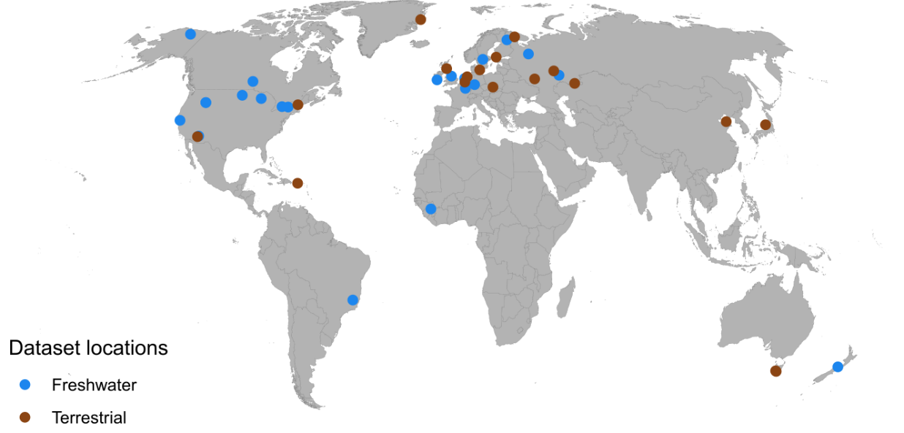
Figure S1. Provenance of the datasets used for this analysis.

Table S1. Exact correlation coefficients of all orders and commonly assessed groups. * denotes weak evidence for a correlation (80% of the sampled correlation coefficients was larger or smaller than zero); ** denotes moderate evidence (90% larger or smaller than zero); *** denotes strong evidence (95% larger or smaller than zero). No signifier indicates that more than 10% of the correlations fell to either side of zero.
Freshwater orders
 | Coleoptera | Diptera | Ephemeroptera | Hemiptera | Megaloptera |  | Odonata | Plecoptera | Trichoptera
Diptera | 0.051
Ephemeroptera | 0.069 | 0.049
Hemiptera | 0.060 | 0.030 | 0.030
Megaloptera | 0.035 | 0.020 | -0.036 | 0.047
Odonata | 0.061 | 0.045 | 0.083 | 0.104
Plecoptera | 0.126** | 0.036 | 0.081 |  | 0.016
Trichoptera | 0.104** | 0.052 | 0.089** | 0.011 | 0.036 |  | 0.064 | 0.104*
Trombidiformes | 0.059 | 0.052 | 0.036 | 0.064 |  |  | 0.007 |  | 0.052
Terrestrial orders
 | Araneae | Coleoptera | Diptera | Hemiptera | Hymenoptera
Coleoptera | 0.256*
Diptera | -0.030 | 0.148
Hemiptera | 0.121 | 0.133 | 0.204
Hymenoptera | 0.118 | 0.103 | -0.019 | 0.231***
Lepidoptera |  | 0.258* | 0.155 | 0.084 | 0.226
Orthoptera |  |  |  | -0.032

Freshwater commonly assessed groupings
 | Acari | Chironomidae | Simuliidae
Chironomidae | 0.054 |  | 0.039
Coleoptera | 0.051 | 0.035 | 0.050
Ephemeroptera | 0.035 | 0.041 | 0.077*
Hemiptera | 0.084 | 0.022 | -0.008
Odonata | 0.008 | 0.030 | 0.044
Plecoptera |  | 0.026 | 0.067
Trichoptera | 0.056 | 0.047 | 0.046
Terrestrial commonly assessed groupings
 | Araneae | Carabidae | Curculionoidea
Collembola | 0.142
Curculionoidea |  | 0.039
Staphylinidae |  | 0.198 | 0.018

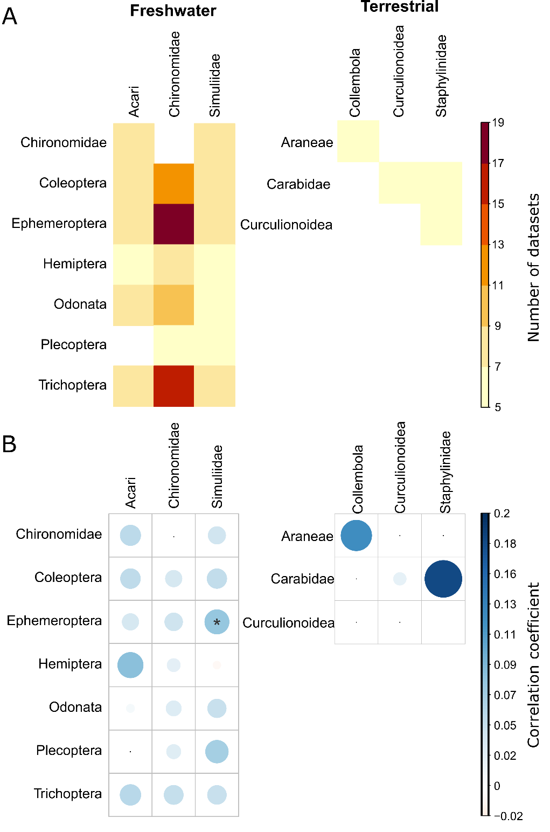
Figure S1. A) Number of datasets available for each pair of commonly assessed groupings. Pairs of taxa were only assessed if they were jointly observed in at least five datasets and 20 individual plots, and each taxon was present in at least half of all years. B) Pairwise correlation coefficients among all assessed taxa not depicted in Fig 2 (for exact correlation coefficients see Table S2). ⬝ denotes a pair was not assessed; * denotes weak evidence for a correlation (0 was outside the 80% credible interval); No signifier indicates that 0 fell within 80% of the sampled correlation coefficients,and thus that by our criteria there is no evidence for a relationship between the abundance trends of the two taxa.
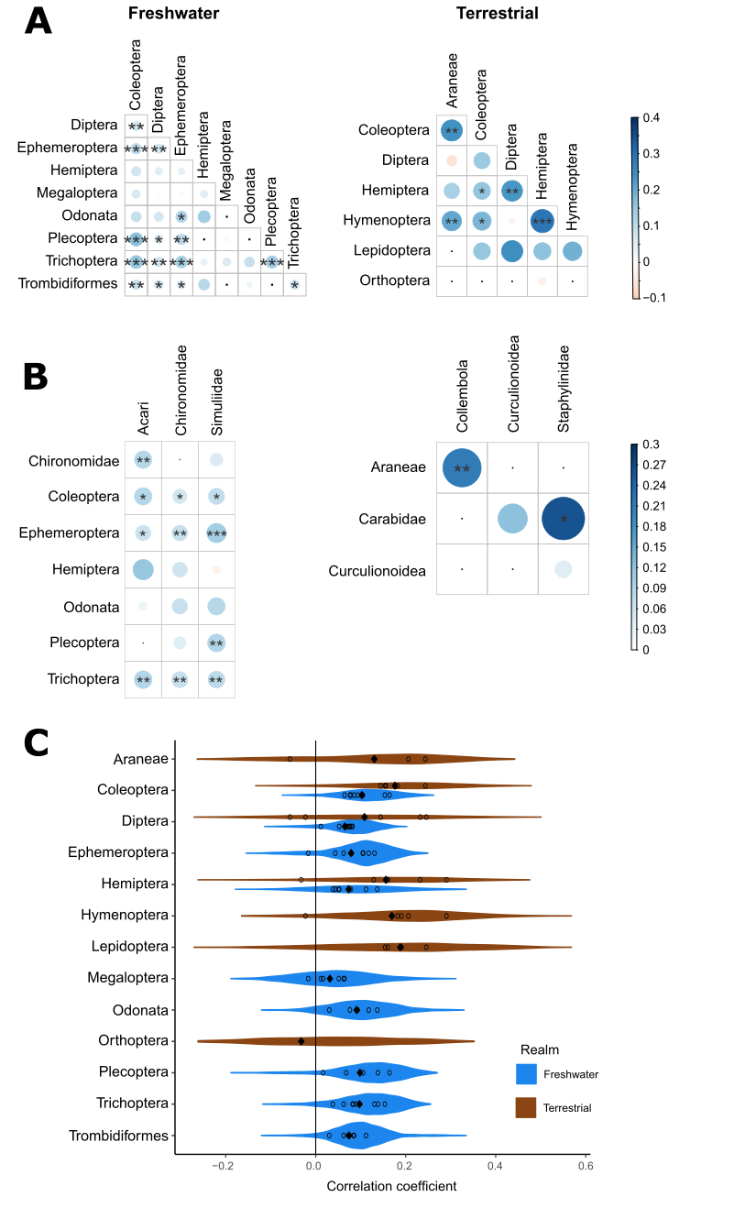

Figure S3. A, B) Pairwise correlation coefficients based on weighted correlation in stage two of the analysis. Weighting of the trend estimates at all locations was done by the inverse mean standard deviations of the two taxa in each plot, so that the most certain trends (i.e. the ones with the lowest standard deviation were assigned the highest weight. We classified the inverse standard deviations into four classes, so that the maximum weight assigned was four times that of the lowest weight. We calculated the weighted correlation coefficients using the wCorr package (Bailey Emad 2021). wCorr: Weighted Correlations. R package version 1.9.5.). For a matrix with the exact correlation coefficients see table S2. Annotation as in Fig. 2. C) Density plots of the correlation coefficients for all comparisons for each assessed order, based on the 1000 weighted correlation coefficients calculated from the sampled posterior distributions of each taxon pair.

Table S2. Weighted correlation coefficients of all assessed orders and commonly assessed groupings. Annotation as in Table S1.
Freshwater orders
 | Coleoptera | Diptera | Ephemeroptera | Hemiptera | Megaloptera | Odonata | Plecoptera | Trichoptera
Diptera | 0.076**
Ephemeroptera | 0.105*** | 0.080**
Hemiptera | 0.078 | 0.052 | 0.044
Megaloptera | 0.064 | 0.011 | -0.017 | 0.051
Odonata | 0.093 | 0.076 | 0.118* | 0.137
Plecoptera | 0.164*** | 0.068* | 0.105** |  | 0.017
Trichoptera | 0.154*** | 0.082** | 0.131*** | 0.038 | 0.062 | 0.091 | 0.138***
Trombidiformes | 0.085** | 0.072* | 0.062* | 0.112 |  | 0.030 |  | 0.084*
Terrestrial orders
 | Araneae | Coleoptera | Diptera | Hemiptera | Hymenoptera
Coleoptera | 0.244**
Diptera | -0.057 | 0.144
Hemiptera | 0.129 | 0.156* | 0.232**
Hymenoptera | 0.206** | 0.182* | -0.023 | 0.291***
Lepidoptera |  | 0.154 | 0.246 | 0.161 | 0.191
Orthoptera |  |  |  | -0.032

Freshwater commonly assessed groupings
 | Acari | Chironomidae | Simuliidae
Chironomidae | 0.084** |  | 0.046
Coleoptera | 0.085* | 0.057* | 0.072*
Ephemeroptera | 0.066* | 0.068** | 0.105***
Hemiptera | 0.116 | 0.061 | -0.018
Odonata | 0.022 | 0.067 | 0.084
Plecoptera |  | 0.041 | 0.088**
Trichoptera | 0.087** | 0.071** | 0.078**
Terrestrial commonly assessed groupings
 | Collembola | Curculionoidea | Staphylinidae
Araneae | 0.21**
Carabidae |  | 0.123 | 0.261*
Curculionoidea |  |  | 0.042

