SUPPLEMENTAL MATERIAL

High frequency monitoring enables operational opportunities for dissolved organic carbon (DOC) mitigation in Germany's largest drinking water reservoir
Qing Zhan^{1,2,3*}, Xiangzhen Kong¹, Karsten Rinke¹

¹ Department of Lake Research, Helmholtz Centre for Environmental Research (UFZ),
Brückstr. 3a, 39114 Magdeburg, Germany
² Department of Water, Environment, Construction and Safety, Magdeburg-Stendal Univeristy of Applied Sciences, Breitscheidstrasse 2, 39114 Magdeburg, Germany
³ Department of Aquatic Ecology, Netherlands Institute of Ecology (NIOO-KNAW), PO Box 50, 6700, AB, Wageningen, the Netherlands
*Corresponding author. E-mail: Q.Zhan@nioo.knaw.nl (Q.Zhan)

Supporting Information include SI Text for a brief description of the high frequency data used in this study. SI Tables S1-S2. SI Figures S1-S6.
SI Text
High frequency monitoring
Königshütte Reservoir receives inflows mainly from the two riverine inflows Warme Bode (I) and Kalte Bode (IBK) besides the diffusive inflows, while it discharges water to downstream river Hirtenstieg (bypass) or to Rappbode Reservoir through the tunnel (DRR). Among the inflows of the four years, Warme Bode contributed to the most part over 60%, Kalte Bode accounts for ca. 32%, and the diffusive inflows the rest (ca. 8%). The discharge in the IBW was of a larger magnitude (mean discharge = 1.650 m³ s⁻¹, see Table S1) compared to the IBK (mean discharge = 0.862 m³ s⁻¹). IBK (s.d. = 0.770 m³ s⁻¹) had relatively smaller variations compared to the IBW (s.d. = 2.863 m³ s⁻¹), which could be because to it has an upstream flood protection reservoir that reduced the water fluctuation (Friese et al. 2014). High discharge into the reservoir usually occurred during the early spring owing to snowmelt and precipitation. At the other end, the total outflows distributed roughly equally into the bypass (55.6%) and DRR (44.4%). However, they exhibited distinct temporal variations: while the discharges towards bypass mainly followed the upstream peaked inflows in order to have a relatively stable water level in Königshütte Reservoir, the discharges in the DRR were manipulated by the reservoir authority and can have a discharge ranging between 0 and 12 m³ s⁻¹. 72.4% of the entire time series when the tunnel was closed (Q_{DRR} = 0 m³ s⁻¹) due to low flow. As a result, the water storage in the reservoir fluctuated from 0.193 to 1.264 Mio. m³ (mean storage = 0.854 Mio. m³). It suffered drought periods with low storage during summer (from July to November) and could experience flooding events with high storage during early spring (from December to March).

Table S1. Basic statistics of the data during 2014 to 2017 used in this study
Data | Number | Mean | s.d. | Max. | Median | Min. | Missing
Water discharge (m³ s⁻¹)
Warme Bode (IBW) | 17530 | 1.650 | 2.863 | 51.813 | 0.690 | 0.000 | 0.5%
Kalte Bode (IBK) | 17530 | 0.862 | 0.770 | 16.692 | 0.595 | 0.020 | 0.1%
Bypass | 17530 | 1.601 | 2.372 | 57.127 | 1.041 | 0.057 | 26.8%
DRR | 1461 | 1.185 | 2.380 | 11.900 | 0.000 | 0.000 | 0.0%
Water volume (Mio. m³) | 17530 | 0.854 | 0.191 | 1.264 | 0.887 | 0.193 | 0.1%
Dissolved organic carbon (g m⁻³)
Warme Bode (IBW) | 17292 | 4.386 | 3.721 | 36.023 | 3.513 | 0.152 | 0.0%
Kalte Bode (IBK) | 17439 | 4.968 | 1.780 | 16.020 | 4.621 | 0.202 | 0.5%
In reservoir (OKR) | 17379 | 4.741 | 1.555 | 24.157 | 4.481 | 0.181 | 5.5%

Table S2. Regression models of lab-based DOC against corrected field SAC₂₅₄₋₃₆₀.
Sample sites | Number  (Outliers) | Regression equation  (Lab DOC ~ field SAC) | r² | DOC Range  (g m⁻³) | Time windows for correction
Warme Bode (IBW) | 96 (0) | DOC=0.27×(SAC₂₅₄₋₃₆₀) + 0.44 | 0.89 | 0.67-37.36 | “2014-01-01 00:05:00 to 2014-11-21 09:00:00” and “2016-06-28 10:00:00 to 2017-12-31 23:46:01”
Kalte Bode (IBK) | 98 (0) | DOC=0.26×(SAC₂₅₄₋₃₆₀) + 0.78 | 0.83 | 0.79-29.22 | “2015-01-08 10:00:00 to 2016-06-09 15:00:00”
In-reservoir (OKR) | 91 (4) | DOC=0.20×(SAC₂₅₄₋₃₆₀) + 1.58 | 0.73 | 1.58-34.61 | “2014-01-01 00:05:00 to 2015-09-09 06:00:00”

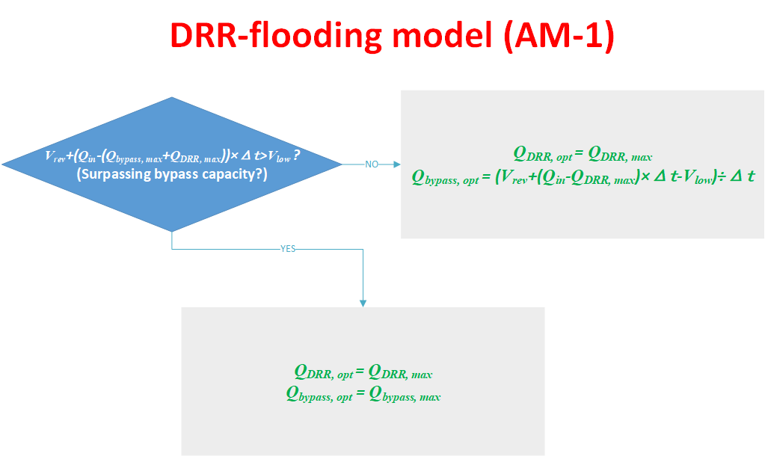
(a)
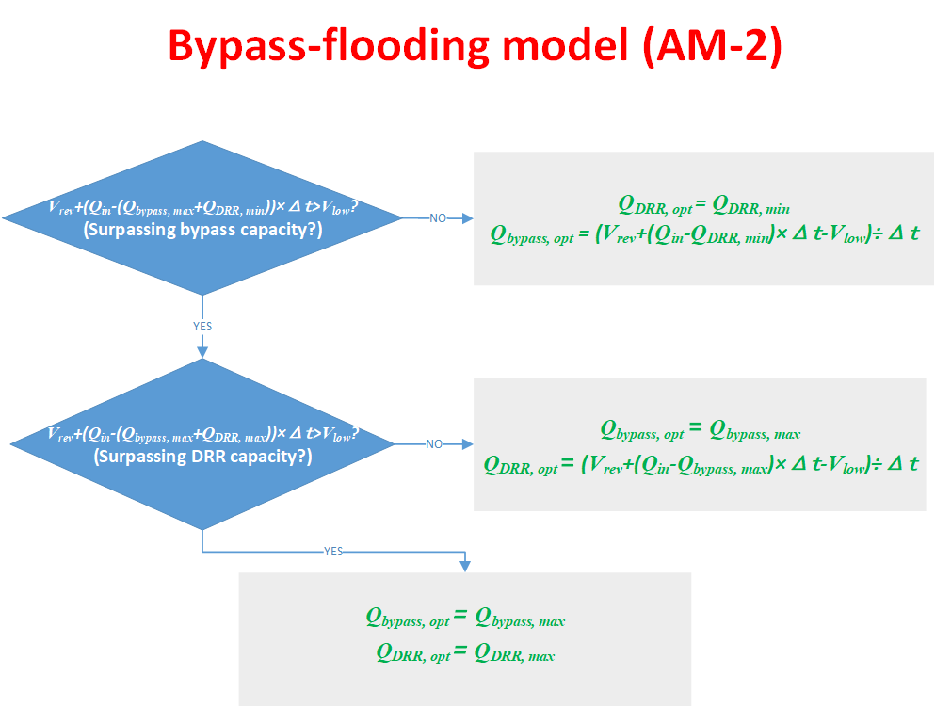
(b)

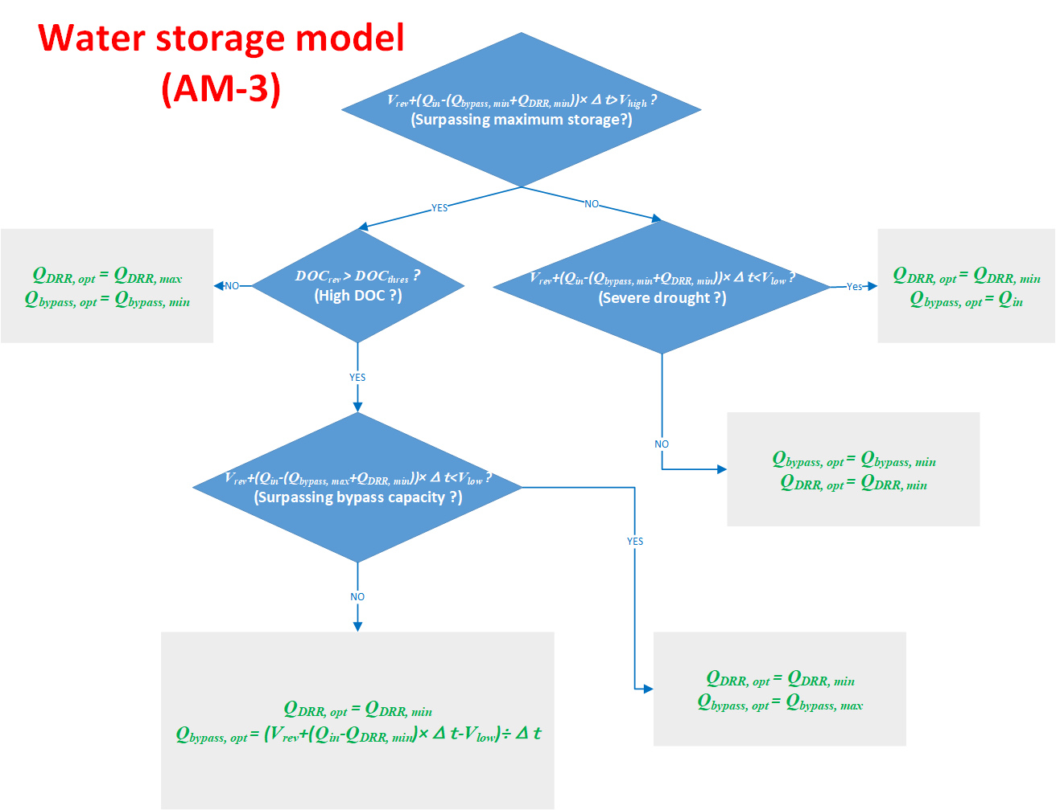
(c)

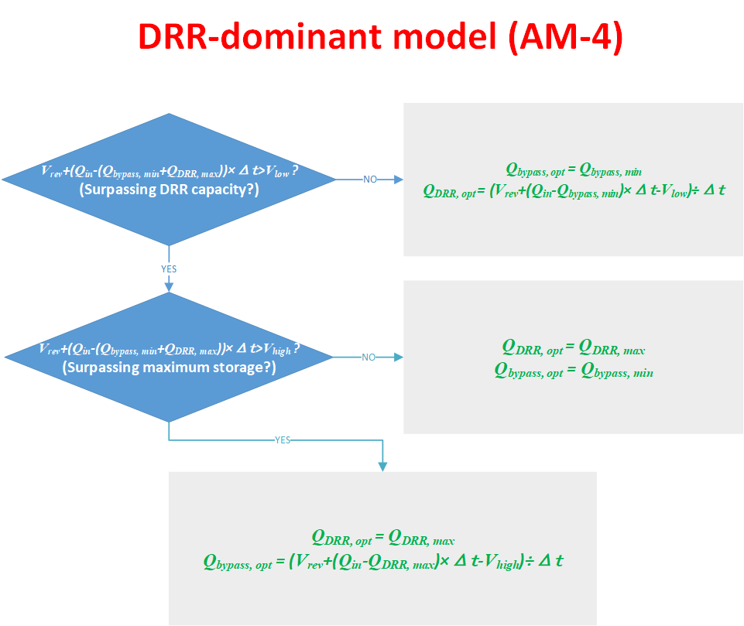
(d)
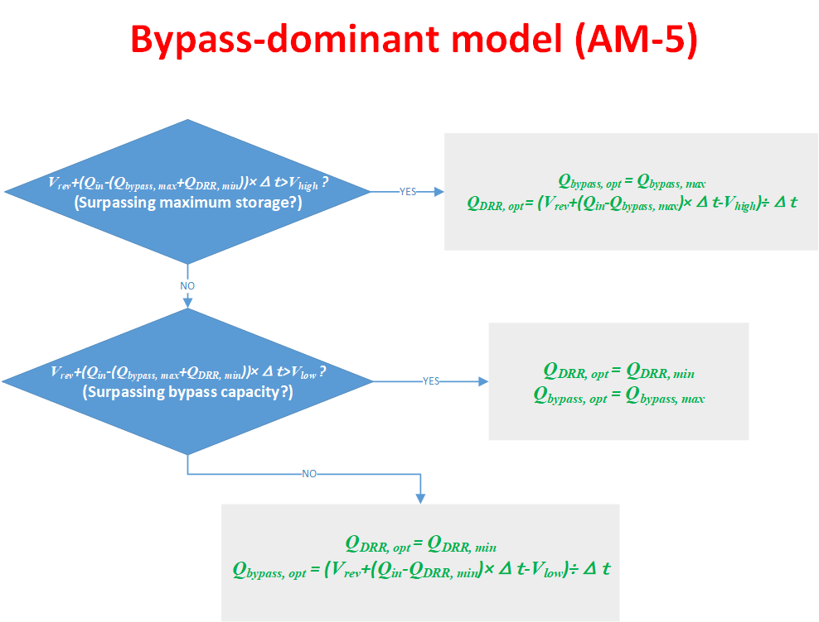
(e)
Figure S1. Equations for calculating the optimum outlet discharges at DRR and bypass in five operational models. The model selection is illustrated in Fig. 3. Check Table 1 for the abbreviations.
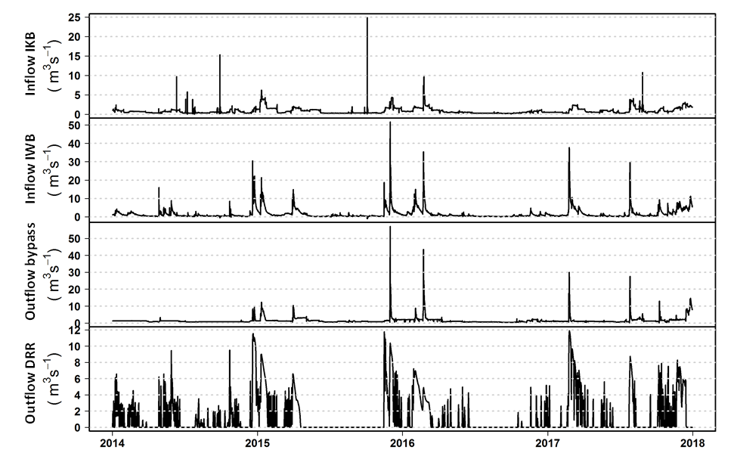Figure S2. High frequency monitoring of discharge at inflows and outflows of Königshütte Reservoir. In panels a-d, the measured discharge values at inflows Kalte Bode (IBK) and Warme Bode (IBW), and at outflows towards bypass and drinking water reservoir (Rappbode, DRR).
(d)
(c)
(b)
(a)

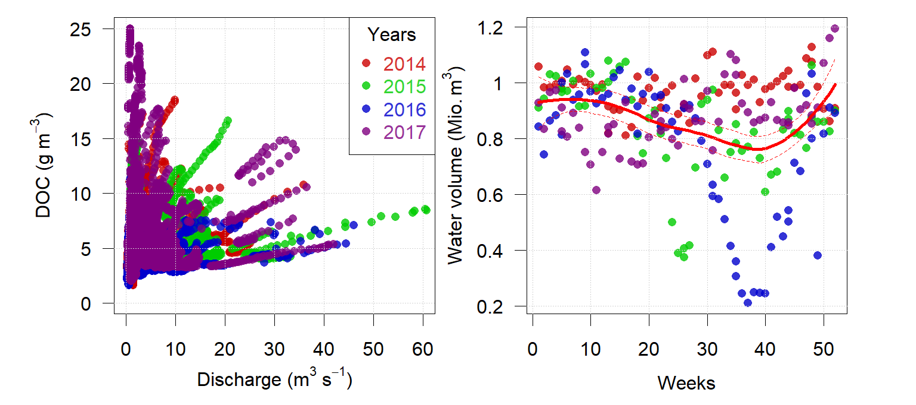
(b)
(a)
Figure S3. Panel a: Scatter points between DOC concentrations of the total inflows (y axis) and the discharge values of total inflow discharges (x axis). Panel b: Average water volume for each month during 4 years denoted by different colors (2014 red, 2015 blue, 2016 green, 2017 purple). The continuous red line is the smoother line using ‘loess’ function in R, and the dotted red lines represent the 95% confidence interval.
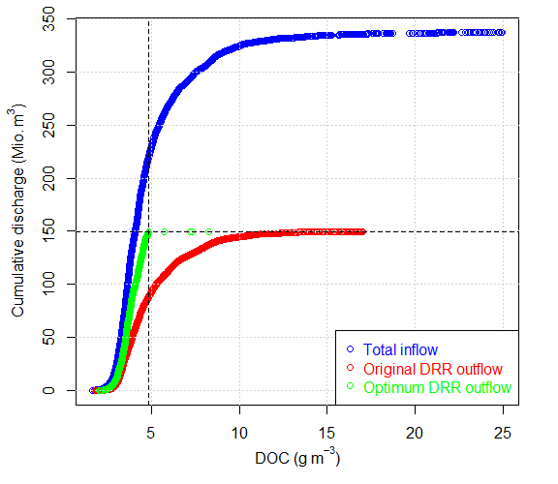
Figure S4. The cumulative inflow and outflow discharges (original and optimum outflows towards DRR, given in million m³) plotted against the DOC concentrations (g m⁻³) at the respective times of measurement (Total constraint scenario). The horizontal dotted line represents the total water transfer towards DRR in the original management regime (=149.6 mio. m³ in total). The vertical dotted line represents the threshold value for DOC concentration in this scenario (= 4.82 g m⁻³).
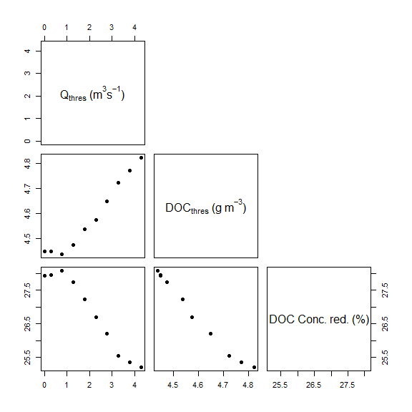
Figure S5. Scatterplot matrix of parameters subjected to optimization and DOC load reduction (dashed black line in Fig. 6). These scenarios are under total constraint that the total water transfer over four years remained identical as the original one (= 149.6 Mio. m³).
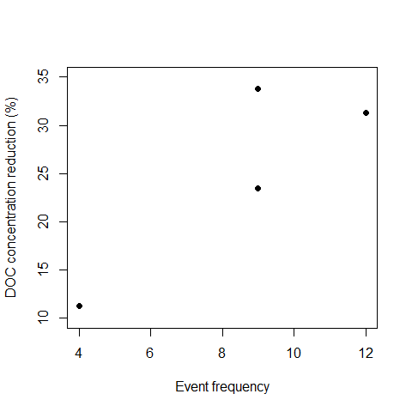
Figure S6. Scatter plot between DOC concentration reduction (%) and event frequencies from our 4-year dataset. Spearman’s correlation coefficient = 0.63, p = 0.36, n = 4.

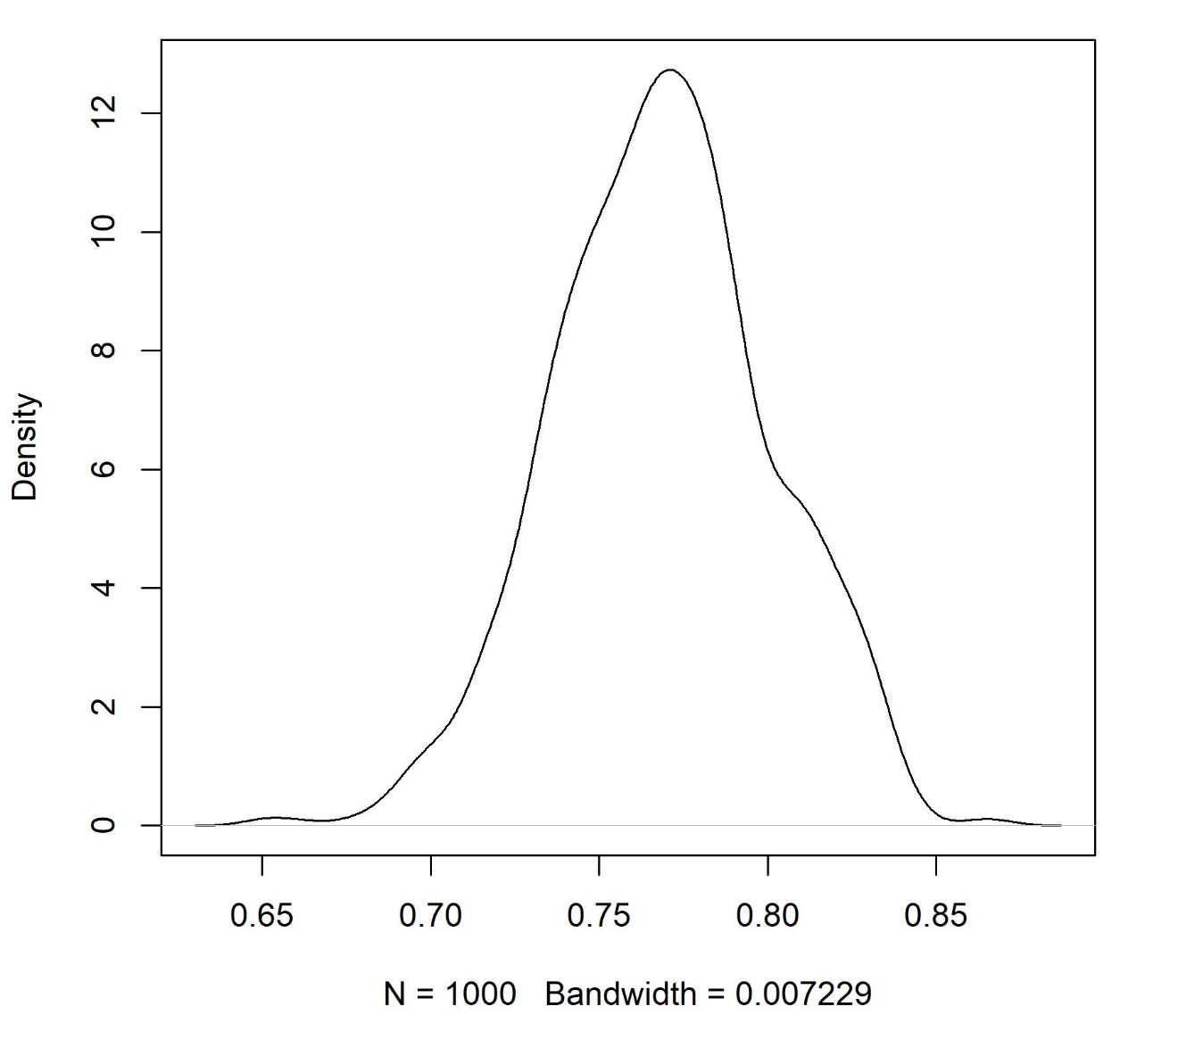
Figure S7. Kernel density estimate of DOC reduction. N = 1,000 times simulation by Monte Carlo simulation technique.

