Supplementary Information
Additional file 1
Title: Analysis of microbial populations in plastic–soil systems after exposure to high poly(butylene succinateco-adipate) load using high-resolution molecular technique
Benjawan Tanunchai¹, Kantida Juncheed^{2,1}, Sara Fareed Mohamed Wahdan^{1,3,4}, Vusal Guliyev^{1,5}, Maria Udovenko¹, Ann-Sophie Lehnert⁶, Eliane Gomes Alves⁶, Bruno Glaser⁷, Matthias Noll⁸, François Buscot^{1,9*}, Evgenia Blagodatskaya^{1,10*}, Witoon Purahong^{1*¶}
Affiliations:
¹UFZ-Helmholtz Centre for Environmental Research, Department of Soil Ecology, Theodor-Lieser-Str. 4, 06120 Halle (Saale), Germany
²Department of Biomedical Science and Biomedical Engineering, Faculty of Medicine, Prince of Songkla University, Songkhla, 90110 Thailand
³Department of Biology, Leipzig University, Leipzig, Germany
⁴Botany Department, Faculty of Science, Suez Canal University, 41522 Ismailia, Egypt
⁵Institute of Soil Science and Agrochemistry, Azerbaijan National Academy of Sciences, 5 M.Rahim, AZ1073 Baku, Azerbaijan
⁶Max Planck Institute for Biogeochemistry, Biogeochemical Processes Department, Hans-Knöll-Str. 10,
07745 Jena, Germany.
⁷Soil Biogeochemistry, Martin Luther University Halle-Wittenberg, Von-Seckendorff-Platz 3, 06120 Halle (Saale), Germany
⁸Institute of Bioanalysis, Coburg University of Applied Sciences and Arts, Coburg, Germany
⁹German Centre for Integrative Biodiversity Research (iDiv) Halle-Jena-Leipzig, Deutscher Platz 5e, 04103 Leipzig, Germany
¹⁰Agro-Technological Institute, RUDN University, Miklukho-Maklaya 6, Moscow, 117198, Russia

¶ Correspondence
*Senior authors
Appendix 1. PBSA chemical and physical properties
Total C, H and N concentrations were determined with an Elementar Vario EL III elemental analyzer (Elementar Analysensysteme GmbH, Hanau, Germany). Physical properties are provided in BioPBS™ FD92PM / FD92PB Technical Data Sheet, PTT MCC Biochem Company Limited.
Sample type | Total C (%) | H (%) | Total N (%)
PBSA | 56.940 | 7.371 | 0.000
Properties Test |  | Test method | Unit | FD92PM / FD92PB
Density |  | ISO 1183 | g/cm3 | 1.24
Melt index flow rate (190°C, 2.16 kg) |  | ISO 1133 | g/ 10 min | 4
Melting point |  | ISO 3146 | °C | 84
Tensile modulus | MD | ISO 527-3 | MPa | 280
 | TD |  |  | 320
Yield stress | MD | ISO 527-3 | MPa | 18
 | TD |  |  | 17
Stress at break | MD | ISO 527-3 | MPa | 32
 | TD |  |  | 27
Strain at break | MD | ISO 527-3 | % | 600
 | TD |  |  | 580
Elmendorf tear strength | MD | ISO 6383-2 | N/mm | 2
 | TD |  |  | 5
Puncture impact |  | PTTMCC  method | kJ/m | 6

Figure S1. Rarefaction curves of archaea (a), bacteria (b), and fungi (c).
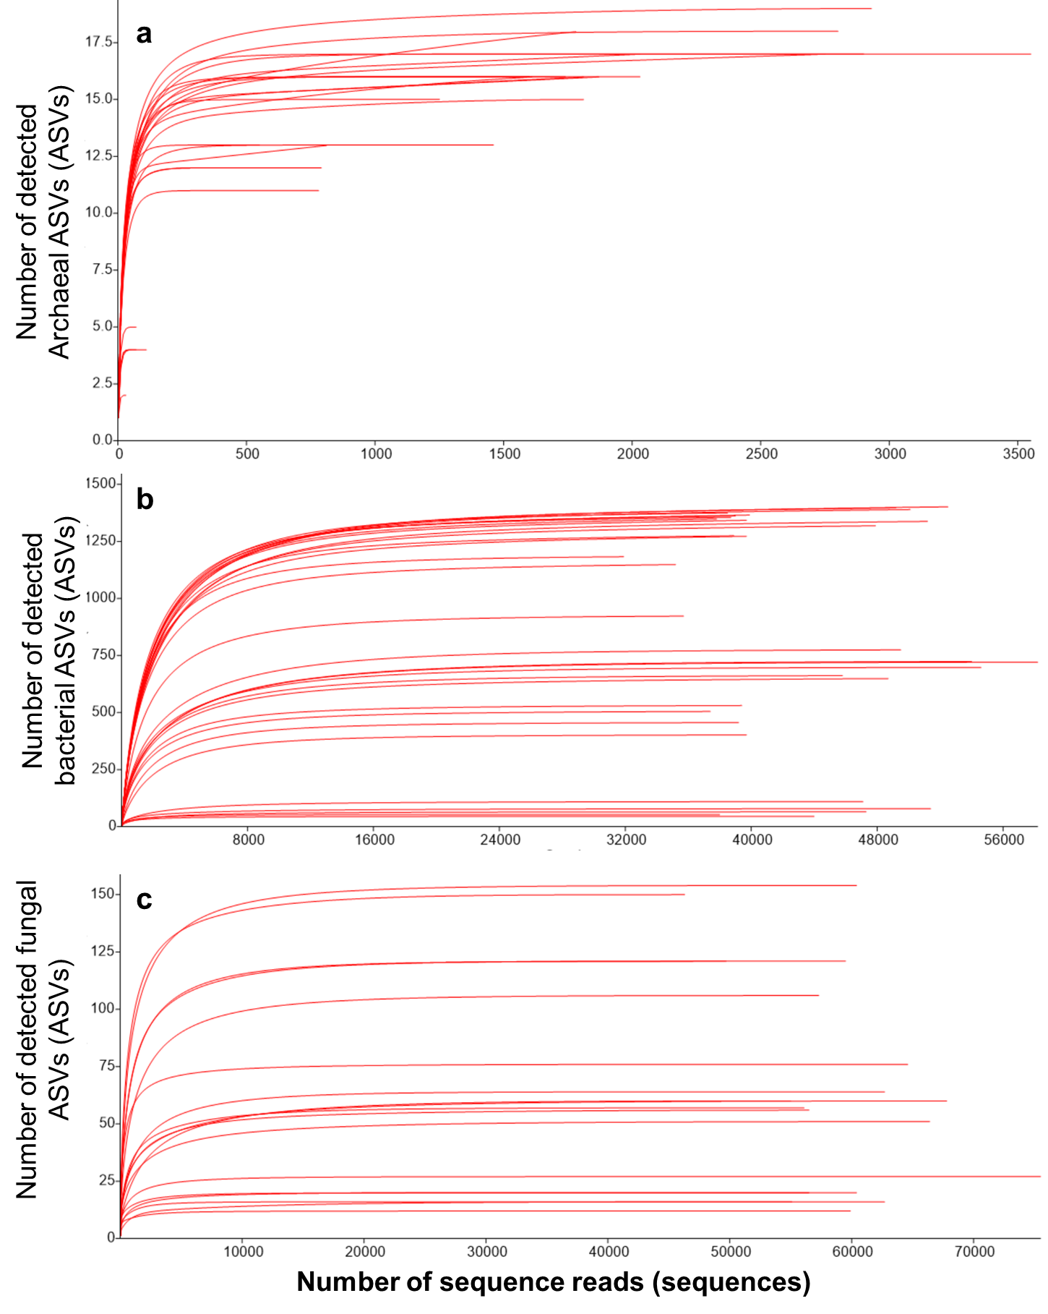

Figure S2. Links between soil pH and microbial richness: a) soil pH values of initial soil, control S, control SN, initial-N soil, and soils in PS, and PSN treatment on 90 days. Correlations between soil pH and richness of archaea (b), bacteria (c) and fungi (d).
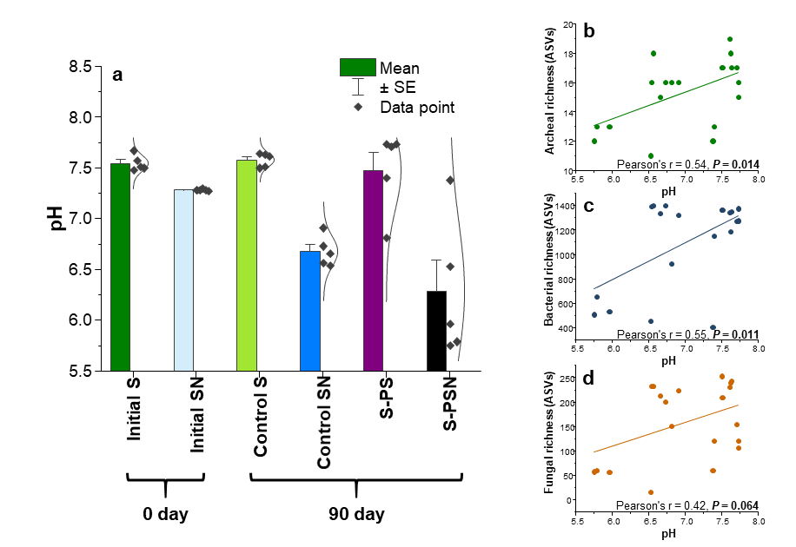

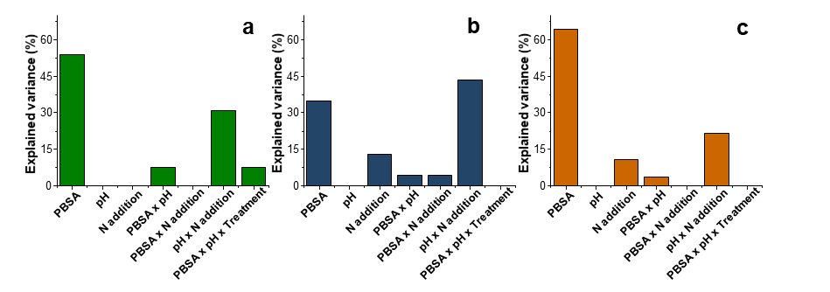
Figure S3. Factors explain variations in microbial community composition: percent explainable variations of archaeal (a), bacterial (b), and fungal (c) communities explained by PBSA addition, N fertilization, soil pH, and combinations of these factors. Total variations of archaeal, bacterial, and fungal communities explained by PBSA addition, N fertilization, soil pH, and combinations of these factors are 13, 23 and 28%, respectively.

Table S1. Information on relative abundance (%) of archaeal ASVs detected in poly(butylene succinate-co-adipate) (PBSA) and soils of all treatments. Please see in another excel file.
Table S2. Information on relative abundance (%) of bacterial ASVs detected in poly(butylene succinate-co-adipate) (PBSA) and soils of all treatments. Please see in another excel file.
Table S3. Information on relative abundance (%) of fungal ASVs detected in poly(butylene succinate-co-adipate) (PBSA) and soils of all treatments. Please see in another excel file.

Table S4. Comparisons between microbial community compositions of (i) PBSA and soil counterparts and (ii) soils of different treatments and (iii) control soils (Control S and Control SN) and PBSA (PS and PSN treatments) using analysis of similarities (ANOSIM) and non-parametric multivariate analysis of variance (NPMANOVA).
(i)
Comparison | Archaea |  | Bacteria |  | Fungi
 | ANOSIM | NPMANOVA | ANOSIM | NPMANOVA | ANOSIM | NPMANOVA
PBSA-soil:  PBSA vs. soil community composition | R = 0.91,  P = 0.010 | F = 12.22,  P = 0.008 | R = 1.00,  P = 0.010 | F = 4.26,  P = 0.008 | R = 0.70,  P = 0.010 | F = 3.07,  P = 0.008
PBSA-soil-N:  PBSA vs. soil community composition | R = 0.37,  P = 0.007 | F = 5.01,  P = 0.008 | R = 0.96,  P = 0.007 | F = 3.74,  P = 0.008 | R = 0.39,  P = 0.040 | F = 2.38,  P = 0.031

(ii)
Comparison | Archaea |  | Bacteria |  | Fungi
 | ANOSIM | NPMANOVA | ANOSIM | NPMANOVA | ANOSIM | NPMANOVA
Control S vs. Control SN | R = 0.03,  P = 0.31 | F = 1.04,  P = 0.374 | R = 1.00,  P = 0.007 | F = 4.67,  P = 0.008 | R = 1.00,  P = 0.008 | F = 2.99,  P = 0.009
Control S vs. Soil-PS | R = 0.12,  P = 0.24 | F = 1.39,  P = 0.275 | R = 0.64,  P = 0.008 | F = 2.09,  P = 0.007 | R = 0.88,  P = 0.008 | F = 3.44,  P = 0.011
Control S vs. Soil-PSN | R = 0.67,  P = 0.008 | F = 4.67,  P = 0.008 | R = 1.00,  P = 0.007 | F = 4.97,  P = 0.006 | R = 0.59,  P = 0.008 | F = 4.62,  P = 0.007
Control SN vs. Soil-PS | R = 0,  P = 0.696 | F = 0.80,  P = 0.679 | R = 0.87,  P = 0.009 | F = 3.91,  P = 0.006 | R = 0.94,  P = 0.008 | F = 3.92,  P = 0.010
Control SN vs. Soil-PSN | R = 0.53,  P = 0.008 | F = 4.60,  P = 0.006 | R = 0.94,  P = 0.008 | F = 4.88,  P = 0.009 | R = 0.59,  P = 0.007 | F = 4.43,  P = 0.008
Soil-PS vs. Soil-PSN | R = 0.47,  P = 0.015 | F = 3.47,  P = 0.024 | R = 0.98,  P = 0.009 | F = 3.84,  P = 0.007 | R = 0.48,  P = 0.008 | F = 3.14,  P = 0.007

(iii)
Comparison | Archaea |  | Bacteria |  | Fungi
 | ANOSIM | NPMANOVA | ANOSIM | NPMANOVA | ANOSIM | NPMANOVA
Control S vs. PBSA-PS | R = 0.92,  P = 0.008 | F = 12.16,  P = 0.008 | R = 1.00,  P = 0.008 | F = 5.82,  P = 0.009 | R = 0.96,  P = 0.008 | F = 5.20,  P = 0.009
Control S vs. PBSA-PSN | R = 0.37,  P = 0.007 | F = 5.41,  P = 0.009 | R = 1.00,  P = 0.009 | F = 6.59,  P = 0.007 | R = 1.00,  P = 0.008 | F = 9.12,  P = 0.007
Control SN vs. PBSA-PS | R = 0.92,  P = 0.008 | F = 12.98,  P = 0.008 | R = 1.00,  P = 0.008 | F = 6.36,  P = 0.007 | R = 0.97,  P = 0.009 | F = 5.16,  P = 0.008
Control SN vs. PBSA-PSN | R = 0.37,  P = 0.008 | F = 5.71,  P = 0.009 | R = 1.00,  P = 0.009 | F = 7.15,  P = 0.008 | R = 1.00,  P = 0.008 | F = 8.87,  P = 0.008
PBSA-PS vs. PBSA-PSN | R = 0.22,  P = 0.033 | F = 2.18,  P = 0.031 | R = 1.00,  P = 0.008 | F = 3.99,  P = 0.008 | R = 0.96,  P = 0.007 | F = 4.03,  P = 0.007

