Supplementary Material

Supplementary Figures

Supplementary Figure 1. Beijing Municipal Map showing Peking University, the PM_{2.5} monitoring station and the eight fixed monitoring sites for PM₁₀ and NO₂.
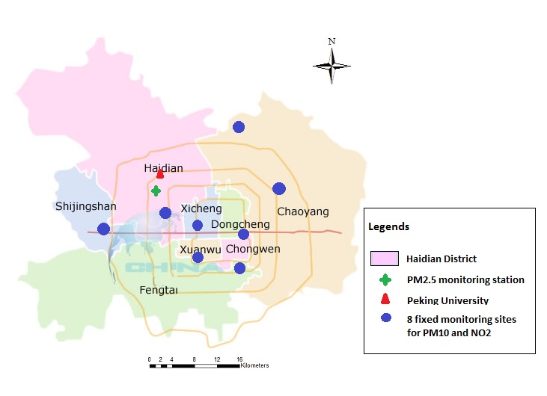
Supplementary Figure 2. Percent change of respiratory mortality cases pre/post the Olympic Games in comparison with the period during the Games.
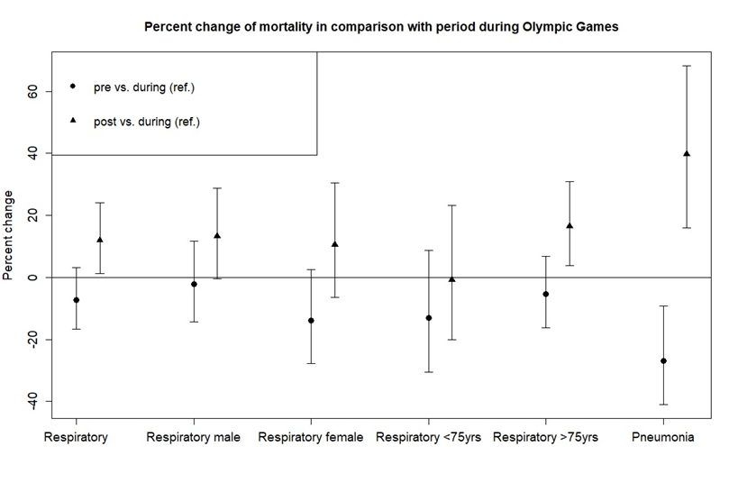

Supplementary Figure 3. Percent change (95%-confidence interval) in subgroups of respiratory mortality per an interquartile range increase in PM mass (lag4), NO₂ (lag4) and PNC (lag7) in the Beijing urban area for the period May 20 to December 1, 2008.
PM: particulate matter; PM₁₀: PM<10µm in diameter; PM_{2.5}: PM<2.5µm in diameter; NO₂: nitrogen oxide; PNC: particle number concentration.
ª All models were adjusted for air temperature, relative humidity, day of week, public holiday, category of period and heating period.
Significant effect modifications are marked with *

Supplementary Figure 4. Percent change (95%-confidence interval) in respiratory mortality per an interquartile range increase in PM mass (lag4), NO2 (lag4) and PNC (lag7). Effect modification by clusters on overall respiratory mortality. ª
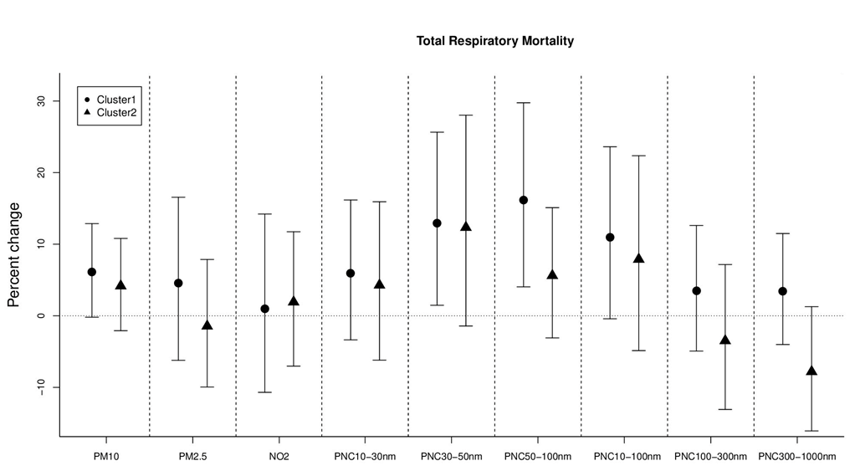
PM: particulate matter; PM₁₀: PM<10µm in diameter; PM_{2.5}: PM<2.5µm in diameter; NO₂: nitrogen oxide; PNC: particle number concentration.
ª All models were adjusted for air temperature, relative humidity, day of week, public holiday, category of period and heating period.
Cluster 1 represents air masses coming from the areas surrounding Beijing with low wind speed;
Cluster 2 consists air masses arriving from northwestern direction with average to high wind speed.

