Mitogenome evolution in the Lacerta viridis complex reveals phylogeny of diverging clades
Robin-Tobias Jauss, Nadiné Solf, Sree Rohit Raj Kolora, Stefan Schaffer, Ronny Wolf, Klaus Henle, Uwe Fritz, Martin Schlegel
Supplementary material
S1: Sampling locations
In this study, we sequenced the mitogenomes of 16 specimens and added four additional mitogenomes from Genbank to our analyses. Our taxon sampling included all four deep branching lineages of the L. viridis complex covering most of its distribution range. Detailed information on the origin of samples is provided in Table S1.
Table S1: Sampling information of specimens from four lacertid clades: L. viridis, L. bilineata, Adriatic clade and Turkish clade. The sample ID, location, date of sampling, accession number and the source of data are provided. ID abbreviations: G: Tissue collection Institute of Biology, University of Leipzig, MTDT: Senckenberg Natural History Collections Dresden, Lb: L. bilineata; L.v: L. viridis; AL: Adriatic clade; BG: Bulgaria; CZ: Czech Republic; ES: Spain; FR: France; GR: Greece; IT: Italy; MD: Republic of Moldova; ME: Montenegro; RS: Serbia; TR: Turkey; UA: Ukraine.
Clade | Sample-ID | Location | Geographical coordinates | Accession number | Study
L. bilineata | G2705_Lb_FR | Malain, France | 4º48´E, 47º21´N | KT722705.1 | Kolora et al. (2015)
L. bilineata | G2705_Lb_FR | Malain, France | 4º48´E, 47º21´N | KT722705.2 | This study
L. bilineata | G2706_Lb_FR | Malain, France | 4º48´E, 47º19´N | ERZ1645114 | This study
L. bilineata | G841_Lb_FR  (≡ MDTD2546) | Cournonterral (Hérault), France | 3º72´E, 43º56´N | ERZ1645110 | This study
L. bilineata | G593_Lb_ES  (≡ NMWYBJ-1) | Bilbao, Spain | -2º92´W, 43º26´N | LR881102 | This study
L. bilineata | G2697_Lb_IT | Calambrone, Pisa, Italy | 10º18´E, 43º35´N | ERZ1645119 | This study
L. viridis | G601_Lv_AT  (≡ NMWY-1) | Hundsheim, Austria | 16º94´E, 48º2´N | AM176577.1 | Böhme et al. (2007b)
L. viridis | G2792_Lv_HU | Tokaj, north eastern Hungary | 21º38´E, 48º10´N | ERZ1645122 | Kolora et al. (2015)  and this study
L. viridis | G664_Lv_CZ | Bzenec, Southern Moravia, Czech Republic | 17º26´E, 48º97´N | ERZ1645123 | This study
L. viridis | G2610_Lv_BG | Kresna Gorge, Bulgaria | 23º15´E, 41º76´N | ERZ1645124 | This study
L. viridis | G2029_Lv_BG | Trilistnik North, Bulgaria | 24º85´E, 42º27´N | ERZ1645125 | This study
L. viridis | G2167_Lv_BG | Gradina, Bulgaria | 25º17´E, 42º15´N | ERZ1645126 | This study
L. viridis | G707_Lv_RS | Vrsackibreg, Eastern Vojvodina, Serbia | 21º32´E, 45º12´N | ERZ1645127 | This study
L. viridis | G899_Lv_MD | Ungurivillage, Northern Moldova | 27º87´E, 48º4´N | ERZ1645128 | This study
L. viridis | G1993_Lv_UA | Vinitsa, Ukraine | 28º47E, 49º23´N | ERZ1645129 | This study
Adriatic | G2701_AL_SL | Stanjel, West Slovenia | 13º50´E, 45º48´N | MT576630 | Kolora et al.in revision
Adriatic | G380_AL_ME | Ubine, Montenegro | 19º28´E, 42º37´N | ERZ1645120 | This study
Adriatic | G376_AL_GR | Zagoria, Greece | 20º77´E, 39 º91´N | ERZ1645121 | This study
Turkish | MTDT_9003_Lv_TR | Bolu Province, Turkey | 32º06´E, 41º06´N | ERZ1645130 | This study
Turkish | MTDT_9004_Lv_TR | Karabük Province, Turkey | 32º36´E, 41º21´N | ERZ1645131 | This study

Table S2: Length and coverage of mitogenomes
Clade | Sample ID | Length (bp) | Coverage
L. bilineata | G270_Lb_FR (KT 22705) | 17.086 | 80
L. bilineata | G2705_Lb_FR | 17.154 | 11,1
L. bilineata | G2706_Lb_FR | 17.164 | 13,5
L. bilineata | G841_Lb_FR | 17.151 | 34,3
L. bilineata | G593_Lb_ES | 17.145 | 11,6
L. bilineata | G2697_Lb_IT | 17.159 | 17,4
L. viridis | G601_Lv_AT | 17.156 | Not reported
L. viridis | G2792_Lv_HU | 17.157 | Not reported
L. viridis | G664_Lv_CZ | 17.166 | 35,5
L. viridis | G2610_Lv_BG | 17.154 | 25
L. viridis | G2029_Lv_BG | 17,167 | 12,4
L. viridis | G2167_Lv_BG | 17.169 | 18,1
L. viridis | G707_Lv_RS | 17.166 | 10,5
L. viridis | G899_Lv_MD | 17.172 | 15,8
L. viridis | G1993_Lv_UA | 17.167 | 12,8
Adriatic | G2701_AL_SL | 17.096 | 80
Adriatic | G380_AL_ME | 17.164 | 25,7
Adriatic | G376_AL_GR | 17.156 | 12,1
Turkish | 9003_Lv_TR | 17.276 | 38,6
Turkish | 9004_Lv_TR | 17.273 | 38,3

Table S3: Distribution of sequence motifs among clades within the L. viridis complex (first number indicates specimens with respective sequence motif, second number indicates total number of specimens investigated).
Sequence motif | Sequence | L. bilineata | L. viridis | Adriatic clade | Turkish clade
11 Bp insert | aacaaacttta | 0/6 | 9/9 | 0/3 | 0/2
TAS-2a | tatacattaa | 6/6 | 0/9 | 2/3 | 2/2
TAS-2b | catacattaa | 0/6 | 8/9 | 0/3 | 0/2
TAS-2c | tatgcattaa | 0/6 | 1/9 | 1/3 | 0/2

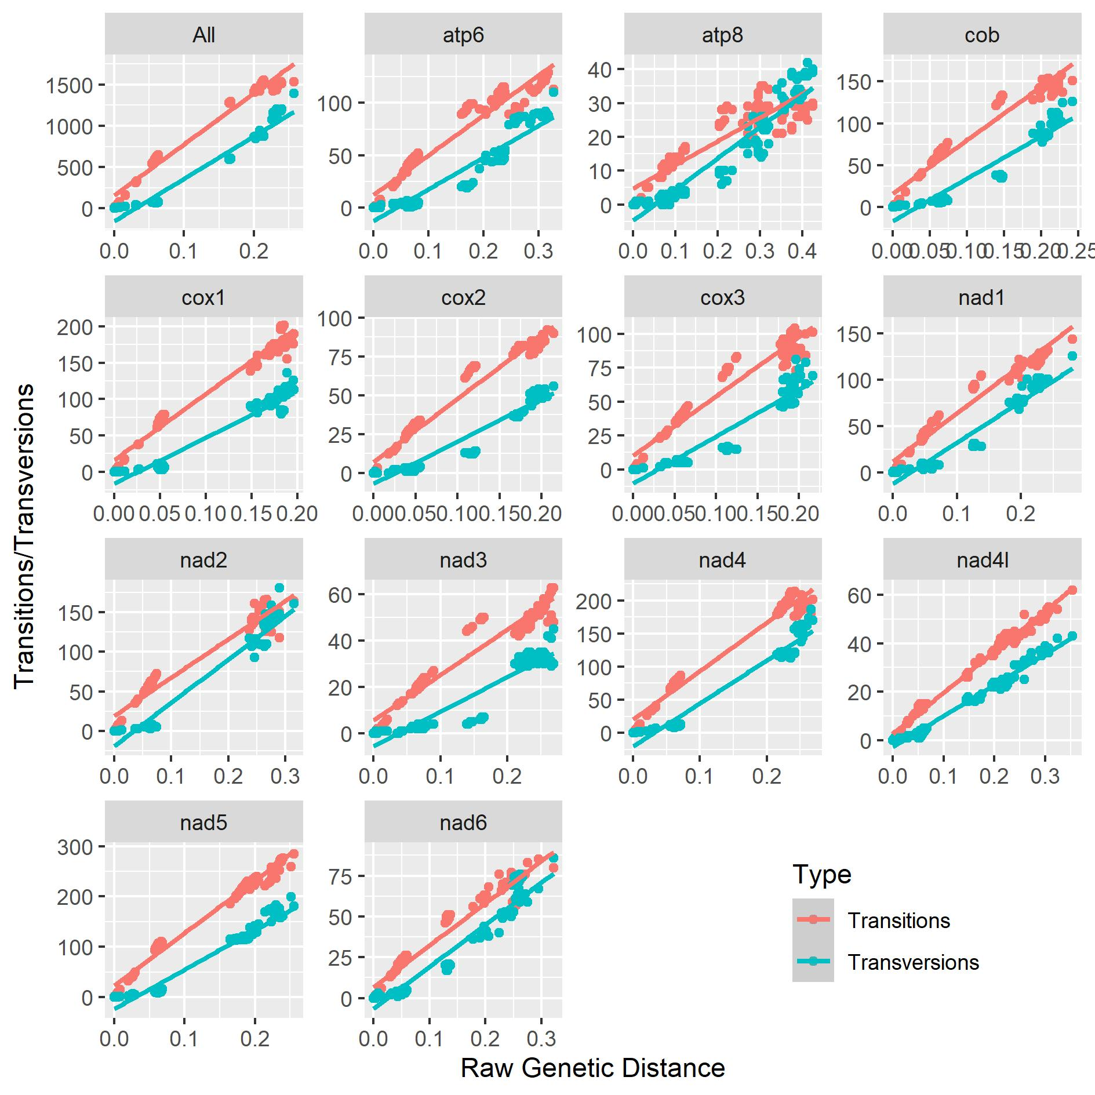
Figure S1: Gene saturation tested by plotting the number of transitions and transversions against the raw genetic distance. Genes show little to no saturation, indicating a robust dataset for phylogenetic analyses.
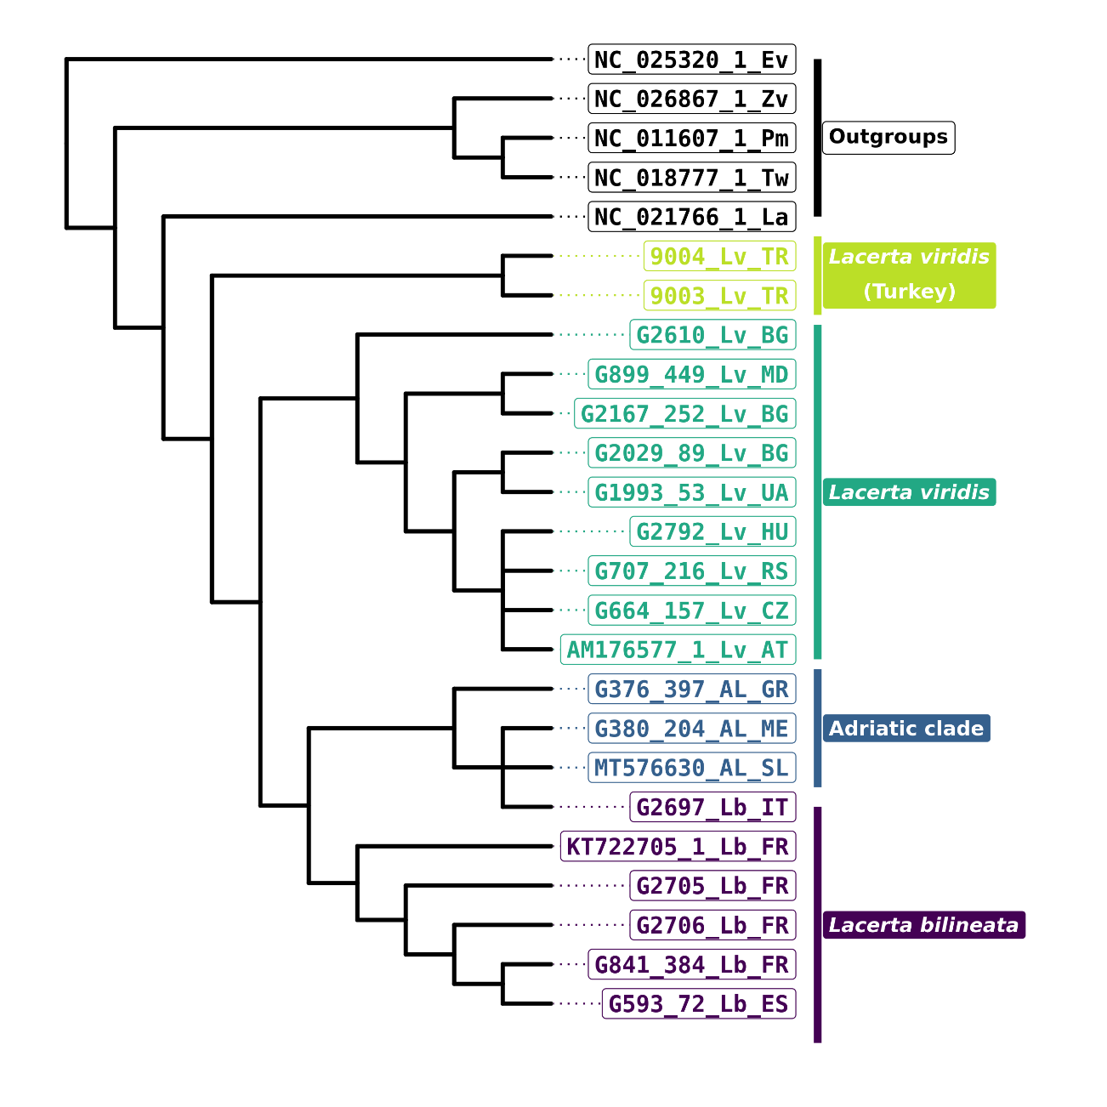Figure S2: Bayesian Inference cladogram (nucleotide alignment) of 20 specimens of the L. viridis-complex, based on 13 protein coding genes. Specimen labels refer to clade and provenance of samples or the accession numbers of additional sequences from Genbank. OG: outgroups (Table S1).
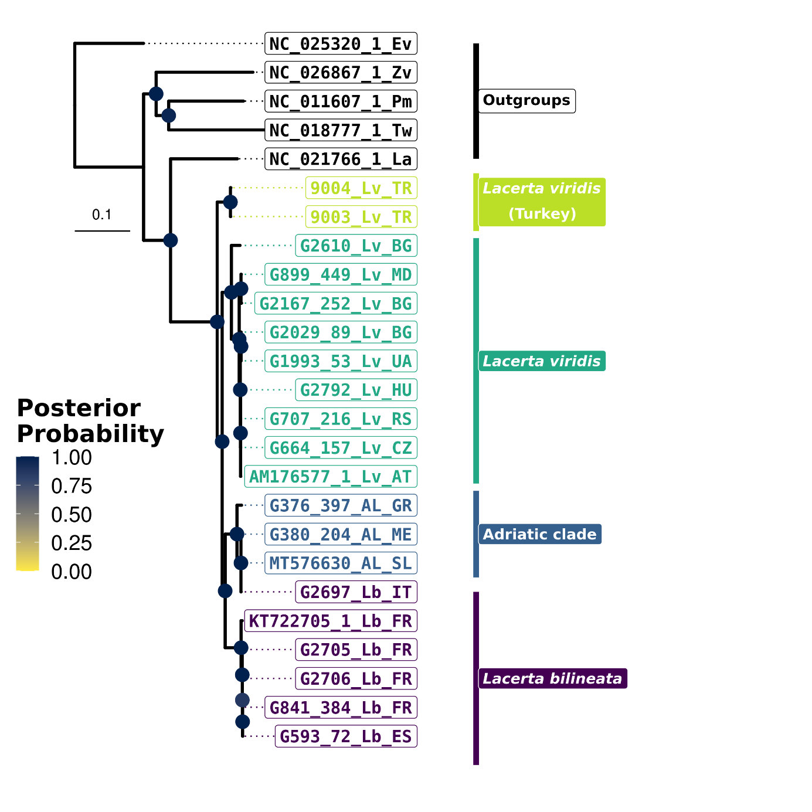
Figure S3: Bayesian Inference phylogram (nucleotide alignment) of 20 specimens of the L. viridis complex, based on 13 protein coding genes. Node labels: posterior probabilities; specimen labels refer to clade and provenance of samples or to the accession numbers of additional sequences from GenBank (Table S1). OG: outgroups; branch labels indicate substitutions/site.
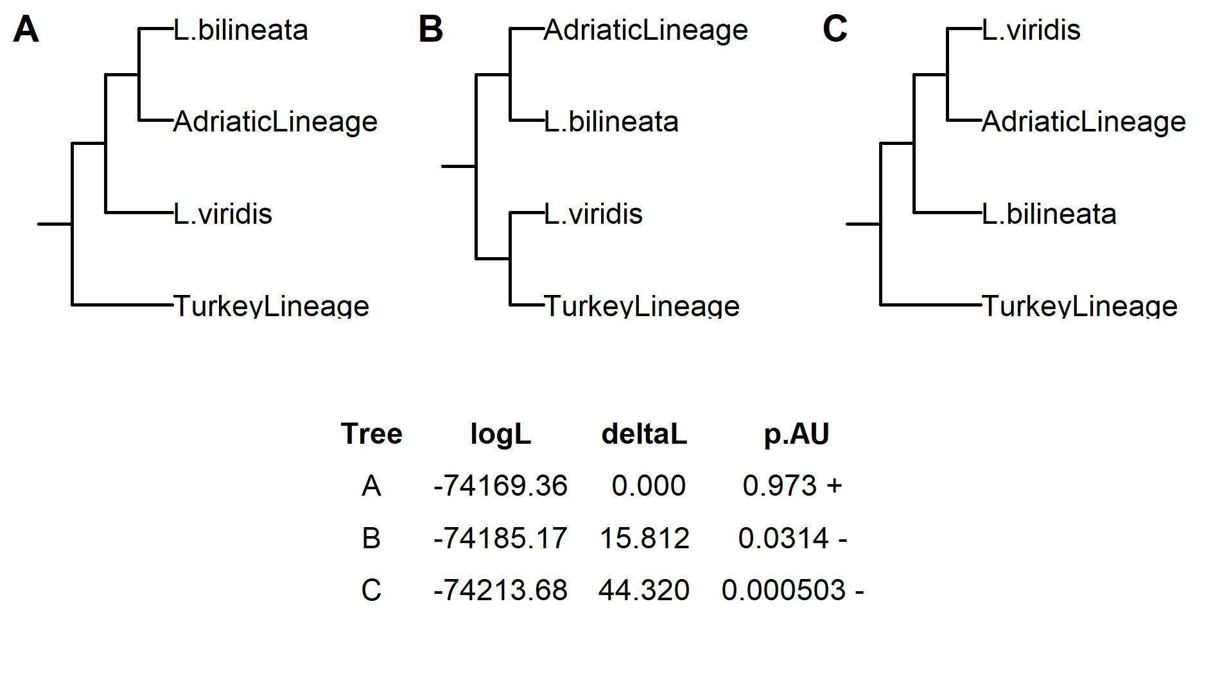
Figure S4: Constrained topology analysis. (A) unconstrained tree, (B) forced monophyly of L. viridis + Turkey clade, (C) forced monophyly of L. viridis + Adriatic clade. Tables gives the log likelihood (logL), delta log likelihood (deltaL) compared to unconstrained tree and significance of approximately unbiased test (p.AU). Plus signs denote accepted topologies, minus signs represent rejected topologies (p.AU < 0.05).

