Supplementary Material

# Supplementary Figures and Tables

|  |  |  |
| --- | --- | --- |
|  | **A** | |
|  | | **B** |

Supplementary Figure X1 (A) Input data (buildings, roads, elevation) for Al-Yazidiyah and (B) scenarios S1 & S2 representation for Al-Yazidiyah. For S1 the WWTP would be replaced by a pumping station connected to the WWTP in Al-Salt.

|  |  |
| --- | --- |
|  |  |
| A | B |

Supplementary Figure X2 (A) Specific treatment cost vs. specific sewer length for on-site and a 500 PE WWTP (B) Sewer length vs. building density plot with on-site threshold for Al Mazarih.

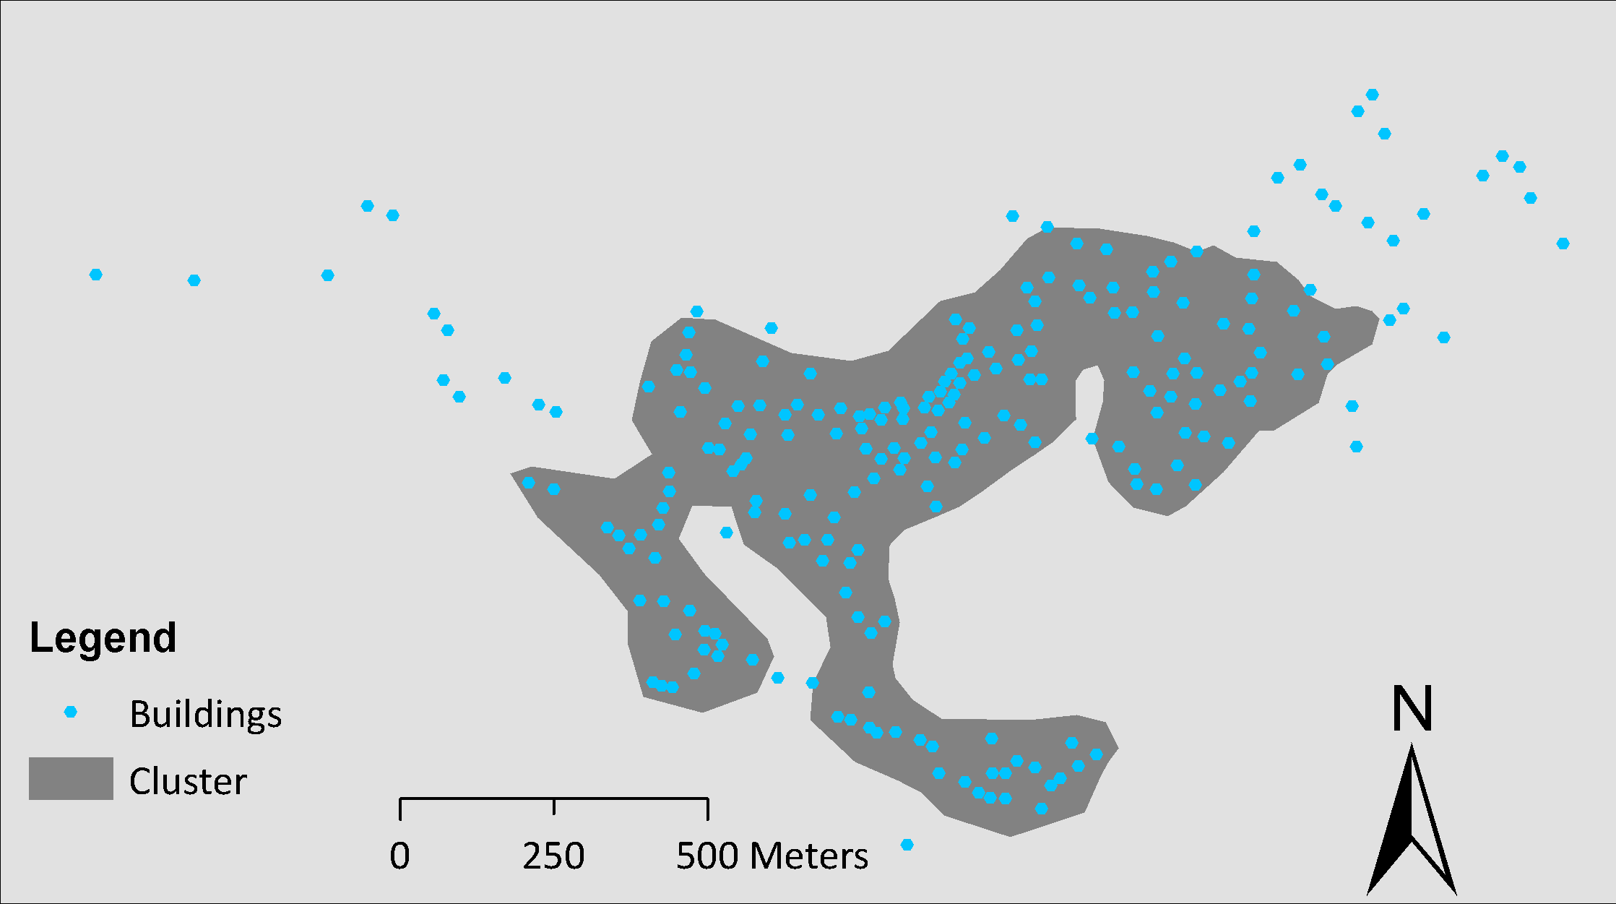

Supplementary Figure X3 Cluster map for S3 in Al Mazarih. All buildings outside the clusters use on-site treatment and buidlings within the five clusters are connected to a local sewer network and small WWTPs.



**Supplementary Figure X4** Total cost of the scenarios in net present value (NPV) per year for the maximum lifetime.

**Supplementary Table X1** Cost items required for the economic scenario assessment. The individual cost items can be country specific or based international benchmark estimates.



*Cost ranges and assumptions are based on data from Jordan and Oman.

**Supplementary Table X2** Summarynet present value (in Million USD) of the cost components involved in the scenarios divided in investment and reinvestment (inv.) and operational (O&M) costs.

|  |  |  |  |  |  |  |  |  |  |  |  |
| --- | --- | --- | --- | --- | --- | --- | --- | --- | --- | --- | --- |
|  |  | S1 | | S2 | | S3 | | S4 | | S5 | |
|  |  | Inv. | O&M | Inv. | O&M | Inv. | O&M | Inv. | O&M | Inv. | O&M |
| Al-Yazidiyah, Jordan | Sewer | 15.1 | 10.1 | 8.8 | 5.9 | 2.6 | 1.20 | - | - | - | - |
| Pumping station | 5.8 | 8.7 | 0.6 | 0.9 | - | - | - | - | - | - |
| Treatment | 4.4 | 3.1 | 4.8 | 2.0 | 4.8 | 2.30 | 4.4 | 8.5 | 0.6 | 20.2 |
| Al-Mazarih, Oman | Sewer | 2.9 | 1.2 | 2.2 | 0.8 | 2.0 | 1.0 | - | - | - | - |
| Pumping station | 1.3 | 2.9 | 0.9 | 1.9 | - | - | - | - | - | - |
| Treatment | 0.3 | 0.2 | 1.2 | 0.4 | 3.0 | 1.2 | 2.4 | 5.9 | 0.6 | 10.5 |