Supplement
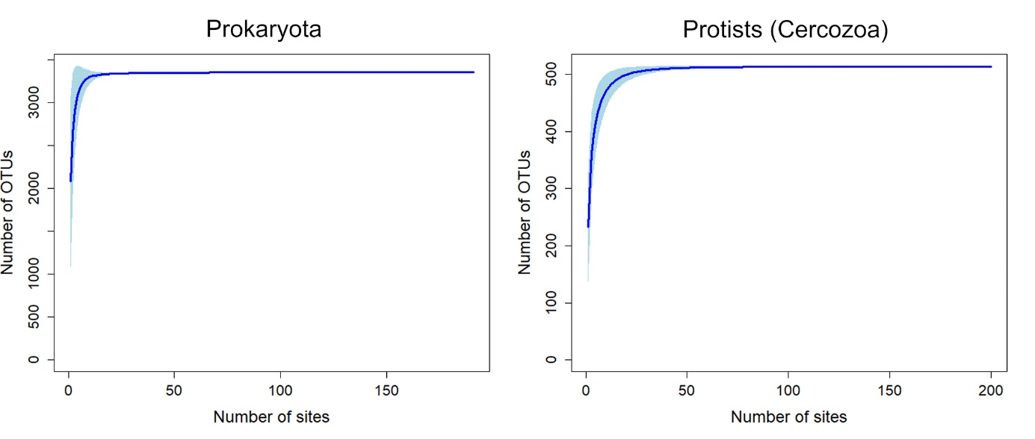 Spplementary Figure 1. Accumulation curves describing the observed number of prokaryotic (left) and protistan (right) OTUs as a function of the sampling effort, saturation was reached.
Supplementary Table 1. Percent Coefficient of Variation (%CV) of OTU richness, Shannon entropy and Pielou evenness, calculated for bacteria/archaea and Cercozoa in bulk soil and at the four different root regions sampled.
 | Bacteria/ Archaea |  |  | Cercozoa
 | %CV of OTU richness | %CV of Shannon entropy | %CV of Pielou evenness | %CV of OTU richness | %CV of Shannon entropy | %CV of Pielou evenness
Bulk soil | 11.312 | 1.831 | 2.209 | 13.325 | 11.840 | 11.072
Root tip | 30.865 | 10.677 | 7.895 | 21.040 | 19.343 | 17.344
Root hair | 32.098 | 17.817 | 13.942 | 24.785 | 25.172 | 22.280
Primordia | 21.341 | 10.594 | 8.283 | 19.322 | 14.379 | 13.038
Lateral | 12.770 | 10.060 | 8.999 | 18.179 | 14.928 | 13.524

Supplementary Table 2. Adjusted p-values of pairwise comparison indicating differences in prokaryote community composition between samples from bulk soil, root tip, root hair zone, lateral root primordia and lateral roots.
Adjusted p-value | Root tip | Root hair | Primordia | Lateral
Bulk soil | 0.01* | 0.01* | 0.01* | 0.01*
Root tip |  | 0.01* | 0.01* | 0.01*
Root hair |  |  | 1 | 0.09
Primordia |  |  |  | 0.03*
*Significant difference based on pairwise comparison of Bray-Curtis dissimilarities

Supplementary Table 3. Adjusted p-values of pairwise comparison indicating differences in protist community composition between samples from bulk soil, root tip, root hair zone, lateral root primordia and lateral roots.
Adjusted p-value | Root tip | Root hair | Primordia | Lateral
Bulk soil | 0.1 | 0.04* | 0.01* | 0.01*
Root tip |  | 1 | 0.02* | 0.02*
Root hair |  |  | 0.74 | 0.01*
Primordia |  |  |  | 0.06
*Significant difference based on pairwise comparison of Bray-Curtis dissimilarities.

