Appendix 1: Stimuli design and examples

This appendix provides supplementary information about our stimuli creation process and the rationale behind specific design choices. In addition, we present each of our stimuli as they were seen by participants in the experiment. The stimuli are grouped thematically by genre (Politics, Economy, Society, Entertainment, and Sports) and for each post, we first present the agreement condition followed by the disagreement condition. We have translated the publisher text, headline, and pair of comments from Swedish into English.

Stimulus creation
The stimuli were created technically by first loading the actual Facebook post into the Firefox web browser, using the post ID retrieved from the Facebook Graph API. Its innerHTML was then captured and processed by a custom Python script using the lxml package. The innerHTML of the post was replaced in the browser with the processed version, and a screenshot taken. During processing, we made the following modifications, with the purpose of eliminating unnecessary variation and visually distracting elements from the stimuli.

We removed the year from the post header and timestamps from the comments to avoid making the posts look outdated. We also removed the comment box where participants could leave their own comments, since commenting functionality was not available in the experiment. We similarly removed icons inviting users to like or share posts.

We attempted to control for variation in the numbers of Facebook reactions, comments, and shares. We replaced the actual reaction, comment, and share counts with numbers randomly generated in the intervals [306-376], [158-194], and [39-49], respectively. These intervals constituted a +/- 10% range of the median values accrued by the 20 selected posts. Since reactions also include emoticons that signal valence, we replaced the emoticons so that the first was always a “like”, followed by two more emoticons randomly chosen from the remaining set of “love”, “laugh”, “surprised”, “sad”, and “angry”. The valence of the emoticons following the “like” is thus randomized.

When selecting comments for the agreement or disagreement pairs, we located real comments on Facebook that exhibited agreement or disagreement in the same reply thread. We were careful to maintain an even tone in regards to civility to avoid giving the impression that certain topics would generate more radical language than others. This was possible because the actual comments left underneath our selected posts were, generally speaking, falling within the same brackets of civility.

To anonymize the identity of the actual commenters, we took steps to change their names and profile pictures. The names of the commenters were replaced with generated names constructed by randomly combining the top 40 most frequent last names in Sweden (according to Sweden’s Statistical Central Bureau) with the top five most popular female and male names per decade, to reflect the Facebook user demography. Moreover, the profile pictures were replaced with images obtained via an online image search, with the criterion “creative commons” activated. Twenty male and twenty female pictures were selected to cover a variation of ages and facial and clothing features (short/long hair, hat, beards, etc.). The genders of the generated name and profile picture were matched. We only chose names of Swedish origin and pictures of ethnically white individuals, to mitigate any racial or immigrant bias.

Stimulus 1
Genre: Politics
Condition: Agreement

Publisher Text: “Right-wing extremists used the terrorist attack last Friday to spread false information that does not match reality,” writes today’s debater. Do you agree? Join the debate – like Aftonbladet Debatt!

Headline: Debate: I am scared that hate is being spread after the terrorist attack.

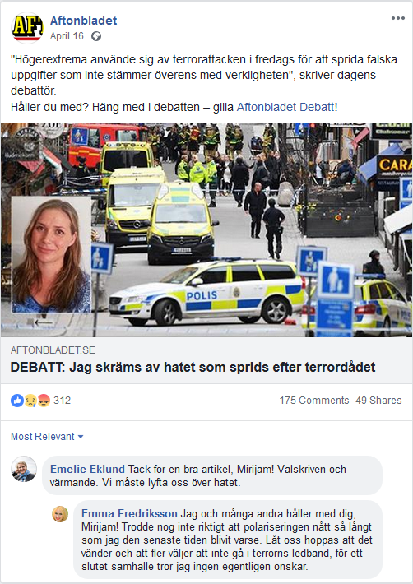

Emelie: Thanks for a great article, Mirijam! Well written and warming. We must rise above the hatred.

Emma: Me and many others agree with you, Mirijam! I did not really think that polarization has reached as far as I have been aware lately. Let's hope that it turns around and that more people choose to not follow the terrorist’s lead, towards a closed society that I think nobody really wants.

Stimulus 2
Genre: Politics
Condition: Disagreement

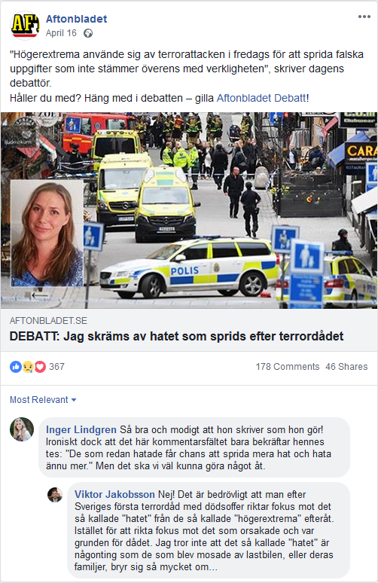

Inger: So good and brave that she writes as she does! Ironically, though, this comment field only confirms her thesis: "The haters get a chance to spread more hate and hate even more." But we should be able to do something about that.

Viktor: No! It is unfortunate that after Sweden's first terrorist attack with a death victim, the focus is on the so-called "hatred" from the so-called "extreme right" afterwards. Instead of focusing on what caused the attack and was the basis for it. I don't think the so-called "hate" is something that those who were mashed by the truck, or their families, care so much about...

Stimulus 3
Genre: Politics
Condition: Agreement

Publisher Text: “If the opposition does not have confidence in this, then it is in our full right to request a motion of no confidence. If the minister is a nice guy has no significant in this context,” writes Anders Björck (M) for Aftonbladet Debate.

Headline: Debate: No, Lövfen – Sweden is not like North Korea

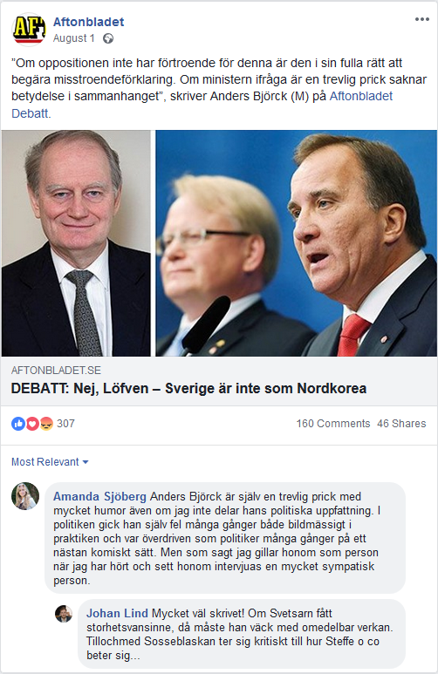

Amanda: Anders Björck himself is a nice guy with a lot of humor even though I do not share his political views. In politics, he himself was wrong many times both figuratively and literally, and went over the top as a politician many times in an almost comical way. But as I said, I like him as a person when I have heard and seen him in interviews, a very sympathetic person.

Johan: Very well written! If The Welder has illusions of grandeur, then he must resign immediately. Even the Social Democratic party’s own supporters are critical of how Steffe and company behave themselves...

Stimulus 4
Genre: Politics
Condition: Disagreement

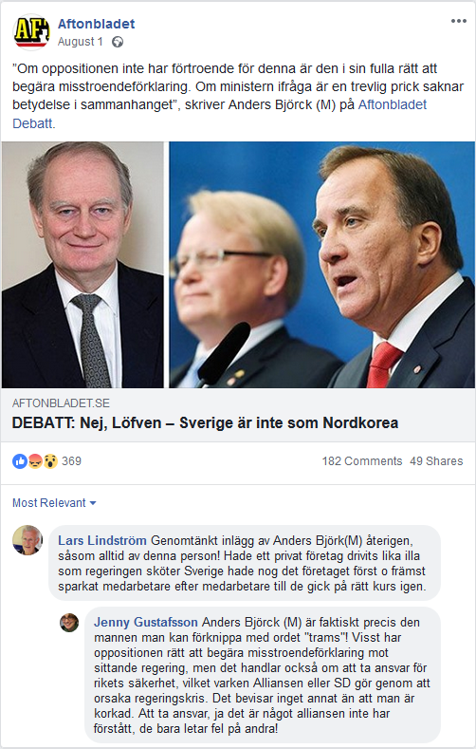
Lars: Well thought-out post by Anders Björk (M) again, as always by this person! If a private company had been run just as badly as the government is in Sweden, it probably would have first and foremost fired employee after employee until they got back on the right course again.

Jenny: Anders Björck (M) is actually exactly the man you can associate with the word "nonsense"! Sure, the opposition has the right to demand a declaration of no confidence against the incumbent government, but it is also about taking responsibility for the security of the kingdom, which neither the Alliance nor the SD does by causing a government crisis. It proves nothing else but being stupid. Taking responsibility, yes it is something the alliance has not understood, they only look for the wrong in others!

Stimulus 5
Genre: Politics
Condition: Agreement

Publisher Text: After Sweden Democrats’ gambit – the collapse continues for the Moderates, shows new poll from Aftonbladet/Inizio

Headline: New hit for AKB. Voters continue to run away from Anna Kinberg Batra

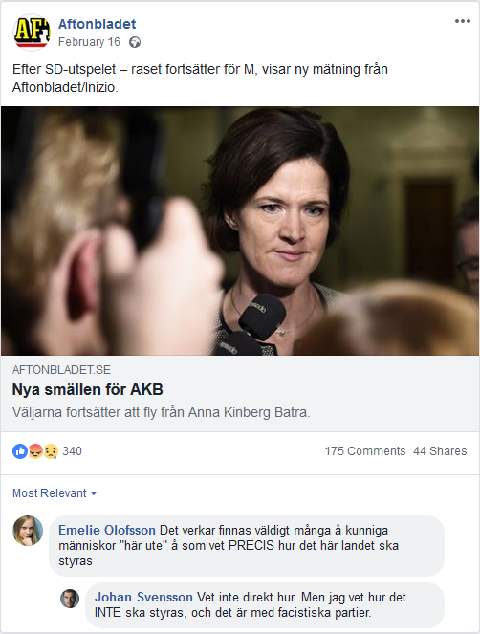

Emelie: There seem to be a lot of knowledgeable people “out here” who know EXACTLY how this country should be governed.

Johan: Don’t know exactly how. But I know how it should be NOT be governed, and that is with fascist parties.

Stimulus 6
Genre: Politics
Condition: Disagreement

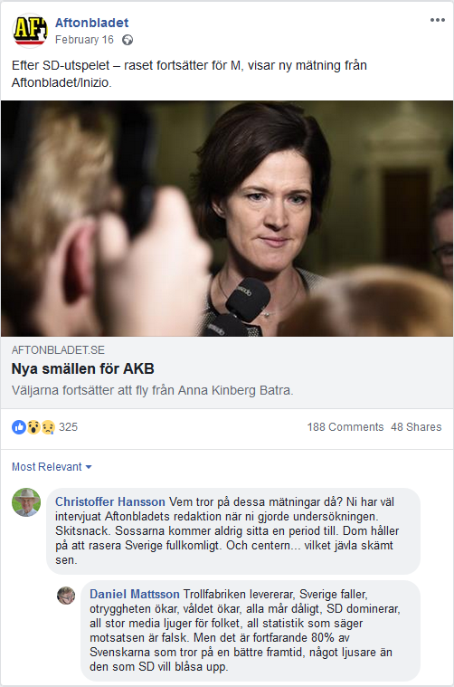

Christoffer: Who believes in these measurements then? You have interviewed Aftonbladets editorial staff when you did the survey. Bullshit. The Social Democrats will never sit for another term. They are about to completely demolish Sweden. And the center parties…what a fucking joke they are.

Daniel: The troll factory is delivering, Sweden is falling, insecurity is increasing, violence is increasing, everyone feels bad, SD dominates, all big media lies to the people. All statistics that say the opposite are false. But it is still 80% of Swedes who believe in a better future, somewhat brighter than the one SD wants to blow up.

Stimulus 7
Genre: Politics
Condition: Agreement

Publisher Text: In a short time several policemen and police offices were attacked. Now the prime minister reacts.

Headline: Löfven on police attacks: “They will never win – we will be tough.

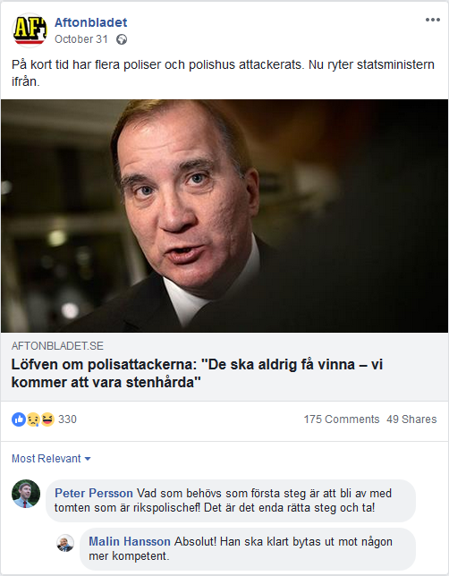

Peter: What is needed as a first step is to get rid of the goober who is the police chief! That is the right step to take!

Malin: Absolutely! He should clearly be replaced by someone more competent.

Stimulus 8
Genre: Politics
Condition: Disagreement

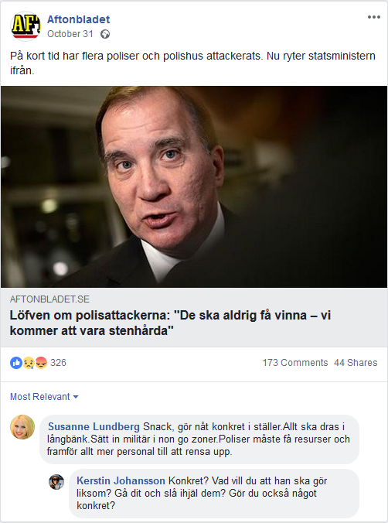

Susanne: You only talk, do something concrete instead. Everything will be delayed. Send the military in the no-go zones. The police needs to have resources, and above all more personnel to clean up.

Kerstin: Concrete? What will you have him do, like? Go there and kill them? Do you also do something concrete?

Stimulus 9
Genre: Economy
Condition: Agreement

Publisher Text: The tax refunds should have been paid out today. But bank customers have to wait.

Headline: The tax authority: There’s a problem with reimbursement payments.

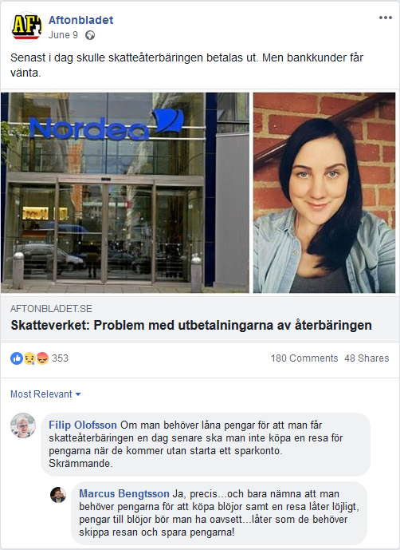

Filip: If you need to borrow money because you get the tax refund a day late, you should not buy a trip with the money without starting a savings account. Scary.

Marcus: Yes, exactly…and just mentioning that you need the money to buy diapers and a trip sounds ridiculous, money for diapers you should have whenever…sounds like they must skip the trip and save the money!

Stimulus 10
Genre: Economy
Condition: Disagreement

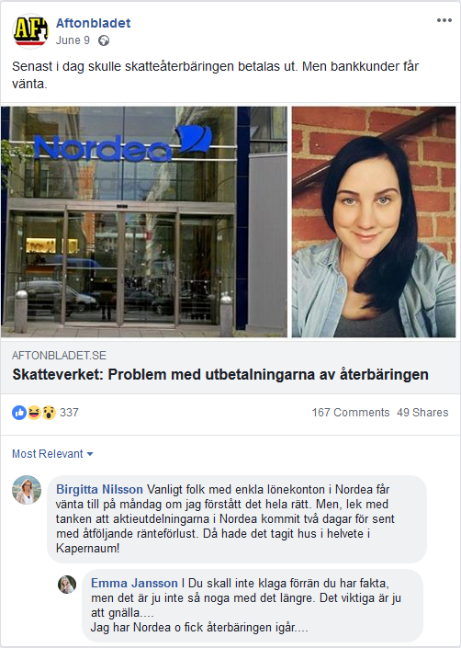

Birgitta: Ordinary people with simple payroll accounts at Nordea may have to wait until Monday if I understand it correctly. But, let’s entertain the idea that the dividends in Nordea came two days late with the respective loss of money from interest. Then all hell would break loose!

Emma: You should not complain before you have the facts, but that isn’t so much the case anymore. The important thing is to whine… I have Nordea and I got the refund yesterday….

Stimulus 11
Genre: Economy
Condition: Agreement

Publisher Text: When you donate to a charity through Swish, some of the money can end up with the banks.

Headline: Swish payments to charity give money to the banks

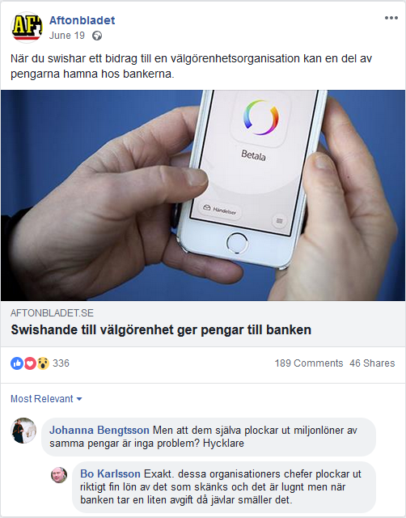

Johanna: But that they themselves pocket millions of the same money isn’t a problem? Hypocrites.

Bo: Exactly. The heads of these organizations pocket a really nice fee of what is donated and are silent, but when the bank takes out a small fee they get slammed.

Stimulus 12
Genre: Economy
Condition: Disagreement

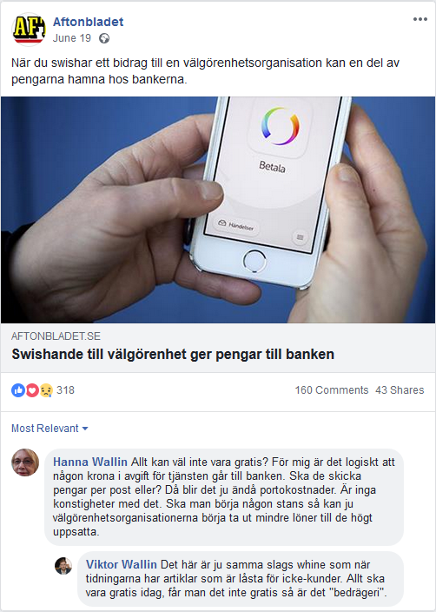

Hanna: Everything can’t be free? For me, it makes sense that some kroner goes to the bank as a service fee. Should they send money by post, or? Then there will be postage costs. There’s nothing weird about it. If you want to start somewhere, the charities can begin paying lower salaries to their high-ranked employees.

Viktor: This is the same kind of whining as when newspapers have articles that are unaccessible to non-subscribers. Everything should be free today, if you do not get it for free then it is “fraud”.

Stimulus 13

Genre: Economy

Condition: Agreement

Publisher Text: Soon the old coins will expire: Here’s how you can get rid of them in time.

Headline: Bjorn, 25, is getting rid of 1500 kroner in coins – here are his best tips.

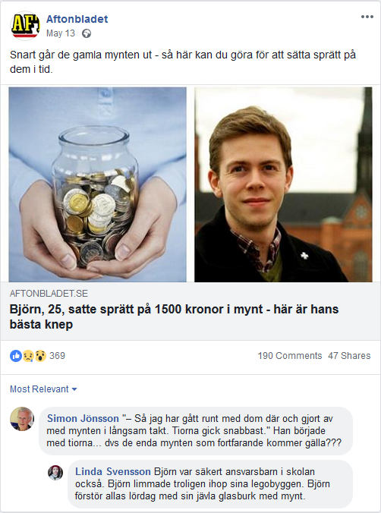

Simon: "– So I've walked around with them and done away with the coins at a slow pace. The tens went the fastest." He started with the tens ... i.e. the only coins that will still be valid???

Linda: Björn was certainly a responsible child in school too. Björn probably glued together his LEGOs. Björn ruins everyone’s Saturdays with his damn glass jar with coins.

Stimulus 14

Genre: Economy

Condition: Disagreement

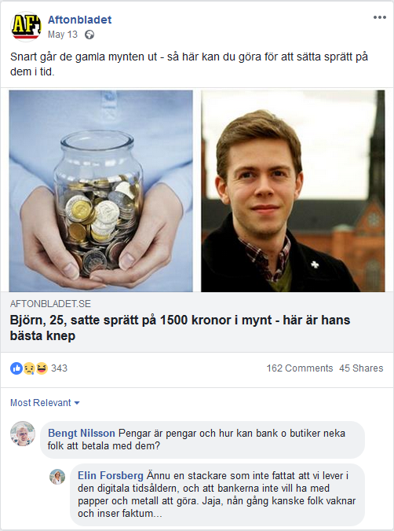

Bengt: Money is money and how can banks and stores deny people to pay with them?

Elin: Yet another poor soul who has not realized that we live in the digital age, and that banks do not want to deal with paper and metal. Well, someday people may wake up and realize that fact...

Stimulus 15

Genre: Economy

Condition: Agreement

Publisher Text: Customers are unaware of the upcoming airline stop

Headline: This airline stops flying in November – but continues selling tickets as if nothing happened.

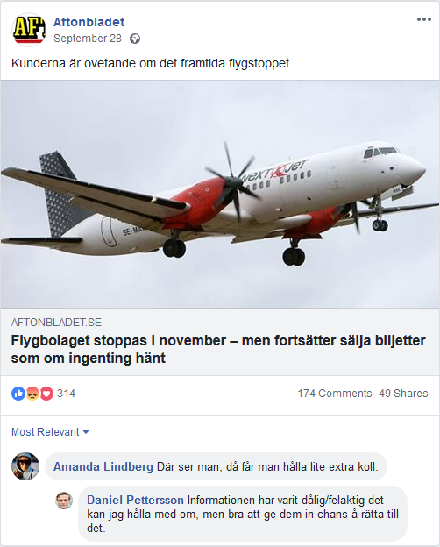

Amanda: Look at that, you have to pay a little extra attention.

Daniel: If the information has been bad/incorrect I can agree with them, but good to give them a chance to correct it.

Stimulus 16

Genre: Economy

Condition: Disagreement

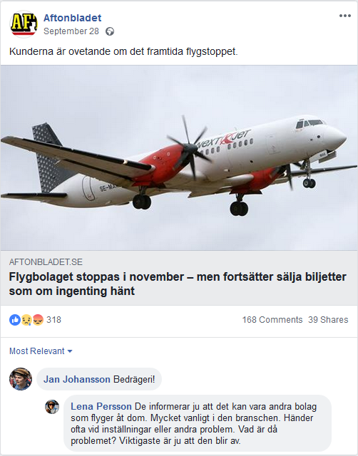

Jan: Fraud!

Lena: They inform of course that there may be other companies flying on their behalf. Very common in that industry. It often happens with cancelled flights or other problems. What is the issue then? The most important thing is that it works.

Stimulus 17
Genre: Society
Condition: Agreement

Publisher Text: Several media outlets around the world have reported that the kebab is under threat – but now comes a reassuring message. Tag a kebab lover who doesn’t have to worry.

Headline: All can breathe out – the EU won’t forbid kebabs

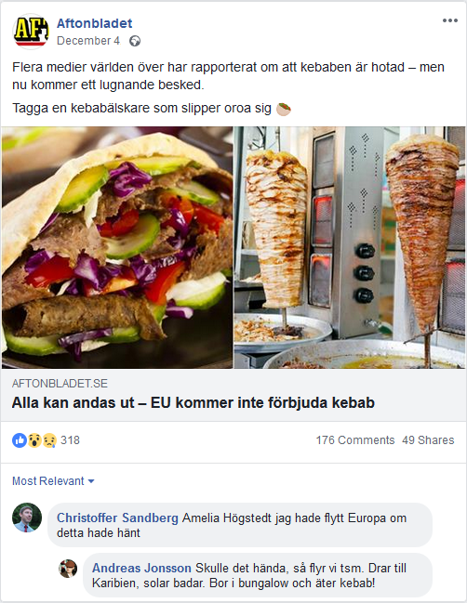

Christoffer: Amelia I would have moved from Europe if this happened

Andreas: Should that happen, we’re moving. Going to the Caribbean, sun-bathing, swimming. Living in a bungalow and eating kebab!

Stimulus 18
Genre: Society
Condition: Disagreement

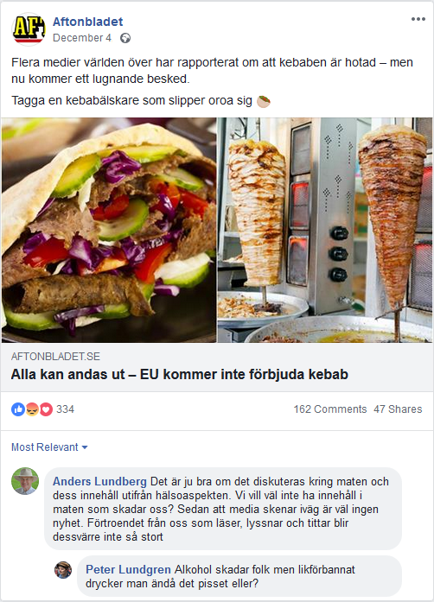

Anders: It is of course good to talk about food and its content from a health aspect. We don’t want to have content in the food that hurts us? That after that the media spins the story is nothing new. The confidence of those who read, listen, and watch isn’t unfortunately so great.

Peter: Alcohol hurts people, but damn, does one drink that piss or not?

Stimulus 19
Genre: Society
Condition: Agreement

Publisher Text: Lawyer: “Everything that allows you to think of something else for a while in there is good”

Headline: The jail goes along with Akilov’s requirements – he gets a chess computer

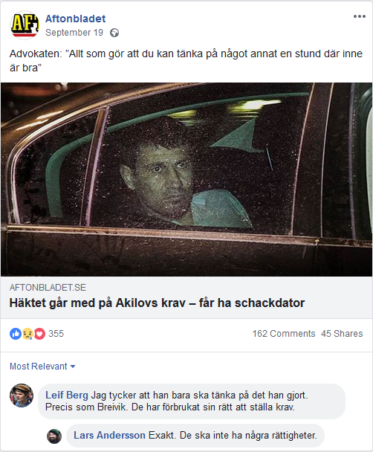

Leif: I think he should just think about what he has done. Just like Breivik. They have lost their right to make demands.

Lars: Exactly. They shouldn’t have any rights.

Stimulus 20
Genre: Society
Condition: Disagreement

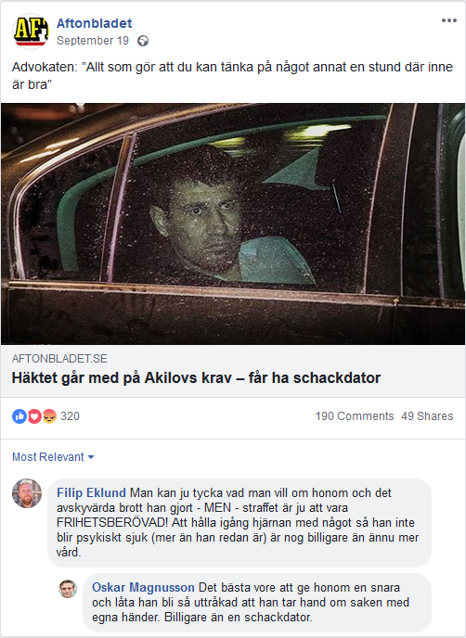

Filip: You can think what you want about him and the heinous crime he committed – BUT – the penalty is of course to be IMPRISONED! Keeping the brain going with something that so that he does not become mentally ill (more than he already is) is probably cheaper than additional healthcare.

Oskar: The best thing would be to give him a noose and let him get so bored that he takes of the matter with his own hands. Cheaper than a chess computer.

Stimulus 21
Genre: Society
Condition: Agreement

Publisher Text: The world health organization, WTO, wants to diagnose people who play games too much.

Headline: Proposal: Playing too much computer games should be classified as a health risk.

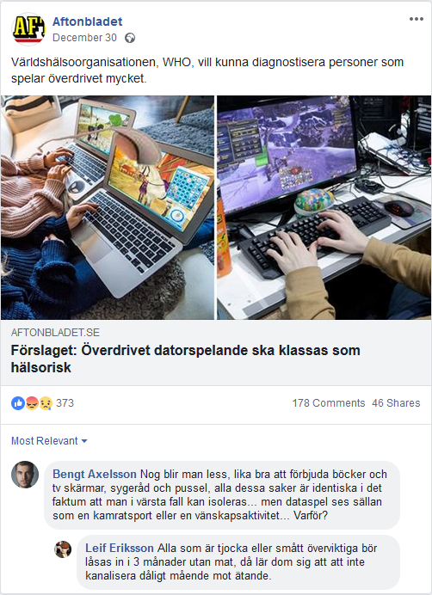

Bengt: Surely I’m disappointed, might as well ban books and TV screens, sewing advice and puzzles, all these things are equally likely in the worst case to make one isolated…but computer games are rarely seen as a team sport or a friend activity…Why?

Leif: Everyone who is fat should be locked away for 3 months without food, then they will not learn to cure bad moods through eating.

Stimulus 22
Genre: Society
Condition: Disagreement

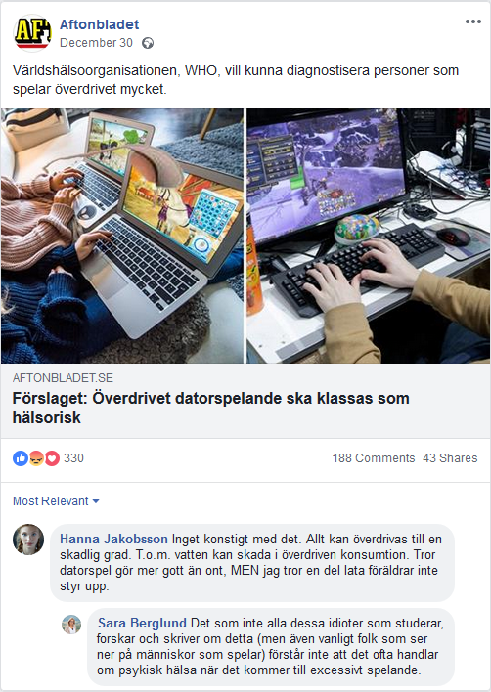

Hanna: Nothing strange about that. Everything can be exaggerated to a harmful extent. Even water can be harmful if overly consumed. I think computer games do more good than evil, BUT I think some lazy parents do not have it under control.

Sara: What all these idiots who study, research, and write about this (and even ordinary people who look down on gamers) do not understand is that it is often about mental health when it comes to excessive playing.

Stimulus 23
Genre: Society
Condition: Agreement

Publisher Text: New research busts the myth.

Headline: “A dog’s sense of smell is not better than humans’.”

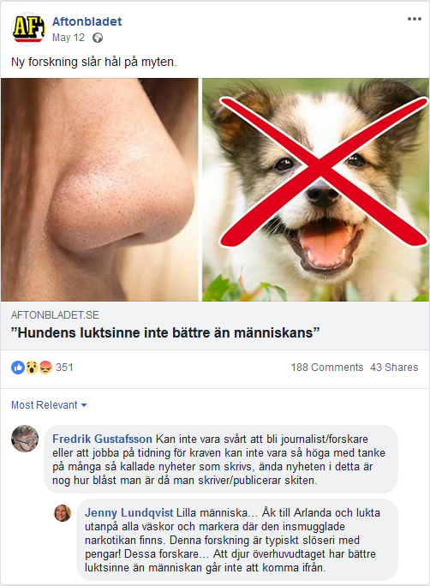

Fredrik: It cannot be hard to become a journalist/researcher or to work for a newspaper because the requirements cannot be so high considering the quality of much of the so-called news that is written. The only news in this article is showing how wasted one is when writing/publishing this shit.

Jenny: Little man, go to Arlanda and smell all the bags and mark where the smuggled drugs are. This research is a typical waste of money! These scientists…the fact that animals in general have a better sense of smell than humans can’t be avoided.

Stimulus 24
Genre: Society
Condition: Disagreement

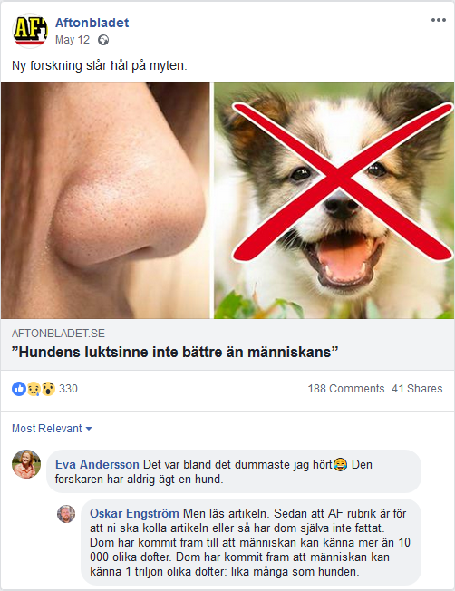

Eva: This is the one of the dumbest things I have heard. That researcher has never owned a dog.

Oskar: But read the article. Since the AF heading is for you to check out the article or they haven’t read it themselves. They have come to the conclusion that man can detect more than 10,000 different scents. They have come to the conclusion that man can sense 1 trillion different scents: as many as the dog.

Stimulus 25
Genre: Entertainment
Condition: Agreement

Publisher Text: Finally a new season! The SVT-series is set to start again.

Headline: Here are the participants in “All for Sweden” 2017

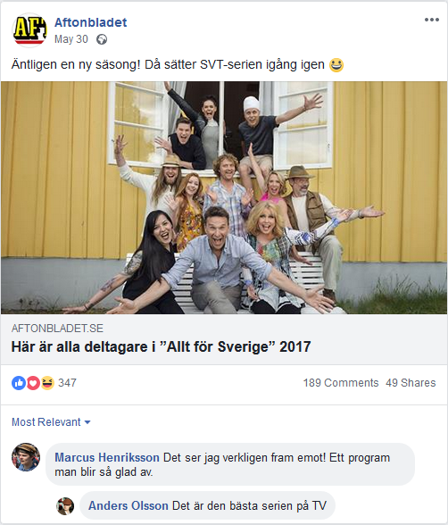

Marcus: I am really looking forward to it! A program that makes you so happy.

Anders: This is the best series on TV

Stimulus 26
Genre: Entertainment
Condition: Disagreement

Linda: Fun and touching – everyone cries. But the “lessons” about Sweden are embarrassing, with stupid generalizations and simplifications. Time for them to meet real people who can give a truer picture.

Mikael: They are not, Anders Lundin is very competent and educated and knows what he’s talking about.

Stimulus 27
Genre: Entertainment
Condition: Agreement

Publisher Text: Municipality: “I have always thought that it is an exciting idea.”

Headline: After the abuse – now a festival without men is being organized.

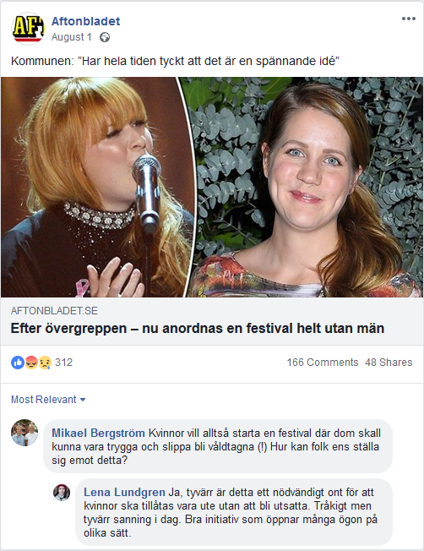

Mikael: So women want to start a festival where they can be safe and not be raped (!) How can people even oppose this?

Lena: Yes, unfortunately this is a necessary evil for women to be allowed out without being vulnerable. Tragic but the sad truth today. Good initiative that opens many eyes in different ways.

Stimulus 28
Genre: Entertainment
Condition: Disagreement

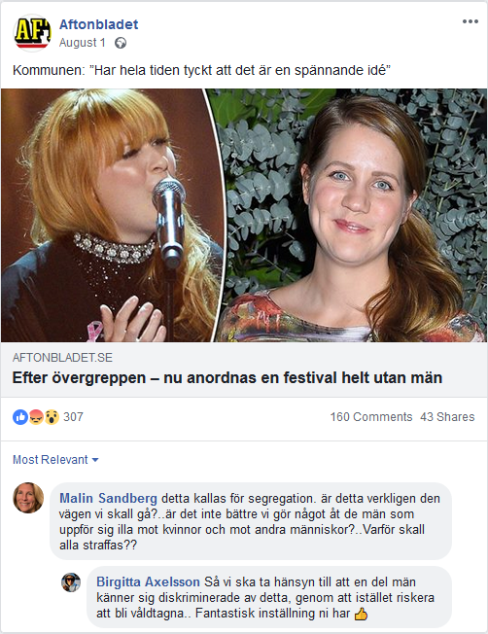

Malin: This is called segregation. Is this really the way we should go? ..is it not better we do something to men who behave badly against women and other people?..Why should everyone be punished?

Birgitta: So we have to take into account that some men feel discriminated against, by risking to be raped instead? Fantastic attitude you have.

Stimulus 29
Genre: Entertainment
Condition: Agreement

Publisher Text: She loves her idol so much that she has done all she can to be her copy.

Headline: She had 50 operations – to look like her idol. The 19-year old Sahar Tabar’s highest wish is to look like Angelia Jolie.

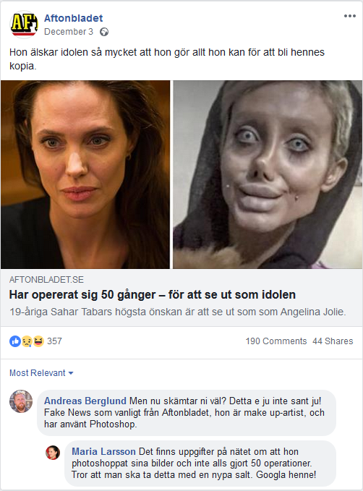

Andreas: But you’re joking, right? This is not true, of course! Fake news as usual from Aftonbladet, she is a make-up artist and has used Photoshop.

Maria: There is information on the internet that she photoshopped her pictures and has not done 50 operations. I think you should take this with a grain of salt. Google her!

Stimulus 30
Genre: Entertainment
Condition: Disagreement

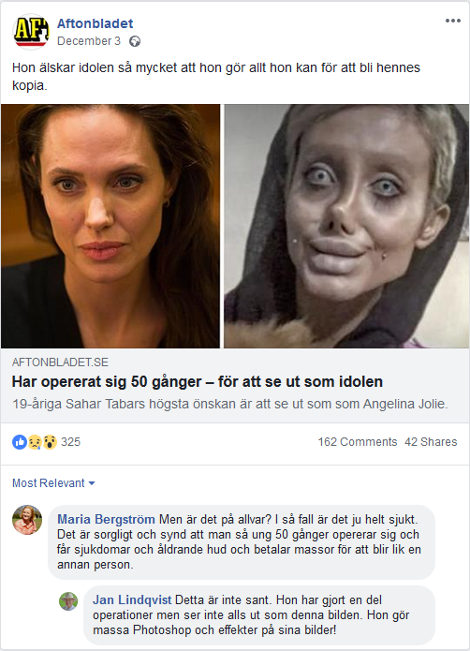

Maria: But is this serious? In that case, it is totally sick. It is sad and a pity that one so young does 50 operations on herself and is getting sick and aging skin and pays lots of money to look like another person.

Jan: It’s not true. She has done some surgery but does not look like this picture at all. She does a lot of Photoshop and effects on her pictures!

Stimulus 31
Genre: Entertainment
Condition: Agreement

Publisher Text: Sweden’s only rock king is back.

Headline: Thåström is back with a new album and tour

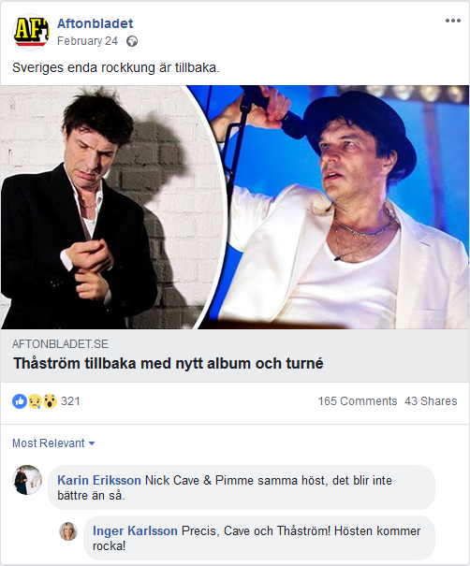

Karin: Nick Cave & Pimme during the same autumn, it doesn’t get any better than that!

Inger: Precisely. Cave and Thåström! This autumn is going to rock!

Stimulus 32
Genre: Entertainment
Condition: Disagreement

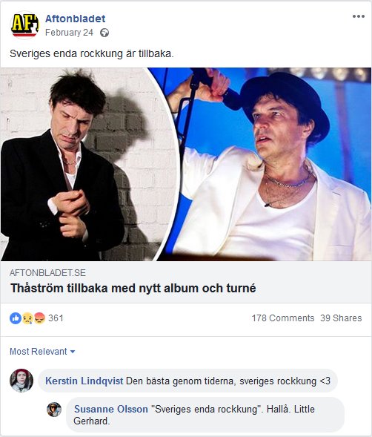

Kerstin: The best of all time, Sweden’s rock king <3

Susanne: "Sweden’s only rock king.” Hello. Little Gerhard.

Stimulus 33
Genre: Sports
Condition: Agreement

Publisher Text: Lovely, Anna!

Headline: Anna Holmlund has her first public appearance – since the accident.

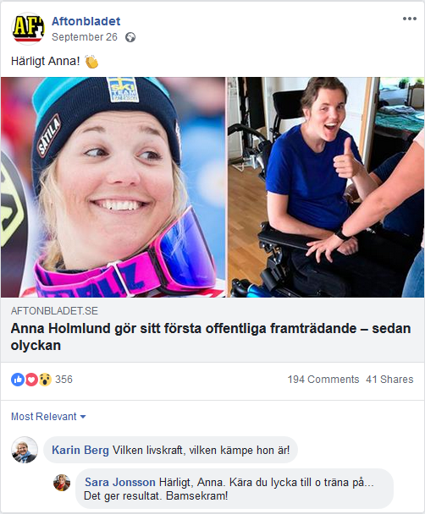

Karin: What a vitality, what a fighter she is!

Sara: Lovely, Anna. Wishing you good luck in training, it gives results. Big hug!

Stimulus 34
Genre: Sports
Condition: Disagreement

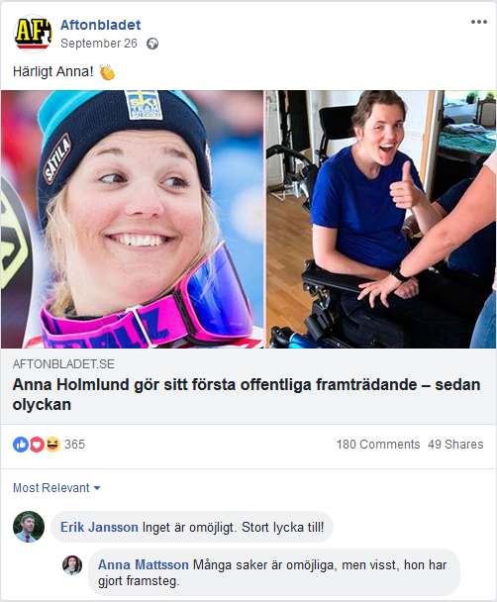

Erik: Nothing is impossible. Good luck!

Anna: Actually, many things are impossible, but sure, she has made progress.

Stimulus 35
Genre: Sports
Condition: Agreement

Publisher Text: Bingolotto’s celebration night is a big success for Leksand’s goalkeeper Tex Williamsson.

Headline: Leksand’s goalkeeper wins a million [kroner] – at the lottery.

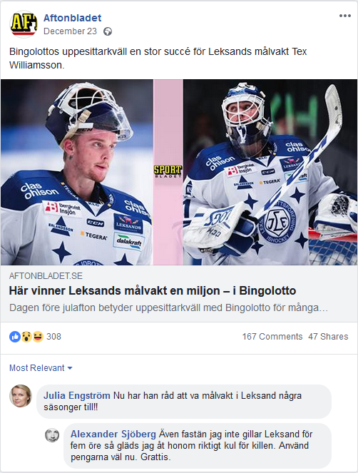

Julia: Now he can afford to be a goalkeeper in Leksand a few more seasons!

Alexander: Even though I don’t like Leksand for five cents, I’m really glad for the guy. Use the money well now. Congrats.

Stimulus 36
Genre: Sports
Condition: Disagreement

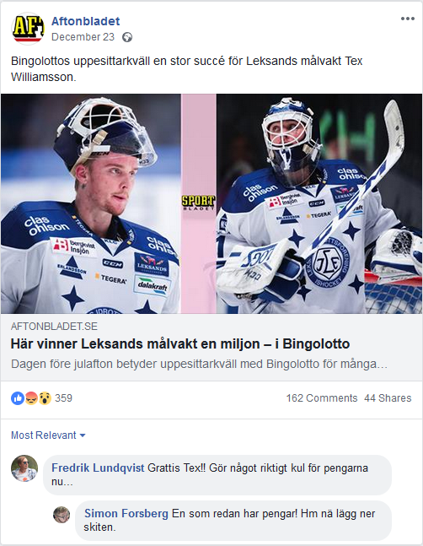

Fredrik: Congrats Tex!! Do something really cool with the money now…

Simon: He already has money! Hm, deposit that shit.

Stimulus 37
Genre: Sports
Condition: Agreement

Publisher Text: Färjestads’ fans sing mocking chants about the deceased goalkeeper hero – now the club is cracking down.

Headline: Supporters are denied entry after the mockery of Stefan Liv: “Won’t get to see live hockey for a long time”

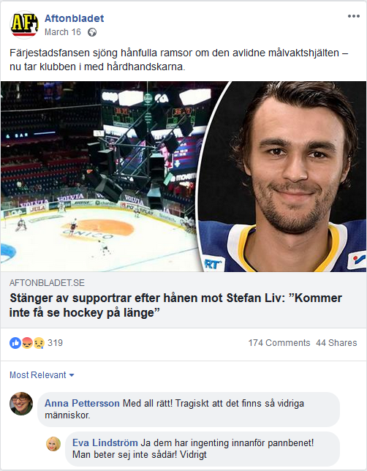

Anna: Rightly so! Tragic that there exists such disgusting people.

Eva: Yes they have nothing behind their forehead! You don’t behave like that! Sickening

Stimulus 38
Genre: Sports
Condition: Disagreement

NOTE: This stimulus was not shown because of an error. Instead, the previous stimulus (the same article, with comments in the agreement condition) was shown twice.

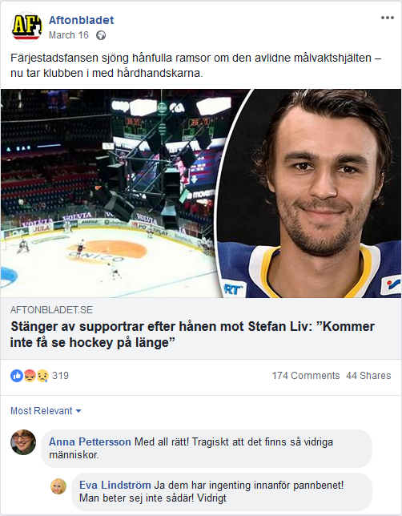

Anna: As usual, only Stockholm clubs that behave badly in sports arenas. Everything else is FAKE NEWS!

Eva: Only a bitter Stockholm supporter could write something so damn stupid.

Stimulus 39
Genre: Sports
Condition: Agreement

Publisher Text: This is how the international swimming association Fina highlights its branch of artistic swimming during the ongoing world championship.

Headline: Raging against their own union’s sexism. “Very humiliating – totally disrespectful”

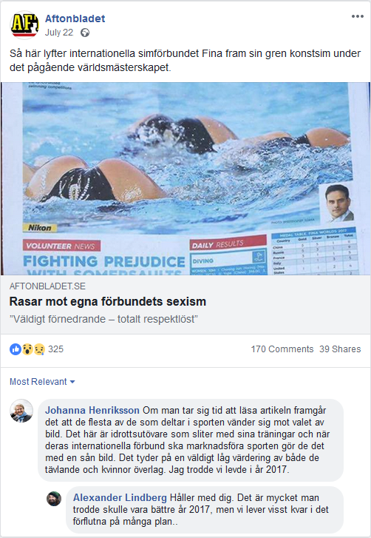

Johanna: If you take the time to read the article, it appears that most of those who participate in the sport are against the choice of picture. These are athletes who make sacrifices by training hard and when their international federation promote the sport, they do so with such a picture. This indicates a very low value of both the contestants and women overall. I thought we lived in the year 2017.

Alexander: I agree with you. There’s a lot you thought would be better in 2017, but we certainly live in the past on many levels.

Stimulus 40
Genre: Sports
Condition: Disagreement

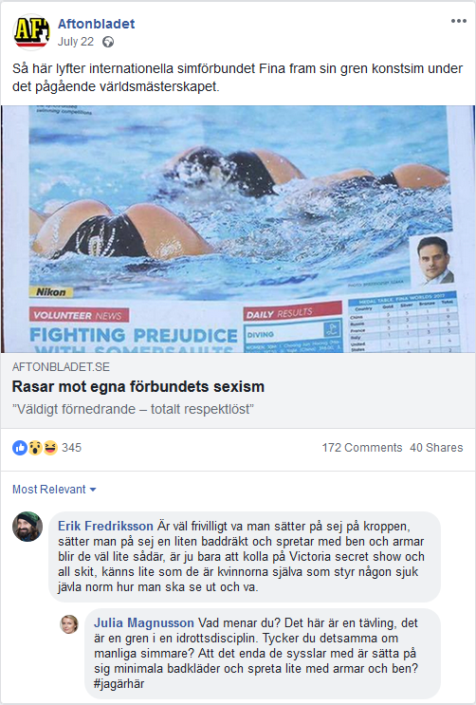

Erik: It’s voluntary what one puts on their body, and you put on a small swimsuit and paddle with their legs and arms it becomes a bit like this, just look at a Victoria Secret show and all that crap, feels a bit like it’s the women themselves who control some sick fucking norm about how to look and be.

Julia: What do you mean? This is a competition, it’s a sport . Do you think the same of male swimmers? That the only thing they are doing is putting on minimal swimwear and paddle a little with their arms and legs? #iamhere

