Additional file
to
In-situ pilot application of nZVI embedded in activated carbon for remediation of chlorinated ethene contaminated groundwater: effect on microbial communities

Marie Czinnerova ¹, Nhung H.A. Nguyen ¹, Jan Nemecek ¹, Katrin Mackenzie ², Christopher Boothman ³, Jonathan Lloyd ³, Tamas Laszlo ⁴, Roman Spanek ¹, Miroslav Cernik ¹, Alena Sevcu *¹

¹Institute for Nanomaterials, Advanced Technologies and Innovation, Technical University of Liberec, Studentská 2, CZ-461 17 Liberec, Czech Republic
²Helmholtz Centre for Environmental Research – UFZ, Department of Environmental Engineering, D-04318 Leipzig, Germany
³School of Earth and Environmental Sciences, University of Manchester M13 9PL, United Kingdom
⁴Golder Associates, Hüvösvölgyi út 54, 1021 Budapest, Hungary
*Correspondence: alena.sevcu@tul.cz

Number of pages: 3
Number of figures: 1
Number of tables: 1

Table S1. Specific primer pairs used for qPCR method
Name | Sequence (5′→3′) | Product size (bp) | Tm  (°C) | Target organism(s); gene(s) | Reference
U16SRT-F | ACTCCTACGGGAGGCAGCAGT | 180 | 60 | Bacteria;  16S rRNA genes | [1]
U16SRT-R | TATTACCGCGGCTGCTGGC
vcrA880F | CCCTCCAGATGCTCCCTTTA | 139 | 60 | Dehalococcoides sp. strain VS; vcrA | [2]
vcrA1018R | ATCCCCTCTCCCGTGTAACC
bvcA277F | TGGGGACCTGTACCTGAAAA | 247 | 60 | Dehalococcoides sp. strain BAV-1; bvcA | [2]
bvcA523R | CAAGACGCATTGTGGACATC
Dsb406F | GTACGACGAAGGCCTTCGGGT | 213 | 60 | Desulfitobacterium sp.; 16S rRNA genes | [3]
Dsb619R | CCCAGGGTTGAGCCCTAGGT
DHC793f | GGGAGTATCGACCCTCTCTG | 191 | 60 | Dehalococcoides sp.;  16S rRNA genes | [4]
DHC946r | CGTTYCCCTTTCRGTTCACT
RTC-f | ACCCTGGTCGGTGTKSTYTC | 106 | 60 | ethenotrophs; α subunit of AkMO, EtnC | [5]
RTC-r | TCATGTAMGAGCCGACGAAGTC
RTE-f | CAGAAYGGCTGYGACATYATCCA | 151 | 60 | ethenotrophs; α subunit of EaCoMT, EtnE | [5]
RTE-r | CSGGYGTRCCCGAGTAGTTWCC
Dre441F | GTTAGGGAAGAACGGCATCTGT | 205 | 55 | Dehalobacter sp.; 16S rRNA genes | [3]
Dre645R | CCTCTCCTGTCCTCAAGCCATA
Dhg1243f | GGYACAATGGGTTGCCACCGG | 127 | 68 | Dehalogenimonas sp.; 16S rRNA genes | [6]
Dhg1351r | AACGCGCTATGCTGACACGCGT
Gall-122F-H | ATATCGGAACATATCCGGAAGT | 262 | 60 | Gallionella ferruginea; 16S r RNA gene | [7]
Gall-384R-H | GGTATGGCTGGATCAGGC
Geo564f | AAGCGTTGTTCGGAWTTAT | 276 | 55 | Geobacteraceae; 16S r RNA genes | [8]
Geo840r | GGCACTGCAGGGGTCAATA

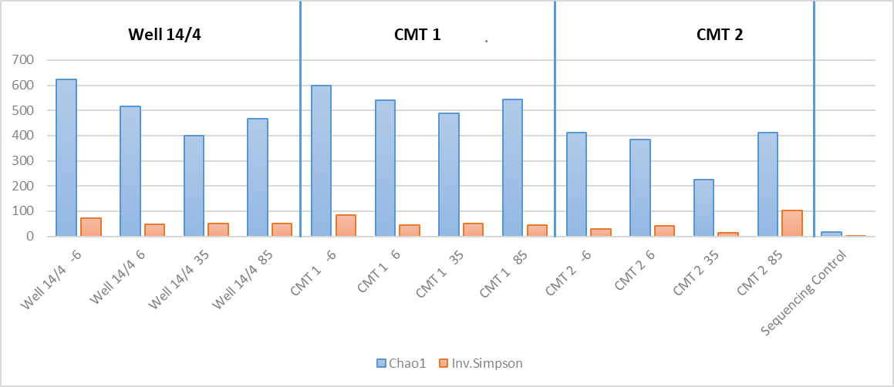
Figure S1. Alpha-diversity measures: comparison of wells based on Chao 1 and Inv. Simpson alpha-diversity indexes.

References
1. Clifford RJ, Milillo M, Prestwood J, Quintero R, Zurawski DV, Kwak YI, Waterman PE, Lesho EP, Mc Gann P (2012) Detection of bacterial 16S rRNA and identification of four clinically important bacteria by real-time PCR. PLoS ONE 7: . https://doi.org/10.1371/journal.pone.0048558
2. Behrens S, Azizian MF, McMurdie PJ, Sabalowsky A, Dolan ME, Semprini L, Spormann AM (2008) Monitoring abundance and expression of “Dehalococcoides” species chloroethene-reductive dehalogenases in a tetrachloroethene-dechlorinating flow column. Appl Environ Microbiol 74:5695–5703 . https://doi.org/10.1128/AEM.00926-08
3. Smits TH., Devenoges C, Szynalski K, Maillard J, Holliger C (2004) Development of a real-time PCR method for quantification of the three genera Dehalobacter, Dehalococcoides, and Desulfitobacterium in microbial communities. J Microbiol Methods 57:369–378 . https://doi.org/10.1016/j.mimet.2004.02.003
4. Yoshida N, Takahashi N, Hiraishi A (2005) Phylogenetic characterization of a polychlorinated-dioxin- dechlorinating microbial community by use of microcosm studies. Appl Environ Microbiol 71:4325–4334 . https://doi.org/10.1128/AEM.71.8.4325-4334.2005
5. Jin YO, Mattes TE (2010) A quantitative PCR assay for aerobic, vinyl chloride- and ethene-assimilating microorganisms in groundwater. Environ Sci Technol 44:9036–9041 . https://doi.org/10.1021/es102232m
6. Chen J, Bowman KS, Rainey FA, Moe WM (2014) Reassessment of PCR primers targeting 16S rRNA genes of the organohalide-respiring genus Dehalogenimonas. Biodegradation 25:747–756 . https://doi.org/10.1007/s10532-014-9696-z
7. Heinzel E, Janneck E, Glombitza F, Schlömann M, Seifert J (2009) Population dynamics of iron-oxidizing communities in pilot plants for the treatment of acid mine waters. Environ Sci Technol 43:6138–6144 . https://doi.org/10.1021/es900067d
8. Cummings DE, Snoeyenbos-West OL, Newby DT, Niggemyer AM, Lovley DR, Achenbach LA, Rosenzweig RF (2003) Diversity of geobacteraceae species inhabiting metal-polluted freshwater lake sediments ascertained by 16S rDNA analyses. Microb Ecol 46:257–269 . https://doi.org/10.1007/s00248-005-8002-3

