Coastal Ocean Darkening Effects via Terrigenous DOM Addition on Plankton: An Indoor Mesocosm Experiment
Nur Ili Hamizah Mustaffa*†, Liisa Kallajoki, Johanna Biederbick, Franziska Isabell Binder, Alexandra Schlenker†, and Maren Striebel
Institute for Chemistry and Biology of the Marine Environment (ICBM), Carl von Ossietzky University of Oldenburg, Schleusenstrasse 1, 26382 Wilhelmshaven, Germany
*Correspondence:
Nur Ili Hamizah Mustaffa (Email:iliehamizah@gmail.com)

†Present address:
Nur Ili Hamizah Mustaffa
Department of Earth Sciences and Environment, Faculty of Science and Technology, Universiti Kebangsaan Malaysia, Selangor, Malaysia
Alexandra Schlenker
Department of River Ecology, Helmholtz Centre for Environmental Research (UFZ), Magdeburg, Germany
Institute for Hydrobiology, Technical University of Dresden, Dresden, Germany

Supplementary Figure 1. Schematic overview of light and tidal cycles. Light intensity (in %, blue line) and tidal cycle (red line) measured between day 7 (16th August 2017) and day 13 (22nd August 2017). Day time included a sunrise (one hour of 10% light intensity [60 µmol m^{–2} s^{–1}] followed by one hour of 30% light intensity [180 µmol m^{–2} s^{–1}] and 14 hours of 50% light intensity [300 µmol m^{–2} s^{–1}] followed by a sunset (one hour of 30% and one hour of 10% light intensity). The tidal cycle consisted of alternating high tide and low tide occurrences each lasting 6:15 hours leading to a shift of one hour a day.

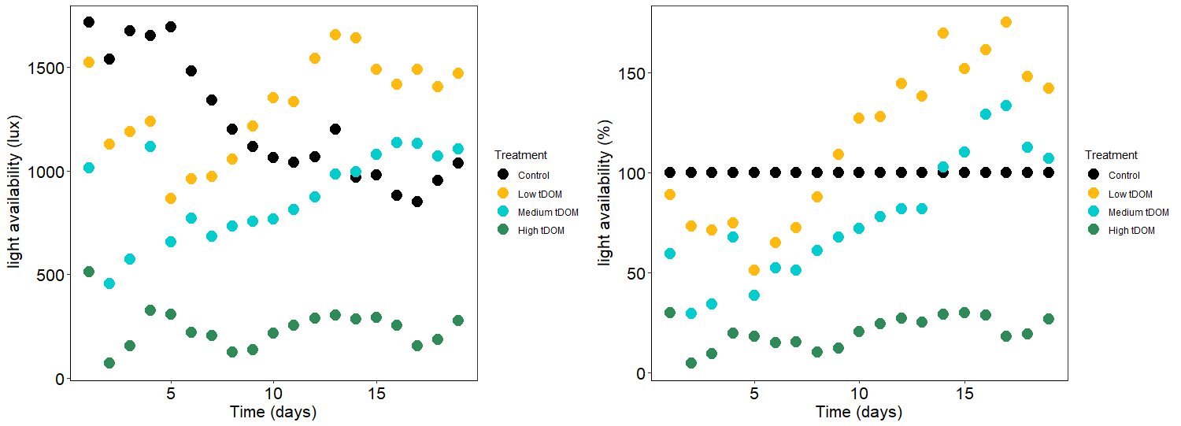
Supplementary Figure 2. A) Absolute light intensity (lux) and (B) the relative amount of light (%) in all treatment during the first half of the experiment. Colors indicate treatments: Black (control), Yellow (low tDOM), green (medium tDOM) and blue (high tDOM).

Supplementary Figure 3. A) In situ light intensity (lux) measured directly above of the sediment at the control (black), low tDOM (yellow), medium tDOM (blue) and high tDOM (green) treatments on day 7 (16th August 2017, shortly after the tDOM addition) when low tide was in the middle of the day. B) Light intensity (lux¹) measured above the sediment in the control (black), low tDOM (yellow), medium tDOM (blue) and high tDOM (green) treatments on day 13 (22nd August 2017) when high tide was in the middle of the day. Red lines (right axis) represent the tidal cycle of the respective day.

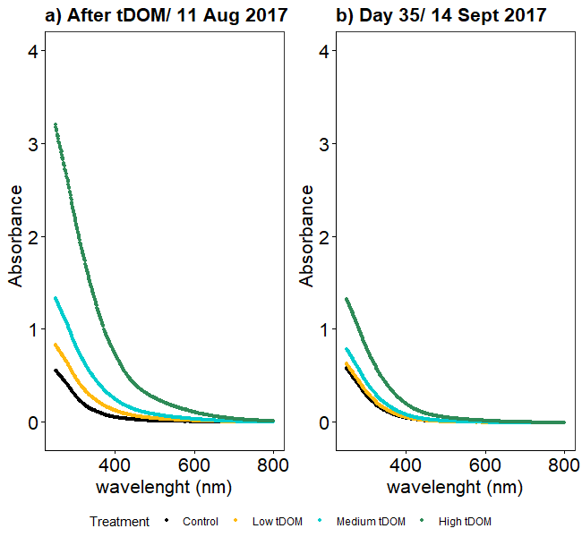
Supplementary Figure 4. Absorbance A) immediately after tDOM was added (11 August 2017) and B) on Day 35 (14 September 2017). Colors represent treatments:control (Black), low tDOM (Yellow), medium tDOM (green) and high tDOM (blue).

Supplementary Figure 5. Correlation between phytoplankton biomass (Chlorophyl a in µg L⁻¹) and phytobenthos biomass (µg cm⁻²) in different tDOM treatments. Colors indicate treatments: Black (control), Yellow (low tDOM), green (medium tDOM) and blue (high tDOM).

Supplementary Figure 6. Bacterial cell count (mL⁻¹) on days 7, 11 and 14 of the experiment.
Colors indicate treatments: Black (control), Yellow (low tDOM), green (medium tDOM) and blue (high tDOM).

