Supplementary Material

GOVERNING EQUATIONS OF THE NUMERICAL MODEL
Physical model:
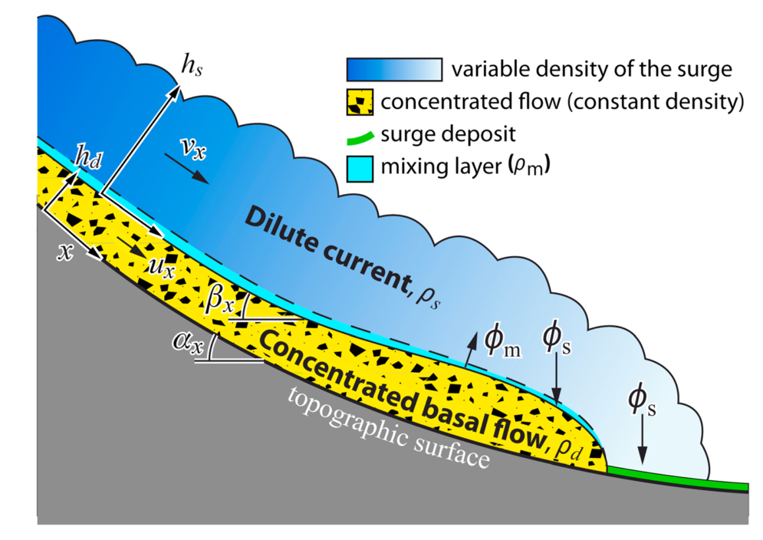
The model is based on two coupled depth-averaged simulations: one for the pyroclastic flow (concentrated basal flow, Fig. 1), one for the overriding ash-cloud surge (dilute current, Fig. 1). The two parts are connected by exchange laws that simulate particles entrainment from the flow to the surge (flux φ_{m}), and sedimentation from the ash-cloud surge to the ground (deposits or flows, flux φ_{s}). The model has been described in detail by Kelfoun (2017) and is summarized in the following. The symbols used and their variables significations are listed in table 1.

Figures 1: Flow diagram of the model. The concentrated flow loses a mass flux ϕs of density ρ_{m} that forms the dilute current (surge). The dilute current is of variable density and loses a mass flux ϕs that can form a concentrated flow or a deposit. From Kelfoun (2017).

Concentrated flow:
The dynamics of the concentrated flow is calculated by solving depth-averaged equations of mass [1] and momentum balance along x in [2] and y in [3], taking into account the mass of the particles exchanged with the dilute part:
$\frac{∂h_{d}}{∂t}+\frac{∂}{∂x}\left(h_{d}u_{x}\right)+\frac{∂}{∂y}\left(h_{d}u_{y}\right)=\frac{ϕ_{s}-ϕ_{m}}{ρ_{d}}$ [1]
$\frac{∂}{∂t}\left(h_{d}u_{x}\right)+\frac{∂}{∂x}\left(h_{d}u_{x}^{2}\right)+\frac{∂}{∂y}\left(h_{d}u_{x}u_{y}\right)=gh_{d}\sin{α_{x}}-\frac{1}{2}\frac{∂}{∂x}\left(gh_{d}^{2}\cos{α_{x}}\right)+\frac{T_{x}}{ρ_{d}}+\frac{ϕ_{s}}{ρ_{d}}×v_{x}-\frac{ϕ_{m}}{ρ_{d}}×u_{x}$ [2]
$\frac{∂}{∂t}\left(h_{d}u_{y}\right)+\frac{∂}{∂x}\left(h_{d}u_{x}u_{y}\right)+\frac{∂}{∂y}\left(h_{d}u_{y}^{2}\right)=gh_{d}\sin{α_{y}}-\frac{1}{2}\frac{∂}{∂y}\left(gh_{d}^{2}\cos{α_{y}}\right)+\frac{T_{y}}{ρ_{d}}+\frac{ϕ_{s}}{ρ_{d}}×v_{y}-\frac{ϕ_{m}}{ρ_{d}}×u_{y}$ [3]
is the basal stress of the pyroclastic flow and is described in the article, as well as the terms $ϕ_{m}$ and $ϕ_{s}$, which represent the mass exchanges between the pyroclastic flow and the surge. $α_{x}$ and $α_{y}$ are the slope of the topographic surface in the x and y direction.
To model the physical behavior of a concentrated flow, the pseudo-plastic rheology is used. This rheology considers the flow to behave as a pseudo-fluid with a yield strength (i.e. a Bingham flow with no viscosity) also called in our case the constant retarding stress. The plastic law needs to be combined with a Voellmy-type resistive stress, as shown by Kelfoun (2011, 2017), Charbonnier et al. (2013), and Gueugneau et al., (2019). The basal stress for this rheology is calculated by:
$T=T\frac{u}{\left\|u\right\|}-c_{1}ρ_{d}\left\|u\right\|u$ [4]
where the first term on the right-hand side is the plastic stress and the second term is the Voellmy stress term. With the plastic rheology, the stresses are assumed to be isotropic. The concentrated flow is considered to form a deposit where its velocity falls to zero.

Ash-cloud surge:
Because the ash-cloud surge density $ρ_{s}$ varies in time and space, a fourth governing equation, the density balance, must be added. The ash-cloud surge is then simulated by solving equations of mass [5], density [6] and momentum balance [7] and [8]:
$\frac{∂h_{s}}{∂t}+\frac{∂}{∂x}\left(h_{s}v_{x}\right)+\frac{∂}{∂y}\left(h_{s}v_{y}\right)=\frac{ϕ_{m}}{ρ_{m}}$ [5]
$\frac{∂ρ_{s}h_{s}}{∂t}+\frac{∂}{∂x}\left(ρ_{s}h_{s}v_{x}\right)+\frac{∂}{∂y}\left(ρ_{s}h_{s}v_{y}\right)=ϕ_{m}-ϕ_{s}$ [6]
$$\frac{∂}{∂t}\left(ρ_{s}h_{s}v_{y}\right)+\frac{∂}{∂x}\left(ρ_{s}h_{s}v_{x}v_{y}\right)+\frac{∂}{∂y}\left(ρ_{s}h_{s}v_{y}^{2}\right)=$$$\left(ρ_{s}-ρ_{a}\right)gh_{s}\sin{β_{y}}-\frac{1}{2}\frac{∂}{∂y}\left(\left(ρ_{s}-ρ_{a}\right)gh_{s}^{2}\cos{β_{y}}\right)+R_{y}+ϕ_{m}u_{y}-ϕ_{s}v_{y}$ [7]
$$\frac{∂}{∂t}\left(ρ_{s}h_{s}v_{x}\right)+\frac{∂}{∂x}\left(ρ_{s}h_{s}v_{x}^{2}\right)+\frac{∂}{∂y}\left(ρ_{s}h_{s}v_{x}v_{y}\right)=$$$\left(ρ_{s}-ρ_{a}\right)gh_{s}\sin{β_{x}}-\frac{1}{2}\frac{∂}{∂x}\left(\left(ρ_{s}-ρ_{a}\right)gh_{s}^{2}\cos{β_{x}}\right)+R_{x}+ϕ_{m}u_{x}-ϕ_{s}v_{x}$ [8]
R = (R_{x}, R_{y}) is the basal stress of the surge, also described in the article. $β_{x}$ and $β_{y}$ are the slopes of the surface covered by the ash-cloud surge (topography plus pyroclastic flows and deposits) in the x and y directions. The mass lost by the ash-cloud surge through the sedimentation either settle back to the pyroclastic flow, or accumulate on the ground forming a deposit or a surge-derived pyroclastic flow, all being simulated by equations [1] to [3].
The ash-cloud surge is assumed to be a turbulent gas-particle mixture. Its turbulent resistive stresses R are calculated by:
$R=-c_{2}ρ_{s}\left\|v\right\|v$ [6]
No air entrainment or temperature effects are taken explicitly into account in the model, due to uncertainties on how to incorporate these processes in such a simplified depth-averaged two phase model.

Exchanges laws:
To couple the two simulated flows, the model includes mass and momentum transfers between the concentrated layer and the overriding surge layer. For that, the ash-cloud surge is generated from the concentrated flow using a mass flux:
$ϕ_{m}=c_{3} u^{3}$ [9]
Then particles from the ash-cloud surge settle with a mass flux:
$ϕ_{s}=\left(ρ_{s}-ρ_{a}\right) w_{sed}$ [10]
Following Eq. 10, surge particles either (i) settle back into the concentrated flow, (ii) accumulate on the ground as a deposit or (iii) accumulate to form a surge-derived pyroclastic flow (Fig. 3). The sedimentation velocity $w_{sed}$ is defined by:
$w_{sed}≃\sqrt{\frac{4\left(ρ_{p}-ρ_{g}\right)gd}{3C_{d}ρ_{g}}}$ [11]
(le Roux, 1992; Sparks et al., 1997; Dellino et al., 2005) where, d is the particle mean diameter and C_{d} is the particle drag coefficient.
Table 1: List of parameters using in the governing equations associated to their symbol.
Parameters Symbols
Space dimensions
Topographic slope in the x direction
Topographic slope in the y direction
Total slope in the x direction
Total slope in the y direction
Basal stresses of the pyroclastic flow $T=(T_{x},T_{y})$
Basal stresses of the ash-cloud surge $R=(R_{x},R_{y})$
Concentrated flow velocities $u=(u_{x},u_{y})$
Ash-cloud surge velocities $v=(v_{x},v_{y})$
Thickness of the pyroclastic flow or the deposit $h_{d}$
Ash cloud surge thickness $h_{s}$
Particle density $ρ_{p}$
Atmosphere density $ρ_{a}$
Density of the pyroclastic flow or the deposit $ρ_{d}$
Gas surge density $ρ_{g}$
Mixture density $ρ_{m}$
Bulk density of the ash-cloud surge $ρ_{s}$
Entrainement mass flux $ϕ_{m}$
Sedimentation mass flux $ϕ_{s}$
Constant retarding stress T
Voellmy drag stress coefficient c₁
Surge turbulent drag stress coefficient c₂
Surge production coefficient c₃
Particle drag coefficient C_{d}
Particle mean diameter d
Gravity g
Time t
Reference
Charbonnier, S. J., Germa, A., Connor, C. B., Gertisser, R., Preece, K., Komorowski, J. C., et al. (2013). Evaluation of the impact of the 2010 pyroclastic density currents at Merapi volcano from high-resolution satellite imagery, field investigations and numerical simulations. J. Volcanol. Geotherm. Res. 261, 295–315. doi:10.1016/j.jvolgeores.2012.12.021.
Dellino, P., Mele, D., Bonasia, R., Braia, G., La Volpe, L., and Sulpizio, R. (2005). The analysis of the influence of pumice shape on its terminal velocity. Geophys. Res. Lett. 32, 1–4. doi:10.1029/2005GL023954.
Gueugneau, V., Kelfoun, K., and Druitt, T. (2019). Investigation of surge-derived pyroclastic flow formation by numerical modelling of the 25 June 1997 dome collapse at Soufrière Hills Volcano, Montserrat. Bull. Volcanol. 81, 25. doi:10.1007/s00445-019-1284-y.
Kelfoun, K. (2011). Suitability of simple rheological laws for the numerical simulation of dense pyroclastic flows and long-runout volcanic avalanches. J. Geophys. Res. 116, 1–14. doi:10.1029/2010JB007622.
Kelfoun, K. (2017). A two-layer depth-averaged model for both the dilute and the concentrated parts of pyroclastic currents. J. Geophys. Res. Solid Earth 122, 1–19. doi:10.1002/2017JB014013.
le Roux, J. P. (1992). Settling velocity of spheres: a new approach. Sediment. Geol. 81, 11–16.
Sparks, R. S. J., Bursik, M. I., Carey, S. N., Gilbert, J. S., Glaze, L. S., Sigurdsson, H., et al. (1997). Volcanic plumes. Wiley doi:10.1017/S0016756897278258.

