Supplementary Material

Synthesis, solution stability and structural characterization of quinolinol based silver(I) complexes

MIROSLAVA LITECKÁ, ERIKA SAMOĽOVÁ, JAKUB OBUCH, VOJTĚCH KUBÍČEK, MÁRIA VILKOVÁ, MARTINA KEPEŇOVÁ and IVAN POTOČŇÁK*

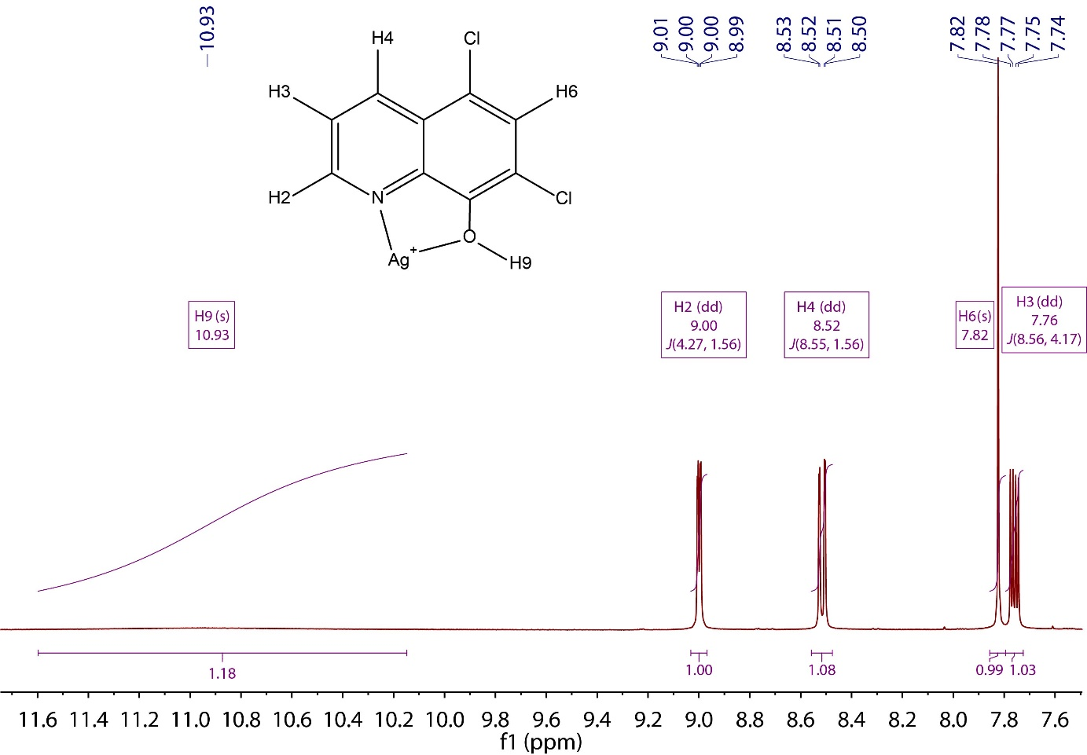
Figure S1. ¹H NMR (400.13 MHz, DMSO-d₆, 25 °C) spectrum of 1.

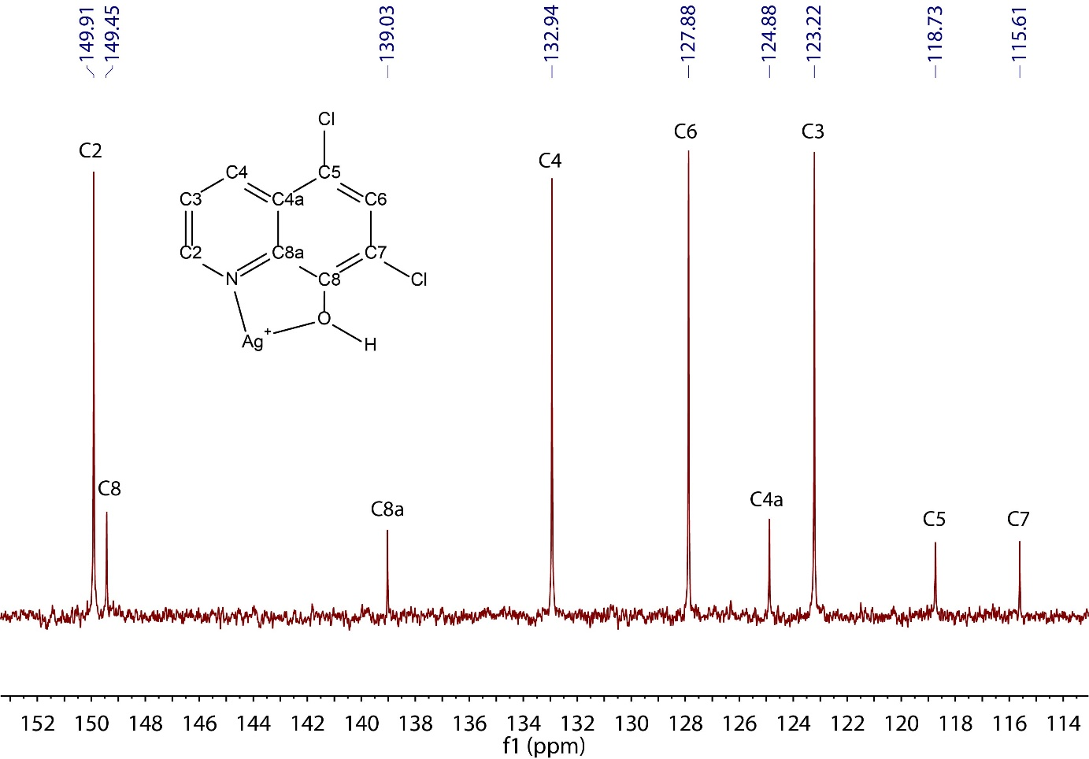
Figure S2. ¹³C{¹H} NMR (101 MHz, DMSO-d₆) spectrum of 1.

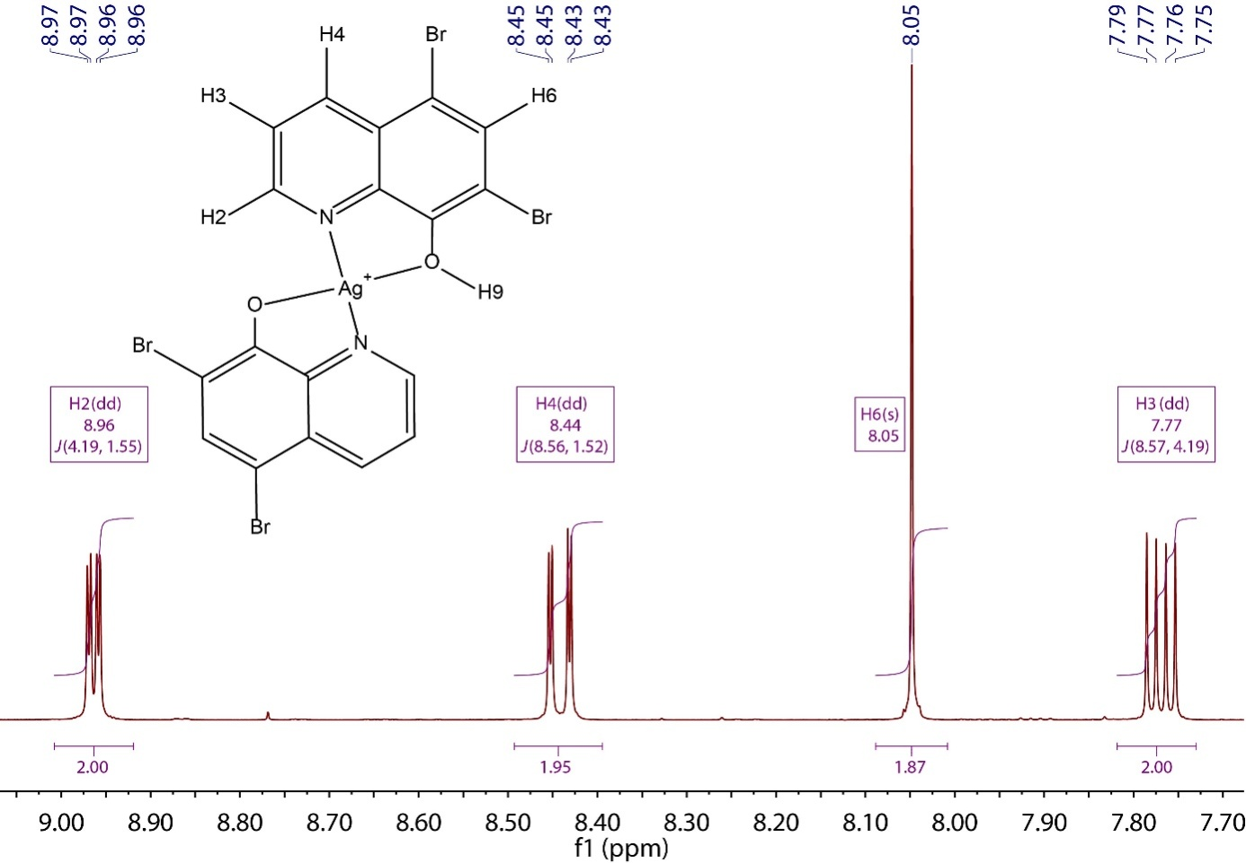
Figure S3. ¹H NMR (400.13 MHz, DMSO-d₆, 25 °C) spectrum of 2.

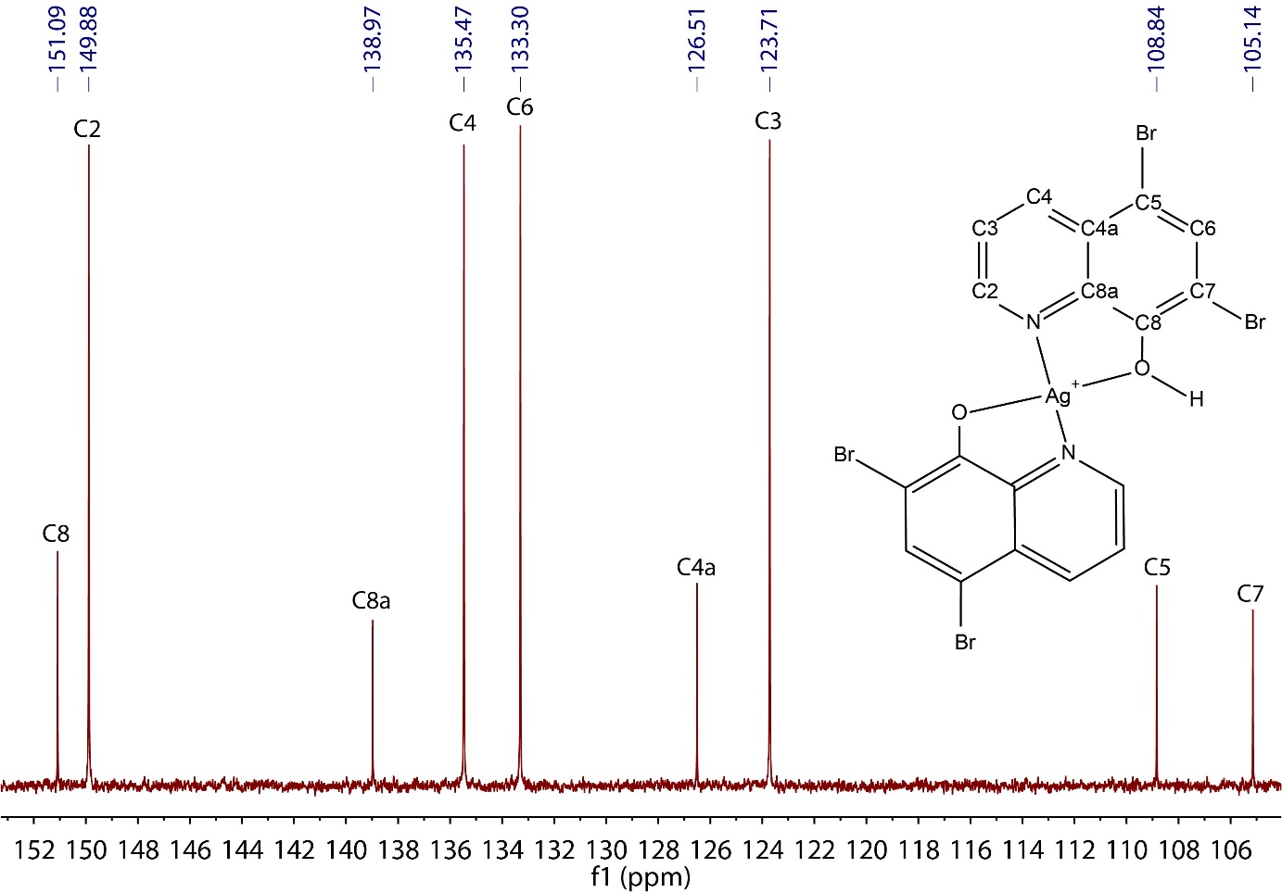
Figure S4. ¹³C{¹H} NMR (101 MHz, DMSO-d₆) spectrum of 2.

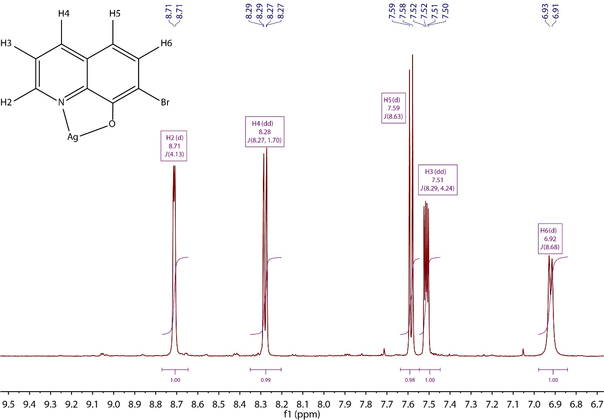
Figure S5. ¹H NMR (600.17 MHz, DMSO-d₆, 25 °C) spectrum of 3.

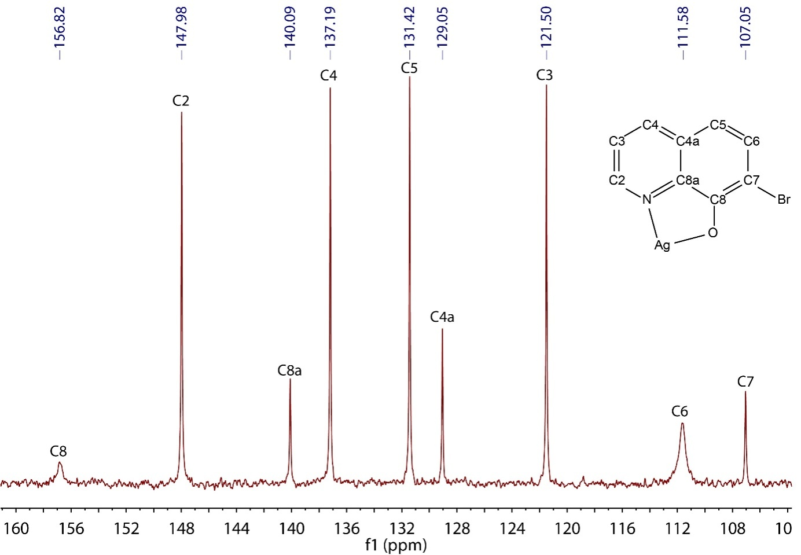
Figure S6. ¹³C{¹H} NMR (150.93 MHz, DMSO-d₆) spectrum of 3.

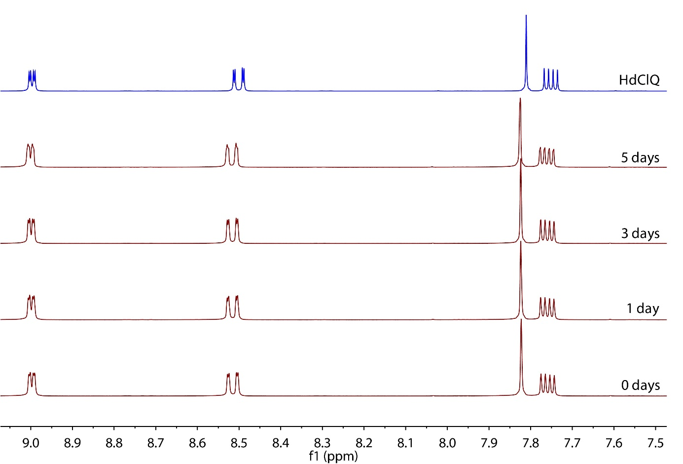
Figure S7. The ¹H NMR spectra (400.13 MHz, DMSO-d₆, 25 °C) of 1 measured at different times after preparation of the solution and the ¹H NMR spectrum of the ligand HdClQ.

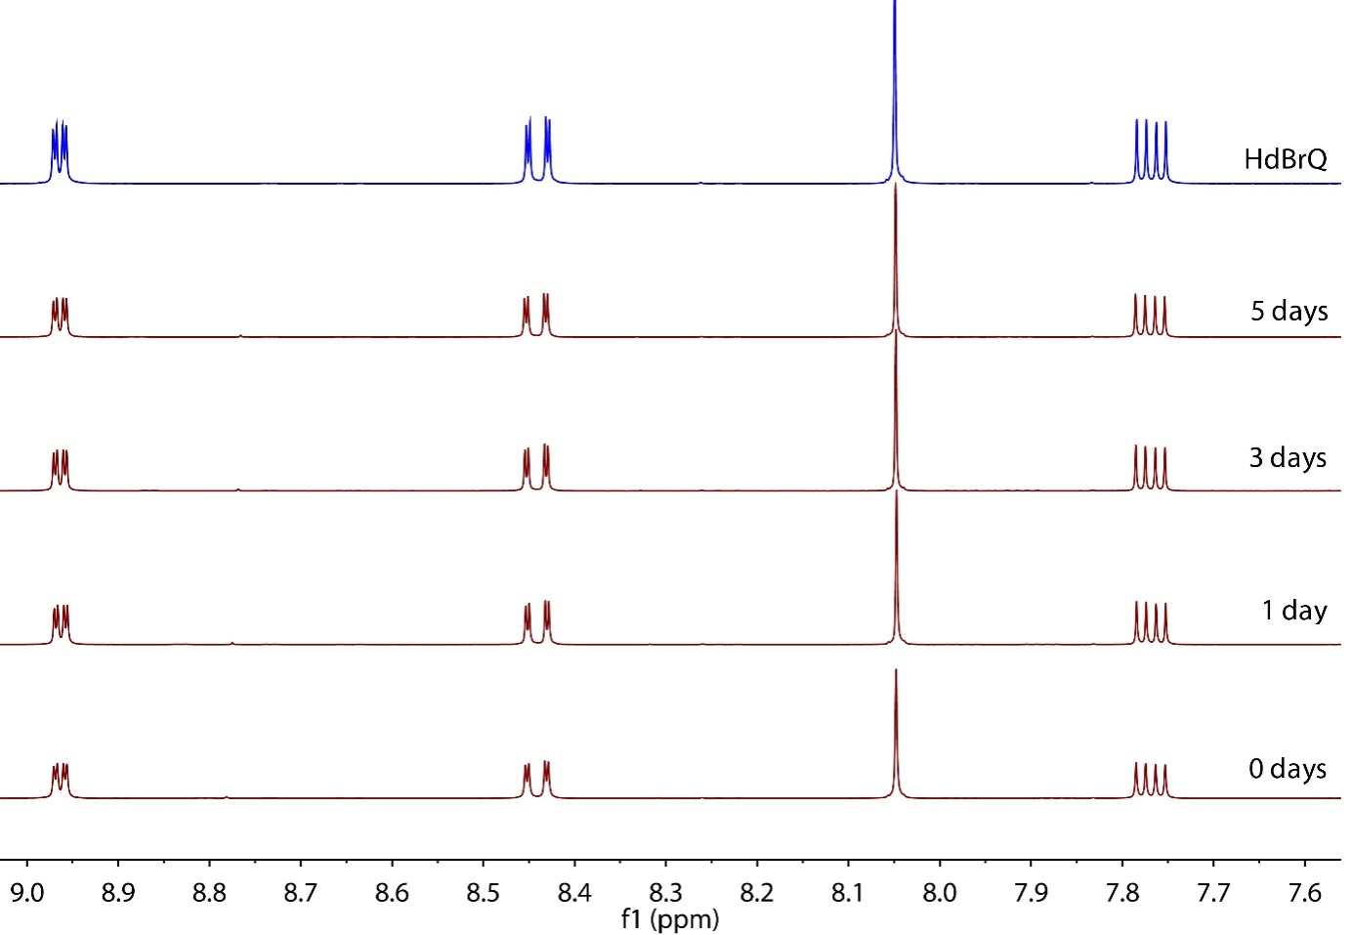
Figure S8. The ¹H NMR spectra (400.13 MHz, DMSO-d₆, 25 °C) of 2 measured at different times after preparation of the solution and the ¹H NMR spectrum of the ligand HdBrQ.

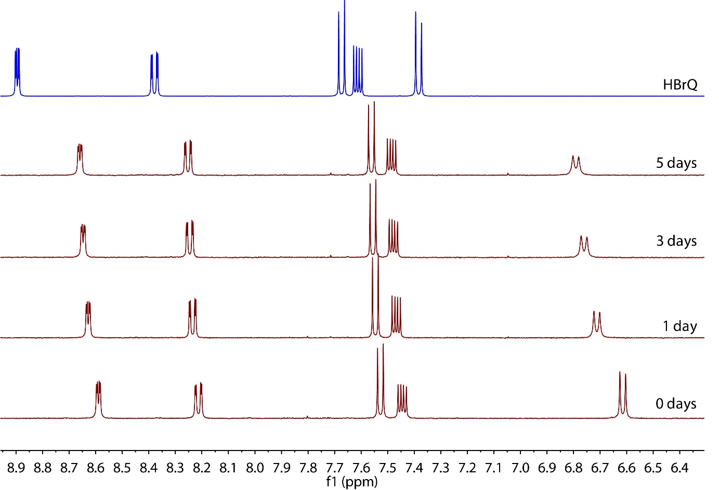
Figure S9.The ¹H NMR spectra (400.13 MHz, DMSO-d₆, 25 °C) of 3 measured at different times after preparation of the solution and the ¹H NMR spectrum of the ligand HBrQ.

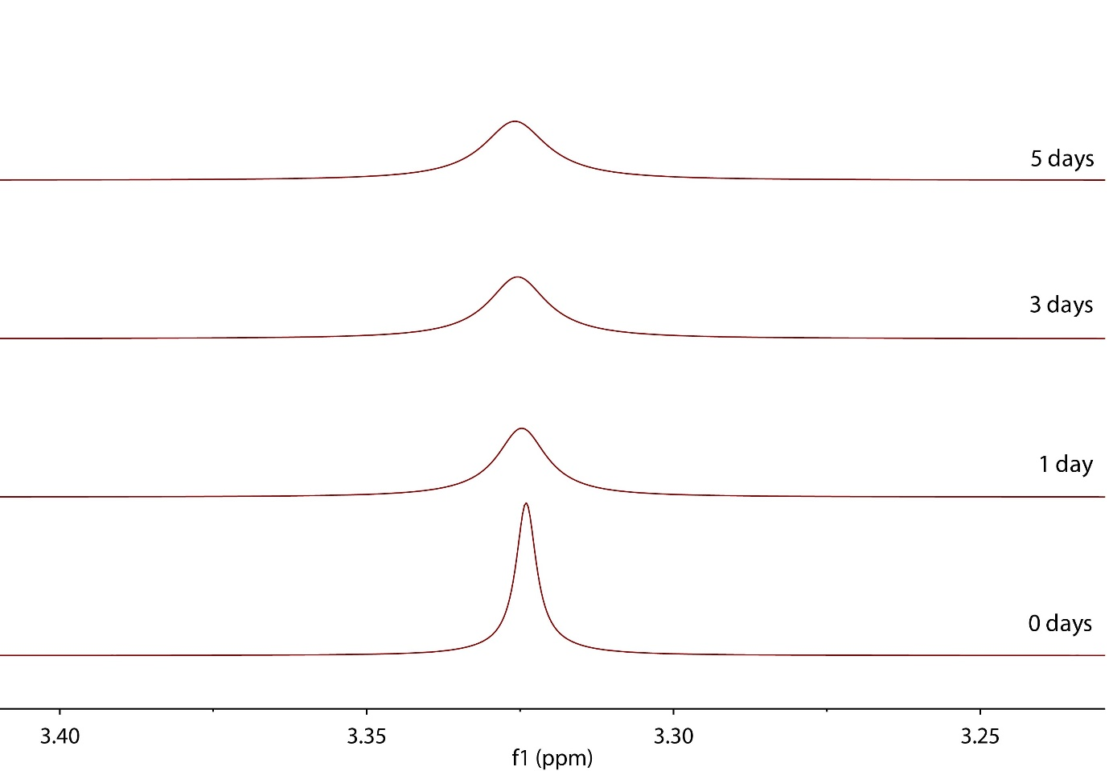
Figure S10. The ¹H NMR spectra (400.13 MHz, DMSO-d₆, 25 °C) of 3 at different times after preparation of the solution. The water signal is depicted to show that the signal is exchange-broadened.

Figure S11. The UV-vis spectrum of 1 and HdClQ in DMSO in 0, 1 and 3 days.

Figure S12. The UV-vis spectrum of 2 and HdBrQ in DMSO in 0, 1 and 3 days.

Figure S13. The UV-vis spectrum of 3 and HBrQ in DMSO in 0, 1 and 3 days.

