SUPPLEMENTAL MATERIAL

Contestation and Responsiveness in EU Council Deliberations

Sara B. Hobolt and Christopher Wratil

1) Data sources, variable definitions and descriptive statistics 2
2) Examples of Council deliberations 10
3) Bivariate relationships 13
4) Information on multiple imputation models 20
5) Responsiveness results by legislative package 21
6) Robustness checks 23
7) Direction of causality 30
8) DICEU codebook 32
9) Media collection search terms 36
10) References 40

- Data sources, variable definitions and descriptive statistics

In this section, we list all data sources and variable definitions for all main variables used in the paper. We also provide basic descriptive statistics for these variables.

Disapproval
Governmental disapproval to EU policy proposals is measured from the DICEU dataset (XX 2019). The coders used a 5-point Likert item to assess the degree of approval of each actor speaking in the debate:
- The speaker expresses full approval.
- The speaker expresses more approval than disapproval.
- The speaker expresses a balance of approval and disapproval.
- The speaker expresses more disapproval than approval.
- The speaker expresses full disapproval.
- Degree of approval cannot be assessed (applies to very short or irrelevant interventions)

The full codebook is attached at the end of this Supplemental Material. Specifically, we use variable V6 ‘General Approval’. The codebook also provides definitions of what constitutes a legislative debate. In previous work, we assessed the inter-coder reliability of disapproval by double-coding a random sample of 22 (about 25% of our 89) debates (XX 2019). Within this sample, the general approval variable was coded for 251 participations of actors in debates (we excluded cases in which at least one of the coders coded ‘9’ ‘Degree of approval cannot be assessed’). Comparing the 251 codings of coder 1 and coder 2, Krippendorff’s alpha indicates a very high reliability of the item at 0.82.
A potential criticism of this comparison is that the general approval variable should not be treated as a single item across debates, since its meaning slightly changes between debates depending on the debate’s content. The alternative option is to conceive of the general approval variable in each debate as a distinct, separate item, and only assess reliability within debates. If we apply this view, we obtain not one Krippendorff’s alpha but 22 alphas – one for each debate. The simple average of these alphas is 0.66 and the average weighted by the number of observations per items is 0.69. While Krippendorff’s alpha within debates is therefore lower than across debates, it is still acceptable. In addition, it is not at all clear that the general approval variable should be treated as separate items across debates.

Public opposition
Public opposition is measured from the Eurobarometer survey series using five different items, one relating to each legislative package. Here we list the question texts and scales in full.

Financial transaction tax: ‘Thinking about reform global financial markets, please tell me whether you are in favour or opposed to the following measures to be taken by the EU. The introduction of a tax on financial transactions.’
- ‘Strongly in favour’ – 1
- ‘Fairly in favour’ – 2
- ‘Fairly opposed’ – 3
- ‘Strongly opposed’ – 4

Tax issues: ‘Thinking about reform global financial markets, please tell me whether you are in favour or opposed to the following measures to be taken by the EU. Tougher rules on tax avoidance and tax havens.’
- ‘Strongly in favour’ – 1
- ‘Fairly in favour’ – 2
- ‘Fairly opposed’ – 3
- ‘Strongly opposed’ – 4

Banking union: ‘Thinking about reform global financial markets, please tell me whether you are in favour or opposed to the following measures to be taken by the EU. The introduction of a tax on profits made by banks.’
- ‘Strongly in favour’ – 1
- ‘Fairly in favour’ – 2
- ‘Fairly opposed’ – 3
- ‘Strongly opposed’ – 4

European Fund for Strategic Investments: ‘For each of the following statements, please tell me whether you totally agree, tend to agree, tend to disagree or totally disagree. Public money should be used to stimulate private sector investment at EU level.’
- ‘Totally agree’ – 1
- ‘Tend to agree’ – 2
- ‘Tend to disagree’ – 3
- ‘Totally disagree’ – 4

EU budget: ‘With which of the following two statements do you most agree?’
- ‘The EU should have greater financial means given its political objectives’ – 0
- ‘The EU’s political objectives do not justify an increase in the Union’s budget’ – 1

First, we calculate the country mean of all responses (excluding ‘don’t know’ and refusal responses). We then use these estimates from the chronologically last survey before a Council meeting for all main models. In order to obtain a single measure of public opposition we z-standardise each item based on the whole sub-sample of debates with government positions on this item, and then simply pool the standardized items in a single measure. To obtain the six-month lag and current opinion, which we use in some robustness checks (see section 6 below), we linearly interpolate the country mean of all responses between survey waves. This provides package-specific estimates of public opposition on the day of the public deliberations. We then again z-standardise each item to combine them in a single variable.

Salient legislative package
We measure public salience based on the number of media stories relating to the topic of the legislative package that appeared in major broadsheet and tabloid newspapers in nine EU countries in the six-month period preceding legislative debates on the package in the Council. We obtain this data through searches in the LexisNexis media database. While we aimed to focus on the two most circulated broadsheet as well as the most circulated tabloid newspaper per country, the availability of newspapers on LexisNexis restricted our selection. Hence, we reverted to selecting the two most circulated broadsheet and the most circulated tabloid newspaper out of those available on LexisNexis for our period of study (2010 to 2015). The final selection of newspapers per country follows.

Austria: Die Presse, Der Standard
France: Le Figaro, Le Monde, Le Parisien // Aujourd’hui en France
Germany: Die Welt // Die Welt am Sonntag, Die Tageszeitung, Bild (Bund) // Bild am Sonntag
Ireland: Irish Independent // Sunday Independent, Irish Times, Irish Daily Mail
Italy: Corriere della Sera, La Stampa
Malta: The Malta Independent, Malta Today
Netherlands: De Volkskrant, NRC Handelsblad, De Telegraaf
Spain: El Pais, El Mundo, ABC
United Kingdom: The Daily Telegraph // Sunday Telegraph, The Guardian, Daily Mail // Mail on Sunday

In order to identify newspaper articles relating to the topics of the legislative packages, we constructed a set of search terms for each of the legislative packages in English, French and German. These sets of search terms were pretested in several rounds to make sure that we capture all articles that touch upon the theme of the legislative package (e.g. also articles that discuss European tax cooperation but might not directly mention the word ‘EU’) without including articles that are not specific to European cooperation (e.g. that discuss tax cooperation with the U.S.). The sets of search terms used are included in section 9 of this Supplemental Material. Table A1 displays the average absolute number of newspaper articles published in each country in the six-month period before a debate.

Table A1: Average number of newspaper articles per package and country

 | FTT | Budget | Banking  union | Tax  issues | EFSI | Country  average
Austria | 82.1 | 69.2 | 59.8 | 17.1 | 2.8 | 49.8
France | 77.1 | 62.5 | 91.3 | 15.2 | 8.4 | 57.4
Germany | 60.4 | 37.3 | 64.1 | 10.2 | 4.6 | 39.4
Ireland | 41.9 | 98.6 | 99.2 | 41.4 | 24.6 | 70.8
Italy | 37.4 | 43.2 | 34.1 | 14.2 | 7.6 | 29.5
Malta | 1.9 | 4.8 | 2.8 | 4.1 | 4.8 | 3.6
Netherlands | 18.1 | 46.9 | 95.7 | 11.8 | 4.0 | 45.9
Spain | 69.9 | 66.3 | 254.5 | 16.1 | 22.6 | 109.3
UK | 95.0 | 158.2 | 106.7 | 31.9 | 2.4 | 89.6
Package average | 53.7 | 65.2 | 89.8 | 18.0 | 9.1 | 55.0

Government positions from the CMP
We take government positions on the ‘planeco’ and a pro-anti EU integration scale based on the CMP from the ‘CMP Government Positions Data’ provided by Wratil (2018). This dataset integrates the CMP with the ParlGov database on government composition (Döring and Manow 2016), and corrects several mistakes and missing links between the databases. The government positions are obtained by seat-weighting the CMP estimates for all parties represented in the cabinet. The version of the data we use incorporates version ‘2018a’ of the CMP database (Volkens et al. 2018). The definitions of the scales in terms of CMP codes are below.

Government planeco position: per403 + per404 + per412
Government EU position: per108 – per110

Receipts from EU budget
We measure a member state’s annual net receipts from the EU budget (receipts – payments) as percentage of national GDP based on information retrieved from www.money-go-round.eu.

Unemployment and inflation rates
We use information on national unemployment and inflation rates from Eurostat. The national unemployment rate is measured as the percentage of the labour-market active population that is unemployed. In turn, we measure inflation as the annual percentage change in the harmonized index of consumer prices (with base year 2015).

Population
We measure population as the number of persons (in million) having their usual residence in a country on 1st of January 2012. This information is taken from Eurostat. Note that when usually-resident population is not available, countries may report legal or registered residents.

Negotiation stage
We coded the negotiation stage at which our debates took place based on draft minutes of Council meetings. These were downloaded from the Council register (https://www.consilium.europa.eu/register/en/content/int?typ=ADV). The Council itself uses a variety of terms to indicate the negotiation stage of the discussed proposal(s), such as “exchange of views” or “political agreement”. Based on these labels, we allocated the debates into three types corresponding to different stages in the negotiation cycle: 1) initial presentations: these debates are characterised by the presentation of new Commission proposals; 2) policy debates: these debates encompass exchanges of views about the current status of proposal(s) and progress reports by the presidency; 3) debates on political agreement: these debates are supposed to reach agreement on the Council’s general approach on a proposal, a presidency mandate (e.g. vis-à-vis the European Parliament), or the final legislative text. Whenever the draft minutes were ambiguous, we also considered our debate transcriptions in order to determine the negotiation stage.
Note that we code the negotiation stage in the Council rather than the stage of inter-institutional negotiations. As a consequence, debates on political agreement do not necessarily occur at the end of decision-making, for instance, because Council general approaches are often agreed on early or Council agreements may be picked into pieces by the EP in the second reading. Moreover, also note that political agreement is not always reached in debates scheduled for this purpose. Hence, we even have cases where the Council goes back from debates on political agreement to policy debates.

Table A2 displays descriptive statistics for all main variables based on the dataset prior to imputation.

Table A2: Descriptive statistics for main variables

 | Mean | S.D. | Min. | Max. | Observations
Disapproval | 2.38 | 1.27 | 1.00 | 5.00 | 752
Public opposition (banking union) | 1.69 | 0.19 | 1.27 | 2.21 | 241
Public opposition (tax issues) | 1.46 | 0.18 | 1.20 | 1.85 | 93
Public opposition (FTT) | 2.16 | 0.37 | 1.46 | 2.95 | 102
Public opposition (EU budget) | 0.57 | 0.17 | 0.26 | 0.85 | 170
Public opposition (EFSI) | 2.13 | 0.23 | 1.64 | 2.54 | 77
Public opposition (merged, z-score) | 0.00 | 1.00 | -2.27 | 2.78 | 683
Salient legislative package | 0.76 | 0.43 | 0.00 | 1.00 | 752
Government planeco position | 4.32 | 3.25 | 0.00 | 12.95 | 694
Government EU position | 1.99 | 2.09 | -4.03 | 10.37 | 694
Receipts from EU budget | 0.56 | 1.62 | -1.43 | 5.21 | 751
Unemployment rate | 9.95 | 5.12 | 4.60 | 27.50 | 752
Inflation rate | 1.52 | 1.50 | -1.60 | 6.10 | 752
Population | 22.62 | 25.31 | 0.42 | 80.33 | 752
Initial presentations (dummy) | 0.15 | 0.36 | 0.00 | 1.00 | 752
Policy debates (dummy) | 0.23 | 0.42 | 0.00 | 1.00 | 752
Debates on political agreement (dummy) | 0.62 | 0.49 | 0.00 | 1.00 | 752

- Examples of Council deliberations

In this section, we provide a few examples from the interventions made by national ministers during the Council negotiations, taken from the transcripts, to demonstrate that debates in the Council better fit the image of informal and technical negotiations than that of scripted and highly public plenary sessions in national legislatures.

Council meeting no. 3281a, Swedish minister speaking to Austrian minister:
‘I strongly support we should adopt the Savings Directive as fast as possible. Just to give a reflection here, if a country is entering into a new period of government with maybe four years to the next election, one has to assess, can we sustain the position for the whole four year period. Is it possible to sustain a veto against the Savings Directive for four years? If that is not possible or realistic, I would argue that it's much better to change position directly, because if there are any troubles they are likely to be of passing nature and you still have four years to the election. If you just have to change position later on, the negative reaction from the voters are much more likely to affect the elections. So we are politicians, sometimes it sounds like we're a group of technocrats meeting here for macroeconomic seminars but we are politicians. I mean if you need to change the position do it directly instead of drawing it out and end up with a situation that it will come into the next election campaign.’

Council meeting no. 3088, UK minister speaking:
‘Thank you, the first thing I want to say is that the UK broadly supports the objectives of the Directive and we welcome those to increase the transparency in this area we certainly welcome the moves to improve coordination between different members of the European Union in this area. But it's been no secret that we've had concerns, like many Member States, about some of the aspect of the Draft Directive and of course there have been quite vocal concerns expressed by the IMF and the OECD as well about aspects of this Directive as well. However, we respect the fact that other Member States feel under some considerable political pressure to make a lot of progress and we've worked in good faith to try and get an agreed text and we have made a number of concessions. For example, on Article 12 and on the restrictions on sovereign debt, on sovereign debt market I would make an observation that no other market in the world is attempting to impose these sorts of regulations and restrictions nor is any other market quite under the microscope that the European Union is. But nevertheless we've shown flexibility, we think the compromise that has been agreed is a good one and we are happy to proceed on that basis. We've also shown flexibility on regulation around equity and corporate bond markets so I hope the UK has demonstrated that it's been very ready to work in the spirit of corporation trying to get a compromise everyone is happy with. We have one remaining concern and that is around Article 24, it is primarily a legal concern, we have very clear legal advice about this. And our concern is the powers that have been granted to ESMA under Article 24. Now we have proposed a couple of compromises, one which would give the Council the power to implement an ESMA decision, another that was rejected, we proposed another compromise which was to give the Commission the power to implement an ESMA decision, that too was rejected, so we have attempted two compromises both of which have been rejected. A third compromise has now been put on the table by the Spanish and we welcome that. It is not everything we want, it is not what we originally proposed, but in the spirit of trying to get agreement around this table we would like to support the Spanish proposal and if that is accepted then we would be happy with the Directive that's currently drafted.’

Council meeting no. 3238, Irish presidency speaking:
‘[…] The two top political issues are well known bail-in and financing. The Presidency's view at this fairly advanced stage of negotiation is the design of the bail-in is the pivotal issue. Finding a sensible compromise on this key topic will unlock final discussion on the financing part of the directive, and the timelines for introducing the bail-in, too. This will pave the way to the final package agreement on a general approach. I must stress that the matters related to bail-in are sensitive as recent developments have shown, I hope the report will sufficiently clear on presenting the issues, and the main possible approaches that have been discussed in the working party and in COREPER. […] [T]he Presidency report invites you to answer three questions. Question one is about a first layer of common elements for the design of the bail-in. Two: do we agree, in particular, that bail-in should have a broad scope; but a limited set of defined exclusions? Also, do we agree that there will be a need for institutions to have appropriate loss absorption capacity, if they are to exclude liabilities, as there is no cost-free way of excluding liabilities. Question two is concerned with the treatment of insured deposits which are above 100,000. Should these deposits be excluded from bail-in, or should they be bailed-in only after other seen or unsecured creditors, like senior bondholders, meaning they benefit from depositor preference. This depositor preference, without the positive preference, they would bear the losses through the same pecking order pari passu, with for example senior bond holders. Question three is twofold. First, I ask you to express a clear preference for the three approaches presented to the Presidency report, or where necessary any combination thereof you would see as a way forward. Second, I ask you to clarify how you see the way forward in reconciling harmonization with some necessary element of flexibility. I am particularly interested in listening to your views on the way of framing that flexibility and as this would have implications for exclusions from bail-in at the discretion of national resolution authorities. So four themes, first of all we are suggesting from the Presidency a wide scope, and that the exclusions would be specifically specified and standardized across the sovereigns. Secondly, we are suggesting a hierarchy of bail-in which would give depositor preference for deposits in excess of 100,000. […]’

- Bivariate relationships

In order to demonstrate that our main results on the relationship between governmental disapproval and public opposition are not due to particular modelling choices but are also present in the ‘raw’ data, in this section we plot and estimate various (conditional) bivariate relationships. We also investigate whether certain sets of countries are driving our results.
First, Figure A1 plots observations on governmental disapproval against public opposition by the salience of the legislative package. It also includes simple linear fit lines for both panels. This demonstrates that also in the raw data the relationship between disapproval and public opposition is positive but evidently stronger in the subset of packages with high domestic salience.

Figure A1: Bivariate relationship between governmental disapproval and public opposition by salience

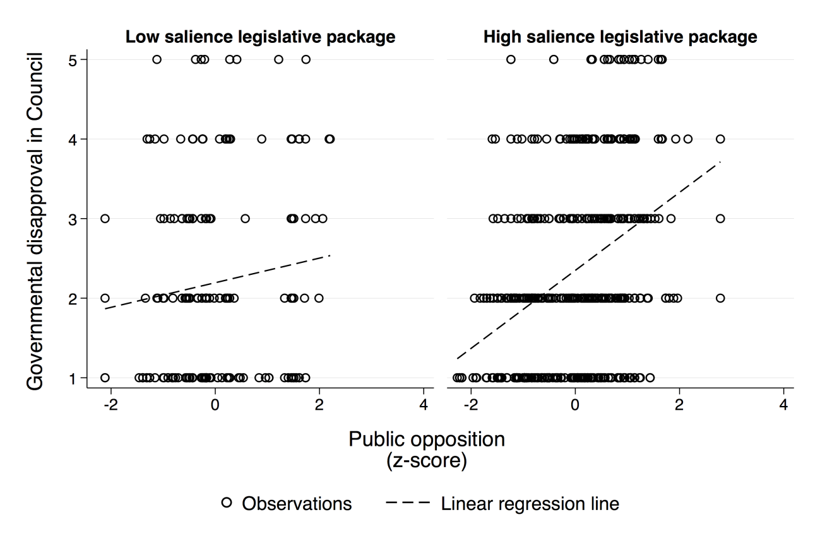

Figure A2 shows the same bivariate relationships for each legislative package. Again, the evident relationships match those from our statistical models. In particular, the relationship is strongest for the FTT, the budget, and to a lesser extent for the banking union. In contrast, the regression line is virtually flat for the EFSI.

Figure A2: Bivariate relationship between governmental disapproval and public opposition by legislative package

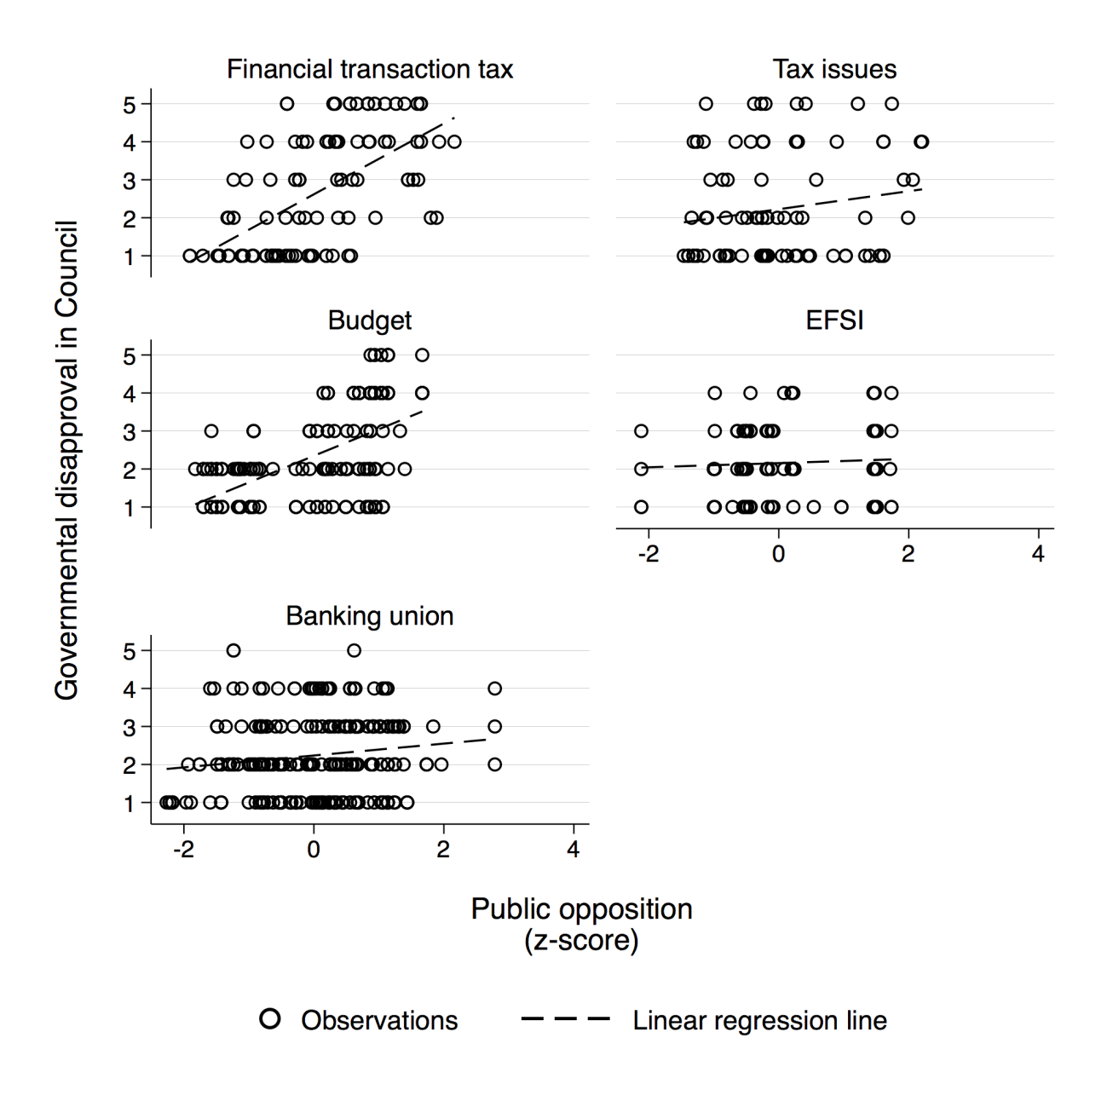

In order to ascertain the statistical significance of these relationships, we estimate mixed effects models that focus on the ‘raw’ bivariate relationships without any control variables and without using multiple imputation. However, to account for the clustering of the data within countries and debates, we include random effects as appropriate. The results are in Table A3. ‘Pooled model’ estimates the interaction effect between public opposition and the salience of the legislative package. The resulting effect of public opinion conditioned by salience is plotted in Figure A3. Models ‘FTT’ to ‘EFSI’ estimate the effects of public opposition for each proposal separately. All the results support our main findings in the paper. In particular, we now also find a highly statistically significant effect of public opposition against the banking union – an effect that turns marginally insignificant when modelling the data.

Figure A3: Effect of public opposition on governmental disapproval by salience (conditional bivariate relationship)

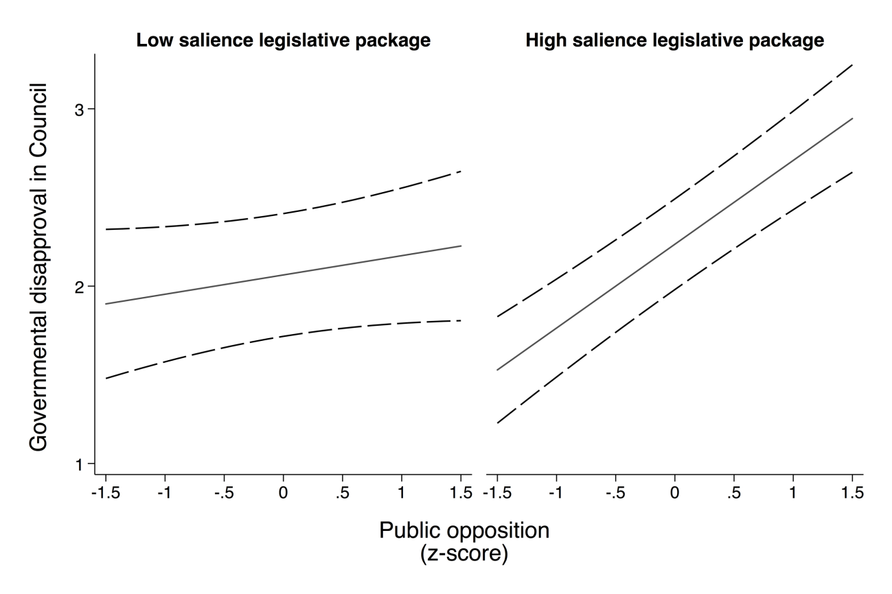
Notes: 95% confidence intervals as dashed lines.

Table A3: Models of bivariate relationships between governmental disapproval and public opposition

 | Pooled  model | FTT | EU budget | Banking  union | Tax  issues | EFSI
Public opposition | 0.109 | 1.788 | 3.776 | 0.870 | 1.215 | 0.237
 | (0.081) | (0.502)** | (0.769)** | (0.433)* | (0.929) | (0.498)
Salient legislative package | 0.173
 | (0.196)
Public opposition * Salient legislative package | 0.364
 | (0.095)**
Constant | 2.063 | -1.236 | 0.138 | 0.749 | 0.437 | 1.651
 | (0.177)** | (1.105) | (0.448) | (0.735) | (1.365) | (1.069)
N | 683 | 102 | 170 | 241 | 93 | 77
Number of countries | 28 | 27 | 28 | 28 | 25 | 25
Number of debates | 53 | 8 | 9 | 18 | 13 | 5
Random effect | Debates, countries | Countries | Countries | Countries | Countries | Countries
Notes: Public opposition is z-standardized for ‘Pooled model’ but measured on original scales for all other models; All are mixed effects linear regressions;
Standard errors in parentheses; * p<0.05; ** p<0.01.

Last, we investigate whether our findings on public opposition may be driven by certain sets of countries. For this purpose, we plot the bivariate relationships between public opposition and governmental disapproval by country in Figures A4.1 and A4.2. In 23 out of 28 countries the relationship between the two variables is positive. In Greece, the linear fit line is basically flat. In Slovenia and Slovakia it is slightly negative, and in the Czech Republic and Italy it is evidently negative. However, none of these negative bivariate relationships is statistically significant. Moreover, we cannot think of any obvious factor these countries have in common that could explain a lower or reversed effect of public opinion. Hence, these differences in the bivariate relationship may well be random.

Figure A4.1: Bivariate relationship between governmental disapproval and public opposition by country

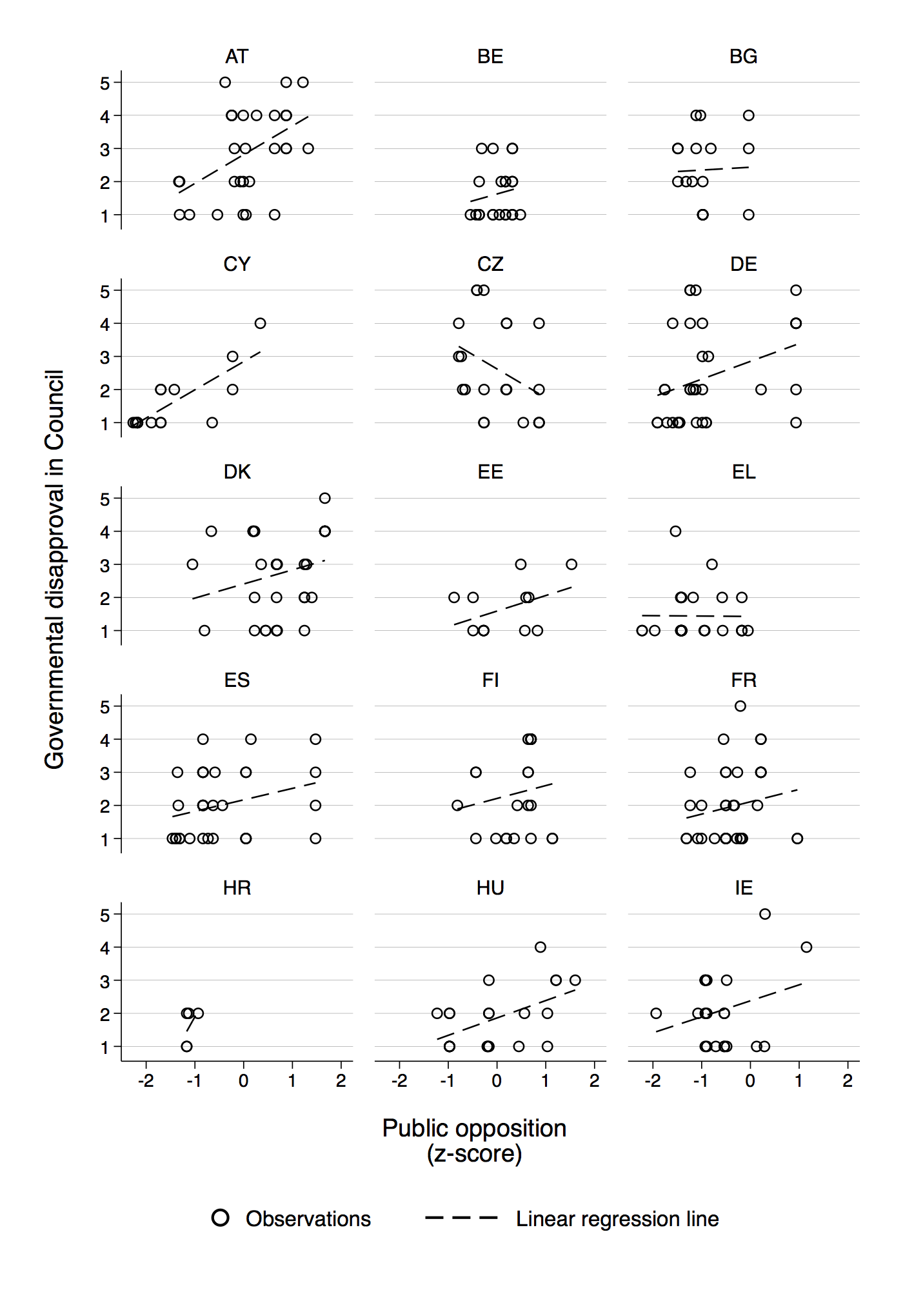

Figure A4.2: Bivariate relationship between governmental disapproval and public opposition by country

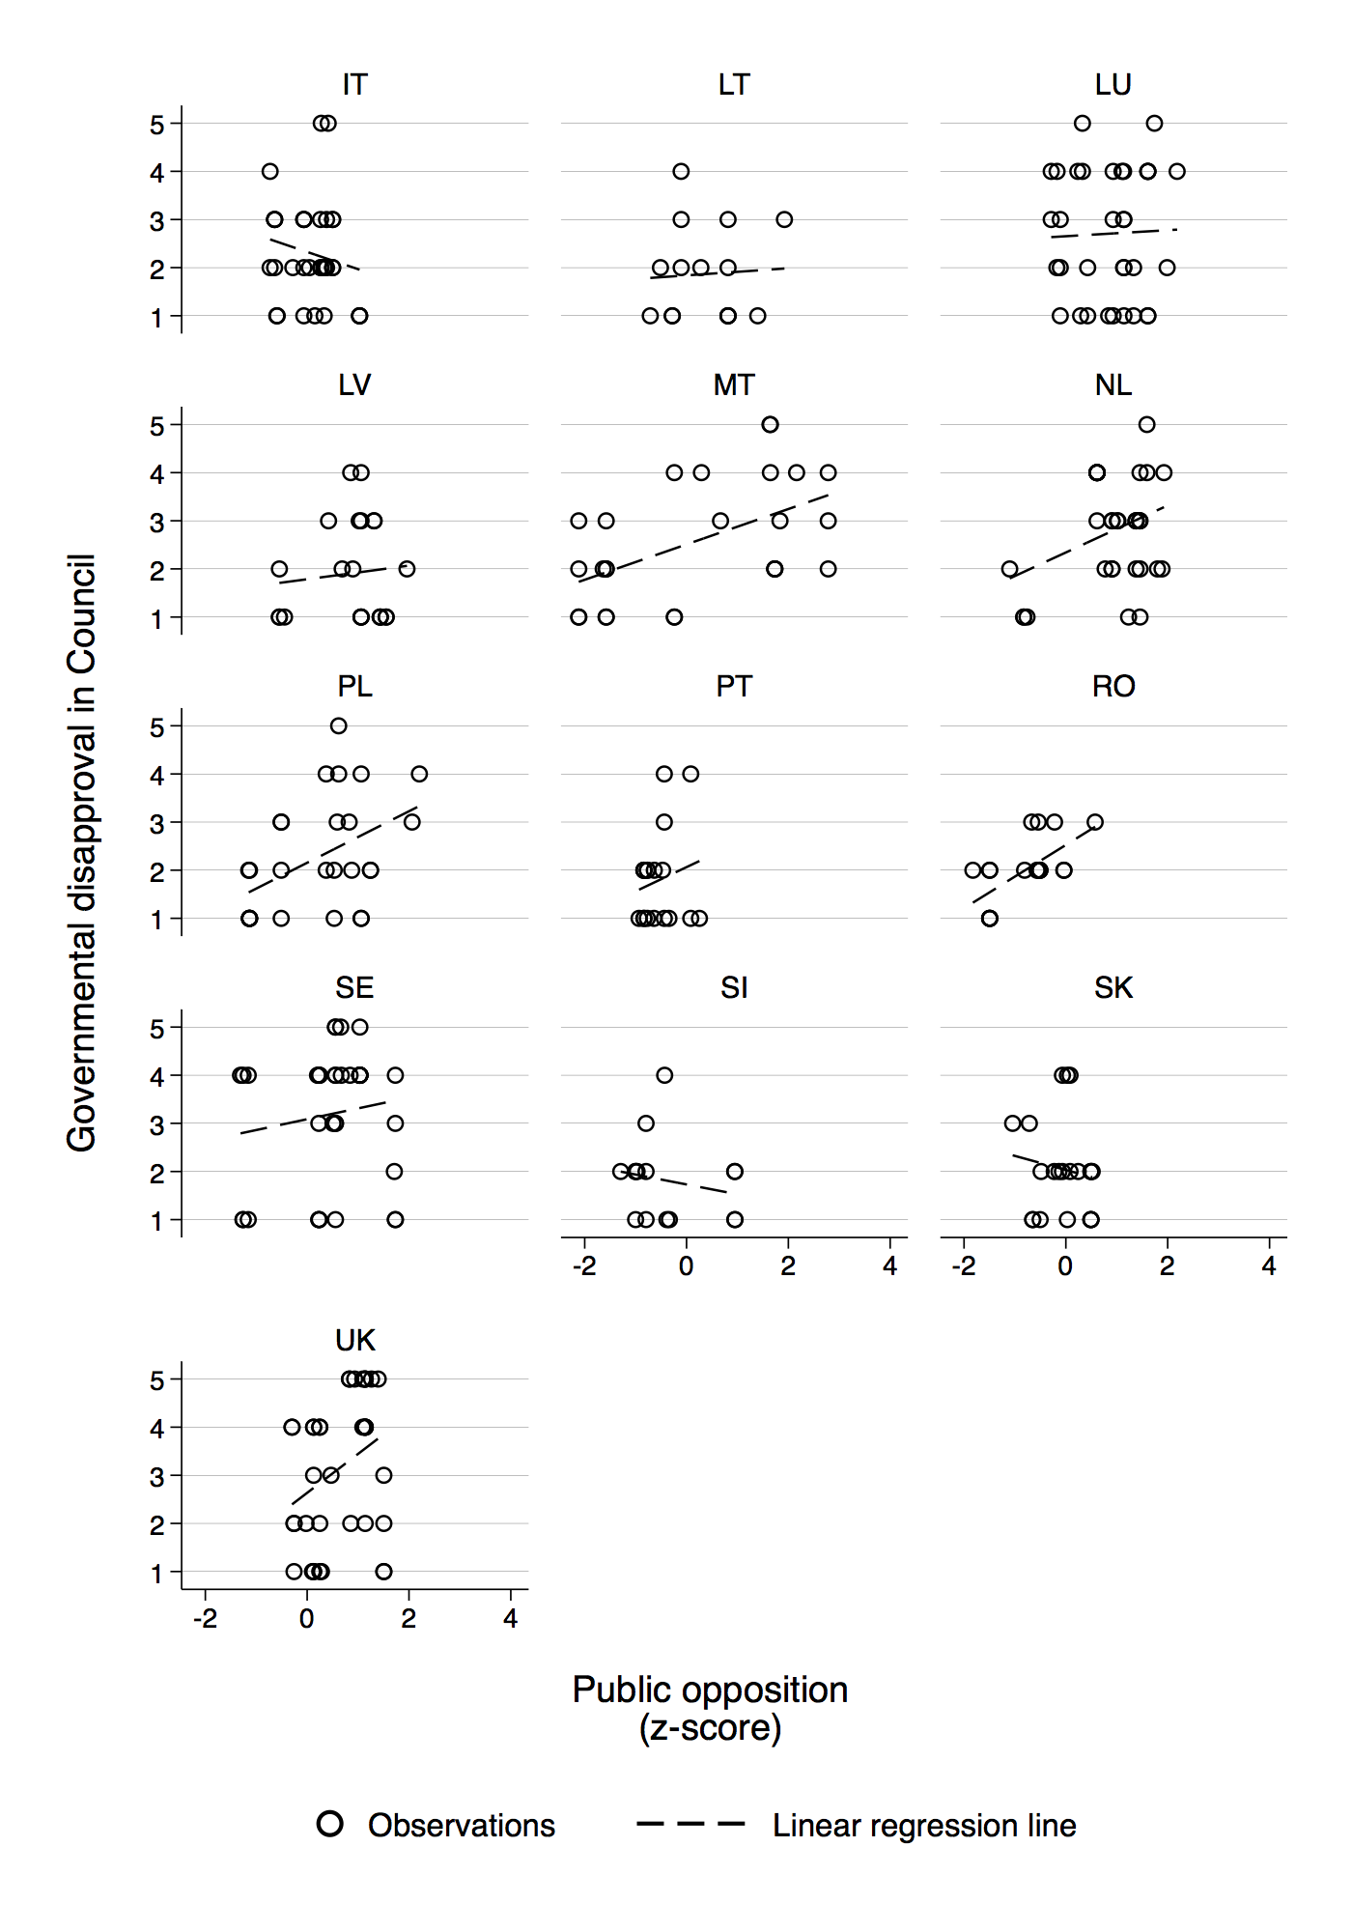

- Information on multiple imputation models

Our main results in the paper as well as most results in this Supplemental Material are based on multiple-imputed data. A challenge in multiple imputation techniques is how one should deal with interaction terms. One solution treats them as ‘just another variable’ in the imputation model. However, this creates problems when estimating and plotting marginal effects from such interactions, since the values for the interaction term are not the product of the base terms but imputed values. Another approach only imputes the base terms and creates the interaction passively after imputation (‘impute then transform’). However, this leads to bias, since the interaction in the analysis model is omitted from the imputation model. For interactions involving categorical variables, a third option is to ‘impute separately in each subgroup’ (i.e. running the imputation model on each subgroup), allowing the associations between the variables to differ. The interaction term is then created passively from the imputations but the imputation model itself has accounted for the interaction. We use this approach for our main pooled models (Table 2 and Figure 2 in the paper), imputing values for packages with high versus low salience separately. However, since this approach can lead to problems when variables in the imputation model are highly or completely missing in a subgroup, we use the ‘just another variable’ approach for all other analyses, from which we do not plot the interaction effects.
Specifically, we use chained equations with predictive mean matching and obtain 30 multiple-imputed datasets. Both our imputation models use all covariates with complete data, the dependent variable, dummy variables for debates and countries as predictors. In addition, to further aid imputation, we also include variables indicating the representation of party families in the government (i.e., the percentage of governmental seats taken by parties from a particular family) as well as current and lagged public opinion on the left-right self-placement item and a question on the EU’s image. Moreover, we also impute public opinion estimates at the time of the debate and the six-month lag since these are used in the robustness checks (see section 6 below) and since they aid imputation of all opinion measures, given opinion tends to be highly correlated over time. In the second imputation model, we also impute the interaction terms between the opinion measures and salience as ‘just another variable’. In the matching step, we randomly draw the imputations from the five nearest neighbours.

- Responsiveness results by legislative package

In this section, we present the results of the responsiveness analysis for each legislative package separately. Figure 3 in the paper is based on these results. Modelling each package separately also allows us to select the most appropriate set of control variables for each. For all packages, we control for the government parties’ planeco position as well as their EU position, since all packages touch upon questions of market regulation and the EU’s authority. Moreover, we control for inflation and unemployment, since previous research has shown that the economy can strongly shape citizens’ policy preferences (see Stevenson 2001 and Franklin and Wlezien 1997, who both focus on unemplyoment and inflation). As we should arguably be interested in the effects of more genuine movements in public opinion than those induced by regular business cycles, we remove the variation that is due to economic “misery” (unemployment + inflation).
In contrast, we expect receipts from the EU budget – first and foremost – to have an influence on negotiations over the budget. But we also include them as a control for the FTT and EFSI. The FTT is by some seen as a potential means to finance national contributions to the EU budget and the EFSI is a major spending programme in the EU budget. Last, we control for population in the FTT, banking union, and tax issue models, since there could be cleavages between small and large economies in each of these negotiations: large economies can more easily tax financial transactions without having to fear diversion; some small economies have relatively large and high-risk banking sectors (e.g. Cyprus, Malta); some small economies operate low corporate tax systems (e.g. Ireland).
The results from linear regression models are in Table A4. The effect of public opposition on governmental disapproval is only positive and statistically significant for the FTT and the EU budget. In the case of the banking union, it is close to statistical significance (p = 0.11). In contrast, the effect of public opposition is virtually zero on tax issues and the EFSI, which is in line with these two packages not being salient above average at the domestic level. Note that our results also reveal that the government’s planeco position is only significantly related to disapproval for the same three high salience packages for which the opinion effect is significant or close to significance. This is in line with a more general expectation that electoral politics factors become important in the Council, when issues are salient domestically.

Table A4: Models of governmental disapproval for each legislative package separately

 | FTT | EU budget | Banking  union | Tax  issues | EFSI
Public opposition | 1.180 | 2.834 | 0.725 | 0.232 | 0.402
 | (0.548)** | (0.681)*** | (0.456) | (0.773) | (0.598)
Government planeco position | -0.152 | -0.047 | -0.046 | -0.044 | -0.036
 | (0.038)*** | (0.027)* | (0.022)** | (0.037) | (0.042)
Government EU position | -0.077 | 0.029 | 0.007 | 0.006 | 0.074
 | (0.053) | (0.042) | (0.035) | (0.052) | (0.051)
Receipts from EU budget | 0.067 | -0.215 |  |  | 0.013
 | (0.112) | (0.066)*** |  |  | (0.080)
Unemployment rate | -0.117 | -0.032 | -0.017 | -0.089 | -0.003
 | (0.041)*** | (0.022) | (0.015) | (0.024)*** | (0.032)
Inflation rate | -0.114 | -0.020 | 0.045 | -0.127 | 0.044
 | (0.074) | (0.043) | (0.050) | (0.117) | (0.284)
Population | -0.003 |  | 0.008 | -0.004
 | (0.009) |  | (0.003)*** | (0.005)
Constant | 2.351 | 1.537 | 1.126 | 3.195 | 1.332
 | (1.527) | (0.552)*** | (0.888) | (1.259)** | (1.376)
N | 102 | 224 | 241 | 107 | 77
Number of countries | 27 | 28 | 28 | 25 | 25
Number of debates | 8 | 13 | 18 | 14 | 5
Random effect | Countries | Countries | Countries | Countries | Countries
Notes: All are mixed effects linear regressions; Standard errors in parentheses;
Multiple imputation estimates using chained equations with predictive mean matching (m = 30);
* p<0.1; ** p<0.05; *** p<0.01.

With regard to receipts from the EU budget, we find that these only matter on the EU budget itself, with recipients being more approving of the draft amending budgets that overwhelmingly stipulate higher appropriations. Higher unemployment leads to less opposition to the FTT and tax regulation issues, but not to the EFSI, where an effect could perhaps be expected most. The population size is only related to opposition on the banking union, where larger member states are more disapproving, which is in line with the idea that small countries with high-risk banking sectors potentially benefit most from the pooling of risks in the banking union (e.g. single resolution fund).

- Robustness checks

In this section, we perform several robustness checks of our main results. Except where mentioned otherwise, the models are specified as our main Model 2 from Table 2 in the paper. All results are reported in Tables A5, A6.1 and A6.2. First, one concern with our approach is that our classification of legislative packages as high versus low salience is not country-specific. This is a consequence of the fact that we only have media data from nine countries. However, in this reduced sample of nine countries, we can create a dummy variable that classifies each country-package dyad according to whether debates on a package on average received media coverage above (‘1’) or below (‘0’) the country’s grand mean of media coverage across all debates. This is a country-specific measure of high versus low domestic salience of a package. Recall that we use media coverage as a mere indicator of salience; it is partially driven by governments’ behaviour at the EU level and, in particular, over-time movements are unlikely to be exogenous. The results of Model R1 in Table A5 include an interaction between the country-specific measure of salient legislative packages and public opposition. Even on this reduced sample with lower statistical power, and using all control variables, we obtain a positive and significant interaction effect between domestic salience and public opposition. Note that in this sample also the main term on public opinion is significant, indicating that governments are responsive on all packages – but more so on salient ones. This strongly corroborates our main findings.
Second, we also test an alternative measure of public salience than the classification of packages by media coverage. Specifically, we draw on a long tradition in the study of public opinion that measures the salience of issues for the public from the fraction of “don’t know” (DK) or refusal responses on a question (Brooks 1990; Gilens 2012; Page and Shapiro 1983; Wratil 2019). The idea here is that if people refuse to provide opinions on an issue (e.g. the FTT or the banking union), then this is an indication that they do not intensely care about this issue, or at least, that the issue does not count for them when casting their vote at the ballot box. We construct this alternative measure of salience as 1 minus the fraction of DK/refusal responses in each country on the Eurobarometer item which operationalises public opposition to a legislative package (from the chronologically last survey before the Council meeting). Moreover, we z-standardise the measure within legislative packages in order to account for the different response scales. We interact this measure with public opposition in Model R2 in Table A5. The results clearly indicate that governments follow public opposition more strongly if more people provide an opinion on an issue, i.e. if salience is higher.
Third, we gauge the sensitivity of our results with regard to the classification of specific packages as high versus low salience packages. In particular, it could be argued that tax issues, while attaining below-average media attention most of the time, should still be classified as salient because they at least obtain average coverage at some times (see Figure 1 in the paper). We therefore build an alternative version of the salient legislative package dummy variable that is only ‘0’ for the EFSI package, and ‘1’ for all other packages. The results are reported as Model R3 in Table A5. They entirely support our main results in the paper. Third, none of our main models in the paper uses fixed effects for debates. Such an estimator could verify that responsiveness is due to governments’ differential behaviour within debates and not to macro-trends in opinion that are erroneously correlated with debate-specific factors. However, including debate fixed effects makes it impossible to identify the coefficient on the dummy variable for salient legislative packages, as one debate concerns one package. Therefore, we did not include such a model in the paper, but we report it as a robustness check. Model R4 includes debate as well as country fixed effects, thus controlling for various confounders on both levels. The results are entirely in line with those of our main models.
Fourth, while we model our dependent variable with linear regressions, the 5-point Likert item may suggest the use of ordered logistic regression instead. Performing a Brant test on the basis of a simple ordered logistic regression model (specification of Model 2 without random effects) estimated on the list-wise deleted dataset before multiple imputation yields clear evidence against the parallel regression assumption, which is the reason why we use linear regressions in the paper. Nevertheless, in Model R5 we report results from an ordered logistic regression with country fixed effects and a random effect for debates (note that cross-classified random effects ordered logistic regression models are not standard). While the results should be interpreted with caution given the Brant test results, they entirely support our main findings in the paper. Fifth, for readers who are sceptical toward multiple imputation, we report the results of a re-estimation using only the list-wise deleted dataset as Model R5. This reveals that the main results are not reliant on the imputations.

Table A5: Robustness checks of models of governmental disapproval

 | Model R1 | Model R2 | Model R3 | Model R4 | Model R5 | Model R6 | Model R7 | Model R8
Public opposition | 0.264 | 0.375 | -0.147 | 0.080 | 0.141 | 0.094 | 0.090 | 0.114
 | (0.123)* | (0.051)** | (0.123) | (0.085) | (0.166) | (0.089) | (0.085) | (0.081)
Salient legislative package | 0.171 |  | 0.429 |  | 0.508 | 0.284 | 0.218 | 0.242
 | (0.188) |  | (0.298) |  | (0.437) | (0.191) | (0.189) | (0.190)
Public opposition * Salient legislative package | 0.324 |  | 0.552 | 0.346 | 0.673 | 0.382 | 0.343 | 0.332
 | (0.157)* |  | (0.133)** | (0.100)** | (0.196)** | (0.103)** | (0.097)** | (0.095)**
Salience (DK/refusal) |  | 0.101
 |  | (0.059)
Public opposition * Salience (DK/refusal) |  | 0.134
 |  | (0.051)**
Government planeco position | -0.054 | -0.070 | -0.058 | -0.056 | -0.126 | -0.059 | -0.055 | -0.056
 | (0.023)* | (0.016)** | (0.016)** | (0.022)** | (0.041)** | (0.018)** | (0.016)** | (0.016)**
Government EU position | -0.030 | -0.020 | -0.007 | -0.007 | -0.001 | -0.013 | -0.004 | -0.005
 | (0.026) | (0.023) | (0.023) | (0.029) | (0.054) | (0.024) | (0.022) | (0.022)
Receipts from EU budget | 0.344 | -0.064 | -0.072 | 0.045 | 0.159 | -0.075 | -0.067 | -0.067
 | (0.251) | (0.036) | (0.039) | (0.080) | (0.154) | (0.040) | (0.037) | (0.037)
Unemployment rate | -0.043 | -0.025 | -0.026 | 0.020 | 0.050 | -0.020 | -0.029 | -0.030
 | (0.016)** | (0.012)* | (0.013) | (0.029) | (0.059) | (0.014) | (0.012)* | (0.012)*
Inflation rate | 0.004 | -0.074 | -0.068 | -0.066 | -0.122 | -0.083 | -0.071 | -0.073
 | (0.089) | (0.045) | (0.043) | (0.057) | (0.096) | (0.048) | (0.043) | (0.043)
Population | 0.003 | 0.006 | 0.005 |  |  | 0.005 | 0.005 | 0.005
 | (0.003) | (0.002)* | (0.003) |  |  | (0.003) | (0.003) | (0.003)
Policy debates | -0.603 | -0.263 | -0.622 |  | -1.195 | -0.287 | -0.520 | -0.563
 | (0.336) | (0.286) | (0.276)* |  | (0.637) | (0.286) | (0.274) | (0.276)*
Debates on political agreement | -0.629 | -0.612 | -0.937 |  | -1.978 | -0.633 | -0.872 | -0.890
 | (0.310)* | (0.262)* | (0.247)** |  | (0.581)** | (0.263)* | (0.246)** | (0.247)**
Constant | 3.701 | 3.283 | 3.178 | 4.348 |  | 3.016 | 3.390 | 3.418
 | (0.445)** | (0.302)** | (0.373)** | (0.558)** |  | (0.339)** | (0.320)** | (0.320)**
N | 258 | 626 | 751 | 751 | 751 | 626 | 751 | 751
Number of countries | 9 | 27 | 28 | 28 | 28 | 27 | 28 | 28
Number of debates | 50 | 53 | 58 | 58 | 58 | 53 | 58 | 58
Fixed effects |  |  |  | Debates,  countries | Countries
Random effects | Debates,  countries | Debates,  countries | Debates,  countries |  | Debates | Debates,  countries | Debates,  countries | Debates,  countries
Type of robustness check | Country-specific classification of packages | Salience measured through DK/refusal | Tax issues as salient package | Debate and country fixed effects | Ordered logistic regression | No multiple imputation | Six-month lag of opinion | Current opinion
Notes: All are mixed effects regressions; Standard errors in parentheses; Multiple imputation estimates using chained equations with predictive mean matching (m = 30),
except for Models R1, R2 and R6, which use list-wise deletion; * p<0.05; ** p<0.01.

Sixth, one question is which temporal measurement of public opinion is most appropriate. While in general we use opinion from the last survey that included an item in order to maintain a causal ordering between opinion and governmental disapproval, and reduce the extent of missing values, there are at least two alternatives: 1) A lot of work on responsiveness to public opinion has (linearly) interpolated public opinion and used a one-year lag (e.g. for final legislative output) or six-month lag (e.g. for actors’ behaviour) (e.g. Soroka and Wlezien 2010). In Council research, the six-month lag is common practice (Hagemann et al. 2017; Wratil 2018b). One central advantage of the interpolated six-month lag compared to opinion from the last survey is that we possibly reduce heteroskedastic measurement error related to the timing of surveys (e.g. the last survey is more/less time away for different debates). However, we pay for this with potentially more measurement error stemming from interpolation. 2) One could also argue that we should not expect governments to react to lagged opinion but sense the state of opinion on the day of the Council meeting. If this is the case, governments should be responsive to interpolated current opinion.
To ascertain the sensitivity of our results to related choices, we re-estimate all our main models with the six-month lag as well as current public opinion on the day of the debate. The results for the pooled model, re-estimating Model 2 in Table 2 in the paper, are reported as Models R7 and R8 in Table A5. They are entirely in line with our main results using opinion from the last survey. The results for the separate models, re-estimating the models from Table A4 in this Supplemental Material are in Tables A6.1 and A6.2. They support our main results from the paper. If anything, the contrast between high versus low salience legislative packages is a bit stronger using the six-month lag as opposed to opinion from the last survey, since the coefficient on public opposition to the banking union turns significant at the 5% level.

Table A6.1: Models of governmental disapproval for each legislative package separately (using six-month lag instead of public opposition from last survey)

 | FTT | EU budget | Banking  union | Tax  issues | EFSI
Public opposition (six-month lag) | 1.408 | 2.666 | 0.922 | 0.177 | 0.247
 | (0.588)** | (0.672)*** | (0.458)** | (0.768) | (0.495)
Government planeco position | -0.152 | -0.045 | -0.045 | -0.044 | -0.039
 | (0.037)*** | (0.027) | (0.022)** | (0.037) | (0.041)
Government EU position | -0.078 | 0.031 | 0.003 | 0.006 | 0.067
 | (0.052) | (0.042) | (0.035) | (0.052) | (0.049)
Receipts from EU budget | 0.070 | -0.206 |  |  | 0.001
 | (0.111) | (0.068)*** |  |  | (0.076)
Unemployment rate | -0.116 | -0.038 | -0.013 | -0.090 | 0.000
 | (0.040)*** | (0.022)* | (0.016) | (0.024)*** | (0.032)
Inflation rate | -0.093 | -0.026 | 0.048 | -0.126 | 0.052
 | (0.076) | (0.043) | (0.050) | (0.117) | (0.284)
Population | -0.002 |  | 0.008 | -0.004
 | (0.009) |  | (0.003)*** | (0.005)
Constant | 1.779 | 1.679 | 0.756 | 3.278 | 1.681
 | (1.614) | (0.540)*** | (0.890) | (1.258)*** | (1.143)
N | 102 | 224 | 241 | 107 | 77
Number of countries | 27 | 28 | 28 | 25 | 25
Number of debates | 8 | 13 | 18 | 14 | 5
Random effect | Countries | Countries | Countries | Countries | Countries
Notes: All are mixed effects linear regressions; Standard errors in parentheses;
Multiple imputation estimates using chained equations with predictive mean matching (m = 30);
* p<0.1; ** p<0.05; *** p<0.01.

Table A6.2: Models of governmental disapproval for each legislative package separately (using current instead of public opposition from last survey)

 | FTT | EU budget | Banking  union | Tax  issues | EFSI
Public opposition (current) | 1.344 | 2.722 | 0.770 | 0.394 | 0.355
 | (0.550)** | (0.682)*** | (0.476) | (0.766) | (0.637)
Government planeco position | -0.154 | -0.045 | -0.047 | -0.045 | -0.038
 | (0.037)*** | (0.027)* | (0.022)** | (0.037) | (0.041)
Government EU position | -0.085 | 0.031 | 0.007 | 0.006 | 0.070
 | (0.053) | (0.042) | (0.035) | (0.052) | (0.050)
Receipts from EU budget | 0.061 | -0.203 |  |  | 0.013
 | (0.112) | (0.068)*** |  |  | (0.082)
Unemployment rate | -0.115 | -0.039 | -0.016 | -0.088 | -0.002
 | (0.040)*** | (0.022)* | (0.015) | (0.024)*** | (0.032)
Inflation rate | -0.092 | -0.025 | 0.044 | -0.128 | 0.040
 | (0.076) | (0.043) | (0.050) | (0.117) | (0.285)
Population | -0.002 |  | 0.008 | -0.004
 | (0.009) |  | (0.003)*** | (0.005)
Constant | 1.911 | 1.658 | 1.046 | 2.936 | 1.435
 | (1.535) | (0.542)*** | (0.922) | (1.265)** | (1.463)
N | 102 | 224 | 241 | 107 | 77
Number of countries | 27 | 28 | 28 | 25 | 25
Number of debates | 8 | 13 | 18 | 14 | 5
Random effect | Countries | Countries | Countries | Countries | Countries
Notes: All are mixed effects linear regressions; Standard errors in parentheses;
Multiple imputation estimates using chained equations with predictive mean matching (m = 30);
* p<0.1; ** p<0.05; *** p<0.01.

- Direction of causality

One concern with the regression analyses we conducted is to what extent a causal effect of public opinion on governmental disapproval can be inferred from them. While the robustness of our results with regard to various specifications rules out most confounding factors, the analyses we presented cannot ultimately rule out reversed causality, i.e. that governmental disapproval drives public opposition (and media coverage). The most convincing approaches to address such concerns with observational data are time-series methods such as autoregressive distributive lag models and Granger causality tests. Given that our data is not time-series cross-section data, we cannot apply such methods. Therefore, we have to revert to alternative tests. Here, we present results of a placebo test in form of a model specification test. The logic is as follows: if governmental disapproval caused public opposition rather than the other way around, we would expect that public opposition after a Council debate should be a better predictor of governmental disapproval than public opposition before the Council meeting. In turn, if public opposition causes governmental disapproval, public opposition before the Council meeting should be a better predictor of governmental disapproval than public opposition in the future.
It is not advisable to test these expectations in a single regression model by including past and future public opposition, since public opinion is highly correlated over time and this would cause problems with multicollinearity. Instead, we use a Clarke (2001, 2007) specification test for non-nested models. This test ascertains whether one of two alternative models fits the data significantly better. It is performed by first running each model separately and calculating the likelihoods of each observation according to both models. The Clarke test then simply is a paired sign test of the observation-specific log-likelihood differences between the two competing models. We compare our Model 2 from Table 2 in the paper to a model with the same specifications except for that we replace the public opposition from the last survey with public opposition from the next survey (i.e. the next survey after the Council meeting). Note that we do not include the random effects for debates and countries, since this complicates the derivation of the observation-specific log-likelihoods. Also note that we have to perform this test on the list-wise deleted data without imputations, since it is not clear how the Clarke test statistics should be calculated on multiply imputed datasets. The results of the Clarke test are in Table A7.

Table A7: Clarke test results for placebo test of direction of causality

 | Clarke test
Number of observations | 523
Expected higher log-likelihoods | 261.5
Observed higher log-likelihoods for ‘Linear model’ | 301
Observed higher log-likelihoods for alternative model | 222
P-value $H_{0}$: median of differences = 0 | 0.001

The results show that for 301 observations, the observation-specific log-likelihoods from Model 2 using the public opposition from the last survey are higher than the log-likelihoods from the alternative model using public opinion from the next survey. In contrast, the alternative model provides higher log-likelihoods for 222 observations. This difference is highly statistically significant. Hence, the specification using past opinion fits the data significantly better than a model using future opinion. If governmental disapproval caused public opposition, we would expect the opposite. Hence, our findings pass the placebo test.

- DICEU codebook

Here, we present the part of our comprehensive DICEU debate codebook that is relevant to the analyses used in this paper.

Debates in the Council of the European Union (DICEU)
- CODEBOOK -
v. 1.0

The videos are coded on the level of debates. Several debates can take place within a meeting. Debates usually occur in the following sequence: First, the presidency raises an issue, then the Commission and/or the presidency themselves deliver a report, and afterwards discussions between the delegations take place. Wherever possible, stick to the debate identification provided in the meeting’s press release (‘Items debated’ list). Disregard any agenda item on which less than two national delegations (excluding the presidency) make contributions.
Create a new row in the EXCEL file for each debate within a meeting copying the provided meta-information (e.g. date, place, participants) and assigning a debate number in chronological order starting with ‘1’ for the first debate of the meeting.
When defining issues and codes, let your decisions be guided by parsimony and reliability instead of the amount of information that could be extracted in theory. For instance, if it is not straightforward to distinguish actors on two neighbouring codes, rather merge these codes. If a conflict is subtle or only apparent for coders with particular expertise or training, rather do not introduce it.
When assessing the position of delegations and institutions, consider all interventions made by speakers of the country, the Commission, the respective institution during the debate. In case actors present a most preferred position and one on which they could compromise, always code the preferred position. Save the transcribed text of the entire debate (including delegations, president, Commission, and other participants’ contributions) in a single TXT-file with encoding UTF-8 and title ‘MEETING NUMBER_DEBATE NUMBER’, e.g. ‘2789_2’, ‘3199_1’. Separate interventions of the actors by using capitalized actor codes (see list at end of this document, e.g. ‘AT’, ‘UK’, ‘COM’, do not write anything else in the same line) bracketed by a blank line before and after. Place these files in the meeting’s folder.

- Length of Debate

Please record the overall length of the debate (including speaking time of presidency and Commission or other speakers) in the following format: HH:MM. Note that this length is usually different from the length of the video since several debates on different items may take place in one meeting.

- Debate Topic Agenda

What is the topic of the debate according to the Council's agenda or press release? (USE THE MORE SPECIFIC TITLE FROM BOTH DOCUMENTS)
Examples: ‘Savings Taxation Directive – Adoption’, ‘Future EU Work Plan for Youth – Policy Debate’, ‘Presidency Working Programme 2015 – Presentation’, ‘Proposal for a Directive of the European Parliament and of the Council establishing a framework for the setting of eco-design requirements for energy related products – Recast – General approach’

- Process Stage

Has the topic (e.g. the legislative proposal) been discussed in the Council before (or only at working group, lower levels)? The president will normally make clear whether the issue has been discussed before or whether this is the initial orientation debate / first occasion the topic is discussed at the ministerial level.
(0) No
(1) Yes

- Professional Position of Main Speaker

For each actor participating in the debate, please indicate the professional position of the main representative, i.e. the person from the delegation with the longest speaking time. The positions of the representatives can be taken from the participants’ list in the press release.
- Minister
- Ministerial bureaucracy (e.g. deputy ministers, state secretaries)
- Permanent representative
- Member of the European Commission
- Vice-President of the European Commission
- President of the European Commission
- Other position

V4_AT – V4_OTH

- Language of Speech

For each of the actors that participate in the debate report in what language they deliver their speech. Note that the use of single words or expressions in another language should not be counted here to assign code (3).
(1) The speaker delivers the speech in English.
(2) The speaker delivers the speech in another language than English.
(3) The speaker delivers major parts of the speech in English as well as in another language.

V5_AT – V5_OTH

- General Approval

Please identify the main dimension of approval and disapproval in the debate and add a short description of this dimension (e.g. V6_DIMENSION = ‘Approval of the presidency's suggestions’, ‘Approval of the Commission's legislative proposal’). In orientation debates, this dimension will typically be approval of the legislative proposal presented by the European Commission. Later on in the process, this dimension will typically be approval of the presidency's suggestions. For each actor that participates in the debate assess the degree of approval on this dimension. If actors convey their position but the exact level of approval is hard to assess, choose (3).
(1) The speaker expresses full approval.
(2) The speaker expresses more approval than disapproval.
(3) The speaker expresses a balance of approval and disapproval.
(4) The speaker expresses more disapproval than approval.
(5) The speaker expresses full disapproval.
(9) Degree of approval cannot be assessed (applies to very short or irrelevant interventions)

V6_AT – V6_OTH

List of Actor Abbreviations

AT Austria
BE Belgium
BG Bulgaria
CY Cyprus
CZ Czech Republic
DE Germany
DK Denmark
EE Estonia
EL Greece
ES Spain
FI Finland
FR France
HR Croatia
HU Hungary
IE Ireland
IT Italy
LT Lithuania
LU Luxembourg
LV Latvia
MT Malta
NL Netherlands
PL Poland
PT Portugal
RO Romania
SE Sweden
SI Slovenia
SK Slovakia
UK United Kingdom
COM European Commission
OTH Other institution (e.g. European Central Bank, EU agency)
N/A Unidentifiable actor

- Media collection search terms

English search terms (LexisNexis)

Legislative Package | No of debates | Nexis Search String (English)
Financial transaction tax | 8 | BODY((financial! transaction! OR financial! operation!) W/70 tax! W/70 (EU OR European!))
EU budget | 13 | BODY((EU OR European!) W/2 budget!)
Banking union | 18 | BODY(banking! W/2 union! W/70 (EU OR European!))
European fund for strategic investments | 5 | BODY(strategic! investment! W/70 fund! W/70 (EU OR European!))
Tax issues | 14 | BODY((((interest W/2 income) OR (interest w/2 revenue) OR (interest W/2 yield) OR (interest W/2 earn!) OR (savings w/2 income)) W/70 tax! W/70 (EU OR European!)) OR (subsidiary! W/30 tax! W/30 (EU OR European!)) OR ((automatic! W/20 information!) W/70 tax! W/70 (EU OR European!)) OR ((administrative! cooperation! OR administrative! co-operation!) AND tax! AND (EU OR European!)) OR (tax! AND ((interest! AND royalty payment!) OR royalty payment!) AND (EU OR European!)) OR (common! consolidated! Corporate! Tax! Base! OR CCCTB AND (EU OR European!)))

French search terms (LexisNexis)

Legislative Package | No of debates | Nexis Search String (French)
Financial transaction tax | 8 | BODY((transaction! financ! OR opération! financ!) W/70 (impôt! OR taxe! OR fiscalité) W/70 (européen! OR UE))
EU budget | 13 | BODY(budget européen! OR budget de l'UE OR budget de l'Union)
Banking union | 18 | BODY((Union bancaire) W/70 (européen! OR UE))
European fund for strategic investments | 5 | BODY(investissement! stratégiqu! W/70 fonds! W/70 (européen! OR UE))
Tax issues | 14 | BODY((fiscalité! W/4 revenus de l'épargne W/70 (européen! OR UE)) OR ((société! mère OR groupe! de sociétés OR filiale! OR société! apparentée!) W/70 (taxe! OR fiscalité OR impôt!) W/70 (européen! OR UE)) OR ((automatique! informations!) W/70 (européen! OR UE) W/70 (taxe! OR impôt! OR financi!)) OR (coopération! administrative! W/70 fiscal! AND (européen! OR UE)) OR (Régime! fiscal! W/70 commun! AND (paiement! W/70 intérêts! AND redevance!) AND (européen! OR UE)) OR ((commun! AND consolidée! AND impôt! AND sociétés! AND (européen! OR UE)) OR ACCIS AND (européen! OR UE)))

German search terms (LexisNexis)

Legislative Package | No of debates | Nexis Search String (German)
Financial transaction tax | 8 | BODY((Finanztransaktion! W/70 Steuer! W/70 (EU OR europ!)) OR (Finanztransaktionssteuer! W/70 (EU OR europ!)))
EU budget | 13 | BODY(EU-Haushalt! OR EU-Budget! OR (europ! Budget! AND EU) OR (europ! Haushalt! AND EU))
Banking union | 18 | BODY(Bankenunion! W/70 (EU OR europ!))
European fund for strategic investments | 5 | BODY((strategisch! Investition! W/70 Fond! W/70 (EU OR europ!)) OR (Juncker-Fond!))
Tax issues | 14 | BODY(((Zinserträg! OR Zinsertrag!) W/70 (Steuer! OR Besteuer!) W/70 (EU OR europ!)) OR ((Muttergesellschaft! OR Tochtergesellschaft! OR Konzerntöchter! OR Konzerntochter!) W/70 (Steuer! OR Besteuer!) W/70 (EU OR europ!)) OR (automatisch! W/70 Information! W/70 (Steuer! OR Besteuer!) W/70 (EU OR europ!)) OR (Zusammenarbeit! AND Verwaltungsbehörd! AND (Besteuerung! OR Steuer!) AND (EU OR europ!)) OR ((Steuer! OR Besteuer!) W/70 !regelung! W/70 Zins! W/70 Lizenzgebühr! AND (EU OR europ!)) OR ((gemeinsam! AND konsolidiert! Körperschaftsteuer!) OR GKKB AND (EU OR europ!)))

Dutch search terms (LexisNexis)

Legislative Package | No of debates | Nexis Search String (Dutch)
Financial transaction tax | 8 | BODY((financiële transactie! W/70 (belasting! OR taks! OR heffing!) W/70 (EU OR europese!)) OR (belasting op financiële transactie! W/70 (EU OR europese!)) OR (Tobin W/3 (taks! OR tax!) W/70 (EU OR europese!)))
EU budget | 13 | BODY((EU-budget! OR EU-begroting!) OR (europese! budget AND EU) OR (europese! begroting AND EU))
Banking union | 18 | BODY((bankenunie! W/70 (EU OR europese!)) OR (bankunie! W/70 (EU OR europese!)) OR (bancaire unie! W/70 (EU OR europese!)))
European fund for strategic investments | 5 | BODY((strategisch! investering! W/70 fonds! W/70 (EU OR europese!)) OR (Juncker! fonds!))
Tax issues | 14 | BODY(((interestopbrengst! OR renteopbrengst! OR rentewinst! OR rentebaten!) W/70 (heffing! OR belast!) W/70 (EU OR europese!)) OR ((moedermaatschappij! OR moederonderneming! OR moederbedrij! OR dochteronderneming! OR dochtermaatschappij! OR dochterbedrij!) W/70 (heffing! OR belast!) W/70 (EU OR europese!)) OR (automatisch! W/70 (informatie! OR uitwissel!) W/70 (heffing! OR belast!) W/70 (EU OR europese!)) OR ((administrat! samenwerk!) OR (samenwerk! W/10 (belastingdienst! OR belastingautoriteit!)) W/70 (heffing! OR belast!) W/70 (EU OR europese!)) OR ((royalty! OR interest!) W/70 (heffing! OR belast!) W/70 (EU OR europese!)) OR ((gemeenschappelij! AND vennootschapsbelasting! AND geconsolideerd!) OR CCCTB AND (EU OR europese!)))

Italian search terms (LexisNexis)

Legislative Package | No of debates | Nexis Search String (Italian)
Financial transaction tax | 8 | BODY((transazion! finanziar! OR operazion! finanziar!) W/70 (impost! OR imposizion! OR tass! OR fiscal! OR Tobin!) W/70 (europ! OR UE OR comunitari!))
EU budget | 13 | BODY((bilancio OR budget) W/2 (UE OR europeo! OR unione europea! OR comunitario!))
Banking union | 18 | BODY((unione bancaria) W/70 (europ! OR UE))
European fund for strategic investments | 5 | BODY(investiment! strategic! W/70 fondo! W/70 (europ! OR UE OR comunitario))
Tax issues | 14 | BODY(((impost! OR tass! OR fiscalita!) W/2 (redditi da risparmi! OR risparmi! OR interessi) W/70 (europ! OR UE OR comunitari!)) OR ((societa madr! OR societa figli! OR societa sussidiaria OR societa sussidiarie) W/50 (fiscal! OR impost! OR imposizione OR tass! OR sanzion! OR mult! OR sentenz! OR amend!) W/30 (europ! OR UE OR comunitari!)) OR ((scambio! automatico! W/5 informazion!) W/70 (fiscal! OR impost!) W/70 (europ! OR UE OR comunitari!)) OR ((cooperazion! amministrativ! W/70 fiscal!) AND (europ! OR UE OR comunitari!)) OR ((regime fiscal! W/70 comun!) AND (pagament! W/50 interessi AND canoni!) AND (europ! OR UE OR comunitari!)) OR ((regime! fiscal! W/3 comun!) AND (europ! OR UE OR comunitari!)) OR (((Consolidata W/3 comun!) W/15 (imponibile OR impost! OR fiscal!) AND (europ! OR UE OR commun!)) OR ((CCCTB) AND (europ! OR UE OR comunitari!)))

Spanish search terms (LexisNexis)

Legislative Package | No of debates | Nexis Search String (Spanish)
Financial transaction tax | 8 | BODY((transaccion! financier! OR operacion! financier!) W/70 (impuesto! OR imposición OR tributación OR tasa OR fiscalidad OR Tobin) W/70 (europe! OR UE OR unión europea OR común OR comunitari!))
EU budget | 13 | BODY(presupesto europeo OR presupuesto de la union europea OR presupuesto de la UE OR presupuesto comunitario OR presupuesto común)
Banking union | 18 | BODY((union bancaria) W/70 (europe! OR UE))
European fund for strategic investments | 5 | BODY((inversion! estrategic! W/70 fondo! W/70 (europe! OR UE OR común OR comunitario))
Tax issues | 14 | BODY(((fiscalidad! OR tributación) W/2 (rendimiento! del ahorro OR ahorro!) W/70 (europ! OR UE OR comunitari!)) OR ((sociedades matrices! OR matriz OR filial! OR sociedad! vinculada!) W/50 (fiscalidad! OR impuesto! OR imposición OR tributación OR multa) W/30 (europ! OR UE OR comunitari! OR Bruselas)) OR ((intercambio! automático! W/2 informacion!) W/70 (fiscalidad! OR impuesto! OR imposición OR tributación) W/70 (europ! OR UE OR común OR comunitari!)) OR ((cooperacion! administrativa! W/70 fiscal!) AND (europ! OR UE OR común OR comunitari! OR Bruselas)) OR ((Régimen! fiscal! W/70 común!) AND (pago! W/70 intereses AND cánones!) AND (europ! OR UE OR comunitari!)) OR ((Régimen! fiscal! W/5 común!) AND (europ! OR UE OR comunitari!)) OR (Consolidada AND común W/15 (imponible! OR impuesto! OR tributacion OR fiscal) AND (europ! OR UE OR comunitari!)) OR (BICCIS AND (europ! OR UE OR comunitari!)))

- References

Brooks, J. E. (1990) ‘The Opinion-Policy Nexus in Germany’, Public Opinion Quarterly 54(4): 508–529.
Clarke, K. A. (2001) ‘Testing Nonnested Models of International Relations: Reevaluating Realism’, American Journal of Political Science 45(3): 724.
Clarke, K. A. (2007) ‘A Simple Distribution-Free Test for Nonnested Model Selection’, Political Analysis 15(3): 347–363.
Döring, H. and Manow, P. (2016) Parliament and Government Database (ParlGov): Information on Parties, Elections and Cabinets in Modern Democracies. Development Version.
Franklin, M. N. and Wlezien, C. (1997) ‘The Responsive Public: Issue Salience, Policy Change, and Preferences for European Unification’, Journal of Theoretical Politics 9(3): 347–363.
Gilens, M. (2012) Affluence and Influence: Economic Inequality and Political Power in America, New York, Princeton and Oxford: Russel Sage Foundation and Princeton University Press.
Hagemann, S., Hobolt, S. B. and Wratil, C. (2017) ‘Government Responsiveness in the European Union: Evidence From Council Voting’, Comparative Political Studies 50(6): 850–876.
Martin, L. W. and Stevenson, R. T. (2001) ‘Government Formation in Parliamentary Democracies’, American Journal of Political Science 45(1): 33–50.
Page, B. I. and Shapiro, R. Y. (1983) ‘Effects of Public Opinion on Policy’, American Political Science Review 77(1): 175–190.
Soroka, S. N. and Wlezien, C. (2010) Degrees of Democracy: Politics, Public Opinion, and Policy, Cambridge: Cambridge University Press.
Volkens, A., Lehmann, P., Matthieß, T., Regel, S. and Weßels, B. (2018) The Manifesto Data Collection. Manifesto Project (MRG/CMP/MARPOR). Version 2018a, Berlin.
Wratil, C. (2018a) CMP Government Positions Data. Version 1.1., Cambridge.
Wratil, C. (2018b) ‘Modes of Government Responsiveness in the European Union: Evidence from Council Negotiation Positions’, European Union Politics 19(1): 52–74.
Wratil, C. (2019) ‘Territorial Representation and the Opinion-Policy Linkage: Evidence from the European Union’, American Journal of Political Science 63(1): 197–211.
Wratil, C. and Hobolt, S.B. (2019) ‘Public Deliberations in the Council of the European Union: Introducing and Validating DICEU’, European Union Politics 1–21.

As there are no classical tabloid newspapers in Spain, we choose the three most circulated broadsheet newspapers available on LexisNexis.
Note that in an unreported model that excludes the control variables, the interaction term is likewise positive and statistically significant.
Videos from October 2011 onwards can be found on http://video.consilium.europa.eu/.

